Formulas
Perimeter and Area:

Shape | Perimeter | Area
Square  s | P = s + s + s + s  or  P = 4s | A = s²  or  A = s × s
Rectangle  w  l | P = (2l) + (2w)  or  P = sum of all sides | A = lw
Parallelogram | P = s₁ + s₂ + s₃ + s₄  or  P = sum of all sides | A = bh
Triangle  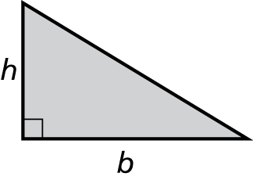 | P = s₁ + s₂ + s₃  or  P = sum of all sides | A = bh ÷ 2  or

Shape | Radius | Diameter | Circumference | Area
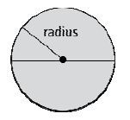  Circle  diameter | r = d ÷ 2 | d = 2r | C = 2πr  or  C = πd | A = πr²

Surface Area: SA = 2 × (area of base) + (perimeter of base) × (height)
or
SA = sum of the area of all the faces

Prism | Surface Area | Volume
Cylinder  h  r | SA = 2πr² + πdh  or  SA = 2πr² + 2πrh | V = area of base × height  or  V = πr²h
Right Rectangular Prism  l  w  h | area of front and back  area of top and bottom  area of ends  +  +  SA =  or  SA = 2lw + 2lh + 2hw | V = area of base × height  or  V = lwh
Cube  s  s  s | SA = 6(area of side)  or  SA = 6s² | V = area of base × height  or  V = s³ or V = s × s × s
Right Triangular Prism  h  b  h | sum of area  of 3 rectangles  +  2 × area  of triangle  SA = | V = area of triangular base × height  or  V = (bh ÷ 2) × height of prism

Scale:
Scale =

Distance:

Pythagorean relationship: c² = a² + b²

Properties of Circles:
central angle
inscribed angle

central angle = 2 × inscribed angle

inscribed angle = central angle ÷ 2

sum of angles in a triangle = 180°

Probability:

