Chapter 1 Problems of the Week
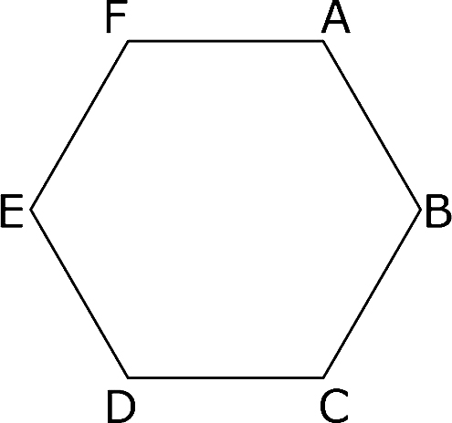
1. The perimeter of hexagon ABCDEF is 48 cm.
Find the length of line segment AD.
Show your thinking.
Draw equilateral triangles.

2. a) For each of the following figures, use the original figure to draw a
i) reflection in the x-axis
ii) translation 1 unit up and 3 units left
iii) rotation of 180° about A

equilateral triangle square

Regular pentagon Regular hexagon

b) Which ones will look like they have not changed their orientation?

______________________________________________
Orientation is the position of an object.

______________________________________________

3. Find images of flowers, starfish, or other natural objects that show rotational symmetry. Make a collage of your images.

