Chapter 4 Problems of the Week
1. A camera negative is the film in a camera that captures an image when you take a picture. Each negative measures 24 mm × 36 mm. From these negatives, pictures can be made in 2 sizes:
• 90 mm × 130 mm
• 100 mm × 150 mm
If you enlarge the negative, will the complete image appear on each size of picture? Explain. Show your calculations.

• 90 mm × 130 mm picture
Use a proportion or the scale.

The image ___________________ fit on a 90 mm × 130 mm picture.
(can or cannot)

• 100 mm × 150 mm picture

The image ___________________ fit on a 90 mm × 130 mm picture.
(can or cannot)

2. In the north, animals need to be able to stay warm in cold temperatures in order to survive. There is a mathematical connection between surface area and volume that is related to an animal’s chance of survival.
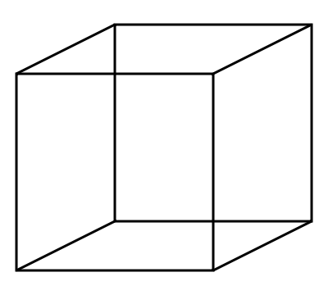
Use different sized cubes explore this situation.

a) Complete the chart.

Side Length of Cube  (cm) | S.A. of Cube  (cm²)  SA = 6s² | V of Cube  (cm³)  V = lwh
1 | 6 × 1²  = 6 × 1× 1  = _______ | 1× 1× 1  = _______ | = _______
2
3
4

b) Use your observations to help explain why large animals find it easier to survive cold temperatures.

__________________________________________________________
__________________________________________________________

