Problems of the Week BLM Answers

BLM 1–1 Chapter 1 Problems of the Week
1. 16 cm
2. a)

b) The square and hexagon. Any even sided shape will appear to have the same orientation.
3. Answers will vary.

BLM 2–1 Chapter 2 Problems of the Week
1. a) b) c) d)
2. 10 cm
3. of the bar of gold is left.
4. 8 squares

BLM 3–1 Chapter 3 Problems of the Week
1. a) 5776 b) Answers will vary. Example: 25² = 625
2. a) 52 cm² b) 4.48 cm, 5.66 cm, 7.21 cm
3. Answers will vary. Example: 12

BLM 4–1 Chapter 4 Problems of the Week
1. cannot; can
2. a) Example:

Side Length of Cube  (cm) | S.A. of Cube  (cm²) | V of Cube  (cm³)
1 | 6 | 3 | 2
2 | 24 | 8 | 3
3 | 54 | 27 | 2
4 | 96 | 64 | 1.5
b) As the size of a cube increases, the surface area (related to heat loss) increases less than volume (related to body size) does. Therefore, large animals lose heat less rapidly than small animals, relative to body size.

BLM 5–1 Chapter 5 Problems of the Week
1. 5; 35; 7; 4, 11, 18, 25, 32, 39; 29.
2. a) 2x² + 2x + 2 b) x² + x + 1 c) x² + x + 1
d) 3
3. 0.05; 0.05n; 0.1; 0.1d; 2(0.05n); 0.75;
0.75 = 2(0.05n) + 0.05n; There are 6 dimes and 3 nickels.

BLM 6–1 Chapter 6 Problems of the Week
1. a)
b) YES. The values of each variable change by the same amount each time.
2. a) y = 4x + 6
b) | x | y
 | 0 | 6
 | 1 | 10
 | 2 | 14
 | 3 | 18
 | 4 | 22
 | 5 | 26
 | 6 | 30
 | 7 | 34
 | 8 | 38
 | 9 | 42
 | 10 | 46
 | 11 | 50
c) YES. The value of each variable changes by the same amount each time.
3. a)
Number of Tables, t | Number of Chairs, s
1 | 6
2 | 12
3 | 18
4 | 24
5 | 30
6 | 36
7 | 42
8 | 48
9 | 54
10 | 60
11 | 66
12 | 72
b)

c) s = 6t

4. a) YES. The value of each variable changes by the same amount each time
b) For each 1.5-point increase in voltage, current increases by 30.

BLM 7–1 Chapter 7 Problems of the Week

1. a) $360 b) $13.50 c) n – 40
d) 360 + 13.5(n – 40)

2. a) Circle with radius x: πx²;
Circle with radius 2x: π(2x)² or 4πx²
b) c)

BLM 8–1 Chapter 8 Problems of the Week
1. a)
Dimes | Nickels | Total ($)
3 | 6 | 0.60
6 | 12 | 1.20
9 | 18 | 1.80
14 | 28 | 2.80
b) Let d = number of dimes
2d = number of nickels
2(0.05)d + 0.1d = 2.80
There are 14 dimes and 28 nickels
(14 × 0.10 + 28 × 0.05 = 2.80).
2. a) s = 87.5 km/h b) 11.4 h
3. 4, 4, 8, 12, 20, 32, 52
4. There are 11 cats.

BLM 9–1 Chapter 9 Problems of the Week
1. a)

b)

c)

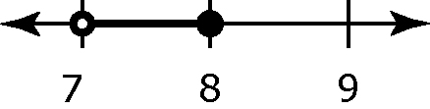
d)

2. a) Statement: 2x + 3 < 9 – x; Solution: x < 2 b) Statement: 4x – 2 ≤ –10; Solution: x ≤ –2
c) Statement: –5x + 3 = –x + 15;
Solution: x = –3

BLM 10–1 Chapter 10 Problems of the Week
1. a) 14.52 cm b) The length of each side of the square is 10.27 cm. c) The length of WX is 20.54 cm. d) 421.89 cm²
2. a)

b) Angle measures will vary but they should all be the same.
c) Angle measures will vary but they should all be the same.
d) ∠AXB is twice any other angle for the circle.

BLM 11–1 Chapter 11 Problems of the Week
1. Answers will vary. Example:
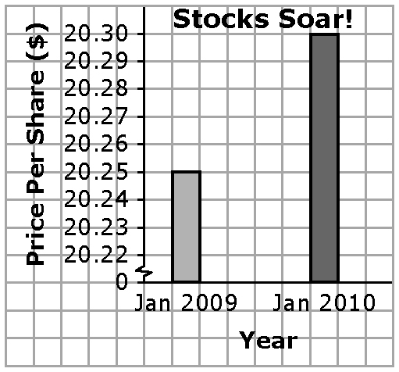
a)

b) The break in the scale creates the misleading impression that the stocks have increased a lot in value.
2. a) Answers will vary. Example: DISAGREE. This year an average of 6.4% of students were absent. Last year an average of 7% of students were absent. Although this is a slight improvement, it is not a significant change.
b) Answers will vary. Examples:
• How many months does the 6.4% rate represent? If it is early in the school year, it would be premature to make a statement about improved attendance.
• What absentee rate would be considered a significant improvement?
• Is an absentee rate of 6% or 7% reasonable?
3. a) Amy: Mean: 7; Median: 9; Mode: 9
Peter: Mean: 6.2; Median: 7; Modes: 3 and 9
Molly: Mean: 8.6; Median: 9; Mode: 9
b) MEAN. It is the most accurate reflection of their quiz scores.

4.
Survey Idea | Influencing Factor
Ask “What does a good band sound like?” | Bias
Hire a survey company and pay them. | Cost
Make all students fill out the survey. | Privacy
Ask if the band members are good looking. | Bias

