10.2 Warm Up
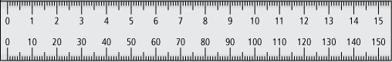
Midpoint means middle or halfway.

1. Find the midpoint of each line segment.

a) | b)  Find the midpoint and draw a perpendicular line.

2. Draw a perpendicular bisector of each line segment.

a) | b)
3. Find the height of the isosceles triangle.

XW = cm

a² + b² = c²
XW² + WY² = XY²
+ WY² = 5²

+ WY² =

– + WY² = –

WY² =

WY =

WY =

The height of the triangle is cm.


4. Calculate the length of the line segment using the midpoints.

a)  If AC = 10 cm, then AB = cm. | b)  If AB = 9 cm, then AE = cm.

