4.1 Warm Up
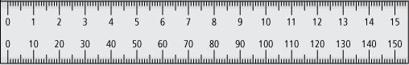
1. Measure each shape.

a)  length:  width: | b)  length of base:  height:

2. a) Use a ruler to draw a 2.5-cm line.  Draw a line that is twice as long.  2.5 × 2 | b) Use a ruler to draw a 6-cm line.  Draw a line that is as long.  6 ÷ 3

3. Multiply.

a) 3 × 4 = | b) 2 × 0.5 =
c) 4 × 0.25 = | d) 1.2 × 6 =

4. Complete.

a) double 5.1 = | b) 19 increased by 5 =
c) half of 48 = | d) 25 reduced by 7 =

