4.4 Warm Up
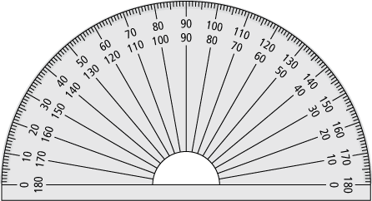
1. Measure the angles in each polygon.

a)

∠A = ° ∠B = °

∠C = ° ∠D = °

b)

∠J = ° ∠K = °

∠L = ° ∠M = °

∠N = °

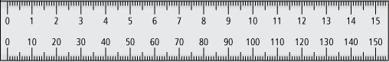
2. Measure the angles and the sides of the trapezoid.

∠P = ° ∠Q = °

∠R = ° ∠S = °

PQ = cm QR = cm

RS = cm PS = cm

