Goal • Use this activity to identify the niche of producers, consumers, and decomposers in a local ecosystem.
What to Do
Choose an organism living in Newfoundland and Labrador. Research its niche in the ecosystem and then display the information on a cereal box. Use the guidelines that follow to organize your information.

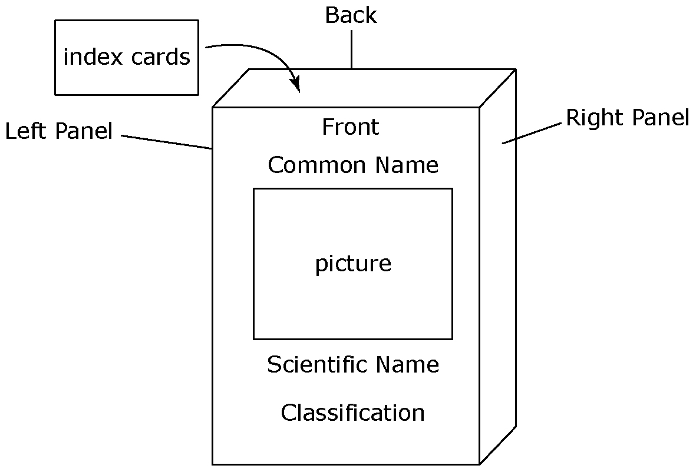

Outside the Box
Front Common name: ___________________________
Scientific name: ___________________________
Classification: herbivore carnivore
omnivore scavenger
producer decomposer

Right Panel Nutrition
For consumers and decomposers, list the organism’s diet and its predators.
For producers, explain
a) how it obtains nutrition,
b) its soil requirements (pH and type of soil)
c) its temperature range of tolerance
What does your organism do during winter to survive for spring?

Back On a map of Newfoundland and Labrador, outline your organism’s range. Include pictures of its habitat.

Left Panel Draw a 4-link food chain, including your organism.

Inside the Box
Prepare 5 index cards, each with a picture of your organism on one side. Choose 5 of the following categories. On the back of each card, include information about one of the categories you chose.
- What commercial value, if any, does your organism have?
- Is your organism an invasive species?
- Do people in this province eat your organism?
- Is your organism endangered or at risk?
- Is your organism’s habitat at risk?
- List an interesting fact about your organism.
- What effect would removing your organism have on the organism’s ecosystem?

