Goal • Use this activity to build your understanding of the interactions of organisms in a food web.
What to Do
Create a 4-link food chain by researching to complete the table that follows.

1. Choose a top-level carnivore that lives in Newfoundland and Labrador. This is your tertiary consumer. Record it in the table under “Organism.”

2. Research online or in print resources to find all of the organisms that it eats. Record your results under “Diet” in the first row.

3. Choose an organism from the tertiary consumer’s diet. Record it as your secondary consumer. Research and record its diet.

4. Choose an organism from the secondary consumer’s diet. Research and record its diet.

5. The primary consumers are herbivores, so the 4th link in your food chain will be a producer. Be specific about the producer your herbivore eats. For example, rabbits eat birch twigs.

6. In groups of 4, on chart paper, record your food chains vertically.

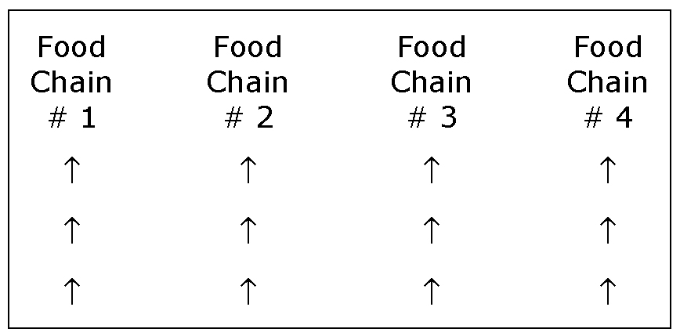

7. Using coloured markers and the information from the “Diet” section of your table, draw arrows showing all of the interactions between your chain and your partners’ chains, creating a food web. For example, if your tertiary consumer eats the secondary consumer of one of your partner’s chains, draw an arrow from the secondary consumer to your consumer.

Type of Consumer | Organism | Diet
Tertiary Consumer

Secondary Consumer

Primary Consumer

Producer

