Habitat in a Box

Front
Sample answer. The student chooses the river otter, scientific name lutra canadensis, classification carnivore.
Right Panel
Diet: cunners, stickleback, sculpin, cod, flounder, ocean pout, rock gunnel, hake, minnow, and trout; will also feed on dragonfly nymphs, water beetles, bugs, frogs, tadpoles, and even mammals such as muskrat, meadow voles, shrews and beavers
Predators: occasionally preyed upon by wolves or coyotes when on land
Back
Winter: They do not hibernate. Instead, they grow a thicker winter pelt, bear their young in late winter.
Range: from Newfoundland and Labrador to Vancouver Island and north to Yukon Territory
Left Panel
Food Chain: pond grass → caddisfly larvae → frogs → river otter

Index card questions:
1. The river otter is trapped for its fur.
2. No, people do not eat the river otter.
3. Oil spills and trapping in Newfoundland and Labrador put otters at risk, but because of the province’s extensive freshwater systems and larger coastlines, the river otter’s habitat is not at risk.
4. Otters swim like streamlined torpedoes and can dive as deep as about 18 m.
5. Removing the river otter would mean less competition for other weasel-like animals such as marten and mink. Beavers would not have to compete with them for beaver ponds or dens.

Building Food Webs

Type of Consumer | Organism | Diet
Tertiary Consumer | Canadian lynx | cunners, stickleback, sculpin, cod, flounder, ocean pout, rock gunnel, hake, minnows, and trout; dragonfly nymphs, water beetles, bugs, frogs, tadpoles; sometimes mammals such as muskrat, meadow voles, shrews, and beavers
Secondary Consumer | Shrew | insects, slugs, spiders, small mice, and worms
Primary Consumer | Insects (grasshoppers) | grasses, leaves, and cereal crops
Producer | grass

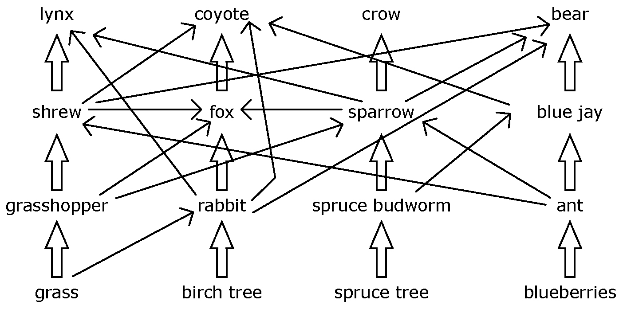

Methods of Heat Transfer

1. conduction 2a. radiation 2b. convection
3. convection 4. radiation 5. radiation

Memory Game

Temperature: A relative measure of how hot or cold something is; the average kinetic energy of the particles in a substance
Celsius: The most common scale for measuring temperature
Fahrenheit: The first widely used temperature scale
Kelvin: A scale used for measuring temperature in scientific experiments
Liquid-in-glass thermometer: A narrow, glass tube marked with a temperature scale and filled with a liquid, such as alcohol or mercury. The liquid expands or contracts in the tube, showing its temperature on
the scale.
Thermocouple: A device used to measure temperature; made of two different types of metal wires that are connected at both ends; temperature differences between the ends cause an electric current to travel along the wires.
Resistance thermometer: A device that uses an object’s electrical resistance to measure temperature
Bimetallic strip: A strip made of two different types of metals that expand by different amounts when heated
Infrared thermometer: A device that measures temperature using the infrared radiation given off by an object
Matter: Anything that takes up space, has mass, and is made of particles
Expansion: An increase in the volume of an object or substance
Contraction: A decrease in the volume of an object or substance
Melting: The process by which a solid changes into a liquid
Freezing: The process by which a liquid changes into a solid
Evaporation: The process by which a liquid changes into a gas or vapour as energy is added
Conduction: The transfer of thermal energy that occurs when warmer particles come in contact with cooler particles and transfer the energy to the cooler particles
Convection: The process by which a warm gas or liquid moves from one place to another, carrying heat
with it
Radiation: The transfer of energy in a wave-like form
Geothermal heating: The process by which heat is pumped from a building through a series of pipes buried in the ground; the pump exchanges the heat with the ground.
Conductor: A substance that transfers heat well
Insulator: A substance that transfers heat poorly
Specific heat capacity: The amount of energy required to raise the temperature of 1.00g of a
substance 1.00°C.
Heat: The total kinetic energy of all the particles in a substance

Particle Theory of Matter Bingo

Note that each question is answered only once, though questions appear more than once on different cards.

Questions | Answers
Name a state of matter. | Solid, liquid, or gas
What change of state occurs when a liquid changes into a gas? | evaporation  (liquid → gas)
Describe how the particles in a solid move. | Particles in a solid vibrate.
Are the particles in a solid close or distant? | Particles in a solid are close.
During freezing, is heat added or taken away? | In freezing, energy is taken away.
State one point of the particle theory of matter. | - Attraction between particles can be weak or strong.  - The particles are constantly moving.  - There are spaces between the particles.  - The particles of one substance are different from the particles of another substance.  - All matter is made up of tiny particles.
Give an example of a solid. | ice
What change of state occurs when a solid changes into a liquid? | melting  (solid → liquid)
Are the particles in a gas close or distant? | Particles in a gas are distant.
Does a solid have definite or indefinite volume? | A solid has definite volume.
During evaporation, is heat added or taken away? | In evaporation, energy is added.
Does a liquid have definite or indefinite volume? | A liquid has definite volume.
Describe how the particles in a liquid move. | Particles in a liquid are free-flowing.
Name another state of matter. | Solid, liquid, or gas
Give an example of a gas. | steam
What change of state occurs when a gas changes into a liquid? | condensation  (gas → liquid)
What change of state occurs when a liquid changes into a solid? | freezing  (liquid → solid)
Describe how the particles in a solid move. | Particles in a solid vibrate.
Are the particles in a solid close or distant? | Particles in a solid are close.
During condensation, is heat added or taken away? | In condensation, energy is taken away.
Give an example of a solid. | ice
Are the particles in a liquid close or distant? | Particles in a liquid are close.
During melting, is heat added or taken away? | In melting, energy is added.
Does a gas have definite or indefinite volume? | A gas has indefinite volume.
Describe how the particles in a gas move. | Particles in a gas have random movement.
What change of state occurs when a gas changes into a solid? | deposition  (gas → solid)
What change of state occurs when a solid changes into a gas? | sublimation  (solid → gas)

Who Dunnit?

Question Card answers
1. Quartz
2. Intrusive rock
3. Heat and pressure
4. Granite
5. a) Limestone
b) Heat and pressure
c) marble
6. Compaction and cementation
7. Mica

Clue Card answers
1. J. Tuzo Wilson
2. S.B. Misra
3. Friedrich Mohs
4. Pele
5. Charlotte Keen
6. Alfred Wegener

Answer to puzzle:
Geologist Joseph Burr Tyrrell, who first discovered the fossilized bones of dinosaurs in Alberta. The find is not a crime scene, but a dig site.

