Unit 1: Sustainable Ecosystems
Chapter 1: Nutrient Cycles and Energy Flow

TRUE/FALSE

1. One way that carbon enters the carbon cycle is through photosynthesis.

ANS: T
This reinforces the idea that plants are carbon sinks.

PTS: 1 OBJ: 1-1 STA: B3.1 TOP: 1.2
MSC: K/U

2. Eutrophication is the result of excess oxygen in a lake.

ANS: F
Algae growth is the result of increased phosphorus or nitrogen.

PTS: 1 OBJ: 1-1 STA: 3.5 TOP: 1.1
MSC: K/U

3. About 10% of the food energy in organisms at one trophic level is transferred to the next trophic level.

ANS: T
Most energy is used by the trophic level.

PTS: 1 OBJ: 1-1 STA: B3.2 TOP: 1.2
MSC: K/U

4. Bioaccumulation is a process that improves trophic efficiency.

ANS: F
Bioaccumulation is the process of taking in more toxins than can be metabolized and eliminated.

PTS: 1 OBJ: 1-1 STA: B3.2 TOP: 1.2
MSC: K/U

5. Oxygen is necessary for fermentation.

ANS: F
Fermentation takes place when oxygen is absent.

PTS: 1 OBJ: 1-1 STA: B3.2 TOP: 1.3
MSC: K/U

6. Greenhouse gases prevent heat from leaving the atmosphere.

ANS: T
Greenhouse gases return heat back to the surface.

PTS: 1 OBJ: 1-1 STA: B3.2 TOP: 1.3
MSC: K/U

7. The boreal forest is a carbon sink.

ANS: T
Ontario’s boreal forest absorbs about 12 million tonnes of carbon dioxide per year.

PTS: 1 OBJ: 1-1 STA: B3.2 TOP: 1.3
MSC: K/U

8. A landfill is an ecosystem.

ANS: T
Landfills can support a variety of organisms, such as raccoons, mice, insects, and many decomposers.

PTS: 1 OBJ: 1-1 STA: B3.1 TOP: 1.3
MSC: K/U

9. Acid precipitation is part of the nitrogen cycle.

ANS: T
One of the compounds in acid precipitation is nitric acid.

PTS: 1 OBJ: 1-1 STA: B3.2 TOP: 1.3
MSC: K/U

10. Shale, a type of rock, is an abiotic factor.

ANS: T
Rock is a non-living part of the ecosystem.

PTS: 1 OBJ: 1-1 STA: B3.1 TOP: 1.1
MSC: K/U

11. The water cycle is the only cycle that involves the hydrosphere.

ANS: F
Other nutrient matter (nitrates, phosphates) can be found dissolved in water.

PTS: 1 OBJ: 1-1 STA: B3.2 TOP: 1.1
MSC: K/U

12. Consumers eat other organisms and produce carbon dioxide as waste.

ANS: T
Cellular respiration produces carbon dioxide as a waste product.

PTS: 1 OBJ: 1-1 STA: B3.2 TOP: 1.3
MSC: K/U

13. Nitrogen in the atmosphere is captured by plants.

ANS: F
Terrestrial plants rely on nitrogen compounds, such as nitrates.

PTS: 1 OBJ: 1-1 TOP: 1.1 MSC: K/U

14. Phosphorus levels in the Great Lakes are the result of overfishing.

ANS: F
High phosphorus levels are linked to fertilizer run-off.

PTS: 1 OBJ: 1-1 STA: B3.2 TOP: 1.1
MSC: K/U

15. Life on Earth relies on the Sun for energy.

ANS: T
Solar energy is converted into food energy by producers.

PTS: 1 OBJ: 1-1 STA: B3.2 TOP: 1.2
MSC: K/U

16. Consumers, like people, rely on plants for oxygen.

ANS: T
Oxygen is produced by the process of photosynthesis.

PTS: 1 OBJ: 1-1 STA: B3.1 TOP: 1.2
MSC: K/U

17. Secondary consumers eat seeds but not leaves.

ANS: F
Secondary consumers are not plant eaters. They eat herbivores.

PTS: 1 OBJ: 1-1 STA: B3.2 TOP: 1.2
MSC: K/U

18. Plants use photosynthesis to capture energy for other trophic levels.

ANS: F
Plants use the energy from photosynthesis for their own growth. Primary consumers take this energy for their own use.

PTS: 1 OBJ: 1-1 STA: B3.2 TOP: 1.2
MSC: K/U

19. The Industrial Revolution started a significant imbalance in carbon in the atmosphere.

ANS: T
It was during the Industrial Revolution that fossil fuels began to be burned at an accelerated rate.

PTS: 1 OBJ: 1-2 STA: B3.2 TOP: 1.3
MSC: K/U

20. Recycling helps reduce carbon in the atmosphere.

ANS: T
Using new materials requires greater use of fuel energy.

PTS: 1 OBJ: 1-2 STA: B3.5 TOP: 1.3
MSC: K/U

MODIFIED TRUE/FALSE

1. The boreal forest of Ontario is protected because it is a small, threatened area.

ANS: F
The boreal forest is the largest terrestrial ecosystem in Ontario and is protected as a sustainable ecosystem.

PTS: 1 OBJ: 1-1 STA: B3.5 TOP: 1.1
MSC: K/U

2. When the acid level in a lake changes, the animals living in the lake stay the same.

ANS: F
As acid levels increase, the variety of animals decreases.

PTS: 1 OBJ: 1-2 STA: B3.1 TOP: 1.3
MSC: K/U

3. Phosphorus is responsible for acid precipitation.

ANS: F
Phosphorus is not released into the air, so it cannot cause acid precipitation.

PTS: 1 OBJ: 1-1 STA: B3.2 TOP: 1.3
MSC: K/U

4. Photosynthesis involves the production of carbon dioxide and is responsible for climate change.

ANS: F
Photosynthesis takes up carbon dioxide to make glucose and helps reduce atmospheric carbon.

PTS: 1 OBJ: 1-1 STA: B3.2 TOP: 1.3
MSC: K/U

5. Decomposers help to release oxygen to the atmosphere.

ANS: F
Decomposers can use oxygen for cellular respiration, but they do not produce oxygen.

PTS: 1 OBJ: 1-1 STA: B3.2 TOP: 1.3
MSC: K/I

6. A carnivore consumes nuts and seeds.

ANS: F
A carnivore eats other animals.

PTS: 1 OBJ: 1-1 STA: B3.2 TOP: 1.2
MSC: K/U

7. The Monarch butterfly’s ingestion of toxins from milkweed provides a positive example of biomagnification.

ANS: F
The Monarch caterpillar eats the milkweed directly, so this is an example of bioaccumulation.

PTS: 1 OBJ: 1-1 TOP: 1.2 MSC: K/U

8. Zooplankton are responsible for much of the oxygen in Earth’s atmosphere.

ANS: F
Phytoplankton are responsible for much of the oxygen in Earth’s atmosphere.

PTS: 1 OBJ: 1-1 STA: B3.2 TOP: 1.2
MSC: K/U

9. Leaching of phosphate into a lake is the result of bacteria acting as decomposers.

ANS: F
Phosphate leaching is a direct movement of phosphates to waterways. Bacteria decomposers help phosphate move back into the lithosphere.

PTS: 1 OBJ: 1-1 STA: B3.2 TOP: 1.1
MSC: K/U

10. Fish are the most acid-sensitive animals in Ontario lakes.

ANS: F
Clams and snails are the most acid-sensitive animals in Ontario lakes..

PTS: 1 OBJ: 1-1 STA: B3.1 TOP: 1.3
MSC: K/U

MULTIPLE CHOICE

1. An ecosystem can be
a. | large. | c. | aquatic.
b. | small. | d. | all of the above.

ANS: D
Ecosystems are found everywhere on the planet and at every scale.

PTS: 1 OBJ: 1-1 STA: B3.1 TOP: 1.1
MSC: K/U

2. Easter Island shows how people can
a. | sustain a diverse ecosystem. | c. | hurt an ecosystem by removing trees.
b. | survive severe weather. | d. | adapt to new conditions.

ANS: C
Deforestation destroys the ecosystem at a fundamental level.

PTS: 1 OBJ: 1-2 STA: B3.5 TOP: 1.1
MSC: K/U

3. Biotic components include
a. | soil. | c. | nutrients.
b. | bacteria. | d. | water.

ANS: B
Bacteria are living things.

PTS: 1 OBJ: 1-1 STA: B3.1 TOP: 1.1
MSC: K/U

4. Some abiotic factors affect some organisms more than others. A mouse is least affected by
a. | light. | c. | oxygen.
b. | water. | d. | nutrients.

ANS: A
Light is critical for the survival of plants, but mice are nocturnal and need little light.

PTS: 1 OBJ: 1-1 STA: B3.1 TOP: 1.1
MSC: K/U

5. The biosphere includes
a. | the lithosphere. | c. | the hydrosphere.
b. | the atmosphere. | d. | all of these.

ANS: D
Living things form a layer over the entire planet.

PTS: 1 OBJ: 1-1 STA: B3.4 TOP: 1.1
MSC: K/U

6. The most vital abiotic cycle is the
a. | water cycle. | c. | nitrogen cycle.
b. | carbon cycle. | d. | phosphorus cycle.

ANS: A
Water is a direct cycle; without water, organisms will not survive.

PTS: 1 OBJ: 1-1 STA: B3.2 TOP: 1.1
MSC: K/U

7. When organisms die
a. | most carbon is released as carbon dioxide. | c. | decomposers release carbon and nitrogen into the air.
b. | nitrogen returns to the air. | d. | phosphate dissolves in water.

ANS: C
Cycling of matter requires the activity of decomposers.

PTS: 1 OBJ: 1-1 STA: B3.2 TOP: 1.2
MSC: K/U

8. Plants are important to the biosphere because they
a. | convert solar energy into chemical energy. | c. | take carbon dioxide out of the air.
b. | cycle water through leaves. | d. | make homes for other organisms.

ANS: A
Plants are producers. They create the food energy that provides the baseline for the ecosystem.

PTS: 1 OBJ: 1-1 STA: B3.2 TOP: 1.2
MSC: K/U

9. Trophic levels help us understand
a. | why big trees can live a long time. | c. | why there are more grasshoppers than hawks.
b. | the importance of decomposers for recycling energy. | d. | how carbon cycles through an ecosystem.

ANS: C
In an ecosystem, what organisms do is related to how they use and transfer energy.

PTS: 1 OBJ: 1-1 STA: B3.2 TOP: 1.2
MSC: K/U

10. Which group is helping to decrease the threats faced by the American eel?
a. | commercial fishers | c. | First Nations
b. | hydro organizations | d. | all of the above

ANS: B PTS: 1 OBJ: 1-2 STA: B3.5
TOP: 1.1 MSC: K/U

11. The Kyoto Protocol is an agreement to
a. | reforest areas where trees are cut. | c. | reduce phosphorus run-off.
b. | reduce carbon gas emissions. | d. | reduce pollution that makes acid precipitation

ANS: B
The Kyoto Protocol specifically targets reduction of atmospheric carbon.

PTS: 1 OBJ: 1-2 STA: B3.5 TOP: 1.3
MSC: K/U

12. Which animal will survive in a lake with a pH of 4?
a. | frogs | c. | trout
b. | clams | d. | perch

ANS: A
Frogs are the least sensitive to changes in pH.

PTS: 1 OBJ: 1-1 STA: B3.1 TOP: 1.3
MSC: K/U

13. Which pH value shows a lake with high level of acid precipitation?
a. | 7 | c. | 5
b. | 6 | d. | 4

ANS: D PTS: 1 OBJ: 1-1 STA: B3.1
TOP: 1.3 MSC: K/U

14. Cellular respiration is a
a. | carbon sink. | c. | way to make methane.
b. | carbon source. | d. | way to make food energy.

ANS: B
Cellular respiration produces carbon dioxide.

PTS: 1 OBJ: 1-1 STA: B3.2 TOP: 1.3
MSC: K/U

15. Fossil fuels are a form of biomass created by
a. | landfills. | c. | ancient cellular respiration.
b. | plants millions of years ago. | d. | carbon from the atmosphere.

ANS: B
Fossil fuels are the product of plant biomass millions of years ago.

PTS: 1 OBJ: 1-1 STA: B3.2 TOP: 1.3
MSC: K/U

16. Monarch butterflies show a positive form of
a. | photosynthetic action. | c. | trophic efficiency.
b. | mutualism. | d. | bioaccumulation.

ANS: D
Monarch butterflies accumulate chemicals from the milkweed they eat so that birds will not eat them.

PTS: 1 OBJ: 1-1 STA: B3.1 TOP: 1.2
MSC: K/U

17. Which trophic level do decomposers take energy from?
a. | producers | c. | carnivores
b. | herbivores | d. | all of these

ANS: D
Decomposers extract energy from members of every trophic level.

PTS: 1 OBJ: 1-1 STA: B3.2 TOP: 1.2
MSC: K/U

18. Bacteria in a landfill produce
a. | oxygen. | c. | carbon dioxide.
b. | methane. | d. | water.

ANS: B
Bacteria produce methane by way of fermentation.

PTS: 1 OBJ: 1-1 STA: B3.2 TOP: 1.3
MSC: K/U

19. Which ecosystem produces more oxygen?
a. | boreal forest | c. | tundra
b. | ocean | d. | deciduous forest

ANS: B
An ocean produces more oxygen than the other ecosystems listed. Tropical forests are responsible for about 30% of Earth’s photosynthesis, the same percentage as the oceans.

PTS: 1 OBJ: 1-1 STA: B3.1 TOP: 1.2
MSC: K/U

20. Acid precipitation is the result of
a. | intense farming practices. | c. | bacteria converting nitrogen to ammonia.
b. | industrial burning of fossil fuels. | d. | decomposition of organic biomass.

ANS: B
Industrial processes burn very large amounts of fossil fuels.

PTS: 1 OBJ: 1-2 STA: B3.5 TOP: 1.3
MSC: K/U

21. How did the residents of Easter Island change the ecosystem of the island?
a. | They cut down trees to clear land for farming. | c. | They overfished the local waters.
b. | They brought animals to the island. | d. | They used rocks for statues.

ANS: A
Deforestation reduced the ability of the island ecosystem to respond to other demands for use.

PTS: 1 OBJ: 1-2 STA: B3.5 TOP: 1.1
MSC: K/U

22. Where are life forms found?
a. | in salt water | c. | in fresh water
b. | underground | d. | in all of these places.

ANS: D
Life is found all places in the biosphere.

PTS: 1 OBJ: 1-1 STA: B3.1 TOP: 1.1
MSC: K/U

23. Bacteria are involved in many cycles of matter. Which cycle does not involve bacteria?
a. | carbon cycle | c. | water cycle
b. | nitrogen cycle | d. | phosphorus cycle

ANS: C
Bacteria have limited involvement in the water cycle.

PTS: 1 OBJ: 1-1 STA: B3.2 TOP: 1.1
MSC: K/U

24. Fertilizer run-off causes eutrophication through
a. | an algal bloom. | c. | deforestation.
b. | greenhouse gases. | d. | acid precipitation.

ANS: A
An algal bloom is the result of increased phosphorus or nitrogen levels. This is the first step in eutrophication.

PTS: 1 OBJ: 1-2 STA: B3.5 TOP: 1.1
MSC: K/U

25. The Great Lakes Water Quality Agreement involves
a. | the United Nations. | c. | Ontario and Michigan.
b. | Canada and the United States. | d. | Ontario, Quebec, Michigan, and New York.

ANS: B
Both Canada and the United States signed the Great Lakes Water Quality Agreement in 1972.

PTS: 1 OBJ: 1-2 STA: B3.5 TOP: 1.1
MSC: K/U

26. During eutrophication the lake ecosystem changes. What happens after the algal bloom?
a. | Fish eat the algae and the populations explode. | c. | The lake becomes more acidic.
b. | The temperature of the lake increases. | d. | The algae cover the surface and plants underneath die.

ANS: D
The algae stop light from reaching plants below the water. These plants then die.

PTS: 1 OBJ: 1-1 STA: B3.1 TOP: 1.1
MSC: K/U

27. Sugar is made of
a. | carbon and hydrogen. | c. | carbon, hydrogen, and oxygen.
b. | carbon, hydrogen, and nitrogen. | d. | carbon, hydrogen, oxygen, and nitrogen.

ANS: C
Glucose is C₆H₁₂O₆.

PTS: 1 OBJ: 1-1 STA: B3.2 TOP: 1.2
MSC: K/U

28. Which trophic level has the largest biomass?
a. | plants | c. | carnivore
b. | herbivore | d. | decomposer

ANS: A
Plants form the foundation that supports all the other trophic levels.

PTS: 1 OBJ: 1-1 STA: B3.2 TOP: 1.2
MSC: K/U

29. PCBs are chemicals that were used in many industries. These chemicals can end up in an aquatic ecosystem. Which aquatic organism will have the highest concentration of PCBs?
a. | rainbow smelt (small fish) | c. | herring gull (bird)
b. | lake trout (large fish) | d. | zooplankton

ANS: C
The top carnivore (herring gull) will have the highest concentration of PCBs.

PTS: 1 OBJ: 1-2 STA: B3.5 TOP: 1.2
MSC: K/U

30. Which of the following is a greenhouse gas?
a. | oxygen | c. | nitric acid
b. | methane | d. | sulfur dioxide

ANS: B
Methane is a greenhouse gas released from landfills, but it can be captured and used as a fuel.

PTS: 1 OBJ: 1-1 STA: B3.2 TOP: 1.3
MSC: K/U

MATCHING

Identify the matter cycle that best matches the description in the question.
a. | water cycle | c. | carbon cycle
b. | nitrogen cycle | d. | phosphorus cycle

1. Which cycle includes matter in the form of precipitation?

2. Which cycle involves matter released by the burning of fossil fuels?

3. Which cycle involves matter being fixed by bacteria?

4. Which cycle involves matter that leaches into water?

1. ANS: A PTS: 1 OBJ: 1-1 STA: B3.2
TOP: 1.1 MSC: K/U

2. ANS: C PTS: 1 OBJ: 1-1 STA: B3.2
TOP: 1.1 MSC: K/U

3. ANS: B PTS: 1 OBJ: 1-1 STA: B3.2
TOP: 1.1 MSC: K/U

4. ANS: D PTS: 1 OBJ: 1-1 STA: B3.2
TOP: 1.1 MSC: K/U

Identify the impact or term that best matches the human activity or function described.
a. | eutrophication of a lake | d. | manufacturers challenge it
b. | industrial pollution | e. | erosion and ecosystem collapse
c. | reduce fertilizer use | f. | phosphate rock

5. What is the impact of deforestation?

6. What happens when a city passes a by-law banning non-essential pesticide use?

7. What is the impact of intense farming?

8. What is used as a source of phosphorus to make fertilizer?

9. How can farmers reduce the environmental impact of farm practice?

10. What is the main source of acid precipitation?

5. ANS: E PTS: 1 OBJ: 1-2 STA: B3.5
TOP: 1.1 MSC: K/U

6. ANS: D PTS: 1 OBJ: 1-2 STA: B3.5
TOP: 1.1 MSC: K/U

7. ANS: A PTS: 1 OBJ: 1-2 STA: B3.5
TOP: 1.1 MSC: K/U

8. ANS: F PTS: 1 OBJ: 1-2 STA: B3.5
TOP: 1.1 MSC: K/U

9. ANS: C PTS: 1 OBJ: 1-2 STA: B3.5
TOP: 1.1 MSC: K/U

10. ANS: B PTS: 1 OBJ: 1-2 STA: B3.5
TOP: 1.1 MSC: K/U

SHORT ANSWER

1. How did removing trees from Easter Island change the ecosystem?

ANS:
The loss of trees led to erosion, a loss of plants for food, loss of most native animals, and no materials for making boats for fishing.

PTS: 3 OBJ: 1-2 STA: B3.5 TOP: 1.1
MSC: K/U

2. Identify an organism that depends on more than one ecosystem to survive, and describe the ecosystems it depends on.

ANS:
Answers will vary, depending on the organism chosen. For example, the ruby-throated hummingbird spends summers in forests and gardens in eastern Canada and winters in tropical forests in Central America. It migrates great distances and relies on the ecosystems on its journey to find food and water.

PTS: 3 OBJ: 1-1 STA: B3.1 TOP: 1.1
MSC: K/U

3. Identify three biotic and three abiotic factors in a specific ecosystem.

ANS:
Answers will vary. For example, a forest ecosystem can include hawks that eat chipmunks that eat acorns. This forest relies on sunlight and water to support the oak tree. The soil must have sufficient nitrogen to support the oak tree.

PTS: 6 OBJ: 1-1 STA: B3.1 TOP: 1.1
MSC: K/U

4. Many elements, such as nitrogen, phosphorus, and carbon, move around the spheres of Earth in a cycle. Explain why this is not true for energy.

ANS:
Energy flows from the Sun to Earth and will then be released back into space.

PTS: 1 OBJ: 1-1 STA: B3.2 TOP: 1.1
MSC: K/U

5. How do decomposers contribute to matter cycles?

ANS:
Decomposers extract energy from plant and animal waste. This releases carbon dioxide into the atmosphere. Nitrogen is released back into the soil or water by way of decomposers. Decomposers also release phosphorus into the soil and water.

PTS: 3 OBJ: 1-1 STA: B3.2 TOP: 1.1
MSC: K/U

6. Outline the nitrogen cycle for a terrestrial ecosystem.

ANS:
Nitrogen in the atmosphere is captured by bacteria in the soil as ammonia and nitrates. Plants take up nitrates as nutrients. Plant matter is eaten by consumers. Animal and plant matter decomposes to release nitrogen into the soil for plants to absorb. Some nitrogen gas is released back into the atmosphere.

PTS: 3 OBJ: 1-1 STA: B3.2 TOP: 1.1
MSC: K/U

7. Outline the nitrogen cycle for an aquatic ecosystem.

ANS:
Nitrogen gas from the atmosphere is dissolved in the water. Nitrogen-fixing cyanobacteria convert nitrogen into ammonium, which is then absorbed by plants. Consumers eat the plant matter and phytoplankton. Decomposers return plant and animal nitrogen matter into water. Some nitrogen is released to the atmosphere as nitrogen gas.

PTS: 3 OBJ: 1-1 STA: B3.2 TOP: 1.1
MSC: K/U

8. How does the use of fertilizer change the nitrogen cycle?

ANS:
Bacteria are not used to convert nitrogen into ammonia and nitrates. This process produces NH₃ gas into the atmosphere.

PTS: 2 OBJ: 1-2 STA: B3.5 TOP: 1.1
MSC: K/U

9. Outline the steps in the eutrophication of a lake.

ANS:
Fertilizer run-off adds phosphorus and nitrogen to a lake. This causes the algae population to increase in a bloom. The algae cut off sunlight to submerged plants. Little new oxygen is produced. The submerged plants die. The dead plant matter decomposes. The decomposers use up the oxygen. Fish no longer have enough oxygen to survive.

PTS: 5 OBJ: 1-2 STA: B3.5 TOP: 1.1
MSC: K/U

10. What is an Environmental Farm Plan? Give an example.

ANS:
Farmers volunteer to examine the environmental impact of their farm. Then they make a plan to reduce the impact. This could mean reducing the amount of phosphorus released into the soil as fertilizer.

PTS: 3 OBJ: 1-2 STA: B3.5 TOP: 1.1
MSC: K/U

11. How is the American eel like the ruby-throated hummingbird?

ANS:
Both species can breed in Canada and migrate to other locations.

PTS: 1 OBJ: 1-1 STA: B3.1 TOP: 1.1
MSC: K/U

12. Explain why protecting species like the ruby-throated hummingbird or American eel requires international cooperation.

ANS:
These animals migrate through different jurisdictions. Protection in only one area is not enough to ensure their survival.

PTS: 2 OBJ: 1-2 STA: B3.5 TOP: 1.1
MSC: K/U

13. List the five types of living things that can be biotic members of an ecosystem.

ANS:
plants, animals, fungi, bacteria, protists

PTS: 5 OBJ: 1-1 STA: B3.1 TOP: 1.1
MSC: K/U

14. The biotic members of an ecosystem can interact in three ways. List these ways.

ANS:
symbiosis, predation, competition

PTS: 3 OBJ: 1-1 STA: B3.1 TOP: 1.1
MSC: K/U

15. Give an example of a symbiotic interaction in an ecosystem.

ANS:
Answers will vary. For example, mushrooms growing on a forest floor benefit from plant energy and help concentrate moisture, which helps trees to grow.

PTS: 2 OBJ: 1-1 STA: B3.1 TOP: 1.1
MSC: K/U

16. Give an example of a predatory interaction in an ecosystem.

ANS:
Answers will vary. For example, a river otter will catch and eat fish, using the energy in the fish to grow and survive. The river otter can also become prey to a larger predator, such as a coyote.

PTS: 2 OBJ: 1-1 STA: B3.1 TOP: 1.1
MSC: K/U

17. Give an example of a competitive interaction in an ecosystem.

ANS:
Answers will vary. For example, two or more types of organism, such as dandelions and grass, compete for the same resources, sunlight and water.

PTS: 3 OBJ: 1-1 STA: B3.1 TOP: 1.1
MSC: K/U

18. Identify five different abiotic characteristics of an ecosystem.

ANS:
water, oxygen, light, nutrients, soil

PTS: 5 OBJ: 1-1 STA: B3.1 TOP: 1.1
MSC: K/U

19. How is water important to an ecosystem?

ANS:
All organisms need water to survive.

PTS: 1 OBJ: 1-1 STA: B3.1 TOP: 1.1
MSC: K/U

20. How is oxygen important to an ecosystem?

ANS:
Many organisms require oxygen to survive.

PTS: 1 OBJ: 1-1 STA: B3.1 TOP: 1.1
MSC: K/U

21. How is light important to an ecosystem?

ANS:
Plants need light for photosynthesis.

PTS: 1 OBJ: 1-1 STA: B3.1 TOP: 1.2
MSC: K/U

22. How are nutrients important to an ecosystem?

ANS:
Plants and animals need nutrients such as nitrogen and phosphorus to grow.

PTS: 1 OBJ: 1-1 STA: B3.1 TOP: 1.1
MSC: K/U

23. How is soil important to an ecosystem?

ANS:
Soil provides nutrients for plants and a habitat for many micro-organisms.

PTS: 2 OBJ: 1-1 STA: B3.1 TOP: 1.1
MSC: K/U

24. Identify the four spheres of Earth.

ANS:
lithosphere, hydrosphere, atmosphere, biosphere

PTS: 4 OBJ: 1-1 STA: B3.4 TOP: 1.1
MSC: K/U

25. Give a local example of the lithosphere.

ANS:
Answers will vary. For example, students may choose a local beach, rocky landmark, or ridge.

PTS: 1 OBJ: 1-1 STA: B3.4 TOP: 1.1
MSC: A

26. Give a local example of the hydrosphere.

ANS:
Answers will vary. For example, students may choose a local river, pond, lake, or stream.

PTS: 1 OBJ: 1-1 STA: B3.4 TOP: 1.1
MSC: A

27. Why is it not reasonable to identify a local example of the atmosphere?

ANS:
The gases of the atmosphere are constantly moving.

PTS: 1 OBJ: 1-1 STA: B3.4 TOP: 1.1
MSC: A

28. How does the water cycle show the way matter moves through all four spheres of Earth?

ANS:
A river otter, part of the biosphere, can drink water from a river, in the hydrosphere. The river otter releases water vapour into the atmosphere by breathing. Water vapour in the atmosphere can fall down onto the lithosphere and drip into the ground water.

PTS: 4 OBJ: 1-1 STA: B3.4 TOP: 1.1
MSC: K/U

29. Which of Earth’s spheres are most involved with the carbon cycle? Use the illustration below to help you decide.

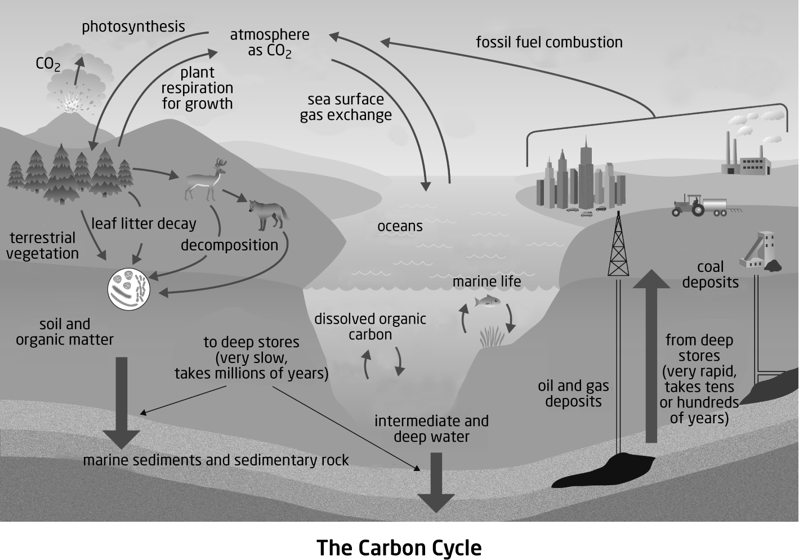

ANS:
The spheres most involved in the carbon cycle are the atmosphere, lithosphere, and biosphere. There is some interaction with the hydrosphere.

PTS: 2 OBJ: 1-1 STA: B3.4 TOP: 1.1
MSC: A

30. How does nitrogen in the atmosphere become involved in the biosphere?

ANS:
Bacteria and cyanobacteria convert nitrogen into ammonia or nitrate. In this form, plants take up nitrogen.

PTS: 2 OBJ: 1-1 STA: B3.4 TOP: 1.1
MSC: K/U

31. How is nitrogen returned to the atmosphere from the biosphere?

ANS:
Some bacteria that decompose matter will release nitrogen into the atmosphere.

PTS: 2 OBJ: 1-1 STA: B3.4 TOP: 1.1
MSC: K/U

32. How is phosphate rock used in manufacturing?

ANS:
Phosphate rock is used to make detergent and fertilizer.

PTS: 2 OBJ: 1-1 STA: B3.4 TOP: 1.1
MSC: K/U

33. How does phosphate move through the ecosystem of a local garden or park?

ANS:
Phosphate in the soil is absorbed by plants. Phosphate moves through organisms that consume the plants and/or the animals that eat the plants. Bacteria break down plant and animal waste, releasing the phosphate back into the lithosphere.

PTS: 3 OBJ: 1-1 STA: B3.2 TOP: 1.1
MSC: A

34. Which of Earth’s spheres are involved in the phosphorus cycle? Use the illustration below to help you decide.

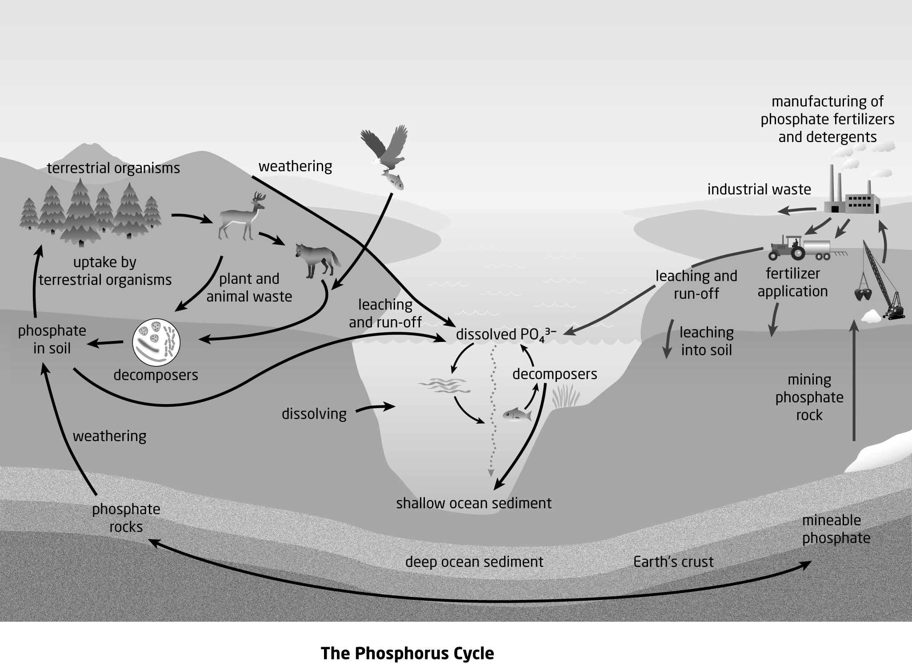

ANS:
Phosphorus cycles through the lithosphere, biosphere, and hydrosphere. Phosphorus does not interact with the atmosphere.

PTS: 3 OBJ: 1-1 STA: B3.4 TOP: 1.1
MSC: A

35. Two relatively recent human activities have increased the amount of phosphorus released from the lithosphere. List these human activities.

ANS:
manufacture of detergent and fertilizer

PTS: 2 OBJ: 1-1 STA: B3.5 TOP: 1.1
MSC: K/U

36. How does the use of fertilizers affect aquatic ecosystems?

ANS:
Excess fertilizer not taken up by plants enters the ground and is transported by water to nearby aquatic ecosystems, causing eutrophication, which leads to the death of aquatic plants and fish.

PTS: 3 OBJ: 1-2 STA: B3.5 TOP: 1.1
MSC: K/U

37. Identify ways to reduce the transfer of phosphorus from the lithosphere to the hydrosphere.

ANS:
Increase the number of plants that can absorb phosphorus released by human activity. Reduce the amount of phosphorus released into waterways, parks, and farms.

PTS: 2 OBJ: 1-2 STA: B3.5 TOP: 1.1
MSC: A

38. How is solar energy stored in the biosphere?

ANS:
Answers will vary but should include examples such as wood, nectar, plants, animals, and fossil fuels.

PTS: 2 OBJ: 1-2 STA: B3.2 TOP: 1.2
MSC: K/U

39. How is photosynthesis important to the biosphere?

ANS:
Photosynthesis converts solar energy into chemical energy with the production of glucose, which provides energy for all the other members of the ecosystem.

PTS: 2 OBJ: 1-1 STA: B3.2 TOP: 1.2
MSC: K/U

40. What is the role of chlorophyll in photosynthesis?

ANS:
Chlorophyll makes leaves green and is the main chemical needed for photosynthesis.

PTS: 1 OBJ: 1-1 STA: B3.2 TOP: 1.2
MSC: K/U

41. Write the words for the chemical formula for photosynthesis.

ANS:
carbon dioxide + water Æ glucose + oxygen

PTS: 2 OBJ: 1-1 STA: B3.2 TOP: 1.2
MSC: K/U

42. How do plants connect to the atmosphere?

ANS:
Plants take up carbon dioxide from the atmosphere and release oxygen to the atmosphere.

PTS: 2 OBJ: 1-1 STA: B3.4 TOP: 1.2
MSC: K/U

43. How do plants connect to the lithosphere?

ANS:
Plants absorb phosphorus, nitrogen, and other nutrients from the soil.

PTS: 2 OBJ: 1-1 STA: B3.4 TOP: 1.1
MSC: K/U

44. How do plants connect to the hydrosphere?

ANS:
Plants absorb water from the ground for photosynthesis.

PTS: 2 OBJ: 1-1 STA: B3.4 TOP: 1.2
MSC: K/U

45. Draw a diagram to show how terrestrial plants build links between the hydrosphere, atmosphere, and lithosphere.

ANS:
Answers will vary, but may be similar to this example.

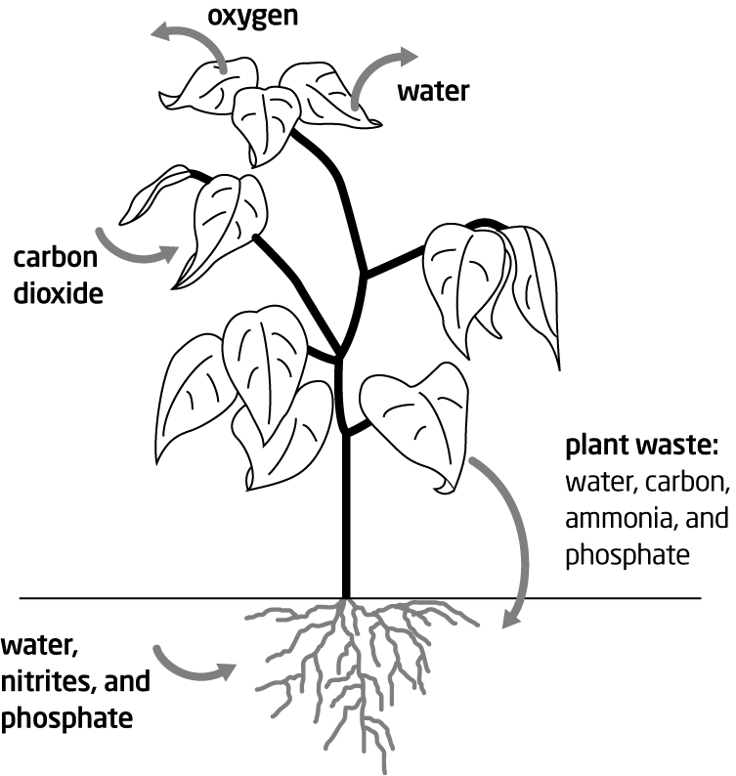

PTS: 4 OBJ: 1-1 STA: B3.4 TOP: 1.2
MSC: A

46. Tropical forests are an important source of oxygen. What is the source of oxygen from tropical forests?

ANS:
The source of oxygen from tropical forests is trees and other plants that make up the forest.

PTS: 1 OBJ: 1-1 STA: B3.1 TOP: 1.2
MSC: K/U

47. Tropical forests cover about 5% of the planet. How is this important to the biosphere?

ANS:
Tropical forests produce about 30% of the world’s oxygen.

PTS: 1 OBJ: 1-1 STA: B3.4 TOP: 1.2
MSC: K/U

48. Explain how the ocean produces about 30% of the oxygen in the atmosphere.

ANS:
Photosynthesis performed by algae and phytoplankton produces most of the oxygen that comes from the oceans.

PTS: 1 OBJ: 1-1 STA: B3.4 TOP: 1.1
MSC: K/U

49. Why is a grasshopper a consumer rather than a producer?

ANS:
Producers produce their own food using energy from the Sun. Plants are producers. Grasshopper eat plants, and cannot make their own food, so they are consumers.

PTS: 1 OBJ: 1-2 STA: B3.2 TOP: 1.2
MSC: K/U

50. Why are the characteristics of a primary consumer?

ANS:
Primary consumers are herbivores that take their energy from plant products.

PTS: 1 OBJ: 1-1 STA: B3.2 TOP: 1.2
MSC: K/U

51. Why are carnivores called secondary consumers?

ANS:
Carnivores do not eat plants directly. These consumers rely on herbivores to transfer plant energy to animal energy.

PTS: 1 OBJ: 1-1 STA: B3.2 TOP: 1.2
MSC: K/U

52. What is meant by the term trophic efficiency?

ANS:
Trophic efficiency is a measure of how much of the energy in organisms at one trophic level is transferred to the next highest trophic level.

PTS: 1 OBJ: 1-1 STA: B3.2 TOP: 1.2
MSC: K/U

53. List three factors that limit the efficiency of energy transfer between trophic levels.

ANS:
Answers may include these factors:
• Not all of the organism is consumed.
• Not all of the consumed matter is digested.
• Every organism loses energy as heat.
• Some energy is used to maintain the consumer.

PTS: 3 OBJ: 1-1 STA: B3.3 TOP: 1.2
MSC: A

54. What is bioaccumulation?

ANS:
Bioaccumulation is the process of ingesting toxins at a rate greater than the rate at which they are eliminated, so the toxins accumulate in the body.

PTS: 1 OBJ: 1-1 STA: B3.2 TOP: 1.2
MSC: K/U

55. How is oxygen related to the way organisms extract the energy from glucose?

ANS:
When oxygen is present, organisms can use cellular respiration to extract energy from glucose. When oxygen is absent, organisms use fermentation to release food energy.

PTS: 2 OBJ: 1-1 STA: B3.2 TOP: 1.3
MSC: K/U

56. Write the word equation for the process of cellular respiration.

ANS:
glucose + oxygen ∅ carbon dioxide + water

PTS: 2 OBJ: 1-1 STA: B3.2 TOP: 1.3
MSC: K/U

57. How is carbon dioxide related to climate change?

ANS:
As atmospheric carbon dioxide levels have increased, the global temperature has increased.

PTS: 2 OBJ: 1-1 STA: B3.2 TOP: 1.3
MSC: K/U

58. How does protecting the boreal forest help reduce our impact on carbon dioxide emissions?

ANS:
The boreal forest is a carbon sink, a massive store of carbon as biomass. Protecting the boreal forest from development means that less carbon will be released from the biomass into the atmosphere.

PTS: 2 OBJ: 1-2 STA: B3.5 TOP: 1.3
MSC: A

59. How can humans make use of landfills?

ANS:
Landfills are deposits of waste biomass. Bacteria in the landfill consume the waste biomass and produce methane. Methane can be collected and used as a fuel to generate electricity.

PTS: 3 OBJ: 1-2 STA: B3.5 TOP: 1.3
MSC: K/U

PROBLEM

1. Use the diagram shown below to answer the following.
a) Identify two abiotic factors and two biotic factors in the diagram. Explain your reasoning.
b) Describe the relationship between an abiotic factor and a biotic factor in this ecosystem.
c) How does the variety of biotic factors help the sustainability of the ecosystem?

ANS:
a) Abiotic factors in the diagram include sunlight, water, water currents, rocks, and air. These are the non-living physical and chemical components of the ecosystem. Biotic factors in the diagram include the fish, seal, seagull, crayfish, dolphins, and aquatic plants. These are the living components of the ecosystem that interact with the environment.
b) Aquatic plants make their own food using energy from the sun through the process of photosynthesis. The aquatic plants also produce oxygen as a result of photosynthesis.
c) There are several food sources for the seals and dolphins. This allows them to vary their diet over time and survive if one of the food sources is absent.

PTS: 8 OBJ: 1-1 STA: B3.1 TOP: 1.2
MSC: A

2. Draw a diagram of the carbon cycle that includes the hydrosphere. (Research may be required.).

ANS:
Answers will vary. The diagram should contain most of the details shown on the diagram below. It should show that carbon dioxide leaves the atmosphere to dissolve in bodies of water, and that carbon dioxide is released into the atmosphere from bodies of water. It should show that organisms in the aquatic ecosystems take carbon from dissolved carbonates to build shells, and that plants in the water absorb carbon dioxide and release oxygen.

PTS: 3 OBJ: 1-1 STA: A1.3, A1.6, B3.2
TOP: 1.1 MSC: A

3. Eutrophication in the Great Lakes is common near shore areas. It is widespread in Lake Erie, and less widespread in Lake Superior and Lake Ontario. Determine the factors that make eutrophication a greater problem in Lake Erie.

ANS:
Lake Erie is the shallowest and warmest of the Great Lakes, so algae grows faster there than in the other lakes. Also, the land around Lake Erie was developed earlier and more intensely than the land around the other lakes, leading to greater leaching and run-off of phosphates. Lake Superior is the deepest and coldest lake, and has less human activity around it. Lake Ontario has a high level of human activity around it, but Lake Ontario is a deep lake, and eutrophication is limited to shallow areas near shore.

PTS: 4 OBJ: 1-2 STA: A1.3, A1.10, B3.5
TOP: 1.1 MSC: A

4. Describe a procedure for testing whether water temperature is a factor in lake eutrophication, complete the test, and analyze the results. Does temperature affect the eutrophication of a lake?

ANS:
Answers will vary. A possible procedure is:
Decide how you will determine eutrophication (oxygen level, algal density). Take four equal samples of lake water. Leave one sample out at room temperature as a control. Add a small amount of phosphorus to the other samples. Leave one sample at room temperature near the control sample. Keep one sample under a heat lamp. Keep an additional sample in a cool area with light. Check that each sample has the same amount of light each day. Use a cover to darken samples in areas with artificial light. Observe changes in the water periodically. Test to determine the level of eutrophication.
Students should conclude that warmer temperatures lead to increased algal growth.

PTS: 4 OBJ: 1-2 STA: A1.11, B2.4 TOP: 1.1
MSC: T/I

5. Trophic efficiency differs at different trophic levels in a food chain. People, like bears and raccoons, are omnivores, which can consume at different trophic levels. Consider the foods you typically eat at home, at school, and in restaurants. In which of these three places do you consume food energy most efficiently?

ANS:
Answers will vary. When we eat fruits, vegetables, and grains, we are primary consumers. Eating plants represents our most efficient use of food energy. Eating herbivores/primary consumers (beef, chicken, etc.) makes us secondary consumers. Fish or other seafood are usually secondary or tertiary consumers. Some game animals are also tertiary consumers. Intensely farmed crops (corn) and livestock (cattle, chickens) use more energy, as do processed and packaged foods, so the efficiency of eating these products is reduced. Many students may find that food prepared at home is the most energy-efficient diet.

PTS: 4 OBJ: 1-2 STA: B3.5 TOP: 1.2
MSC: A

6. a) Which natural process reduces atmospheric carbon, photosynthesis or cellular respiration?

Photosynthesis carbon dioxide + water ∅ glucose + oxygen
Cellular respiration glucose + oxygen ∅ carbon dioxide + water

b) List three ways in which this natural activity could be enhanced in your local community.
c) Share your ideas with two or three other students. As a group, choose one way in which your community could reduce atmospheric carbon through photosynthesis. Make a plan to implement your strategy. Prepare a report explaining your choice of strategy and describing how it could be implemented.

ANS:
a) Photosynthesis reduces atmospheric carbon.
b) Answers will vary, but will likely include planting trees, reducing paper use, creating greenspace, and supporting local food sources.
c) Answers will vary.

PTS: 7 OBJ: 1-2 STA: A1.11, B3.5 TOP: 1.3
MSC: A

7. Describe a procedure for testing how acid precipitation affects algae growth in a lake (or pond). Complete the test and analyze the results. How does acid precipitation affect algae growth in a lake (or pond)?

ANS:
Answers will vary. A possible procedure is:
Take four samples of lake (or pond) water. Number the samples one, two, three, and four. Leave one sample as a control. Add one drop of sulfuric acid solution to sample two. Add two drops of sulfuric acid solution to sample three. Add three drops of sulfuric acid solution to sample four. Leave all samples in the same area for similar light and temperature conditions. Observe the samples several times over a period of two weeks. Use a light source (overhead projector or flashlight) to measure algae growth. Lower algae growth will allow more light through the container. The darkest container will have the greatest algae growth.
Students should conclude that highly acidic water will harm algae. Mildly acidic water may support increased growth.

PTS: 6 OBJ: 1-1 STA: A1.1, A1.2, A1.4, A1.5, A1.8, B2..4
TOP: 1.3 MSC: T/I

8. One way to add carbon dioxide to water is to blow air from your lungs into water. Explain how you could use this method to determine how increasing the amount of carbon dioxide in the water in a lake or pond affects aquatic plant growth. Complete your procedure and analyze the results. Does increasing the amount of carbon dioxide in the water in a lake or pond affect aquatic plant growth?

ANS:
Answers will vary. A possible procedure is:
Take samples of lake or pond water. Leave one sample as a control. Exhale for 10 s into the second sample. Exhale for 20 s into the third sample. Exhale for 30 s into the fourth sample. The time for exhaling can vary. Repeat over a period of time. Observe any differences in the growth of algae.
Students should conclude that increased carbon dioxide will help support plant growth. (Algae growth can show this more effectively than vascular plant samples.)

PTS: 4 OBJ: 1-1 STA: A1.2, A1.5, A1.6, A1.8. A1.10, B2.4
TOP: 1.1 MSC: T/I

9. Carbon dioxide from the atmosphere dissolves in water. Describe a procedure for testing whether increasing the amount of carbon dioxide dissolved in water changes the pH of the water. Complete the test and analyze the results. Use your results to explain what happens to lakes and oceans as atmospheric carbon dioxide increases.

ANS:
Answers will vary. A possible procedure is:
Take four samples of water (tap water, distilled water, or pond water). Label each with a number. Leave the first sample as the control. Use a straw to exhale into sample two for 30 s. Use a straw to exhale into sample three for 1 min. Use a straw to exhale into sample four for 2 min. Use pH paper to test the pH of the water.
Students should find that as more carbon dioxide is added to the water, the pH will decrease. They should recognize that as atmospheric carbon dioxide increases, carbon dioxide uptake by lakes and oceans increases, and lakes and oceans grow more acidic. (When carbon dioxide enters water it becomes carbonic acid.)

PTS: 4 OBJ: 1-1 STA: A1.2, A1.5, A1.6, A1.8, A1.10, B2.4
TOP: 1.3 MSC: T/I

10. Carbon dioxide is one factor that can make a lake or pond acidic. Research this problem. Identify a strategy that could be used to reduce the acid levels in a lake or pond in your local area.

ANS:
Answers may vary. Students could suggest that more vascular plants be added to the lake or pond. These plants will convert the dissolved carbon dioxide into biomass and add oxygen to the water. Adding limestone chips or magnesium oxide can also reduce the level of carbon dioxide dissolved in water. This is an area of interest because carbon dioxide acidity can stress plumbing infrastructure.

PTS: 3 OBJ: 1-2 STA: A1.1, B3.5 TOP: 1.3
MSC: A

ESSAY

1. How is DDT an example of the danger of biomagnification?

ANS:
DDT is an insecticide that entered the hydrosphere through run-off. Algae in the water systems absorbed the DDT from the water. Microscopic animals ate the algae, including the DDT. Small fish ate the microscopic animals and absorbed the DDT. Larger fish ate the smaller fish. DDT is not metabolized, so it accumulated in the bodies of consumers. Fish-eating birds such as osprey or eagles ate fish containing DDT and the concentration of DDT was magnified at each higher trophic level. This high level of DDT in the bird weakened its eggshells, leading to lowered success of offspring. This reduced the future population of the fish-eating bird species.

PTS: 5 OBJ: 1-1 STA: B3.5 TOP: 1.2
MSC: K/U

2. People can choose to reduce the impact of their activities; for example, foresters plant tree seedlings after harvesting trees. Identify ways in which human activity changes the overall balance of the water, carbon, phosphorus, and carbon cycles. Outline some choices an individual can make that will reduce the impact of this human activity.

ANS:
Answers may vary; the following are some possible examples:
Water cycle: The amount of fresh water available is limited. Current levels of use of fresh water are threatening local resources and future water supplies. Not leaving taps running, doing cold-water washes, and taking showers instead of baths are some ways individuals can reduce their use of fresh water. Also, individuals can avoid buying bottled water, thus reducing fossil fuel use in transportation and creation of plastic, and reducing landfill.
Carbon cycle: Choosing manufactured products that are made locally reduces the use of fossil fuels in transportation and hence reduces atmospheric CO₂. Choosing alternative fuels may reduce the amount of fossil fuel use.
Phosphorus cycle: Fertilizers not absorbed by plants pollute the hydrosphere through storm run-off and leaching through the soil into the groundwater. Using alternatives to phosphate fertilizers such as compost or organic fertilizers can prevent this.
Nitrogen cycle: Burning of fossil fuels produces nitrogen oxide which combines with water to create acid precipitation, which damages terrestrial and aquatic ecosystems. Reusing items, recycling, and reducing consumption by rethinking choices are all ways in which individuals can help to reduce use of fossil fuels.

PTS: 9 OBJ: 1-2 STA: B3.5 TOP: 1.3
MSC: A

3. The Ontario Government has circled the intensely urban Greater Toronto Area with a Greenbelt. The Greenbelt is intended to protect air and water and provide locally grown food. One result of this change has been fewer homes build in the Greenbelt area. Explain how housing developments affect the water and carbon cycles.

ANS:
Answers may vary. For example, housing developments interrupt the carbon cycle by the elimination of plants, including trees, that remove carbon dioxide from the atmosphere. Materials used to build the structures must be harvested, processed, or mined, which requires use of fossil fuels to manufacture, extract, and transport these materials. The housing development will interrupt the water cycle by blocking precipitation that would move into the ground-water layer. If the development is not connected to a municipal water system, people will access ground water through wells. Excessive use of water will reduce the ground water available.

PTS: 4 OBJ: 1-2 STA: B3.5 TOP: 1.1
MSC: A

4. You are responsible for organizing an Earth Day presentation to the school. Complete these tasks:
– Review Chapter 1: Nutrient Cycles and Energy Flow and select a topic for the presentation related to the concepts in this chapter.
– Identify an appropriate guest speaker for the topic of your choice.
– Prepare an outline of the content to be included in the presentation.
– Prepare a short report for the school principal that explains why your presentation will be an effective educational component of the school’s Earth Day programming.

ANS:
Answers will vary. The guest speaker could be a parent or a local scientist, farmer, government or industrial representative, etc.

PTS: 12 OBJ: 1-2 STA: A1.3, A2.1, B3.5
TOP: 1.3 MSC: C

5. A local birding club is raising money to create a refuge for ruby-throated hummingbirds. Identify dangers that hummingbirds may face as they return north for breeding. Identify the conditions these birds need in order to successfully breed. Prepare a report to explain what is needed for the refuge and how people in the area can help these birds.

ANS:
Answers will vary, but may include the following points:
The main danger for hummingbirds during migration is late snow or frosts that will kill the flowers the hummingbirds need for nectar. Hummingbirds expend a huge amount of energy flying and need a constant supply of nectar, which requires a variety of flowering plants. Flowers with nectar need to be in bloom throughout the summer. Cats are the main predator of hummingbirds, but praying mantises, frogs and snakes, spiders, and predatory birds also prey on them. A variety of trees and shrubs are needed for nesting sites. The nest must be up off the ground and sheltered from the wind and sun. People in the area can provide gardens with a variety of flowering plants and/or set up hummingbird feeders. Since these birds also eat insects, people should avoid using pesticides. People can provide nesting material such as animal hair, feathers, and cotton fluff and put a bell on their cat to prevent the cat catching birds.

PTS: 8 OBJ: 1-1 STA: A1.3, A1.10, B3.1
TOP: 1.1 MSC: A

6. Food choices can have an impact on the environment. Identify three food choices that you can make that will help sustain ecosystems in Ontario and globally. Explain how your choices make a difference.

ANS:
Answers will vary. Possible answers include:
Reducing or eliminating beef and other meats: Large amounts of fossil fuels are used to make the fertilizer that grows the corn the animals are fed. Large amounts of water are used to grow this feed—more than 4000 L of water are used to produce 1 kg of beef.
Phosphate from fertilizers enters aquatic ecosystems through run-off and leaching. Livestock also produce huge amounts of waste that poisons rivers. Forests are destroyed to create grazing land for cattle. This destroys wildlife habitats. Topsoil is also destroyed, leading to erosion. Cattle flatulence is a major producer of methane emissions.
Avoiding seafood on the watch lists: Many species of fish are endangered due to overfishing. Bottom trawl nets damage sea-floor habitats and result in bycatch, the accidental capture and killing of untargeted wildlife.
Buying locally grown food, avoiding foods that are transported by truck or air, and eating food in season: This reduces fossil fuels to transport food. It also supports smaller local farmers that use more energy-efficient methods than giant agribusiness farms.
Choosing foods that have been grown organically: Organic farmers do not use pesticides and chemical fertilizers, improving the health of water and soil systems. Organic foods do not have genetically modified components, whose effect on ecosystems is still largely unknown. However, there is concern that GM plants have the potential to corrupt entire ecosystems.
Reasons given for each choice should relate back to the concepts explored in this chapter.

PTS: 4 OBJ: 1-2 STA: A1.3, B3.5 TOP: 1.3
MSC: A

7. This figure illustrates movement of matter and energy through a food chain. Explain each component of this diagram: food chains, trophic levels, biomass, trophic efficiency, the role of decomposers.

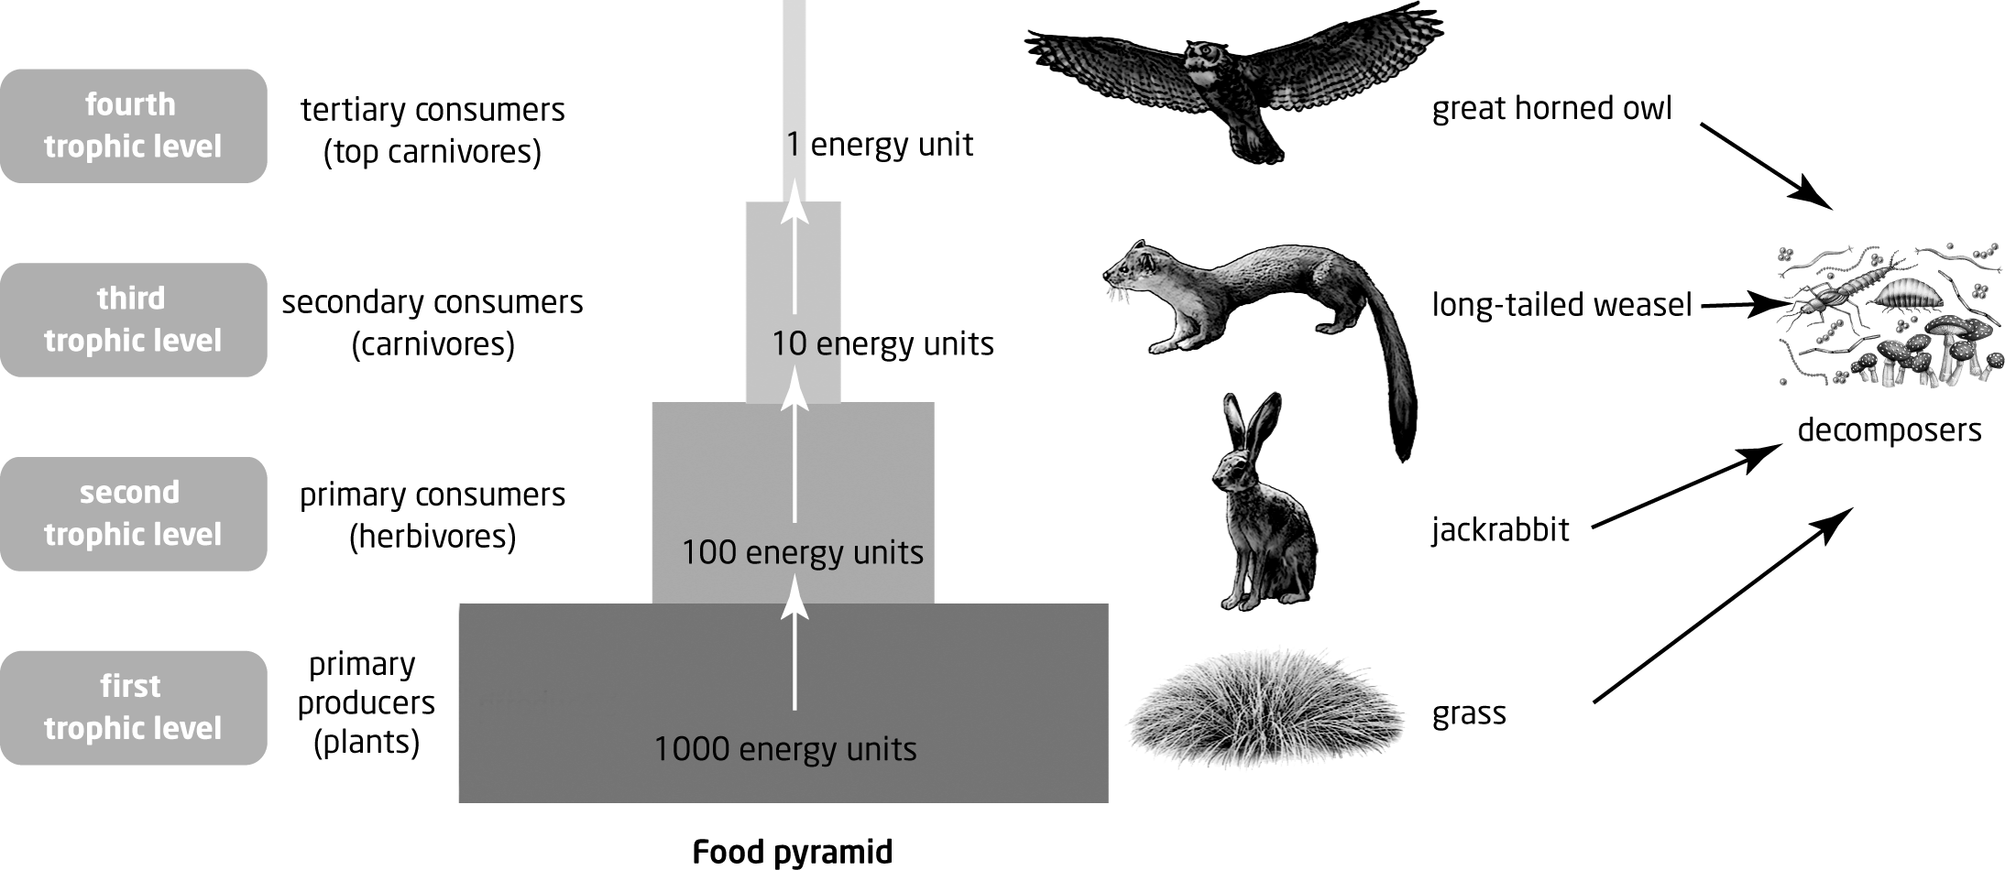

ANS:
Answers may vary, but may include these points:
– A trophic level is a category of organisms that is defined by how the organisms gain energy.
– The size of the rectangle in the food pyramid represents the energy found in the biomass for that trophic level.
– The lower levels are larger because only about 10% of the energy is transferred to the next trophic level. (The rectangles are not to scale.)
– The white arrows indicate the direction of energy flow; energy does not fall back down to lower levels.
– Some energy is lost to the atmosphere from each trophic level.
– All the levels of a food chain are linked to decomposers.

PTS: 5 OBJ: 1-1 STA: A1.8, B3.2 TOP: 1.2
MSC: C

8. The story of Easter Island is a story of limited natural resources. The loss of the island’s natural forest affected the ability of the island to produce food for the population. Use this idea to explain how some current human activity endangers human survival.

ANS:
Answers will vary. Possible activities include the following:
Deforestation has been caused by increased urbanization and conversion of forest lands into agricultural fields or grazing lands for cattle, or for industrialization or mining. This removes crucial carbon sinks, destroys ecosystems, and leads to erosion that affects the fertility of the area.
The huge amounts of water needed to grow grain to feed cattle is depleting aquifers.
CO₂ emissions have increased so much that oceans are reaching their capacity as carbon sinks. Acidification is destroying ocean ecosystems. Global warming may lead to flooding, shortages of water, desertification, and famine and disease.
Many human activities are poisoning the environment and food sources.
Students may choose to consider the impact of human activity in other parts of the world.

PTS: 5 OBJ: 1-2 STA: B3.5 TOP: 1.1
MSC: A

9. In any society, a source of food is a priority. This can lead to decisions that hurt a sustainable environment. Explain how a food-first approach can stress the environment through phosphorus use, lead to drought or extended lack of water, and reduce variety in the trophic levels.

ANS:
Answers will vary. For example, phosphorus use as a fertilizer can lead to increased plant growth. Run-off from this use can damage food sources in ponds, lakes, and rivers. Choosing to grow more food can lead to clearing more forest. Reduced forest cover affects the soil’s ability to absorb water into the ground water. Water then leaves the area quickly, taking nutrients in the run-off. This leads to dry soil that is sensitive to erosion. Choosing to grow a limited number of high-yield crops reduces the trophic levels. The reduced variety of members in the different trophic levels reduces the number of links among the biosphere and the abiotic spheres.

PTS: 4 OBJ: 1-2 STA: B3.5 TOP: 1.2
MSC: A

10. The members of an ecosystem are like the members of a team. The success of a team depends on everyone contributing and working together effectively. Choose a type of team (e.g., a football team, a project team) and continue this analogy. Explain how a damaged ecosystem is like a team that is not working well together.

ANS:
Answers may vary; for example, a football could be energy, and players with the ball could be producers. Players after the producer are the primary consumers. As some players are tired, other players take their place. This suggests variety within the trophic level. The coach selects who is allowed to play, so the coach is the top carnivore.

PTS: 4 OBJ: 1-1 STA: A1.11, B3.2 TOP: 1.1
MSC: A

11. The boreal forest is an important part of the biosphere. The Ontario government has set aside a large part of the boreal forest as a protected area. Research information about the boreal forest ecosystem. Identify a variety of species for each trophic level. What would happen to these organisms if the forest were harvested and removed?

ANS:
Answers will vary. Students will identify plants and animals such as:
Primary producers: key trees, such as balsam fir, black spruce, white spruce, and jack pine; ferns, such as the spiny wood fern and lady fern
Primary consumers: migrating birds such as the blackpoll warbler, Cape May warbler, and a variety of other birds; insects such as the Monarch butterfly and Luna moth, and mosquitoes; woodland caribou
Secondary consumers: wood frog, boreal chorus frog, snapping turtle, blue-spotted salamander, and other amphibians and reptiles; northern pike, muskellunge, yellow pickerel, and other fish species
Tertiary consumers: black bears, lynx, porcupine, pine marten, beaver, mink, and other carnivorous mammals; hawks and owls
If the forest is removed, all of these species are placed at risk.

PTS: 6 OBJ: 1-2 STA: A1.3, A1.6, B3.2
TOP: 1.2 MSC: T/I

