Unit 1: Sustainable Ecosystems
Chapter 2: Populations and Sustainable Ecosystems

TRUE/FALSE

1. An example of a population includes all the mosquitoes that have bitten me.

ANS: F
Mosquitoes may have bitten you at different times in your life. A population refers to a group of organisms in a particular time and place.

PTS: 1 OBJ: 1-1 STA: B2.1 TOP: 2.1
MSC: K/U

2. Exponential growth is found if hunting pressure is stopped.

ANS: T
When African elephants were protected from ivory hunters, the population increased exponentially.

PTS: 1 OBJ: 1-1 STA: B3.5 TOP: 2.1
MSC: K/U

3. Hunting was the primary reason wild turkeys died out in Ontario.

ANS: F
Habitat destruction was the primary reason turkey populations died out in Ontario.

PTS: 1 OBJ: 1-2 STA: B3.5 TOP: 2.1
MSC: K/U

4. Populations stop growing because of limited food.

ANS: T
Food is one limiting factor that can stop population growth.

PTS: 1 OBJ: 1-1 STA: B3.3 TOP: 2.1
MSC: K/U

5. Urban sprawl is a form of intensification.

ANS: F
Intensification uses existing urban space, so it is an alternative to urban sprawl.

PTS: 1 OBJ: 1-2 STA: B2.1 TOP: 2.1
MSC: K/U

6. The abiotic limiting factors define an ecological niche.

ANS: F
An ecological niche includes both abiotic factors and biotic interactions.

PTS: 1 OBJ: 1-1 STA: B2.1 TOP: 2.1
MSC: K/U

7. All predators are animals.

ANS: F
Plants, like a sundew, can act as a predator and consume prey.

PTS: 1 OBJ: 1-1 STA: B2.1 TOP: 2.2
MSC: K/U

8. Competition for resources increases when the population increases.

ANS: T
More individuals compete for the same amount of resources.

PTS: 1 OBJ: 1-1 STA: B3.3 TOP: 2.2
MSC: K/U

9. A large ecological footprint is linked with unsustainable use of resources.

ANS: T
A large ecological footprint uses many non-renewable resources.

PTS: 1 OBJ: 1-2 STA: B3.5 TOP: 2.3
MSC: K/U

10. Toronto is found on the watershed of Lake Ontario.

ANS: T
Toronto covers land where water drains into Lake Ontario.

PTS: 1 OBJ: 1-2 STA: B3.1 TOP: 2.4
MSC: K/U

11. Forests help the environment by cycling matter.

ANS: T
Trees take in carbon and other matter that is then passed on to producers or released by decomposers.

PTS: 1 OBJ: 1-1 STA: B3.2 TOP: 2.4
MSC: K/U

12. If one organism benefits from another, the interaction is mutualism.

ANS: F
If one organism benefits from another, the interaction is parasitism.

PTS: 1 OBJ: 1-1 STA: B2.1 TOP: 2.2
MSC: K/U

13. Brainworm shows an example of mutualism.

ANS: F
Brainworm shows an example of parasitism.

PTS: 1 OBJ: 1-1 STA: B2.1 TOP: 2.2
MSC: K/U

14. People on Easter Island had a large ecological footprint on their area.

ANS: T
The people of Easter Island did not practice sustainable use of land and resources.

PTS: 1 OBJ: 1-2 STA: B3.5 TOP: 2.3
MSC: K/U

15. People in the developed world, such as Canadians, are well educated, so they have a small ecological footprint.

ANS: F
Canadians have a large ecological footprint. Education does not reflect sustainable practice.

PTS: 1 OBJ: 1-2 STA: B3.5 TOP: 2.3
MSC: K/U

16. Lynx regulate the population of hares.

ANS: T
This is a good example of top-down predation.

PTS: 1 OBJ: 1-1 STA: B3.3 TOP: 2.2
MSC: K/U

17. Moose and deer are competitors.

ANS: F
The ranges of moose and deer may overlap, but moose and deer have different niches.

PTS: 1 OBJ: 1-1 STA: B3.3 TOP: 2.2
MSC: K/U

18. “All the moose in Algonquin Park” is an example of a population.

ANS: T PTS: 1 OBJ: 1-1 STA: B2.1
TOP: 2.1 MSC: K/U

19. Ecotourism is a way for people to profit from sustaining their environment.

ANS: T PTS: 1 OBJ: 1-2 STA: B3.5
TOP: 2.4 MSC: K/U

20. Ecosystem collapse is the result of sustainable living.

ANS: F
Ecosystem collapse is the result of unsustainable living.

PTS: 1 OBJ: 1-1 STA: B3.5 TOP: 2.4
MSC: K/U

MODIFIED TRUE/FALSE

1. Carrying capacity is a definite limit on population size.

ANS: F
Carrying capacity is a fluid concept that changes as the biotic interactions change.

PTS: 2 OBJ: 1-1 STA: B3.3 TOP: 2.1
MSC: K/U

2. The redside dace population is limited by fertilizer run-off.

ANS: F
The redside dace is limited by deforestation, since trees over rivers reduce the water temperature.

PTS: 2 OBJ: 1-1 STA: B3.3 TOP: 2.1
MSC: K/U

3. The Golden Horseshoe is a type of freshwater crab found in the Great Lakes.

ANS: F
The Golden Horseshow is a highly developed region near the west end of Lake Ontario.

PTS: 2 OBJ: 1-2 STA: B3.1 TOP: 2.1
MSC: K/U

4. The water in a bog is like the water in a eutrophied lake.

ANS: F
The water in a bog is low in nutrients.

PTS: 2 OBJ: 1-1 STA: B3.3 TOP: 2.2
MSC: K/U

5. Grasshoppers affect shrew populations by bottom-up population regulation.

ANS: T PTS: 1 OBJ: 1-1
STA: B3.3 TOP: 2.2 MSC: K/U

6. The brook stickleback prefers a narrow niche.

ANS: F
The brook stickleback will choose a broad niche, but uses a narrow niche when the nine-spine stickleback is also present.

PTS: 2 OBJ: 1-1 STA: B3.3 TOP: 2.2
MSC: K/U

7. Coral reef bleaching is the result of algae overgrowth.

ANS: F
Coral bleaching is the result of algae loss.

PTS: 2 OBJ: 1-1 STA: B3.3 TOP: 2.2
MSC: K/U

8. White-tailed deer populations are limited by brainworm parasites.

ANS: F
White-tailed deer are largely unaffected by the brainworm.

PTS: 2 OBJ: 1-1 STA: B3.3 TOP: 2.2
MSC: K/U

9. Removing forests from Ontario has allowed more water to be collected for agricultural use.

ANS: F
Deforestation leads to desertification with increasing erosion and less water retention.

PTS: 2 OBJ: 1-1 STA: B3.5 TOP: 2.4
MSC: K/U

10. Saving Canadian habitats will safeguard Canadian birds for the future.

ANS: F
Migratory birds use habitats in other countries. These habitats must also be protected.

PTS: 2 OBJ: 1-2 STA: B3.5 TOP: 2.4
MSC: K/U

MULTIPLE CHOICE

1. Exponential population growth cannot be sustained in nature because
a. | migration takes energy away from growth. | c. | of limiting factors that restrict growth.
b. | hunting prevents growth. | d. | the winter stops growth.

ANS: C
Population growth is fundamentally related to the success of offspring. Factors that limit offspring survival, such as availability of food and nesting sites, are more important than predation, hunting, or migratory expense.

PTS: 1 OBJ: 1-1 STA: B3.3 TOP: 2.1
MSC: K/U

2. A population reaches its carrying capacity
a. | when no more individuals can be supported. | c. | every summer when young are produced.
b. | when all food has been eaten. | d. | after it has been protected from people.

ANS: A
Carrying capacity is related to sustainable use of resources and services of the ecosystem.

PTS: 1 OBJ: 1-1 STA: B3.3 TOP: 2.1
MSC: K/U

3. Which human activity will most change the carrying capacity for native plants?
a. | Forests and grasslands are removed for urban development. | c. | Intensification of urban areas results in taller apartment buildings.
b. | Growing food locally helps to maintain farming and farmland. | d. | Provincial parks have areas set aside for camping.

ANS: A
All human activity can affect the population growth of native species, but urban sprawl has the greatest impact on the species living in the area.

PTS: 1 OBJ: 1-2 STA: B3.5 TOP: 2.1
MSC: K/U

4. The redside dace is an Ontario fish that has been affected by urban sprawl. How has urban development changed the ecosystem of these fish?
a. | Industrial pollution has changed the water quality. | c. | Agriculture has polluted the streams.
b. | Overfishing has reduced the population. | d. | Deforestation has increased the heat of the streams.

ANS: D PTS: 1 OBJ: 1-2 STA: B3.5
TOP: 2.1 MSC: K/U

5. The southern Ontario Greenbelt surrounding the Greater Toronto Area requires
a. | people to grow their own food and reduce the need for farmland. | c. | reforestation of city land to improve air quality.
b. | intensification of existing urban areas to reduce development of open land. | d. | uses of electric cars to reduce the emission of greenhouse gases.

ANS: B PTS: 1 OBJ: 1-2 STA: B3.5
TOP: 2.1 MSC: K/U

6. The biotic niche factors for the brown bat do not include
a. | prey, such moths or beetles. | c. | obstacles, like tree branches.
b. | predators, such as owls. | d. | competitors, like the nighthawk.

ANS: C PTS: 1 OBJ: 1-1 STA: B3.1
TOP: 2.2 MSC: K/U

7. A wetland bog has low levels of
a. | nutrients. | c. | light.
b. | water. | d. | acid.

ANS: A PTS: 1 OBJ: 1-1 STA: B3.1
TOP: 2.2 MSC: K/U

8. Insects help the growth of pitcher plants in a bog by providing
a. | a source of nutrients. | c. | a way to carry seeds to a new location.
b. | drops of water. | d. | bacteria that fix nitrogen.

ANS: A PTS: 1 OBJ: 1-1 STA: B3.1
TOP: 2.2 MSC: K/U

9. An example of top-down population regulation is
a. | the wolf and the moose. | c. | the lynx and the hare.
b. | the wasp and the sundew plant. | d. | the shrew and the grasshopper.

ANS: C PTS: 1 OBJ: 1-1 STA: B3.3
TOP: 2.2 MSC: K/U

10. How does competition limit the size of a population?
a. | Brainworms kill moose but not white-tailed deer. | c. | Algae in coral reefs cause bleaching.
b. | Increased population can lead to fewer babies produced. | d. | Bog plants consume insects for nutrients.

ANS: B PTS: 1 OBJ: 1-1 STA: B3.3
TOP: 2.2 MSC: K/U

11. Which of these statements is true?
a. | Moose populations are regulated by wolves. | c. | Mild winters regulate the population of moose.
b. | Wolf populations are regulated by moose. | d. | Cold winters regulate the population of wolves.

ANS: B PTS: 1 OBJ: 1-1 STA: B3.1
TOP: 2.2 MSC: K/U

12. The story of competition and stickleback fish shows that
a. | food is found only at the bottom of the shoreline. | c. | competition increases with a rise in population.
b. | one species eats insects and the other eats vegetation. | d. | a species can occupy a broad niche without competition.

ANS: D PTS: 1 OBJ: 1-1 STA: B3.3
TOP: 2.2 MSC: K/U

13. Symbiosis includes mutualism and
a. | parasitism. | c. | conservatism.
b. | preservation. | d. | consumerism.

ANS: A PTS: 1 OBJ: 1-1 STA: B3.1
TOP: 2.2 MSC: K/U

14. Algae in a coral reef
a. | provide food for fish. | c. | create shade for corals.
b. | are parasites of corals. | d. | provide energy to corals.

ANS: D PTS: 1 OBJ: 1-1 STA: B3.1
TOP: 2.2 MSC: K/U

15. Two essential factors for coral reefs are
a. | fish populations and oxygen levels. | c. | algal partners and sea temperature.
b. | shark populations and pH levels. | d. | decaying fish matter and light.

ANS: C PTS: 1 OBJ: 1-1 STA: B3.3
TOP: 2.2 MSC: K/U

16. A parasite is an organism that
a. | harms the host. | c. | consumes the host.
b. | relies on a host. | d. | helps the host.

ANS: B PTS: 1 OBJ: 1-1 STA: B3.1
TOP: 2.2 MSC: K/U

17. Brainworm parasites have an important impact on
a. | white-tailed deer populations. | c. | hare populations.
b. | moose populations. | d. | lynx populations.

ANS: B PTS: 1 OBJ: 1-1 STA: B3.3
TOP: 2.2 MSC: K/U

18. Which human activity can cause the white-tailed deer to move northward, bringing brainworm to moose populations?
a. | protecting wetlands | c. | harvesting forests
b. | hunting of deer | d. | building of roads in the north

ANS: C PTS: 1 OBJ: 1-2 STA: B3.3
TOP: 2.2 MSC: K/U

19. How does the brainworm benefit from the white-tailed deer?
a. | Worms consume the brain of the deer, leaving the deer incapacitated. | c. | Deer carry and release worm eggs at new locations.
b. | Worm families grow in the deer and are released when the deer dies. | d. | Deer kill the snails and slugs that eat the worms.

ANS: C PTS: 1 OBJ: 1-1 STA: B3.1
TOP: 2.2 MSC: K/U

20. How did the human brain affect our ecological niche? The human brain
a. | allowed us to live in deserts and forests. | c. | created multiple sustainable systems.
b. | helped us conserve resources. | d. | allowed an increase in diversity.

ANS: A PTS: 1 OBJ: 1-2 STA: B3.5
TOP: 2.3 MSC: K/U

21. The human population increases because
a. | the planet is ideally suited to human growth. | c. | climate change is creating more opportunities for people to grow.
b. | we use energy to change niches to suit our needs. | d. | there is no carrying capacity for people.

ANS: B PTS: 1 OBJ: 1-2 STA: B3.3
TOP: 2.3 MSC: K/U

22. The human carrying capacity is probably
a. | 2 billion. | c. | 7 billion.
b. | 5 billion. | d. | 10 billion.

ANS: D PTS: 1 OBJ: 1-2 STA: B3.3
TOP: 2.3 MSC: K/U

23. The rapid increase in human population began as the result of
a. | the Industrial Revolution. | c. | the discovery of the New World by European explorers.
b. | recovery from a disease. | d. | new medical achievements.

ANS: A PTS: 1 OBJ: 1-2 STA: B3.5
TOP: 2.3 MSC: K/U

24. Doubling time of the human population is about
a. | 650 years. | c. | 200 years
b. | 400 years. | d. | 60 years.

ANS: D PTS: 1 OBJ: 1-2 STA: B3.3
TOP: 2.3 MSC: K/U

25. An ecological footprint is a measure of
a. | the physical size of a town or city. | c. | how much food is eaten by a person over a period of time.
b. | a person’s standard of living. | d. | how much demand people put on the environment.

ANS: D PTS: 1 OBJ: 1-2 STA: B3.5
TOP: 2.3 MSC: K/U

26. Which is not measured to determine an individual’s ecological footprint?
a. | land use | c. | energy consumption
b. | income | d. | waste production

ANS: B PTS: 1 OBJ: 1-2 STA: B3.5
TOP: 2.3 MSC: K/U

27. Canadians have a large ecological footprint because
a. | the population is increasing rapidly. | c. | Canada’s freshwater drains into oceans.
b. | we use many resources. | d. | we live in a temperate zone

ANS: B PTS: 1 OBJ: 1-2 STA: B3.5
TOP: 2.3 MSC: K/U

28. Ecosystem services are benefits such as
a. | easy access to food. | c. | the cycling of nutrients by decomposers.
b. | limits to oxygen. | d. | landfill site reclamation.

ANS: C PTS: 1 OBJ: 1-1 STA: B3.3
TOP: 2.4 MSC: K/U

29. Regrowing a forest will
a. | cause desertification in neighbouring areas due to demands on the ground water. | c. | increase water run-off.
b. | reduce water run-off. | d. | lead to eutrophication of nearby lakes.

ANS: B PTS: 1 OBJ: 1-2 STA: B3.1
TOP: 2.4 MSC: K/U

30. Sustainable coffee plantations do not involve
a. | biodiversity of trees. | c. | reduced use of fertilizers.
b. | reduced use of pesticides. | d. | use of machines to collect the beans.

ANS: D PTS: 1 OBJ: 1-2 STA: B3.1
TOP: 2.4 MSC: K/U

31. People have changed the wild turkey population in Ontario. Today the wild turkey population is
a. | endangered. | c. | declining.
b. | growing. | d. | extinct.

ANS: B
This is an example of positive human interaction.

PTS: 1 OBJ: 1-2 STA: B3.5 TOP: 2.1
MSC: K/U

MATCHING

Identify the term that best matches the definition or statement given.
a. | bottom-up population regulation | f. | carrying capacity
b. | migratory birds | g. | ecosystem service
c. | watershed | h. | cross-pollination
d. | urban intensification | i. | ecological footprint
e. | abiotic limiting factor | j. | doubling time

1. Water temperature is important to perch.

2. the size of a population in equilibrium with the environment

3. A new development is built within the city boundary.

4. Decrease of grasshopper populations leads to smaller shrew populations.

5. the time it takes for a population to increase by 100%

6. a measure of the impact of an individual on the environment

7. Organisms benefit from various elements of the environment.

8. Run-off water drains over an area of land to a river or lake.

9. Pollen from one flower fertilizes a flower on a different plant.

10. Aerial insectivores leave Canada in the winter and return in the spring.

1. ANS: E PTS: 1 OBJ: 1-1 STA: B2.1, B3.1
TOP: 2.1 MSC: K/U

2. ANS: F PTS: 1 OBJ: 1-1 STA: B2.1, B3.3
TOP: 2.1 MSC: K/U

3. ANS: D PTS: 1 OBJ: 1-2 STA: B2.1, B3.5
TOP: 2.1 MSC: K/U

4. ANS: A PTS: 1 OBJ: 1-1 STA: B2.1, B3.3
TOP: 2.2 MSC: K/U

5. ANS: J PTS: 1 OBJ: 1-1 STA: B2.1, B3.3
TOP: 2.3 MSC: K/U

6. ANS: I PTS: 1 OBJ: 1-2 STA: B2.1, B3.5
TOP: 2.3 MSC: K/U

7. ANS: G PTS: 1 OBJ: 1-1 STA: B2.1, B3.3
TOP: 2.4 MSC: K/U

8. ANS: C PTS: 1 OBJ: 1-1 STA: B2.1, B3.3
TOP: 2.4 MSC: K/U

9. ANS: H PTS: 1 OBJ: 1-1 STA: B2.1, B3.3
TOP: 2.4 MSC: K/U

10. ANS: B PTS: 1 OBJ: 1-1 STA: B2.1, B3.3
TOP: 2.4 MSC: K/U

SHORT ANSWER

1. Can an ecosystem support more than one population? Explain.

ANS:
An ecosystem supports many populations. The term population applies to all the members of a particular species in the ecosystem at any one time.

PTS: 2 OBJ: 1-1 STA: B3.3 TOP: 2.1
MSC: K/U

2. How do populations in the boreal forest change throughout the year?

ANS:
The boreal forest populations change with the seasons. Migratory birds that breed in the boreal forest are not present there in the winter. In the winter, insect populations are reduced to those few species that hibernate.

PTS: 1 OBJ: 1-1 STA: B3.3 TOP: 2.1
MSC: A

3. Identify two different abiotic factors that can affect the success of a perch population.

ANS:
Answers may vary, but most students will identify oxygen in the water and water temperature.

PTS: 2 OBJ: 1-1 STA: B3.1 TOP: 2.1
MSC: K/U

4. How do insect populations act to limit perch?

ANS:
Perch eat insect larvae found in the water. If insect populations decrease, perch populations will decrease. If insect populations increase, perch populations will increase.

PTS: 2 OBJ: 1-1 STA: B3.3 TOP: 2.1
MSC: A

5. Oxygen dissolved in water is an abiotic limiting factor for insects and perch. Explain how this is possible.

ANS:
Insects and fish, such as perch, require oxygen for cellular respiration. Low oxygen levels can only support a small number of insects and fish.

PTS: 2 OBJ: 1-1 STA: B3.1 TOP: 2.1
MSC: A

6. How did human activity lead to the deforestation of much of southern Ontario?

ANS:
Forests were harvested for the lumber and then the land was cleared for agriculture and urban development.

PTS: 2 OBJ: 1-2 STA: B3.5 TOP: 2.1
MSC: K/U

7. How did the deforestation of southern Ontario affect the redside dace?

ANS:
Trees covered streams and rivers where these fish lived. The tree cover cooled the water to a temperature range that supported these fish. With trees removed, the water temperature increased so that many fish could not survive the new conditions.

PTS: 2 OBJ: 1-2 STA: B3.3 TOP: 2.1
MSC: K/U

8. Existing redside dace populations are found in isolated areas. How is this a problem for the survival of the species?

ANS:
Each separate population has limited options if conditions change. This could lead to local extinction.

PTS: 1 OBJ: 1-2 STA: B3.3 TOP: 2.1
MSC: A

9. What is competition?

ANS:
Competition describes how different species try to use the same resources.

PTS: 1 OBJ: 1-1 STA: B3.3 TOP: 2.2
MSC: K/U

10. How does competition for limited resources lead to greater biodiversity?

ANS:
If two species were to try to get the same resource in the same way at the same time, the less-efficient species would become extinct. So, two competing species are forced to use the resource they are competing for in different ways. This promotes biodiversity.

PTS: 2 OBJ: 1-1 STA: B3.3 TOP: 2.2
MSC: A

11. Light is a limiting factor for plants. This can affect the diversity of plantlife in a lake.
a) Where would you expect to find the most diverse plantlife in a deep lake?
b) Where would you expect to find the brook stickleback in a deep lake?

ANS:
a) Deep lakes support the most plantlife near shore.
b) The brook stickleback would most likely be found near the shore by vegetation. These fish are unlikely to be found in deep areas of the lake.

PTS: 2 OBJ: 1-1 STA: B3.3 TOP: 2.2
MSC: A

12. Maple trees are tall shade trees.
a) How does this affect the ability of new maple seedlings to survive?
b) Where are maple seedlings likely to survive and grow?

ANS:
a) Shade from the mature tree prevents the growth of new seedlings.
b) Answers may vary. For example, new maple seedlings will survive where trees have been removed or near the edge of the forest near open fields.

PTS: 2 OBJ: 1-1 STA: B3.3 TOP: 2.2
MSC: A

13. A bog is a form of wetland. What are the characteristic features of a bog?

ANS:
The water is stagnant and acidic. It is also low in nutrients such as nitrogen and phosphorus.

PTS: 2 OBJ: 1-1 STA: B3.1 TOP: 2.2
MSC: K/U

14. How do the pitcher plant and sundew acquire nutrients that are not available in the water of the bog where they grow?

ANS:
The pitcher plant and sundew consume insects for nutrients that are not otherwise available.

PTS: 1 OBJ: 1-1 STA: B3.1 TOP: 2.2
MSC: K/U

15. What does the term ecological niche mean?

ANS:
The term ecological niche describes the abiotic limiting factors and biotic relationships of a species in a given area.

PTS: 1 OBJ: 1-1 STA: B3.1 TOP: 2.3
MSC: K/U

16. What is the carrying capacity of a population?

ANS:
The population of a species will grow until it reaches an upper limit called the carrying capacity. This is the point at which the resource use by the species and the ability of the environment to refresh the used resources are in balance.

PTS: 2 OBJ: 1-1 STA: B3.3 TOP: 2.1
MSC: K/U

17. What happens to a population that grows beyond its carrying capacity?

ANS:
If a population exceeds the ability of its ecosystem to provide resources, the population will drop to a natural equilibrium. Once the resources recover from overuse, the population can begin to grow again.

PTS: 1 OBJ: 1-1 STA: B3.3 TOP: 2.1
MSC: A

18. Explain how the Easter Island story provides a message about carrying capacity. How did the arrival of European explorers affect the possible outcome?

ANS:
The Easter Island story shows that the human population exceeded the carrying capacity of the environment. Evidence for this was the removal of all trees and extinction of many animals. Without the arrival of the European explorers, the population of people on Easter Island would have dropped dramatically.

PTS: 2 OBJ: 1-1 STA: B3.5 TOP: 2.1, 2.3
MSC: A

19. How can a primary consumer, such as the grasshopper, regulate the population of the shrew, a secondary consumer?

ANS:
The grasshopper, a plant-eating species, is the prey for the shrew, a carnivore. If the grasshoppers consume too many of the plants they eat for food, their numbers may eventually decline due to lack of food to support the population. If the population of grasshoppers decreases, there will be less food for the shrews. As the food that the shrews eat decreases, the number of shrews will eventually decrease too. So, a large population of grasshoppers can lead to a reduced population of shrews. This is an example of bottom-up regulation.

PTS: 2 OBJ: 1-1 STA: B3.3 TOP: 2.2
MSC: A

20. How does this graph show that the hare population is regulated by the lynx population?

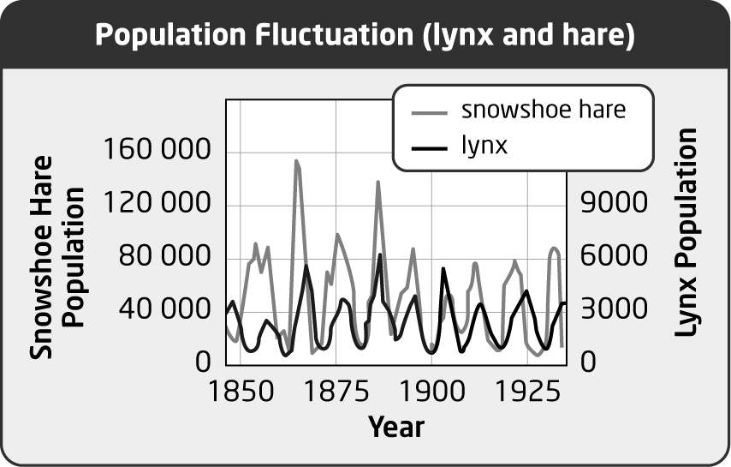

ANS:
The hare population shows the greatest variation. Lynx numbers never reach the high levels that can be reached by the hare population. In this example, the lynx population consumes more hares during a period when hares are plentiful. This results in smaller hare populations in the next few years. As a consequence, the lynx population will also decrease. With fewer predators around, the hare population will increase. This supports greater predation from the lynx, and so the hare population crashes again.

PTS: 2 OBJ: 1-1 STA: A1.8, B3.3 TOP: 2.2
MSC: A

21. a) Explain why wolves are not the primary regulator of moose in the boreal forest.
b) How is Isle Royale an exception?

ANS:
a) Moose populations are affected by many factors, including the brainworm parasite, ticks, and winter conditions. Moose are not the primary prey of wolves. Wolves have a variety of prey that can provide nourishment.
b) Isle Royale is an exception because the limited space means that there are not as many prey choices for the wolves, so they must select moose as a prey more often.

PTS: 3 OBJ: 1-1 STA: B3.3 TOP: 2.2
MSC: A

22. How does the wolf population on Isle Royale keep the moose population in balance with the resources available on the island?

ANS:
If there are too many moose on Isle Royale, there are more opportunities for wolves to track and consume them. As the moose population increases, the wolves will choose moose more often, reducing the number of moose on the island. This limits the impact the moose have on vegetation on the island, so they do not eat it all.

PTS: 2 OBJ: 1-1 STA: B3.3 TOP: 2.2
MSC: A

23. Explain how algae and coral are an example of mutualism.

ANS:
The algae live inside the coral, so they are protected from many predators. Living there, the algae are able to extract nutrients from the coral. Coral reefs must be shallow enough for light to reach them. The algae use the light for photosynthesis. The food produced by photosynthesis is then used as an energy source for the coral.

PTS: 2 OBJ: 1-1 STA: B3.1 TOP: 2.2
MSC: K/U

24. How does the brainworm benefit from the white-tailed deer?

ANS:
The deer eat plants that have slugs or snails attached. The slugs or snails have brainworm living inside them. These worms reproduce, and larval worms leave the deer’s body in new locations. The deer provide a good breeding environment and also distribute the worm into new areas.

PTS: 1 OBJ: 1-1 STA: B3.3 TOP: 2.2
MSC: A

25. Moose have only recently been affected by brainworm, which can kill them. Explain how human activities may have promoted this change.

ANS:
Deforestation for lumber or agriculture has created an environment that has encouraged white-tailed deer to live further north. In moving north, these carriers of the brainworm have spread this parasite into areas where moose live.

PTS: 2 OBJ: 1-2 STA: B3.5 TOP: 2.2
MSC: A

26. What happened to human populations in Europe around the time of the Industrial Revolution?

ANS:
Human populations began to grow exponentially. (One factor in this was that new ways of using energy for transportation (e.g., railroads) improved food availability, increasing health and life expectancy.)

PTS: 1 OBJ: 1-2 STA: B3.5 TOP: 2.3
MSC: A

27. What must people do to achieve an ecological footprint that reflects the principles of sustainability?

ANS:
To live within the principles of sustainability, people must consume fewer resources and/or use existing resources more efficiently.

PTS: 1 OBJ: 1-2 STA: B3.5 TOP: 2.3, 2.4
MSC: K/U

28. List three ecosystem services that the forest can provide.

ANS:
Answers may vary, but may include the following: water retention, reduced erosion in watersheds, habitats for many organisms, food for organisms.

PTS: 3 OBJ: 1-1 STA: B3.1 TOP: 2.4
MSC: K/U

29. Identify two key ways in which insects provide.ecosystem services.

ANS:
Insects can act as pollinators that help increase the reproductive efficiency of many plants.This is best seen by the honeybee.
Insects can also act to help decomposers. Burying beetles help increase the activity of bacteria and fungi by breaking down dead animals with larvae.

PTS: 2 OBJ: 1-1 STA: B3.3, B3.4 TOP: 2.4
MSC: A

30. How do the choices we make as consumers of coffee affect ecosystem biodiversity?

ANS:
By choosing shade-grown coffee we support ecosystems that support a variety of plants and animals, including migratory birds.

PTS: 1 OBJ: 1-2 STA: B1.1 TOP: 2.4
MSC: K/U

31. How does the human brain allow us to occupy a broad niche?

ANS:
Humans have the ability to survive in harsh conditions and use many different resources from the environment.

PTS: 1 OBJ: 1-2 STA: B3.5 TOP: 2.3
MSC: K/U

32. How is bottom-up regulation different from top-down regulation?

ANS:
Bottom-up regulation is found when lower-order consumers (e.g., grasshoppers) control the success of high-level consumers (e.g., shrews). Top-down regulation is found when a higher-order consumer (e.g., lynxes) regulates the population of lower-order consumers (e.g., hares).

PTS: 2 OBJ: 1-1 STA: B3.3 TOP: 2.2
MSC: K/U

33. List three factors that affect moose populations in the boreal forest.

ANS:
Answers may vary and could include harsh winters, ticks, brainworm, and predation.

PTS: 3 OBJ: 1-1 STA: B3.3 TOP: 2.2
MSC: K/U

34. How does deforestation affect terrestrial ecosystems?

ANS:
When rain falls, little water is retained. Water run-off erodes the soil, leaving low nutrient levels in the soil. This results in desertification.

PTS: 2 OBJ: 1-2 STA: B3.5 TOP: 2.2, 2.4
MSC: A

35. How does deforestation affect aquatic environments?

ANS:
Reduced tree cover means that more direct light reaches the water. This increases the overall temperature of the water and reduces temperature diversity. With increased surface run-off, more soil and nutrients enter the water and may contribute to eutrophication.

PTS: 2 OBJ: 1-2 STA: B3.5 TOP: 2.2, 2.4
MSC: A

36. How is the brainworm a parasite to the white-tailed deer?

ANS:
Although the brainworm does not seem to harm the deer, the worm benefits, but the deer does not benefit from the interaction.

PTS: 1 OBJ: 1-1 STA: B3.3 TOP: 2.2
MSC: K/U

37. Why is the algae that lives in coral not considered to be a parasite of the coral?

ANS:
The algae benefits from living with the coral, but the algae also contributes to the success of the coral. When the algae is absent, coral is not healthy.

PTS: 1 OBJ: 1-1 STA: B3.3 TOP: 2.2
MSC: K/U

38. What is meant by the term coral bleaching?

ANS:
Coral bleaching is the loss of colour that results from the death of algae living with coral.

PTS: 1 OBJ: 1-1 STA: B2.1 TOP: 2.2
MSC: K/U

39. Explain the dip in the graph that happens a few hundred years before the Industrial Revolution, which occurred in the late 18th and early 19th centuries.

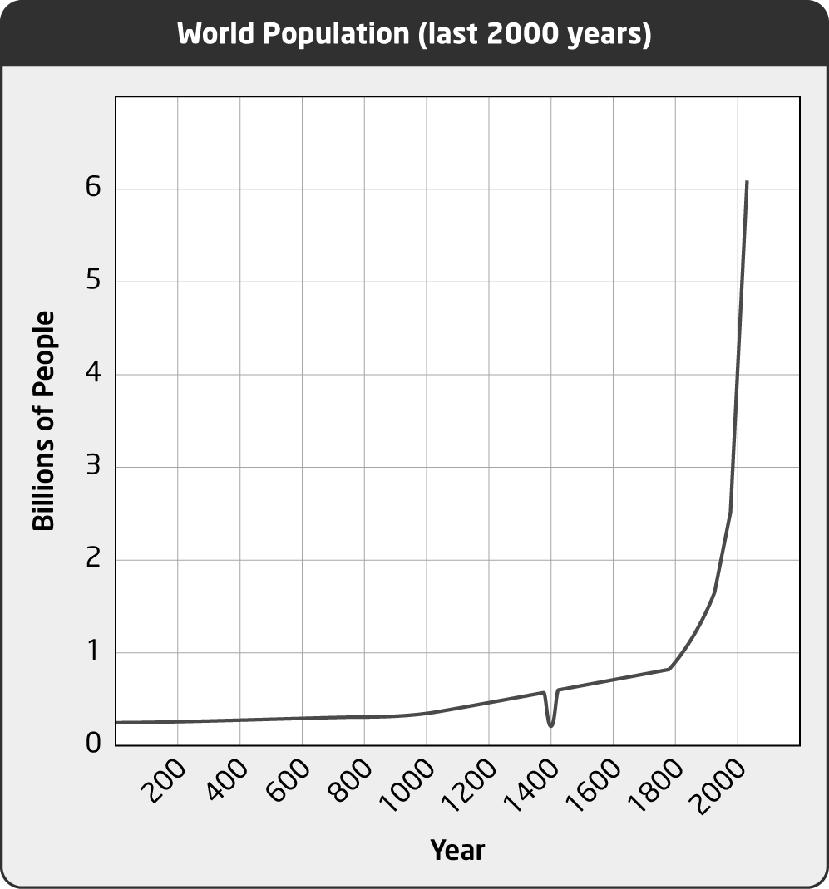

ANS:
This dip represents the large population loss caused by the Black Death pandemic that killed millions of people in Europe in the middle of the 14th century.

PTS: 1 OBJ: 1-2 STA: A1.9 TOP: 2.3
MSC: K/U

40. Toronto experienced a garbage strike in July 2009. That fall, more people than normal reported problems with raccoons invading their houses, sheds, and garages. Explain what happened in terms of ecological resources.

ANS:
The garbage strike meant that food waste was left near residential areas. Raccoons took advantage of this new food resource and were able to avoid problem areas near cars and dogs. In the fall, more raccoons were used to these residential areas and tried to find winter shelters in the buildings.

PTS: 2 OBJ: 1-2 STA: B3.3, B3.5 TOP: 2.1
MSC: A

41. White-tailed deer are normally found in mixed deciduous forests and in meadows that border forests. How do suburban areas attract deer away from wild areas? (Find out what deer eat.)

ANS:
Suburban areas tend to keep more treed areas than more intense urban areas. Because development is less intense, there are areas of forest regrowth and meadow that attract deer. Deer prefer deciduous leaves of smaller trees, and these trees are plentiful in areas where forest has been removed for building.

PTS: 2 OBJ: 1-2 STA: B2.5, B3.5 TOP: 2.1
MSC: A

42. In urban areas, many people consider the Eastern gray squirrel to be a nuisance animal. In fact, some people refer to them as “tree-rats.” What ecological service do these animals perform?

ANS:
Grey squirrels are important for seed dispersal. Although they do eat tree seeds, they bury many seeds for later use. These seeds are randomly buried in their local territory. Only a few of these seeds are later discovered and eaten. The rest have the opportunity to germinate some distance from the parent tree. In an urban area, people control where trees appear, so this service is no longer valued. In this environment, the squirrels perform a service by eating seeds such as maple keys that might otherwise be considered nuisance tree litter that can block an eavestrough (gutter).

PTS: 2 OBJ: 1-2 STA: B3.1 TOP: 2.4
MSC: A

43. Many of Ontario’s migratory birds fly through southern Ontario (Niagara) to nest in the boreal forest farther north. Why do these birds need to fly so far north to build their nests?

ANS:
These birds clearly nest in forests. Very little forest remains in southern Ontario. Urban and suburban development has reduced the diversity of plant and insect life, so that there are insufficient resources to support these birds. They must fly farther north.

PTS: 2 OBJ: 1-2 STA: B2.5, B3.5 TOP: 2.4
MSC: A

44. List two factors that may affect the decline of honeybee populations.

ANS:
Answers will vary but could include any of these factors: pesticides, radiation from cellphones, parasites, and stress caused by confinement during transportation.

PTS: 2 OBJ: 1-2 STA: B3.5 TOP: 2.4
MSC: K/U

45. How does pollination affect the human population?

ANS:
Many food crops, including fruits, vegetables, nuts, spices, and oilseed, require pollination for fertilization and reproduction.

PTS: 1 OBJ: 1-2 STA: B3.3 TOP: 2.4
MSC: K/U

46. Name two ecological services that insects provide.

ANS:
They help with decomposition and they pollinate many food plants.

PTS: 2 OBJ: 1-1 STA: B3.3 TOP: 2.4
MSC: K/U

47. A forest provides ecological services. How does the diversity of trees help the forest provide these services?

ANS:
Answers will vary, but may include these points: Tree diversity offers greater habitat variety. This allows more diverse animal life. Different types of tree grow to different heights and contribute to matter cycling at different rates. Each tree will grow different seeds or nuts that can be used as food by different consumers.

PTS: 2 OBJ: 1-1 STA: B3.1 TOP: 2.4
MSC: A

48. Many Group of Seven paintings show the natural environment. Do artists need to travel to remote areas to make such images? How are these artists important to the environment?

ANS:
Local areas can show the natural environment, such as a local park or garden. Artists who capture the beauty of the natural world also send a message that the natural world is valuable.

PTS: 2 OBJ: 1-2 STA: B1.2 TOP: 2.4
MSC: A

49. How is coffee cultivation related to supporting migrating birds?

ANS:
Coffee can be grown in areas with a variety of trees, including tall trees, or coffee can be grown on a plantation of short bushes. The plantation does not support a diverse collection of birds with various habitats. Coffee grown among tall trees supports the growth of these tall trees, which provide a variety of habitats for migrating birds.

PTS: 2 OBJ: 1-2 STA: B3.5 TOP: 2.4
MSC: A

50. How do burying beetles help with the decomposition of a dead mouse?

ANS:
Burying beetles remove soil beneath the mouse. This helps to bury the mouse and brings it in closer contact with the bacteria and fungi that can decompose it completely. Also, beetles lay eggs in the dead body so that their growing larvae can feed on the body. This helps to break the body down, leaving behind feces that bacteria can decompose completely.

PTS: 2 OBJ: 1-1 STA: B3.3, B3.4 TOP: 2.4
MSC: A

51. A population growth graph for coyotes in southern Ontario begins slowly, shows a period of exponential growth, and then levels off. Describe a sequence of events that would lead to this type of growth pattern.

ANS:
Answers may vary. For example, the sequence would start with a small number of coyotes living in the area. These animals would have many offspring that would survive, due to abundant resources. The offspring would then produce new generations and the population would increase rapidly until the carrying capacity of the ecosystem is reached. At this point, the population of coyotes would stay about the same from year to year.

PTS: 3 OBJ: 1-1 STA: A1.11 TOP: 2.1
MSC: A

52. Do foxes and wolves compete for resources? Explain.

ANS:
Generally, foxes and wolves do not compete for resources. Foxes typically consumer smaller animals such as rodents, leaving larger animals, such as deer and moose, to the wolves. This is an example of specialization to a narrow niche. Wolves will choose to consume smaller animals if they are abundantly available.

PTS: 2 OBJ: 1-1 STA: B3.3 TOP: 2.2
MSC: A

53. Do deer and moose compete for resources? Explain. (Research may be required.)

ANS:
Deer and moose are not competitors. They do not have the same diet, nor do they occupy the same places. White-tailed deer prefer open fields and wooded areas. Moose prefer bogs and boreal forest.

PTS: 2 OBJ: 1-1 STA: B3.3 TOP: 2.2
MSC: A

54. Identify three ways in which human activity can affect fish in Ontario.

ANS:
deforestation, excess nutrient in run-off water, urban use of water

PTS: 1 OBJ: 1-2 STA: B3.5 TOP: 2.1
MSC: A

55. People living in Ontario have many kinds of pets. Select one species of pet that could have a negative impact on a local ecosystem. Explain your choice.

ANS:
Answers will vary. Snakes can escape and outcompete local snakes, but they are unlikely to survive winter conditions. Cats can damage a fragile ecosystem by killing birds and damaging nesting sites. Birds that are released can outcompete native birds. This is evident in the commonly found starling, house finch, and pigeon.

PTS: 3 OBJ: 1-2 STA: B3.5 TOP: 2.1
MSC: A

56. Canadians do not have the largest ecological footprint of the developed world. Compared to people in developing nations, however, Canadians use a disproportionate amount of the world’s resources. List three resources that Canadians use at rates that would be unsustainable if everyone in the world consumed the resource at this rate.

ANS:
Answers will vary but may include water, energy, food, lumber products, and minerals.

PTS: 3 OBJ: 1-2 STA: B3.5 TOP: 2.3
MSC: A

57. Propose a local nature preserve or provincial park as the destination of a school trip. Explain how time spent in this place could enrich the lives of those who go on the trip.

ANS:
Answers will vary. Students will select various sites. Benefits of visiting the site may include the opportunity to experience clean air, appreciate the beauty of nature, develop spiritually, learn more about the natural world, and have experiences that will increase one’s understanding of the value of local natural resources.

PTS: 3 OBJ: 1-2 STA: B3.5 TOP: 2.4
MSC: A

58. Farms in Ontario produce a variety of foods. As demand for food increases, so does the demand for more Ontario farmland.
a) Would clearing boreal forest areas for farming be a solution to this problem? Explain.
b)What limits the availability of good farmland in Ontario the most?

ANS:
a) No. Land that supports the boreal forest will not support most agriculture. Most farming requires a different climate and drainage conditions than those of the boreal forest.
b) Urban development competes for farmland. An increasing demand for food is related to an increasing population. The Ontario land suitable for producing food is located in the southern parts of the province where the population is concentrated, so it is also needed for housing or commercial property.

PTS: 3 OBJ: 1-2 STA: B1.1 TOP: 2.4
MSC: A

59. Where is the Oak Ridges Moraine? Who controls development of this area?

ANS:
The Oak Ridges Moraine is located to the north and east of the Greater Toronto Area. The Government of Ontario controls development in this area.

PTS: 2 OBJ: 1-1 STA: B1.2 TOP: 2.1
MSC: K/U

60. Locate two sources of information on farming by the Iroquois nations in Ontario. List the crops planted. How were the locations of farms determined? How did you identify reliable sources for this information?

ANS:
The main Iroquois crops were corn, beans, and squash. Sunflowers were also raised. Farms were located on cleared land outside villages located near a water supply such as a spring or stream. When the soil fertility declined after years of farming, the village moved to a new location in the forest and cleared a new site. Sources selected will vary. First Nations and museum web sites can be good sources of historical information.

PTS: 3 OBJ: 1-2 STA: A1.3, A1.9 TOP: 2.1
MSC: T/I

PROBLEM

1. Select one wild animal or plant species in your local area. Using the knowledge of people in the community, electronic resources, and/or your own field studies, determine whether the local population of this species is expanding, shrinking, or in equilibrium. Is the local population near its carrying capacity? Write a report that outlines your findings. Include evidence to support your conclusions.

ANS:
Answers will vary. Students should support their conclusions with information from reliable sources. Local conservationists can be helpful. Birding associations, hunting clubs, anglers’ associations, and forestry groups may provide useful information.

PTS: 8 OBJ: 1.1 STA: A1.3, A1.6, A1.7, A1.10
TOP: 2.1 MSC: T/I

2. The red-headed woodpecker is a native migratory species of Ontario. The population has declined dramatically in the last 20 years. The two maps below show the areas in which the red-headed woodpecker was found from 1981–1985 and from 2001–2005.

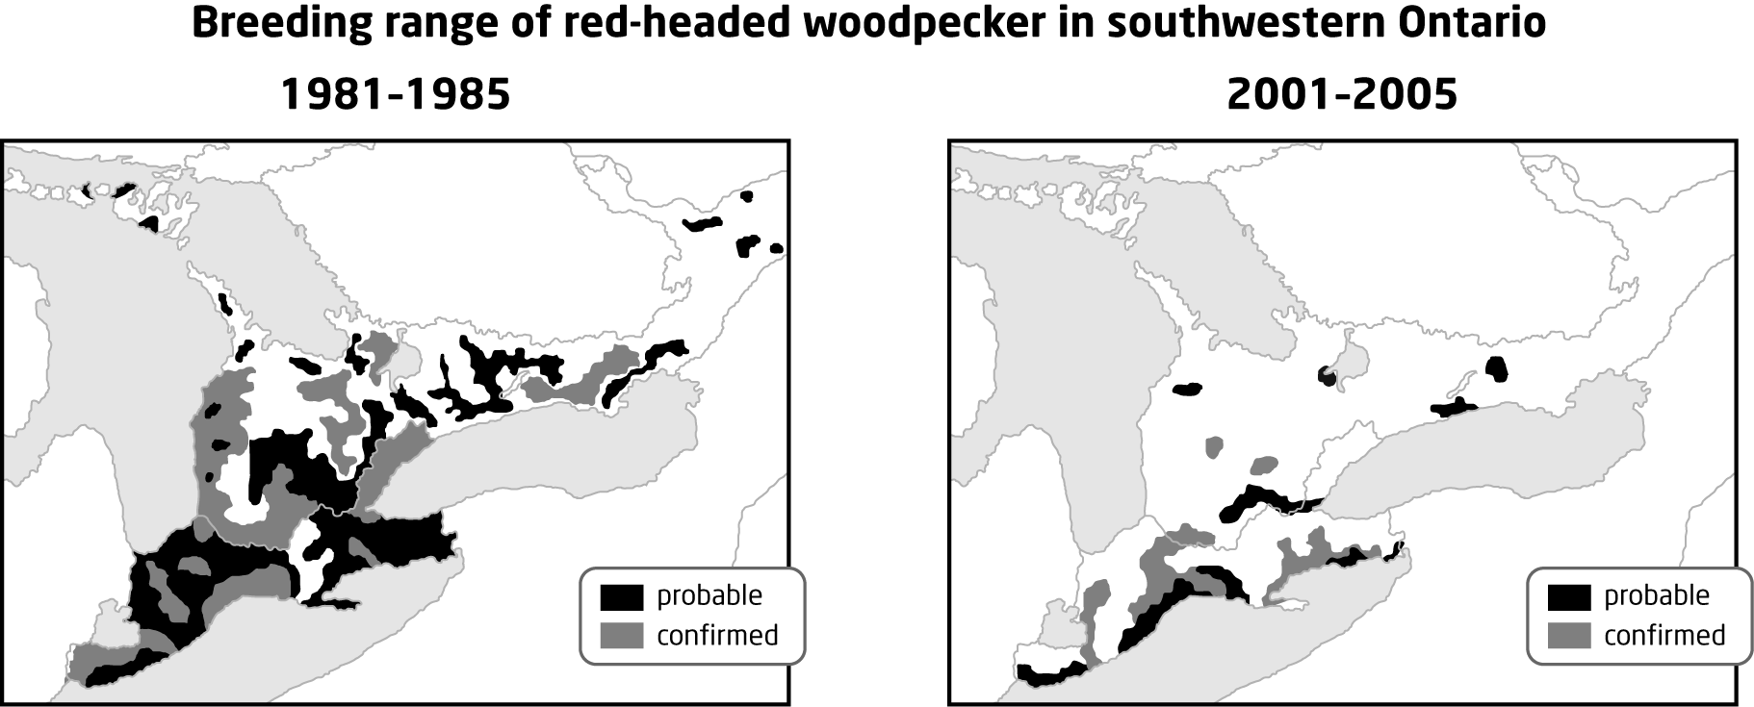

a) Research the needs of the red-headed woodpecker. What factors have likely caused the decline of the red-headed woodpecker in Ontario?
b) Suggest ways to support the population growth of the red-headed woodpecker and any difficulties there may be in implementing these strategies.

ANS:
Answers will vary.
a) The red-headed woodpecker lives in open woodland and on woodland edges. These habitats tend to contain more snags (dead trees), which the birds often use for nesting and perching. Red-headed woodpeckers feed on insects in the summer and nuts in the winter. The red-headed woodpecker population in Ontario has declined by more than 60% in the last 20 years because of habitat loss due to forestry and farming, and competition from European starlings for nest sites. In some areas, birds get killed on the roads when they are foraging for insects. The harvesting or removal of dead trees in which the red-headed woodpecker nests is believed to be a significant factor in its decline.
b) Restoring natural habitat will help, but it is difficult to set aside protected areas when the human population in this area keeps growing. However, people could be educated about the importance of snags as homes for many species of wildlife, and these could be left standing rather than be taken down. Since the starling is a competitor, starling removal might help, but starlings are not easily controlled.

PTS: 7 OBJ: 1.2 STA: A1.9, A1.10, A1.11, B1.1, B2.5, B3.5
TOP: 2.1, 2.2, 2.4 MSC: T/I, C

3. The double-crested cormorant is a fishing bird that was affected by pollutants in the Great Lakes. Successful nesting sites declined and the birds became rare. In recent years, populations of double-crested cormorants have grown. Recent populations of these birds on the Great Lakes are shown in the table below.

Population of double-crested cormorants
on the Canadian Great Lakes in 1997
Body of Water | Number of pairs of birds
St. Lawrence River | 727
Lake Ontario | 8 205
Lake Erie | 7 434
Lake Huron
North Channel | 6 255
Georgian Bay | 7 688
Main body of Lake Huron | 3 747
Lake Superior | 1 985
Total | 36 041

a) Create a bar graph showing the relative population size for each of the four Great Lakes.
b) What does this data indicate about fish in these lakes?

ANS:
a) For example,

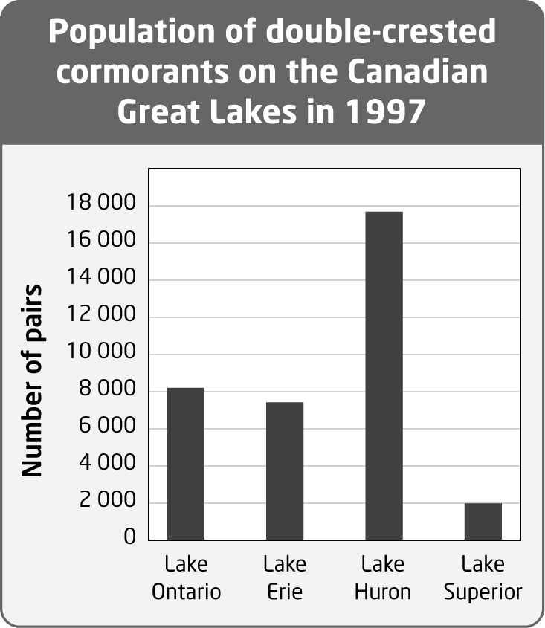

b) Fish in lakes with more cormorants have fewer contaminants in their bodies.

PTS: 5 OBJ: 1-2 STA: A1.8, A1.11, A1.12, B1.1
TOP: 2.1 MSC: T/I, C

4. In late summer, Monarch butterflies fly to Mexico for the winter. Study the map below.

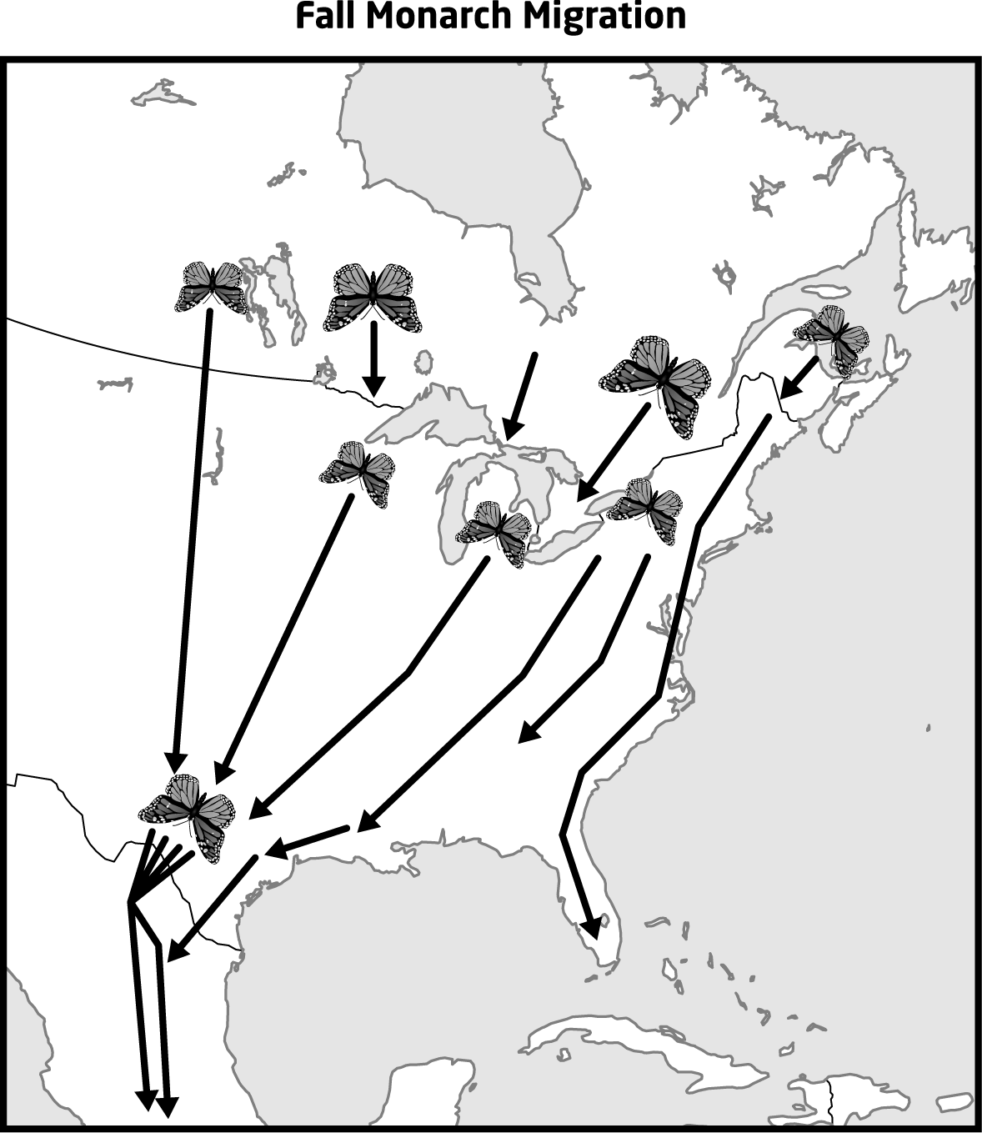

a) Predict where butterflies cross the border from Canada to the United States.
b) Describe how you could test your prediction.
c) Research the work of Canadian researcher Frederick Urquhart on Monarch migration. Compare the methods he used to trace Monarch migration with those you described in part b).

ANS:
a) Butterflies avoid open water by crossing near narrow areas between the Great Lakes.
b) & c) Butterflies can be caught, tagged, released, and recaptured to track their flight paths. This is the method used by Frederick Urquhart to trace Monarch migration.

PTS: 6 OBJ: 1-1 STA: A1.1, A1.6, A1.8, A1.10
TOP: 2.1, 2.4 MSC: T/I

5. The map below shows the Atlantic migration flyways of birds of North America. Look at this map and at a relief map of this area. What do you notice about the locations of the flyways? How do the Great Lakes affect bird migration? How can people near the Great Lakes help ensure successful bird migration?

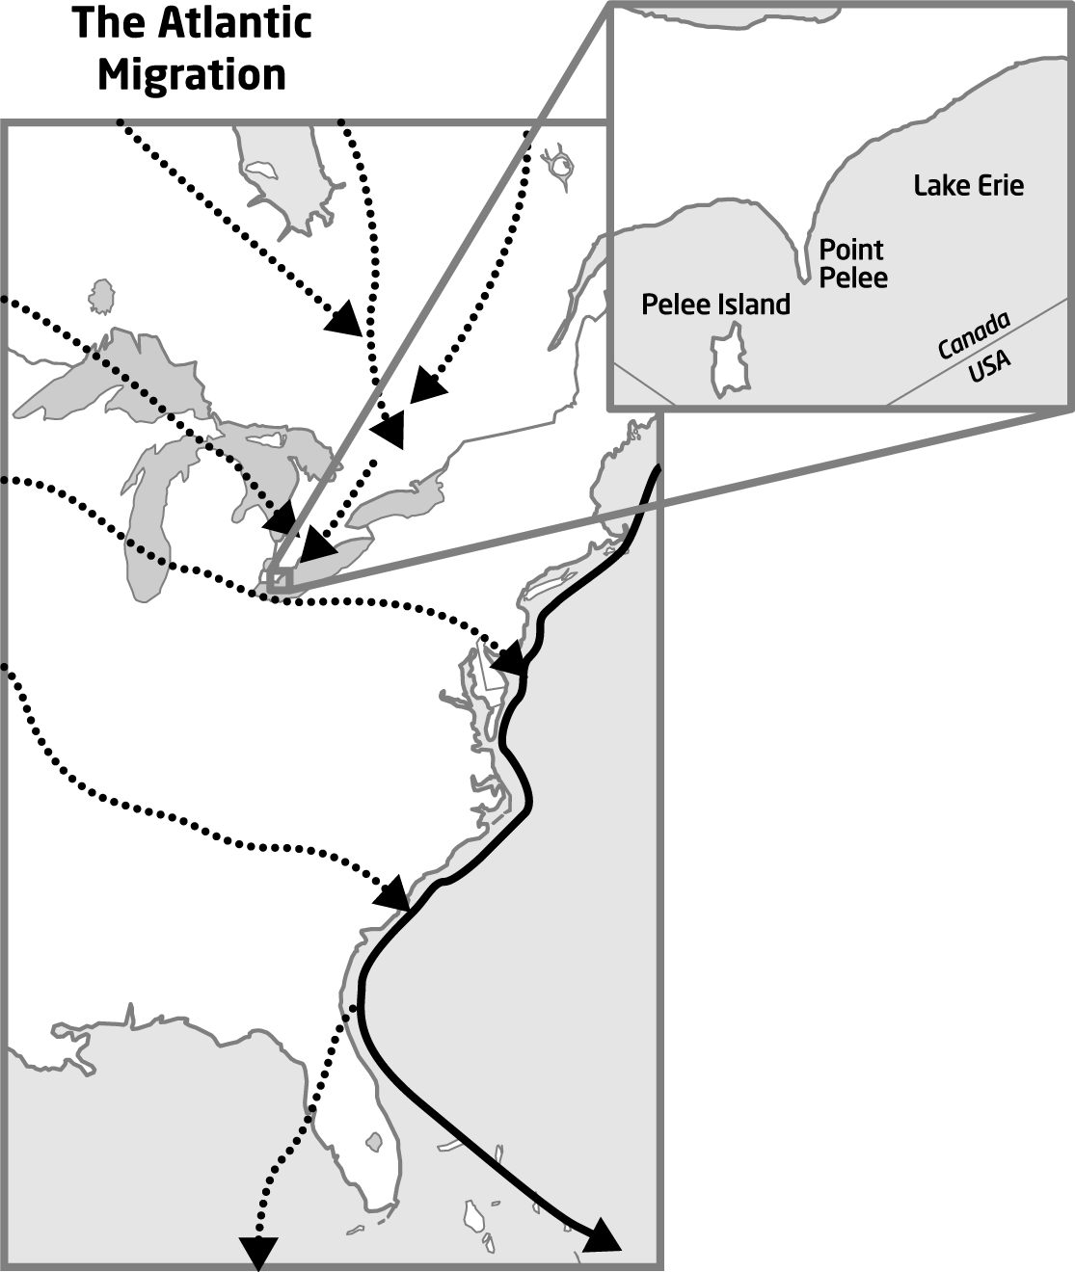

ANS:
The flyways follow coastlines, go around mountain ranges, and avoid large stretches of open water, such as the Great Lakes. This makes Point Pelee, the most southern tip of Ontario, a major bird migration hub. Protecting this area from development is important for the future success of migrating birds.

PTS: 2 OBJ: 1-2 STA: A1.10, B1.1, B3.5
TOP: 2.1, 2.4 MSC: A

6. The bald eagle, a fishing bird, is a top carnivore in the Great Lakes. Populations in southern Ontario declined dramatically in the 20th century. Tracking of bald eagles in the region has shown a recent increase in the population.
a) Graph the data in the table below. What does the graph show?

Bald eagle population in southern Ontario
Year | 1981 | 1990 | 2001 | 2006 | 2007
young produced | 2 | 11 | 36 | 55 | 47
active nests | 2 | 8 | 22 | 34 | 38

b) What information might be helpful in explaining the trends shown on the graph?

ANS:
a) For example,

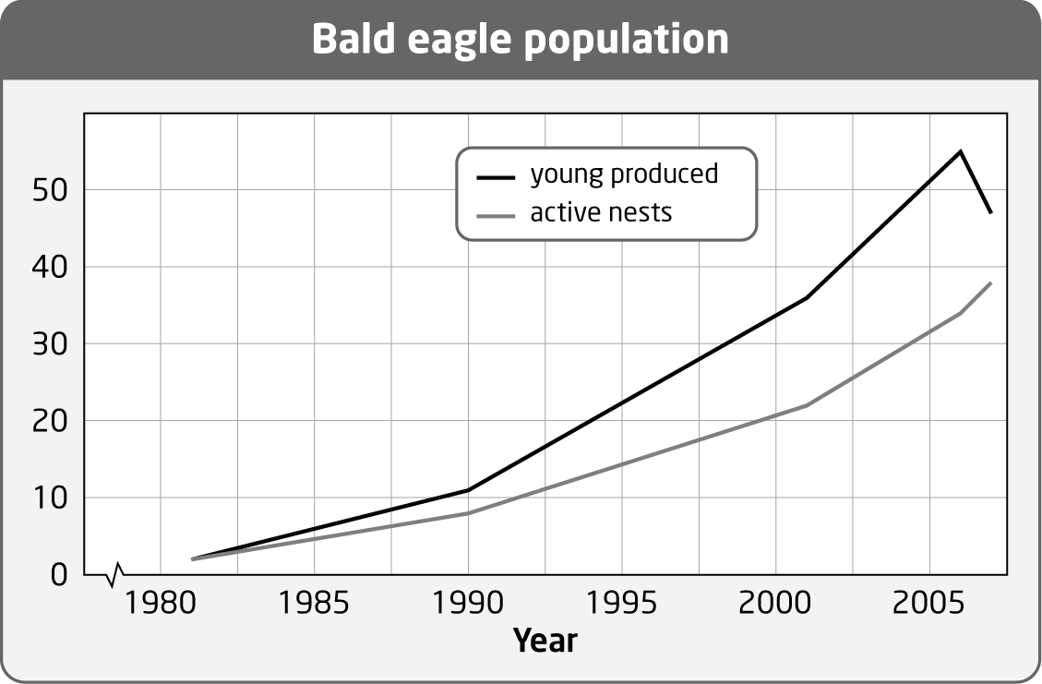

The trend shows increasing growth in number of active nests. Not as many chicks survived in 2007 as would be expected.
b) Any or all of the following would be helpful in explaining the trends: data on the bald eagle population in the region for more of the years in this period—dips such as that seen in 2007 may be a regular periodic occurrence; data on populations of plants and animals in the bald eagle’s food chain over the same period, particularly around 2007—there may have been food shortages; data on any other factors that may have affected the survival of fledgling eagles over the period (weather, human activities).

PTS: 5 OBJ: 1-2 STA: A1.8, A1.11, A1.12, B3.3
TOP: 2.1, 2.4 MSC: T/I, C

7. The Ontario government has regulations regarding the safety of water in wells. For example, to disinfect a well, the Ministry of Health and Long-Term Care instructs people to measure the casing diameter of the well and the depth of water in the well. The table below then tells the amount of bleach needed to disinfect the well.
For example, if your well has a diameter of 100 mm and the depth of the water in the well is 6 m = 3 m ∞ 2 of water, then you would add 30 mL ∞ 2 = 60 mL of bleach.

Volume of bleach to add for every 3 m of water in a well
Casing diameter (mm) | Volume of unscented bleach (mL)  (5.25% solution)
50 | 6
100 | 30
150 | 60
200 | 100
250 | 200
300 | 250
400 | 400
500 | 650
600 | 900
900 | 2000
1200 | 3600
.
a) Create a line graph of the data in the table.
b) What is the diameter of a well that requires 2700 mL of bleach?
c) How much bleach should be added to a well with a diameter of 750 mm?

ANS:
a) For example,

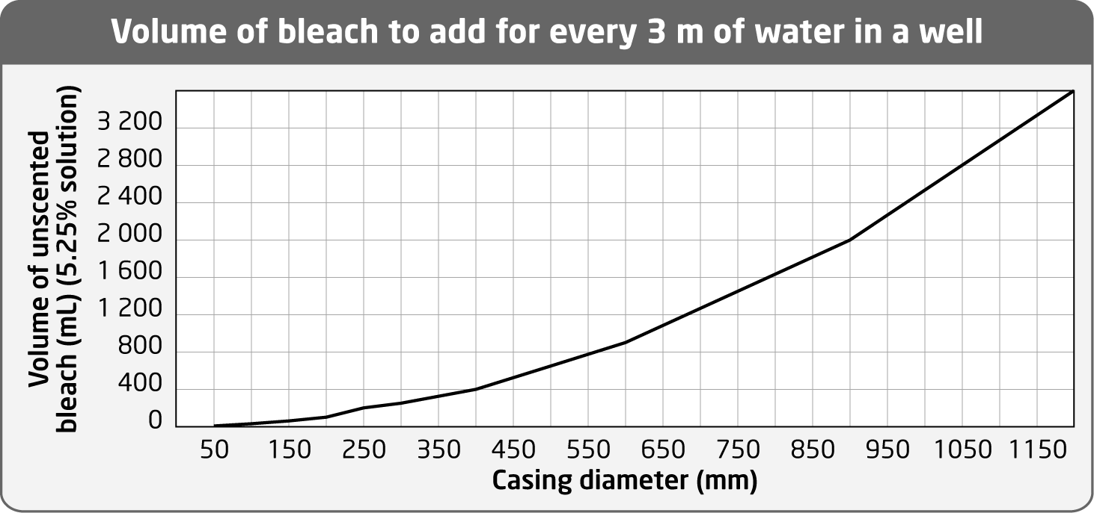

b) The diameter of the well is about 1070 mm.
c) 1400 mL of bleach should be added.

PTS: 6 OBJ: 1-2 STA: A1.11, A1.12
TOP: 2.3 MSC: T/I, C

8. Maple syrup is made from sap harvested from maple trees. A stand of sugar maple managed for the production of sap is referred to as a sugar bush. Research sugar bush management to answer the following questions:
a) Sugar bushes are often monocultures. Why does this threaten the sustainability of the sugar bush?
b) Maple trees that grow faster produce sap sooner. What soil characteristics lead to maximum maple tree growth and sap production?
c) Large trunk diameters in maple trees are related to increased sap flow. Compare the growth of two maple trees under different conditions. Both trees have a trunk diameter of 12.5 cm when first measured. Tree A’s diameter increases by 5 mm a year and tree B’s diameter increases by 3 mm per year. What is the diameter of each tree after 10 years and after 40 years?

ANS:
a) Healthy forests are diverse forests, so it is good to have a diversity of tree species, even in a sugar bush. Monocultures are vulnerable to destruction by pests. The sugar maple borer is one pest that can threaten a sugar bush.
b) For maximum tree growth and sap production, soils should be deep, moist, fertile, and well drained with a pH of 5.5 to 7.3. Healthier maple tree stands have higher levels of soil calcium. Acid precipitation leaches calcium from the soil.
c) Tree A grows at a rate of 5 mm/year and tree B grows at a rate of 3.5 mm/year.
12.5 cm = 125 mm
Diameter A = 125 + 5t and diameter B = 125 + 3.5t, where t is the number of years.
After 10 years, tree A will have a diameter of 175 mm = 17.5 cm and tree B will have a diameter of 160 mm = 16 cm.
After 40 years, tree A will have a diameter of 325 mm = 32.5 cm and tree B will have a diameter of 265 mm = 26.5 cm.

PTS: 4 OBJ: 1-2 STA: A1.12, A1.13, B3.5
TOP: 2.3 MSC: T/I, C

9. Opossums (possums) are nocturnal animals that have been moving northward since the middle of the 20th century and are now well established in southern Ontario. This area also contains raccoon populations. Are opossums and raccoons competitors? As a field biologist, you could go to areas with established opossum populations, areas with established raccoon populations, and areas where both populations exist. What evidence would you expect to see if these animals were competitors?

ANS:
Both of these animals are omnivores and occupy a broad niche when possible. If they are competitors, they should each have a narrower niche in areas where they overlap. Whether this is so can be determined by examining the contents of stomachs, by setting up cameras to watch the animals eat, or by examining the scats the animals leave behind.

PTS: 4 OBJ: 1-1 LOC: A1.1, A1.7, B1.1, B3.5
TOP: 2.1 MSC: T/I

ESSAY

1. To promote ecotourism in the boreal forest, you would like to target international birders (people who look for birds) and wildlife photographers. Prepare a plan for a website that outlines the birds that are available to see at different times of the year. Support your work with evidence that you have found through research.

ANS:
Students will have to choose a specific area and then research the birds that are found and the times that these birds first appear and then migrate away. Additional information that supports this work can be used to highlight the ecotourism experience.

PTS: 6 OBJ: 1-2 STA: A1.7, A1.10, A1.11
TOP: 2.4 MSC: T/I

2. The Canadian flag shows the maple leaf as the national symbol. Canada’s forests provide a broad range of ecosystem services essential to human wellbeing. Suggest a new symbol for the Canadian flag that represents another type of ecosystem or a type of organism that provides important ecosystem services to Canadians. Justify your choice.

ANS:
Answers will vary. Possible choices include lakes and rivers, the Prairies, watershed ecosystems, honeybees, etc. The important component here is not the particular choice, but the reasons given for that choice.

PTS: 3 OBJ: 1-1 STA: A1.7, A1.10
TOP: 2.4 MSC: A

3. Fire is a crucial element of boreal ecology, and many boreal plants and animals flourish in the aftermath of wildfires. Research and explain the relationship between forest fires and the ecological niche of the moose in the boreal forest.

ANS:
Moose eat aquatic vegetation and various parts of deciduous trees—leaves in summer and twigs and buds in winter. The dominant conifers of the boreal forest are not on their diet. After a forest fire, most of the first growth is deciduous trees and shrubs. Moose begin to invade a burn a year or two after the fire to take advantage of this source of food. With food available in abundance, the population of moose in the area will expand rapidly and remain high until conifers begin to mature and crowd out the deciduous trees.

PTS: 3 OBJ: 1-1 STA: A1.3, A1.7, A1.11, B3.3
TOP: 2.2 MSC: A

4. The red-tailed hawk and the great horned owl are Ontario birds that have a very similar diet. Describe their diets. What factors reduce competition between these two birds in Ontario? Research and discuss.

ANS:
The great horned owl feeds on many types of small animals, primarily rodents. Great horned owls are mainly nocturnal (they hunt at night), but they also hunt during the day in the wintertime. They live in both deciduous and coniferous woodlands and nest in trees. These owls do not migrate.
Red-tailed hawks prefer open fields to forest. Like the great horned owl, they feed on many types of small animals, primarily rodents. They help to control populations of small rodents that might otherwise affect agricultural crops. This hawk is diurnal (hunts during the day). They nest in the tops of trees or on cliffs. Northern populations of the red-tailed hawk migrate south in the winter.
Competition is reduced by the fact that these birds prefer different habitats and hunt at different times of the day. In the winter, Ontario populations do not compete, as the hawks have migrated. Competition may occur between the red-tailed hawk and the great horned owl during twilight.

PTS: 3 OBJ: 1-1 STA: A1.3, A1.7, A1.11, B3.3
TOP: 2.2 MSC: A

5. Aerial insectivores such as swifts, swallows, martins, flycatchers, and whip-poor-wills are becoming increasingly scarce in Ontario. What are some possible reasons for this?

ANS:
Answers will vary. At this point the reason for the decline of aerial insectivores is not known for certain. Population reductions may be related to changes in the food supply, loss of nest sites, such as open chimneys and wooden barns, or changes in foraging habitat. The most likely cause is decline of insect populations. There may be changes in the timing of seasonal emergence of some insects, possibly due to climate change. Loss of insects may be caused by the widespread use of pesticides in agricultural areas. Nocturnal species of insects are harmed by increasing light pollution in expanding urban areas. Many kinds of flying insects have an aquatic stage that is very sensitive to changes in ultra-violet light radiation, fluctuations in temperature, increased acidification, and pesticide run-off.

PTS: 6 OBJ: 1-2 STA: A1.7, B1.1, B2.5, B3.5
TOP: 2.3 MSC: A

6. The double-crested cormorant is an example of how people can change their activities to support the environment. For many years, these fishing birds faced hardship through contaminants in the water. Now, the populations are increasing. Determine the traditional niche of these birds, which human activity affected their ability to survive, how human activity changed to improve their chances of survival, and new challenges faced by these birds.

ANS:
Cormorants are native to the Great Lakes and eat fish. Because of industrial pollution, many birds were unable to produce viable offspring. Deformed cormorant embryos caused an outcry that led to reduced contamination. As fish now contain fewer pollutants, the birds are now able to produce viable young. This creates tension with fishers and other people who enjoy the outdoors but dislike how cormorant colonies kill trees.

PTS: 5 OBJ: 1-2 STA: A1.7, B1.1, B1.2, B2.5, B3.5
TOP: 2.2, 2.3 MSC: T/I

7. Algonquin Park in Ontario is an ideal place to study the interaction of white-tailed deer with moose. This area was heavily forested by the early 1900s, and has since enjoyed a period of naturalization. It is possible that at one time the deer population in Algonquin Park reached 100 000. As the deer population increases, the brainworm is more common. This leads to lower moose populations. Determine the factors that affect the deer population in Algonquin Park. Prepare a plan to either reduce the deer population or save the deer population. Develop a campaign that will support your plan. Summarize your plan with supporting information as a flyer to be distributed at a local community meeting.

ANS:
Student answers will vary depending on their research. Some may decide that winter feeding of deer should end, or that wolf populations should be controlled.

PTS: 7 OBJ: 1.2 STA: A1.1, A1.7, A1.11, B1.2
TOP: 2.2 MSC: T/I, A

8. Ontario’s far north is a place of striking wilderness. Can a commitment to ecotourism provide financial support for people in remote areas? Select a particular area in northern Ontario and identify the features that will attract tourism. Specify problems that need to be overcome for success. Make a list of steps that need to be taken for this enterprise to succeed. Justify all changes to the environment.

ANS:
Answers will vary. Students will need to consider issues related to infrastructure: transportation, shelter, water, sewage, and food.

PTS: 5 OBJ: 1-2 STA: A1.1, A1.3, A1.7, B1.1
TOP: 2.4 MSC: A

9. Every day you are in contact with forest products. One of the most commonly used items is paper. Paper is produced from the pulp of trees harvested from forests. Recycling is one way to reuse tree fibre in paper. Discover and describe how the forestry industry can make choices that help to protect the local environment. Identify ways that end users, such as you and your family, can support more sustainable practices.

ANS:
Answers will vary. Students should include some discussion about managed forests vs. clear-cutting. Conservation through reduced use will also likely be discussed.

PTS: 4 OBJ: 1-2 STA: A1.7, B1.1 TOP: 2.3
MSC: A

10. At one time the Nipigon River supported many of Canada’s largest brook trout. This river drains the water from Lake Nipigon into Lake Superior. This movement of water has been used to generate electricity by way of dams. The brook trout fishery has been restored with a number of different initiatives. With research, determine what actions have been taken to support the restoration of the brook trout fishery. Identify which groups of people have been involved in this work.

ANS:
Introduced species competed for spawning grounds, so restoration of spawning areas has helped populations increase. A water management plan allows more water to flow in the river to allow young fish to survive. Gull Bay First Nation on Lake Nipigon has contributed to this plan.

PTS: 7 OBJ: 1-2 STA: A1.7, B1.1, B1.2
TOP: 2.1, 2.2 MSC: T/I

