Unit 1: Sustainable Ecosystems
Chapter 3: Biodiversity

TRUE/FALSE

1. Biodiversity measures the size of animals in a given area.

ANS: F
Biodiversity measures the number and variety of organisms in a specific region.

PTS: 1 OBJ: 1.1 STA: B2.1 TOP: 3.1
MSC: K/U

2. A quadrat is used to measure an area for counting organisms.

ANS: T PTS: 1 OBJ: 1-1 STA: B2.1
TOP: 3.1 MSC: K/U

3. Large mammals, such as caribou, are the most diverse organisms.

ANS: F
Small organisms, such as invertebrates, plants, and fungi, show the greatest diversity.

PTS: 1 OBJ: 1-1 STA: B3.1 TOP: 3.1
MSC: K/U

4. Ontario has one biodiversity hotspot.

ANS: F
Ontario’s biodiversity hotspots are Carolinian Canada and the Georgian Bay Biosphere Reserve.

PTS: 1 OBJ: 1-1 STA: B3.1 TOP: 3.1
MSC: K/U

5. There is more biodiversity in the tropics.

ANS: T PTS: 1 OBJ: 1-1 STA: B3.3
TOP: 3.1 MSC: K/U

6. Many diversity hotspots are found in developing nations.

ANS: T PTS: 1 OBJ: 1-1 STA: B3.3
TOP: 3.1 MSC: K/U

7. A community includes all the populations of one species.

ANS: F
A community includes all the populations of different species that interact in a specific area or ecosystem.

PTS: 1 OBJ: 1-1 STA: B2.1 TOP: 3.2
MSC: K/U

8. Biodiversity depends on the interactions of different populations.

ANS: T PTS: 1 OBJ: 1-1 STA: B3.2
TOP: 3.2 MSC: K/U

9. A keystone species is also known as the dominant species.

ANS: F
A keystone species is not generally as abundant as the dominant species.

PTS: 1 OBJ: 1-1 STA: B2.1 TOP: 3.2
MSC: K/U

10. The dominant species in a terrestrial system is a producer.

ANS: T
The dominant species has the most biomass, which is the primary producer in a terrestrial system.

PTS: 1 OBJ: 1-1 STA: B3.1 TOP: 3.2
MSC: K/U

11. The prairie dog is a keystone species.

ANS: T PTS: 1 OBJ: 1-1 STA: B3.1
TOP: 3.2 MSC: K/U

12. Black-footed ferret recovery relies on captive breeding and release.

ANS: T PTS: 1 OBJ: 1-2 STA: B3.5
TOP: 3.2 MSC: K/U

13. The beaver is an ecosystem engineer.

ANS: T PTS: 1 OBJ: 1-1 STA: B2.1
TOP: 3.1 MSC: K/U

14. Ecosystem engineers are industrious organisms.

ANS: F
Ecosystem engineers cause dramatic changes to the landscape.

PTS: 1 OBJ: 1-1 STA: B2.1 TOP: 3.2
MSC: K/U

15. As the physical environment changes, species in the ecosystem change.

ANS: T PTS: 1 OBJ: 1-1 STA: B3.3
TOP: 3.2 MSC: K/U

16. Habitat loss is the result of human activity.

ANS: F
Natural disasters can also result in habitat loss.

PTS: 1 OBJ: 1-1 STA: B3.1 TOP: 3.3
MSC: K/U

17. Draining wetlands is a form of habitat destruction.

ANS: T PTS: 1 OBJ: 1-2 STA: B3.5
TOP: 3.3 MSC: K/U

18. There are two patterns of extinction.

ANS: T PTS: 1 OBJ: 1-1 STA: B3.1
TOP: 3.3 MSC: K/U

19. Wetland restoration can include creating recreational areas for people to enjoy.

ANS: T
A natural site can support recreational activities such as kayaking, canoeing, and birding.

PTS: 1 OBJ: 1-2 STA: B3.5 TOP: 3.4
MSC: K/U

20. Restoring an ecosystem can involve removing one or more species.

ANS: T PTS: 1 OBJ: 1-2 STA: B3.5
TOP: 3.4 MSC: K/U

MODIFIED TRUE/FALSE

1. A biodiversity hotspot is an area where organisms are endangered.

ANS: F
A biodiversity hotspot is a relatively small area with an exceptionally large number of species.

PTS: 1 OBJ: 1-1 STA: B3.3 TOP: 3.1
MSC: K/U

2. In the summer, Ontario has more bird species than Colombia.

ANS: F
Colombia has four times as many bird species as Canada.

PTS: 1 OBJ: 1-1 STA: B3.1 TOP: 3.1
MSC: K/U

3. Succession can lead to local extinction of a dominant species.

ANS: T
If the dominant species is a tree species, this species may go extinct locally.

PTS: 1 OBJ: 1-1 STA: B3.3 TOP: 3.2
MSC: K/U

4. The black-footed ferret is a keystone species that the prairie dog relies on for success.

ANS: F
The prairie dog is the keystone species. The black-footed ferret relies on the prairie dog.

PTS: 1 OBJ: 1-1 STA: B3.1 TOP: 3.2
MSC: K/U

5. The extinction of the American chestnut tree affected no other species.

ANS: F
Seven species of insect became extinct because they relied on the American chestnut.

PTS: 1 OBJ: 1-2 STA: B3.3 TOP: 3.2
MSC: K/U

6. Damming rivers to run electrical generators is a form of green energy that does not hurt the environment.

ANS: F
Damming rivers affects the habitat of some fish and a variety of other organisms.

PTS: 1 OBJ: 1-2 STA: B3.5 TOP: 3.3
MSC: K/U

7. Deforestation leads to habitat destruction.

ANS: T
Deforestation is one activity that leads to habitat destruction, but other activities include draining wetlands and damming rivers.

PTS: 1 OBJ: 1-2 STA: B3.5 TOP: 3.3
MSC: K/U

8. Most alien species are harmless or beneficial to their new environment.

ANS: T PTS: 1 OBJ: 1-2
STA: B3.5 TOP: 3.3 MSC: K/U

9. The round goby entered the Great Lakes the same way the lamprey eel did.

ANS: F
The lamprey entered the Great Lakes through the Erie Canal that connects the Great Lakes to the Atlantic Ocean. The round goby entered the Great Lakes in the ballast of a ship from Eurasia.

PTS: 1 OBJ: 1-1 STA: B3.5 TOP: 3.3
MSC: K/U

10. Biocontrol involves controlling invasive species.

ANS: T PTS: 1 OBJ: 1-2
STA: B3.5 TOP: 3.4 MSC: K/U

MULTIPLE CHOICE

1. Biodiversity is a measure of
a. | plant species | c. | fungus species
b. | animal species | d. | all of these

ANS: D PTS: 1 OBJ: 1-1 STA: B3.1
TOP: 3.1 MSC: K/U

2. Tropical rainforests have
a. | more people to support. | c. | more conservationists.
b. | more species. | d. | more restoration projects.

ANS: B PTS: 1 OBJ: 1-1 STA: B3.1
TOP: 3.1 MSC: K/U

3. The boreal forest
a. | is getting smaller because of logging. | c. | supports high populations of people.
b. | is protected from all forestry. | d. | will be cut down for farming.

ANS: A PTS: 1 OBJ: 1-2 STA: 3.5
TOP: 3.3 MSC: K/U

4. Logging in a forest
a. | allows new species to succeed. | c. | can cause mass extinction.
b. | can destroy habitat for many species. | d. | can lead to urban sprawl.

ANS: B PTS: 1 OBJ: 1-2 STA: B3.5
TOP: 3.3 MSC: K/U

5. Biodiversity hotspots in Ontario are
a. | wetland areas. | c. | near the Great Lakes.
b. | on Hudson’s Bay. | d. | include the Great Lakes.

ANS: C PTS: 1 OBJ: 1-1 STA: B3.3
TOP: 3.2 MSC: K/U

6. Carolinian Canada is
a. | another name for the boreal forest. | c. | an area with high biodiversity.
b. | found on Manitoulin Island. | d. | Ontario sites first visited by Europeans.

ANS: C PTS: 1 OBJ: 1-1 STA: B3.3
TOP: 3.2 MSC: K/U

7. Restoration of a wetland area means
a. | people can use this area for recreation. | c. | only volunteers who help are allowed into the area.
b. | people are not allowed near the area. | d. | local people have to boil their water.

ANS: A PTS: 1 OBJ: 1-2 STA: B1.1
TOP: 3.4 MSC: A

8. Maintaining biodiversity means
a. | eating a vegetarian diet to save animals. | c. | protecting ecosystems through stewardship.
b. | not eating fish to save sharks. | d. | creating more zoos to show people endangered animals.

ANS: C PTS: 1 OBJ: 1-2 STA: B3.5
TOP: 3.4 MSC: A

9. Which of these species is most likely to be the dominant species in the boreal forest?
a. | white pine | c. | black spruce
b. | moose | d. | eastern white cedar

ANS: C PTS: 1 OBJ: 1-1 STA: B3.3
TOP: 3.2 MSC: K/U

10. Which method is the best for measuring the biodiversity of a large meadow or open field?
a. | canopy spraying | c. | transect sampling
b. | catch, tag and release | d. | netting

ANS: C PTS: 1 OBJ: 1-1 STA: A1.2, A1.4
TOP: 3.1 MSC: T/I

11. Which method is best suited to measuring the biodiversity of the area near the school grounds or local park?
a. | netting | c. | canopy fogging
b. | transect sampling | d. | quadrat sampling

ANS: D PTS: 1 OBJ: 1-1 STA: A1.2, A1.4
TOP: 3.1

12. Biodiversity records are important for
a. | keeping track of what went extinct. | c. | keeping track of a record catch of fish.
b. | planning land use. | d. | reminding us to leave nature alone.

ANS: B PTS: 1 OBJ: 1-2 STA: B3.1
TOP: 3.1 MSC: K/U

13. The Leitrim Wetland near Ottawa is home to
a. | more than 2200 plants. | c. | the red mulberry tree.
b. | about 40 percent of Canada’s breeding birds. | d. | more than 200 species of plants.

ANS: D PTS: 1 OBJ: 1-1 STA: B3.3
TOP: 3.1 MSC: K/U

14. The massassauga rattlesnake is found in
a. | the Georgian Bay Biosphere Reserve. | c. | the Leitrim Wetland.
b. | the Rouge Valley. | d. | the boreal forest.

ANS: A PTS: 1 OBJ: 1-1 STA: B3.3
TOP: 3.1 MSC: K/U

15. Migrating birds rely on Canadian habitat for
a. | nesting sites and food. | c. | escape from the heat.
b. | relief from tropical predators. | d. | avoiding snakes.

ANS: A PTS: 1 OBJ: 1-1 STA: B3.3
TOP: 3.3 MSC: K/U

16. Sea otters are a keystone species because they
a. | are the favoured food of killer whales. | c. | control populations of salmon.
b. | control sea urchin populations. | d. | dig holes in the sea bottom that can be used by fish as nesting sites.

ANS: B PTS: 1 OBJ: 1-1 STA: B3.3
TOP: 3.2 MSC: K/U

17. Prairie dog populations dropped because
a. | people killed them as nuisance animals. | c. | cats introduced by farmers to control mice also killed prairie dogs.
b. | urban development destroyed their habitat. | d. | bobcat populations increased.

ANS: A PTS: 1 OBJ: 1-2 STA: B3.5
TOP: 3.2 MSC: K/U

18. Captive breeding programs are designed to
a. | sell rare animals as pets. | c. | clone more animals.
b. | provide sample animals for zoos around the world. | d. | release populations back into the wild.

ANS: D PTS: 1 OBJ: 1-2 STA: B3.5
TOP: 3.2 MSC: K/U

19. Which species benefits from the beaver pond?
a. | white-tailed deer | c. | zebra mussel
b. | lamprey eel | d. | basket-tail dragonfly

ANS: D PTS: 1 OBJ: 1-1 STA: B3.1
TOP: 3.2 MSC: K/U

20. The common earthworm is an exotic species introduced into North America. No native earthworms lived in the Great Lakes area before the exotic earthworms arrived. The native earthworm for western North America is the giant palouse worm that is now rare. In the 19th century palouse worms grew to be 1 m long. Now they are about 8 cm long. People who study this worm would like it to be listed as an endangered species.
Which of these statements is true?
a. | Earthworms in our garden are endangered. | c. | The familiar earthworm is normally poisoned by farmers as a pest.
b. | The boreal forest once supported the giant palouse worm. | d. | The common earthworm is an invasive species.

ANS: D PTS: 1 OBJ: 1-2 STA: B3.5
TOP: 3.3 MSC: A

21. Beaver activity can change the environment and lead to a process of succession. The last stage in this process is
a. | the black spruce bog. | c. | desertification.
b. | the beaver meadow. | d. | the beaver pond.

ANS: B PTS: 1 OBJ: 1-1 STA: B3.1
TOP: 3.2 MSC: K/U

22. Which of these human activities contributes the least to habitat destruction?
a. | forestry | c. | fly fishing
b. | urban development | d. | transportation corridors (highways)

ANS: C PTS: 1 OBJ: 1-2 STA: B3.5
TOP: 3.3 MSC: A

23. Wetlands are often drained for
a. | agriculture and development. | c. | fighting fires.
b. | forestry activity. | d. | remove snakes.

ANS: A PTS: 1 OBJ: 1-2 STA: B3.5
TOP: 3.3 MSC: K/U

24. It is not usually the case that invasive species
a. | outcompete native species. | c. | die off in the winter.
b. | alter the food chain. | d. | take over nesting sites.

ANS: C PTS: 1 OBJ: 1-1 STA: B3.1
TOP: 3.3 MSC: A

25. Which human activity tends to support invasive species?
a. | damming rivers to interrupt spawning | c. | deforestation to increase the temperature of streams
b. | enriching water with nutrient run-off | d. | foreign ships travelling the Great Lakes

ANS: D PTS: 1 OBJ: 1-2 STA: B3.5
TOP: 3.3 MSC: A

26. Which of these organisms connects the ocean to the forest?
a. | sea gulls | c. | pine trees
b. | salmon | d. | black bears

ANS: B PTS: 1 OBJ: 1-1 STA: B3.2
TOP: 3.3 MSC: K/U

27. Extinction will occur if
a. | a new species is introduced into an area. | c. | there is a natural disaster like a hurricane.
b. | the death rate is greater than the birth rate. | d. | people build houses.

ANS: B PTS: 1 OBJ: 1-1 STA: B3.3
TOP: 3.3 MSC: K/U

28. Some people think that we are facing a new mass extinction. Which of these factors is probably not a factor that leads to mass extinction?
a. | overexploitation | c. | deforestation
b. | climate change | d. | hurricanes

ANS: D PTS: 1 OBJ: 1-2 STA: B3.5
TOP: 3.3 MSC: A

29. Tagging wildlife such as turtles or moose is important to
a. | see if they survive. | c. | record where they are found.
b. | learn more about their life history. | d. | make an database of the population.

ANS: B PTS: 1 OBJ: 1-2 STA: B3.1
TOP: 3.4 MSC: K/U

30. Which of these steps is the most important for restoring a clay and stone quarry?
a. | fogging the canopy to determine the existing insect population | c. | landscaping the area with native plant.
b. | tagging wildlife in the area | d. | creating a parking lot for visitors

ANS: C PTS: 1 OBJ: 1-2 STA: B3.5
TOP: 3.4 MSC: K/U

MATCHING

Identify the term that best matches the definition or statement given.
a. | captive breeding | f. | wetland
b. | keystone species | g. | overexploitation
c. | succession | h. | connectivity
d. | hurricanes | i. | mass extinction
e. | deforestation | j. | bioremediation

1. a series of changes to an environment

2. No trees are planted after land is logged and cleared.

3. the use or extraction of a resource until it is depleted

4. a sudden change to Earth’s ecosystems

5. a way to bring back animals from near extinction

6. Living plants and fungi clean soils by collecting poisons in the plants.

7. an area covered by water for all or part of the year

8. organisms that play a critical role in the health of an ecosystem

9. a natural source of habitat destruction

10. Salmon from the Pacific carry nitrogen to the western forest.

1. ANS: C PTS: 1 OBJ: 1-2 STA: B3.5
TOP: 3.2 MSC: K/U

2. ANS: E PTS: 1 OBJ: 1-1 STA: B3.3
TOP: 3.2 MSC: K/U

3. ANS: G PTS: 1 OBJ: 1-1 STA: B3.3
TOP: 3.2 MSC: K/U

4. ANS: I PTS: 1 OBJ: 1-1 STA: B3.3
TOP: 3.3 MSC: K/U

5. ANS: A PTS: 1 OBJ: 1-2 STA: B3.5
TOP: 3.3 MSC: K/U

6. ANS: J PTS: 1 OBJ: 1-1 STA: B3.1
TOP: 3.3 MSC: K/U

7. ANS: F PTS: 1 OBJ: 1-2 STA: B3.5
TOP: 3.3 MSC: K/U

8. ANS: B PTS: 1 OBJ: 1-1 STA: B3.1
TOP: 3.3 MSC: K/U

9. ANS: D PTS: 1 OBJ: 1-2 STA: B3.5
TOP: 3.3 MSC: K/U

10. ANS: H PTS: 1 OBJ: 1-2 STA: B3.5
TOP: 3.4 MSC: K/U

SHORT ANSWER

1. List the four ways of measuring biodiversity.

ANS:
canopy fogging, quadrat sampling, transect sampling, netting

PTS: 4 OBJ: 1-1 STA: B2.1, B3.1 TOP: 3.1
MSC: K/U

2. Select a method to measure the biodiversity of the school grounds or a local park. Give reasons for selecting this method.

ANS:
Answers will vary. Most students will select quadrat or transect sampling. Many may miss transect because they think it is only underwater. Canopy fogging is a possible choice in a heavily wooded area with a high number of insects. Netting is a possible response if birds are common.

PTS: 2 OBJ: 1-1 STA: A1.2 TOP: 3.1
MSC: T/I

3. Recent research into caribou populations in Canada have led to some interesting findings. Explain how genetics has helped people understand how climate change in the past created more caribou diversity.

ANS:
Climate change about 10 000 years ago allowed two groups of caribou to mix in the mountains of British Columbia. One population descended from barren land caribou. Barren land caribou tend to migrate. The other population is an established woodland group that tends to not migrate.

PTS: 3 OBJ: 1-1 STA: B3.3 TOP: 3.1
MSC: A

4. Explain how a natural disaster can destroy the habitat in a local area.

ANS:
Answers will vary. Some of the common natural disasters will include: tornadoes, fires, floods, ice storms, and drought.

PTS: 1 OBJ: 1-1 STA: B3.1 TOP: 3.3
MSC: K/U

5. How does building a shopping mall affect the habitat in your local area?

ANS:
The plants are destroyed. The dirt is removed. The surface is covered with asphalt and/or concrete. Any animals that did not leave will die.

PTS: 2 OBJ: 1-2 STA: B3.5 TOP: 3.3
MSC: A

6. A housing development is often as destructive as a commercial property, such as a shopping mall. How does urban intensification reduce this impact?

ANS:
More housing is added to sites where housing already exists. This means that land areas that act as habitat for various organisms experience minimal change.

PTS: 2 OBJ: 1-2 STA: B3.5 TOP: 3.3, 2.1
MSC: A

7. Tropical rainforests cover about 7 percent of Earth’s surface. How are they important to the planet’s biodiversity?

ANS:
It is estimated that tropical rainforests hold about half of the world’s species.

PTS: 1 OBJ: 1-1 STA: B3.3 TOP: 3.1
MSC: K/U

8. An invasive species might also be an alien species. Give one example of this.

ANS:
Answers will vary. Examples include zebra mussels and lamprey eels.

PTS: 1 OBJ: 1-2 STA: B3.5 TOP: 3.3
MSC: K/U

9. a) How is an invasive species distinct from an alien species?
b) The starling is an alien bird. Is it also an invasive species? Explain.

ANS:
a) An invasive species invades the habitat or body of a native species. An alien species is an introduced or non-native species.
b) The starling is an alien species that is also an invasive species. The starling is a European species that was introduced to North America in the 19th century and now lives throughout the continent. Millions of starlings now live in habitats that once supported a larger variety of birds.

PTS: 3 OBJ: 1-2 STA: B3.3, B3.5 TOP: 3.3
MSC: K/U, A

10. How do wetlands contribute to biodiversity?

ANS:
Wetlands support a large number of aquatic species, including plants, animals, protists, fungi, and bacteria, and many species of birds.

PTS: 1 OBJ: 1-1 STA: B3.1 TOP: 3.1
MSC: K/U

11. How do zebra mussels affect the survival of whitefish or smelt?

ANS:
Zebra mussels eat the same food as tiny crustaceans. This competition reduces the population of these crustaceans. These crustaceans are the main food of the whitefish and smelt. As the crustacean population declines, so do the whitefish and smelt.

PTS: 2 OBJ: 1-1, 1-2 STA: B3.3, B3.5 TOP: 3.3
MSC: K/U

12. How did zebra mussels arrive in the Great Lakes?

ANS:
Zebra mussels arrived in ballast water of ocean-going ships.

PTS: 1 OBJ: 1-2 STA: B3.5 TOP: 3.3
MSC: K/U

13. Which provinces and/or territories have the greatest responsibility for preserving wetlands?

ANS:
Ontario, Manitoba, Saskatchewan, the Northwest Territories, and British Columbia.

PTS: 3 OBJ: 1-1, 1-2 STA: B1.2, B3.3 TOP: 3.3
MSC: K/U

14. What is ballast water?

ANS:
Ballast water is water carried on a ship to help with stability.

PTS: 1 OBJ: 1-2 STA: B3.5 TOP: 3.3
MSC: K/U

15. What has been the result of overexploitation of cod in the Atlantic?

ANS:
Overexploitation of cod has reduced the cod numbers so that few can be fished.

PTS: 1 OBJ: 1-2 STA: B3.5 TOP: 3.3
MSC: K/U

16. When did the cod catch reach its maximum number?

ANS:
In the 1960s

PTS: 1 OBJ: 1-2 STA: B3.5 TOP: 3.3
MSC: K/U

17. Make a diagram showing how nitrogen in the Pacific Ocean is related to nitrogen in the forests of British Columbia.

ANS:
For example,

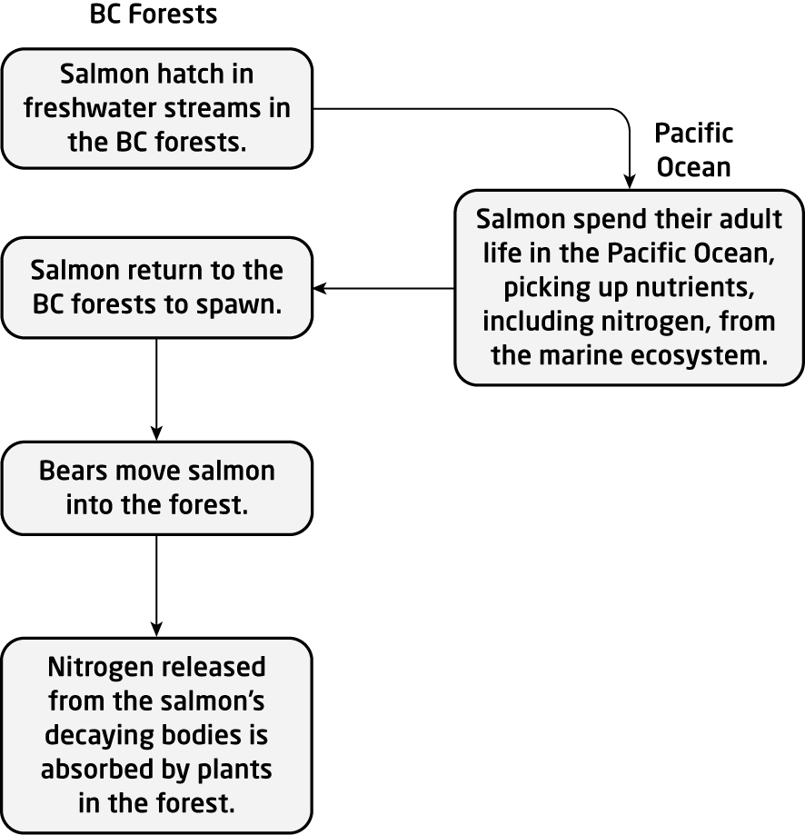

PTS: 4 OBJ: 1-1 STA: A1.11, B3.2 TOP: 3.3
MSC: K/U, C

18. Make a diagram showing how the nitrogen of Lake Superior is related to nitrogen in the boreal forest north of the lake.

ANS:

For example,

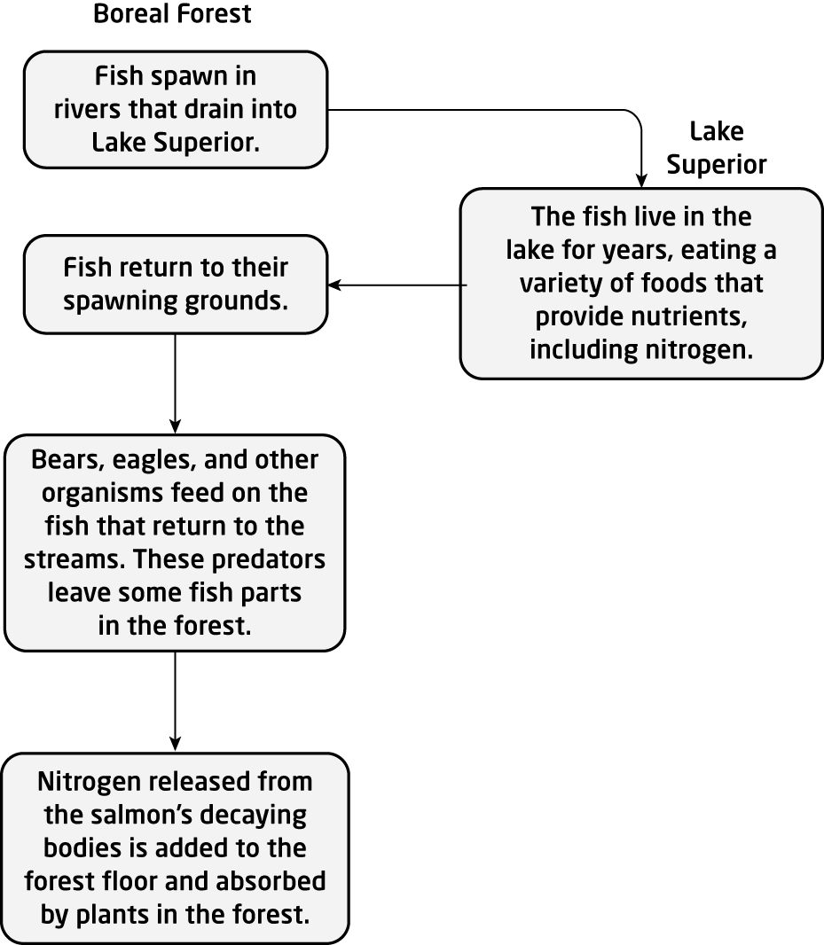

PTS: 5 OBJ: 1-1 STA: A1.11, B3.2, B3.3
TOP: 3.3 MSC: C, A

19. Explain the two kinds of extinction that naturally occur on the planet.

ANS:
The two kinds of extinction are background extinction and mass extinction. Background extinction happens with a small number of species over a long period of time. Mass extinction involves a wide collection of species that become extinct in a short time during a period when the ecosystem can no longer sustain a diverse collection of species.

PTS: 2 OBJ: 1-1 STA: B3.3 TOP: 3.3
MSC: K/U

20. What percentage of the original wetlands of Lake Ontario still exist?

ANS:
About 10%

PTS: 1 OBJ: 1-2 STA: B3.5 TOP: 3.3
MSC: K/U

21. How do alien species continue to enter the Great Lakes?

ANS:
Ballast water from ocean-going vessels is a major source of these organisms.

PTS: 1 OBJ: 1-2 STA: B3.5 TOP: 3.3
MSC: A

22. Ships take on ballast before a voyage and often release it when they reach their destination, bringing alien species into freshwater lakes. Suggest how the ballast water problem can be reduced.

ANS:
Ships can release freshwater ballast while at sea and take on saltwater ballast. Saltwater organisms are less likely to survive the freshwater environments at the ship’s destination.

PTS: 2 OBJ: 1-2 STA: B3.5 TOP: 3.3
MSC: A

23. Many people keep birds like budgies or zebra finches as pets. If these birds escaped into the wild, how would they affect the ecosystem in your area?

ANS:
These birds might survive for a while, but would not survive the winter in Canada. They could survive in the wild in Florida.

PTS: 2 OBJ: 1-2 STA: B3.5 TOP: 3.3
MSC: A

24. How does the round goby disturb native species?

ANS:
The round goby will eat the eggs of native species and it outcompetes native species for spawning areas.

PTS: 2 OBJ: 1-1 STA: B3.3 TOP: 3.3
MSC: K/U

25. Clear-cutting a forest has a similar effect to a forest fire. Both actions result in habitat loss. How does fire help with forest renewal?

ANS:
Fire burns many trees, allowing sunlight to the ground where new trees can grow. Jack pine seeds need the intense heat of a fire to open so that the new trees can start to grow.

PTS: 2 OBJ: 1-2 STA: B3.5, B3.1 TOP: 3.3
MSC: A

26. Bird populations in the boreal forest have decreased. Suggest three possible contributing factors and possible solutions.

ANS:
Answers will vary.
Deforestation leaves limited breeding habitats. Protecting the forest from logging should increase bird populations.
Deforestation in wintering sites reduces survival of migrating birds. Protecting tropical forests should increase bird populations.
Urban centres along the flyways reduce the survival of migrating birds. Urban centres cannot be removed, but food sources and suitable habitats for the birds in these areas could be increased. More birds will survive the migration and populations will increase.

PTS: 5 OBJ: 1-1, 1-2 STA: A1.1, B3.3, B3.5
TOP: 3.3 MSC: K/U, T/I

27. The red mulberry tree is found in southwestern Ontario and many parts of the United States.The Peary caribou is found only in the Canadian arctic. Give arguments for and against protecting each of these species in Canada.

ANS:
Answers will vary.
Since the red mulberry is found in many parts of the United States, it can be reintroduced if it goes extinct locally. The plants are easy to grow and replant in the natural area. However, this plant provides food for many bird species. Protecting this plant will support those species.
The Peary caribou lives in the Canadian arctic where very few people live. Most will never see these animals. It is thought that warmer and wetter winters, resulting in ice layers in the snow pack that hinder foraging, are the cause of the decline of these caribou, so it may be difficult to solve the problem in time. However, if this species is not protected, it may go extinct. Caribou are a key species in northern ecosystems. They play an important role in nutrient cycling as they are the only mammal that has adapted to feed on lichen. The rare Arctic wolf, a key predator of the Peary caribou, and likely other species will be affected if the Peary caribou becomes extinct.

PTS: 3 OBJ: 1-2 STA: A1.10, B3.5
TOP: 3.1 MSC: A

28. How many kinds of fish live in Lake Malawi?

ANS:
about 1000 species of fish

PTS: 1 OBJ: 1-1 STA: B3.3 TOP: 3.1
MSC: K/U

29. Why are tropical hotspots harder to preserve?

ANS:
Tropical hotspots are often found in developing nations that do not have people with sufficient training to act as environmental planners.

PTS: 2 OBJ: 1-2 STA: B1.2 TOP: 3.1, 3.3
MSC: K/U

30. Outline six keystone organisms in the boreal forest.

ANS:
Answers will vary. There are many keystone plant and animal species in the boreal forest. Students could work in groups and present their answers on chart paper.

PTS: 6 OBJ: 1-1 STA: B3.3 TOP: 3.1
MSC: K/U, A

31. Use the sea otter as an example of a keystone species. Make a flowchart showing how the activity of the sea otter helps maintain diversity of their habitat. Show the consequence of removal of the sea otter.

ANS:
For example,

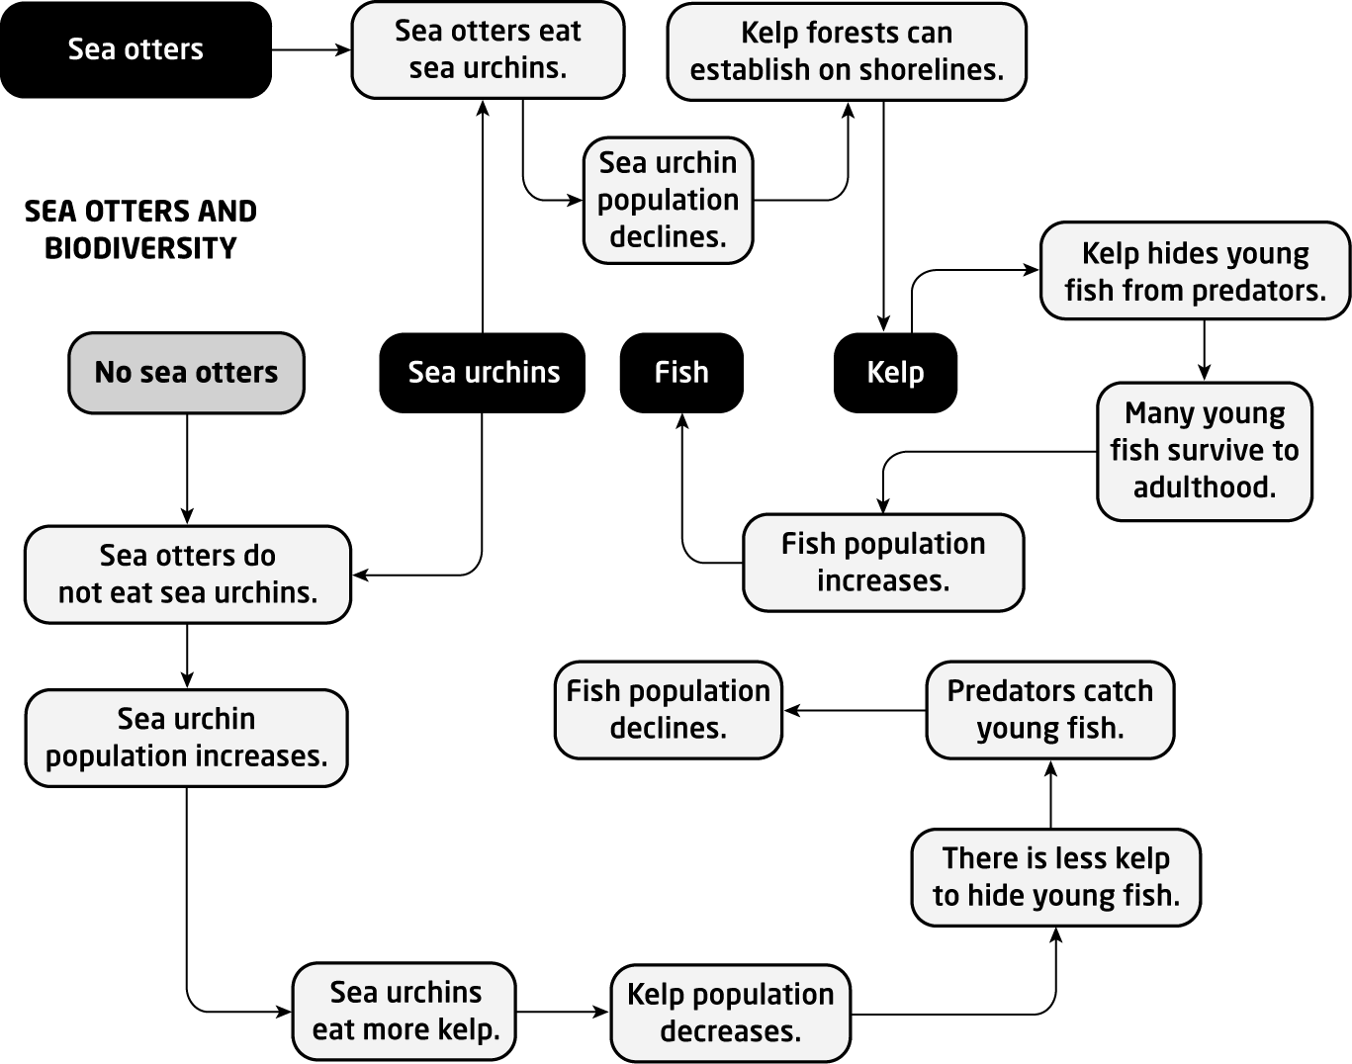

PTS: 4 OBJ: 1-1 STA: B3.3 TOP: 3.2
MSC: K/U, C

32. How is environmental stewardship related to the preservation of existing ecosystems?

ANS:
As stewards, people take on the responsibility of ensuring that species in an ecosystem are able to survive. This may require efforts to maintain a small population of a keystone species.

PTS: 2 OBJ: 1-2 STA: B3.5 TOP: 3.4
MSC: K/U

33. How is biodiversity a measure of ecosystem sustainability?

ANS:
Biodiversity is a measure of the many different species in an area. A high number of species means that there are multiple connections within that ecosystem. This allows the system to withstand change.

PTS: 2 OBJ: 1-1 STA: A2.1, B3.1 TOP: 3.1
MSC: K/U

34. Why are wetlands in urban areas in need of intense restoration?

ANS:
Wetlands in urban areas have often been drained for development or used as dumping grounds for waste.

PTS: 1 OBJ: 1-2 STA: B3.5 TOP: 3.4
MSC: A

35. Toronto was built on a watershed draining into both Lake Ontario and the Don River. Many small streams and creeks that ran through Toronto were covered. Some of these underground streams can be found as roads. Why might it be desirable to cover a stream in a growing city?

ANS:
In a growing city, a stream would likely be used as a destination for sewage and garbage. Covering up these stinky streams would make living in the city easier for people.

PTS: 2 OBJ: 1-2 STA: B3.5 TOP: 3.4
MSC: A

36. In southern Ontario, urban areas such as the Greater Toronto Area have been directed to continue urban intensification. What are the major uses of land in southern Ontario outside of the major urban areas, and how can the provincial government encourage people in these areas to support local ecosystems?

ANS:
A significant part of southern Ontario is agricultural land. The provincial government could encourage farmers to leave some areas as natural ecosystems. This might help support declining populations of plants and animals.

PTS: 2 OBJ: 1-2 STA: B1.2, B3.5 TOP: 3.4
MSC: A

37. Some native Ontario species have experienced population increases and now risk contact with humans. Coyotes have been seen in residential neighbourhoods throughout the Greater Toronto Area. Black bears and cougars are also venturing into areas near urban areas. Suggest reasons for this.

ANS:
Answers will vary. People have been encroaching into areas where these animals lived, so now they are forced to share space with humans. As people reduce the natural habitat available, these animals have fewer food sources and extend their territory into urban areas.

PTS: 3 OBJ: 1-1, 1-2 STA: B3.5 TOP: 3.3
MSC: A

38. Raccoons and robins are native species that coexist with people in urban areas. How have these animals, which naturally live in forests, been successful in urban areas?

ANS:
Robins successfully find food in city gardens and lawns. Raccoons continue to forage, but now include human garbage and pet food in their diets.

PTS: 2 OBJ: 1-1, 1-2 STA: B3.3, B3.5 TOP: 3.3
MSC: A

39. Although raccoons and robins do well in cities, bats and many insects do not. Suggest reasons for this.

ANS:
Insecticides and pesticides used to control insects have reduced the number of insects available to support bat populations. In areas with rules limiting insecticide use, bat populations may increase.

PTS: 2 OBJ: 1-1, 1-2 STA: B3.3, B3.5 TOP: 3.3
MSC: A

40. What is meant by the term forest management?

ANS:
Forest management means that a cleared forest is re-grown.

PTS: 1 OBJ: 1-2 STA: B1.2, B3.5 TOP: 3.3
MSC: K/U

41. Some red pines in Ontario were planted in areas that had been cleared for agriculture. How did these red pines contribute to later reforestation?

ANS:
The red pines prevented soil erosion. They provided shade for a variety of other plants to grow beneath them. Natural succession allowed other native plants to grow in the new forest.

PTS: 3 OBJ: 1-2 STA: B1.2, B3.5 TOP: 3.4
MSC: K/U

42. Explain how biocontrol used to control the Gypsy moth has affected native species of moth.

ANS:
Biocontrol uses one species to control a different species. A European fly called a parasitoid was introduced into Ontario to control the Gypsy moth. To survive, this fly now attacks native moths, including most of the native robin moth.

PTS: 3 OBJ: 1-2 STA: B1.2, B3.5 TOP: 3.4
MSC: K/U

43. How does clover make it easier to re-vegetate a landscape? What is this process called?

ANS:
Clover is a ground cover plant that adds nitrogen to the soil. The addition of nitrogen to the soil allows other plants to survive. This process is called augmentation.

PTS: 2 OBJ: 1-2 STA: B3.5 TOP: 3.4
MSC: K/U

44. Give an example of an ethical reason for environmental stewardship.

ANS:
Answers will very. For example, caring for and contributing to the wellbeing of others is an ethical principle held by many. Some people want to protect the environment to prevent harm to human communities; others care just as much about protecting other species for their own sakes.

PTS: 1 OBJ: 1-2 STA: B3.5 TOP: 3.4
MSC: K/U

45. Open-pit mining is used to extract oil from the tar sands in Alberta and diamonds from the James Bay Lowlands in northern Ontario. What is the environmental impact of open-pit mining?

ANS:
Open-pit mining can destroy the ecosystem of an entire area. Open-pit mines cannot support any of the plants and animals that would create a connected ecosystem.

PTS: 2 OBJ: 1-2 STA: B3.5 TOP: 3.4
MSC: K/U, A

46. What industry was located at the Don Valley Brick Works?

ANS:
Bricks were made and shale was mined in a quarry behind the brick factory.

PTS: 2 OBJ: 1-2 STA: B3.5 TOP: 3.4
MSC: K/U

47. How can a biodiversity specialist help a mining company?

ANS:
Answers will vary. A biodiversity specialist will identify the variety of species in an area set to be mined. A report can recommend ways to avoid specific areas or create new habitat to replace habitat that will be destroyed.

PTS: 2 OBJ: 1-2 STA: A2.1, B3.5 TOP: 3.4
MSC: A

48. First Nations people in Canada have a tradition of transmitting knowledge through story. As the oral tradition has declined, so has traditional ecological knowledge.
a) What is traditional ecological knowledge?
b) How did First Nations people develop this knowledge?

ANS:
a) Traditional ecological knowledge is the understanding of how to use a resource sustainably.
b) This knowledge comes from generations of people interacting with the various organisms in an ecosystem.

PTS: 2 OBJ: 1-2 STA: B1.2 TOP: 3.3
MSC: K/U, A

49. How many mass extinctions have there been in the past? Which was the largest extinction?

ANS:
There have been five mass extinctions. The Late Ordovician was the largest.

PTS: 1 OBJ: 1-1 STA: A1.6 TOP: 3.3
MSC: A

50. We could be facing the next mass extinction. What evidence suggests this?

ANS:
Overexploitation of resources has resulted in hundreds of species on the brink of extinction. Earth is in a critical state, with increasing numbers of biotic and abiotic factors being thrown out of balance.

PTS: 2 OBJ: 1-1, 1-2 STA: B3.3 TOP: 3.3
MSC: A

51. What strategies are available to help reduce the chance of a mass extinction?

ANS:
Reducing the impact of human activity through reduced resource use, ecosystem restoration, and remediation can reduce the chance of a mass extinction.

PTS: 2 OBJ: 1-2 STA: B3.5 TOP: 3.3
MSC: A

52. What kind of geological activity can lead to extinction?

ANS:
Eruptions from volcanoes

PTS: 1 OBJ: 1-1 STA: B3.1 TOP: 3.3
MSC: K/U

53. What is meant by the term biodiversity crisis?

ANS:
Extinction rates for a wide variety of organisms are 100 to 1000 times the normal rate of extinction over Earth’s history.

PTS: 1

54. How is the speed of extinction related to ecosystem change?

ANS:
Extinction is a measure of ecosystem change. An increasing rate of extinction indicates dramatic ecosystem change.

PTS: 2 OBJ: 1-1 STA: B3.3 TOP: 3.3
MSC: K/U

55. Assume that Canadians become good environmental stewards and reduce their impact on ecosystems. Will this result in a more balanced planet?

ANS:
Restoring and preserving the ecological diversity of Canada will help, but it is not enough to create a balanced planet. Resources from Canada and other developed nations must be used to help support this same work in less developed areas of the world.

PTS: 2 OBJ: 1-2 STA: B3.5 TOP: 3.3
MSC: A

56. How are the species in an ecosystem like the rivets in an airplane wing?

ANS:
An airplane wing is held together by many rivets. A few missing rivets may not create a large problem, but if enough rivets are lost, the wing will fall apart. Similarly, if enough species in an ecosystem are lost, the ecosystem will collapse.

PTS: 3 OBJ: 1-1 STA: B3.3 TOP: 3.4
MSC: K/U

57. Some farms in Ontario include a sugar bush—a woodland primarily composed of mature maple trees. In early spring these trees can be tapped to collect their sap and make maple syrup.
a) How does this benefit the farmer?
b) How does this benefit the environment?

ANS:
a) The sugar bush provides extra income before the start of the growing season.
b) The woodland area provides a habitat for forest organisms.

PTS: 2 OBJ: 1-2 STA: B3.5 TOP: 3.4
MSC: A

58. New species are found often in tropical regions, but rarely in Canada. Recently, however, a new species of caribou has been discovered in Canada—the mountain caribou of British Columbia. These caribou are the result of a blending of woodland caribou and barren land caribou about 10 000 years ago. Typically, barren land caribou migrate and woodland caribou do not. Different groups of the mountain caribou do both. What does this suggest about the future prospects of caribou species?

ANS:
It suggests that caribous have the capacity to adapt to some new conditions.

PTS: 1 OBJ: 1-1 STA: B3.3 TOP: 3.1
MSC: A

59. Frederick Urquhart discovered that Canada’s Monarch butterflies left Canada in the fall to travel south to Mexico. To do this, he had to tag butterflies and release them. Suggest a place where the tag could be located without damaging the butterfly. Explain your choice.

ANS:
Answers may vary. Monarchs are tagged on the underside of the hind wing of the butterfly where it will not impede flight.

PTS: 1 OBJ: 1-2 STA: A2.2, B3.3 TOP: 3.4
MSC: A

PROBLEM

1. Plan a school trip to measure the biodiversity of the schoolyard or a local park or conservation area. Prepare a short plan for the day that includes an outline of the method(s) of measurement to be used by the students. List all the equipment needed. Include safety information where required. Contact a responsible adult (teacher, park personnel, conservation personnel, administrator, etc.) to determine how many adults are needed for this work and if any special permission forms are required.

ANS:
Answers will very.
Have policy documents for your school available.
Provide students with contact names and phone numbers so that they can ask for information.
Provide students with a list of parks near the school.
If possible, use input from these plans to help organize a real trip to collect data.

PTS: 8 OBJ: 1-1 STA: A1.4, A1.11, B2.2
TOP: 3.1 MSC: T/I

2. a) Locate the nations listed in the chart below on a map of the world. In what part of the globe are all these nations located?

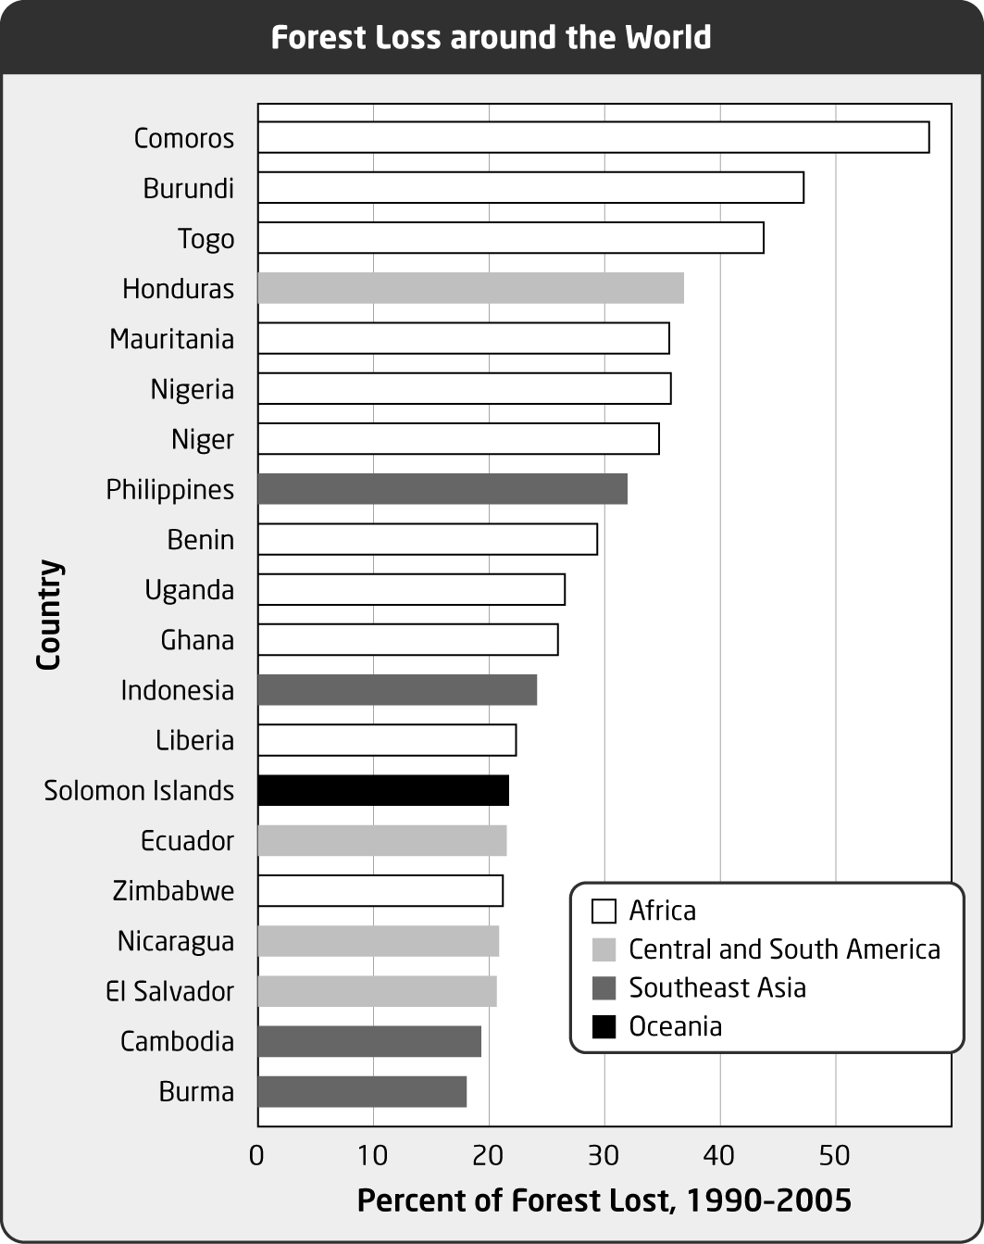

b) Use the Internet to obtain the information to complete the table below. Continue the table to include all the countries listed on the graph above.

Nation | Total area (sq km) | Population (millions) | Average age (years) | % below poverty line
Comoros
Burundi
Togo | 56 385 | 6.020 | 18.7 | 32%
Honduras

ANS:
a) These nations are all located in the tropical zone that circles the planet.
b) Numeric data will depend on when the research is conducted. For example,

Nation | Total area (sq km) | Population (millions) | Average age (years) | % below poverty line
Comoros | 2 170 | 0.752 | 18.8 | 60
Burundi | 27 830 | 8.988 | 16.7 | 68
Togo | 56 385 | 6.020 | 18.7 | 32
Honduras | 112 090 | 7.793 | 20.3 | 51
Mauritania | 1 030 700 | 3.129 | 19.2 | 40
Nigeria | 923 768 | 149.229 | 19 | 70
Niger | 1 267 000 | 15.306 | 15.2 | 63
Philippines | 300 000 | 97.977 | 22.5 | 30
Benin | 112 620 | 8.792 | 17.2 | 37
Uganda | 236 040 | 32.370 | 15 | 35
Ghana | 239 460 | 23.832 | 20.7 | 29
Indonesia | 1 919 440 | 240.272 | 27.6 | 18
Liberia | 111 370 | 3.442 | 18 | 80
Solomon Islands | 28 450 | 0.596 | 19.7 | not available
Ecuador | 283 560 | 14.573 | 25 | 38
Zimbabwe | 390 580 | 11.393 | 17.6 | 68
Nicaragua | 129 494 | 5.891 | 22.1 | 48
El Salvador | 21 040 | 7.185 | 22.5 | 31
Cambodia | 181 040 | 14.494 | 22.1 | 35
Burma | 678 5000 | 48.138 | 28.2 | 33

PTS: 8 OBJ: 1-2 STA: A1.8. A1.10
TOP: 3.3 MSC: T/I, C

3. Conservation is both local and global. It is important for people to take care of their own local environment, but it is also important to look beyond the local area. The biosphere connects all of the ecological systems together. Select one region where poverty makes it difficult for the local people to conserve their environment. Research the ecosystems and species at risk in this area. Prepare a newsletter article that can inform people in your area of the issues and make suggestions of what they could do to help.

ANS:
Answers will vary. Some ways people can help is to be informed, through choosing to buy fair trade and environmentally friendly products, through political action, and through donations to organizations that are working to solve the problem.

PTS: 10 OBJ: 1-2 STA: A1.11, B1.2, B2.1, B3.5
TOP: 3.1, 3.2, 3.3 MSC: C, A

4. Ramsar sites are wetlands identified as important for protection and wise use. Ramsar sites are found throughout Ontario, as see from the table below.

Ramsar sites in Ontario
Ramsar site | Size (hectares)
Polar Bear Provincial Park | 2 408 700
Southern James Bay | 25 290
Matchedash Bay Provincial Wildlife Area | 1 840
Mer Bleue Conservation Area | 3 447
Minesing Swamp | 6 000
Long Point | 13 730
Point Pelee National Park | 1 564
St. Clair National Wildlife Area | 244

a) Make a circle graph to show the relative sizes of the Ramsar sites listed above.
b) Polar Bear Provincial Park and Southern James Bay in northern Ontario are much larger than the Ramsar sites in southern Ontario. Suggest reasons why this might be so.

ANS:
a) For example,

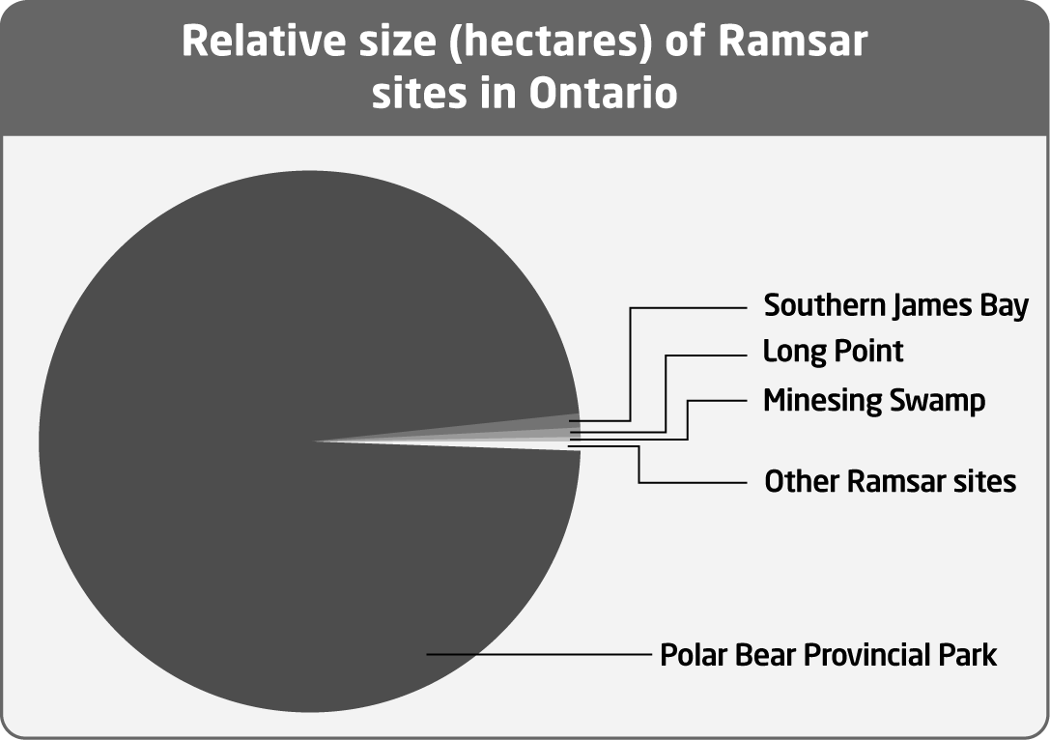

Note: The areas of the other sites are 1% or less of the area of Polar Bear Provincial Park. It may be difficult to see these slices on a regular circle graph. Students may want to use a chart that shows an enlargement of the small values, such as the “bar of pie” or “pie of pie” charts in Excel.
b) Long before the Ramsar Convention came into force, southern Ontario became heavily populated. Southern Ontario has always supported most of Ontario’s population. Over time, most of the wetlands of southern Ontario have been lost due to farming, dredging to deepen harbours, draining and filling so the land can be developed, invasive species, and pollution. The important ecological role of wetland habitats has been recognized only relatively recently.

PTS: 6 OBJ: 1-2 STA: A1.6, B3.5 TOP: 3.1
MSC: C, A

5. Bioremediation can solve a pollution problem by mimicking a natural process. Bioremediation often involves bacteria as part of the process. Filtering dangerous waste products can reduce the environmental impact of an industrial site. Refer to the structure of the Oak Ridge Moraine, shown below, to suggest how the area beneath a factory floor could be constructed to trap and filter dangerous waste and ensure that material closest to the outside world is environmentally safe. Include a biological filter of appropriate bacteria as part of your solution.

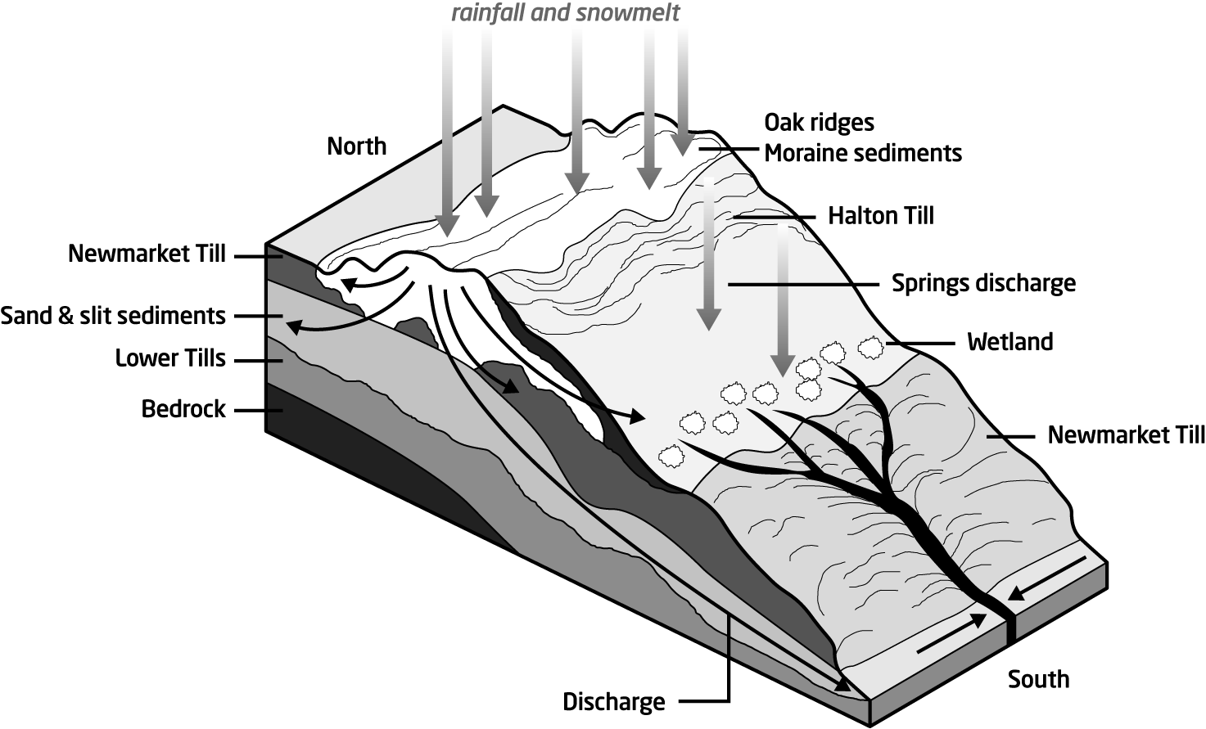

ANS:
The Oak Ridge Moraine filters water. Layers of sand and gravel can help trap contaminants allowing cleaner water to pass through. The area beneath the factory floor could be designed in a similar way. A plastic liner can contain the area. Above this can be a mixture of sand and gravel, then a layer of sand. On top would be a soil with bacteria that can degrade the toxin.

PTS: 10 OBJ: 1-2 STA: A1.1, A1.2, A1.3, A1.5, A1.8
TOP: 3.4 MSC: T/I, A

6. Many pollutants entered the Great Lakes many years ago. These materials often fell into sediment at the bottom of the lakes. One program for Great Lakes restoration includes sediment remediation. This process means removing large quantities of sediment from the identified area. This chart shows much sediment remediation was completed through the program over a period of 10 years.

Sediment remediated in the Great Lakes Basin
Year | Volume of sediment removed (1000 m³)
1997 | 102
1998 | 714
1999 | 205
2000 | 307
2001 | 304
2002 | 148
2003 | 745
2004 | 265
2005 | 309
2006 | 335
2007 | 733

a) What was the total volume of sediment removed in the period 1997–2007?
b) How will this activity affect the aquatic system in the short term?
c) How will this activity affect the aquatic system in the long term?
d) List two more steps you would expect to see in the restoration plan (after the sediment is removed).

ANS:
a) 4 167 000 m³
b) This activity will be very disruptive in the short term. Many organisms will be removed with the sediment.
c) This activity will help support a healthy ecosystem in the long term.
d) Answers will vary. Sediment from similar areas could be added so that new populations of missing organisms can be re-established. The area could be isolated from human activity as the organisms in the area become established.

PTS: 5 OBJ: 1-2 STA: A1.6, B3.5 TOP: 3.4
MSC: T/I, A

7. Mining is an important economic sector, but it can harm ecosystems. The table below presents some information about mining in Ontario.

Production of Some Ontario Minerals 2008
Mineral mined | Amount mined
cadmium | 116 000 kg
cobalt | 1 784 000 kg
copper | 186 462 000 kg
gold | 49 736 000 g
nickel | 114 841 000 kg
zinc | 110 486 000 kg
cement | 5 675 000 t
diamonds | 730 000 ct
phosphate | 900 000 t
salt | 9 513 000 t
sand and gravel | 98 888 000 t
stone | 64 215 000 t
[kg = kilograms, g = grams, t = tonnes, ct = carats]

a) Which mineral was mined in the greatest amount? Use these conversions as necessary: 1 t = 1000 kg, 1 kg = 1000 g, 1 g = 5 ct. Show your calculations.
b) The mining of which mineral is likely to cause the greatest damage to ecosystems? Give reasons. You may need to research mining activities to make an informed decision.

ANS:
a) Tons are the largest unit, so start there. Sand and gravel = 98 888 000 t = 98 888 000 000 kg. This is the greatest amount on the chart, so sand and gravel was mined in the greatest amount.
b) Sand and gravel is a candidate because of the sheer volume. Gold production creates many toxic byproducts.

PTS: 4 OBJ: 1-2 STA: A1.12, A1.13, B3.5
TOP: 3.3 MSC: T/I, A

8. The wolverine is a solitary predator found throughout much of Canada’s boreal forest. In Ontario, the wolverine is limited to the northwest, away from the Great Lakes. Populations have been declining and this animal is now considered threatened in Ontario. A study from Alaska and Yukon studied wolverine tracks in snow using quadrats that were about 25 km². The survey was completed sometime between 24 and 72 hours after a snowfall ended.
a) Why do you think such large quadrats used?
b) Why would the scientists look for tracks rather than for wolverines?
c) Identify two safety precautions the researchers should take to protect themselves.
d) Suggest reasons why observations were not made one week after the snowfall ended.

ANS:
a) Wolverines are solitary animals, so the population will be spread out over a large area.
b) Wolverines are hard to find, but they leave tracks that can be seen when the wolverine is no longer nearby.
c) Researchers should bring/wear warm clothing and have equipment for radio communication so that people don’t freeze and can get help if they run into trouble.
d) After a longer period of time, there could be another snowfall, or tracks could become obscured by those of wolverines or other animals, making observations difficult to interpret.

PTS: 4 OBJ: 1-1 STA: A1.4, A1.5, B2.5
TOP: 3.4 MSC: T/I, A

9. European honeybees are largely responsible for the pollination of food crops. Problems with European honeybee hives can affect the amount of food produced by many flowering plants, such as beans, apples, and pears. Butterflies, bumble bees, and some other bees are native pollinators. Many native bees contribute to crop production, so they can help to maintain our food sources.
Prepare a plan to plant a local native plant garden near your school to support native pollinators.
Through Internet research and other sources, identify one or more pollinators that are native to your area. Find out which plants are needed throughout the spring, summer, and fall to support populations of these pollinators.
List the steps needed to build this garden. Identify the people and materials needed for this work.
Determine how you will measure the success of your garden.
List the people you will need to contact to make this project work. How will their work expertise contribute to the success of the project?

ANS:
Answers will vary.
Students will likely need to make observations of bees and then identify them. Having a camera available to capture pictures of the bees can be helpful for later identification.
The plan will need to eliminate any pesticides. Any plants that need to be removed will need to be removed by hand, or with hand tools.
The plan should include perennial plants that will support the bee population in years to come.
A variety of plants will need to be placed in the garden. Early flowers are important to keep the bees alive after they emerge from winter hibernation. Raspberry bushes have early flowers. Fireweed flowers could be planted in the summer. Goldenrod flowers could be planted in the late summer into early fall.
Bees will also need a source of water. In a dry summer, someone may need to add water to the garden from time to time.
Soil may be needed as well as fertilizer or mulch to help establish this garden. Local horticultural clubs may have some advice. Students may want to get permission to actually create this garden.
One or more students should arrange to make observations at specific points in the summer. Students should record the kinds and numbers of pollinators observed and which plants they visit. Planning an observation chart before the garden is built will help students understand what data they should collect.
Students would need to meet with a variety of people to complete this project. Electronic research can lead them to sites supported by insect specialists with university training. Preparing the garden would involve people at school who maintain the grounds. To build the garden, students would need to arrange to purchase gardening materials such as soil, plants, and mulch. Workers in a garden centre may be able to provide specialized knowledge about native plants. Using the tools to make the garden may require assistance from someone with experience gardening or working as a landscaper.

PTS: 16 OBJ: 1.2 STA: A1.1, A1.2, A1.3, A1.4, A2.1, B1.2
TOP: 3.4 MSC: T/I, A

10. Sustainable use of resources is a key to protecting the biodiversity of Earth’s ecosystems.
The activities of a school require the use of many resources. Develop a plan for how your school can use fewer resources. Research may be needed. Connect the reduced use of resources to ecosystem gains.
Create a three-step plan to reduce the school’s resource use. At each step, explain the target. Outline how you will know when you will meet this target. List the key school staff whose support and/or expertise you will need for the plan to succeed. Create a team of students to present a proposal that includes a promotional campaign t educate students and staff at the school about the objectives and rationale for the plan.

ANS:
Answers will vary. Typical responses will include: reducing paper use; reducing electricity use; reducing the amount of garbage produced; recycling more material; turning down the heat and wearing warmer clothes; bringing lunch in reusable containers; rand educing food waste. A before-and-after description will help students clarify the problem and identify appropriate solutions. For example, reducing paper use can mean not using paper towels wastefully, or teachers using both sides of a page to make a handout. Important staff to have involved are the principal, caretaker, office manager, hall monitors, cafeteria workers, and workers in other specialized groups, such as an onsite daycare.

PTS: 14 OBJ: 1-2 STA: A1.11, B1.1, B3.5
TOP: 3.3, 3.4, 2.4 MSC: C, A

11. To discover the mystery of Monarch migration, Frederick Urquhart, a professor at the University of Toronto, needed to catch, tag, and release thousands of butterflies each year. Urquhart spent several years experimenting with various tagging methods before a successful system was found—tiny adhesive labels with information recorded on them. Using the data collected from tagged butterflies over many years, Urquhart was able to determine that Monarchs can travel almost 200 km per day at times. They move toward Mexico in the fall, and do not mate or lay eggs during migration.
a) Butterfly tags cannot be very big, but they must contain key information. Identify two pieces of information that would need to be on a tag.
b) Suggest ways to get thousands of butterflies tagged.
c) Why would the butterflies not mate or lay eggs during migration?
d) What human activities in Canada can hurt Monarch populations? (Research the diet of both caterpillars and adult butterflies.)
e) Suggest two ways in which your school can support Monarch migration.

ANS:
a) Answers will vary but may include capture location, capture date, instructions to return the tag if found to the University of Toronto.
b) Answers will vary. You could promote the program and ask for volunteers to help.
c) Butterflies migrating so far need to save their energy for the journey
d) Monarchs suffer from habitat destruction. The caterpillar feeds on milkweed, which is often removed as a noxious plant. Adult butterflies rely on nectar in flowers, but many native flowers are not cultivated by people in their gardens.
e) The school can plant a butterfly garden (on school grounds or in a local park) that includes milkweed and a variety of other native plants, such as fireweed and goldenrod.

PTS: 4 OBJ: 1-1, 1-2 STA: A2.2, B3.5 TOP: 3.4
MSC: T/I, A

ESSAY

1. Canada supports a number of caribou populations. List all the caribou species in Canada. Which of these caribou species is most at risk? Why is this species declining?

ANS:
Four subspecies of caribou occur in Canada: woodland, Peary, barren-ground west of the Mackenzie River, also known as Grant’s caribou, and barren-ground east of the Mackenzie River. A fifth subspecies, Dawson’s or the Queen Charlotte Islands population of woodland caribou, died out in the 1930s and was declared extinct in 1984.
The Peary caribou is most at risk. The Peary caribou has been assessed as endangered by the Committee on the Status of Endangered Wildlife in Canada. Consultations are underway to determine if Peary caribou should be listed under the federal Species at Risk Act. Numbers have declined by about 72 percent in the last 60 years, mostly because of severe icing episodes due to changing weather conditions, where ice has covered vegetation and led to caribou starvation.

PTS: 6 OBJ: 1-1 STA: A1.7, B3.3 TOP: 3.1
MSC: K/U, T/I, C

2. Name a dominant species in your area and a keystone species in your area. Do any human activities threaten the keystone species? Use a variety of research resources, including government and environmental groups. Prepare your information in a short PowerPoint presentation that could be shared with the local community.

ANS:
Answers will vary. A dominant species is very abundant. A keystone species exerts an impact on its community that is both strong and disproportionate to its abundance. You may want to provide students with a list of potential contacts in government and/or environmental organizations.

PTS: 6 OBJ: 1-1, 1-2
STA: A1.1, A1.3, A1.7, A1.10, A1.11, B3.1, B3.3, B3.5 TOP: 3.2
MSC: K/U, T/I, C, A

3. The Toronto Zoo is an attraction for visitors, but it is also an important place for captive breeding programs. Select a species that is part of the Toronto Zoo captive breeding program. Find out about the dangers facing this species in the wild and ways its their future can be secured. Use this information to create a poster that will help raise funds to assist the Toronto Zoo in its conservation programs.

ANS:
Answers will vary. The Toronto Zoo captive breeding program includes mammals, birds, amphibians, fish, and insects.

PTS: 10 OBJ: 1-2 STA: A1.11, B1.2, B3.3, B3.5
TOP: 3.2, 3.3 MSC: C, A

4. The Vancouver Island marmot is one of the world’s most endangered mammals. Research the Vancouver Island marmot and write a report on why it is endangered.

ANS:
The Vancouver Island marmot is in decline due in part to habitat disruption caused by logging. This marmot prefers sub-alpine open areas that provide good soil for burrowing, plentiful plants to eat, and suitable rocks for lookout spots. Newly logged areas attract marmots to form temporarily successful colonies but prevent them from dispersing to natural habitats that result in higher long-term survival. Weather fluctuations and changing deer numbers and the resulting responses by predators such as cougars and wolves are other factors.

PTS: 4 OBJ: 1-1 STA: A1.10, B3.3 TOP: 3.2
MSC: K/U, A, C

5. The Ramsar Convention is an international treaty for the conservation and sustainable use of wetlands. Wetlands of international Importance, known as Ramsar sites, are identified as a focus for conservation efforts. There are a number of Ramsar sites in Canada.
a) Where did the Ramsar Convention get its name?
b) Where is the largest Ramsar site in Canada?
c) Identify a Canadian group or agency that helps to educate the public about the importance of wetlands.
d) Identify and describe a type of career that involves working with wetlands. What are the requirements for entering this career?

ANS:
a) The Ramsar Convention was developed and adopted by participating nations at a meeting in Ramsar, Iran.
b) Queen Maud Gulf in British Columbia
c) Answers will vary. Ducks Unlimited is the most likely source, but local hunting clubs, conservation area workers, wetlands support groups, and birding clubs are also good choices.
d) Answers will vary. For example, a wetland ecologist works on wetland protection projects that require monitoring, sampling, analysis, research, restoration planning and implementation, and mitigation. They may work as research scientists, on behalf of environmental-protection organizations, or even for construction firms, assessing environmental impact issues. Wetland ecologists in the field may have assignments such as sampling water to monitor the quality of fish habitats or taking a census of birds in a certain area. Other ecologists work on policy legislation or review applications for replacing, restoring, or altering wetlands. The minimum requirement for ecologists is a bachelor's degree in ecological science or a related subject, plus field experience. For wetland ecologists, a Master's degree is becoming the minimum because of the fieldwork component involved. In addition to research experience, most positions require a high level of communication skills. Wetland scientists are often required to prepare reports, file environmental impact statements, write research applications and grants, and present their findings to colleagues and clients. A variety of computer programs are used to analyze data and proficiency in these can increase career opportunities.

PTS: 12 OBJ: 1-2 STA: A1.3, A2.1, B1.1
TOP: 3.3 MSC: K/U, T/I

6. Non-recyclable takeout food packaging creates a huge amount of waste, most of which is landfilled. Styrofoam and polypropylene (designated with a 5), which are often used, cannot be recycled. Now more restaurants are using containers made of paper and foil, and more environmentally friendly alternatives to polypropylene and other plastics are beginning to be developed. There are also environmental impacts to recycling, however.
How can the environmental impact of takeout food containers be reduced? Survey individuals to determine their awareness of and attitudes surrounding this issue, and what they are doing or are willing to do to reduce landfill from takeout containers. Survey local restaurants to determine what factors affect the type of packaging they choose, what success and problems they have experienced with recycling programs in the restaurant, and their ideas for solutions to this problem. Determine through observation which types of containers create the most litter in your area. Research how the different types of containers are treated by the waste management system in your municipality. Find out about the results achieved in communities that have passed laws to reduce waste from non-recyclable food containers. Explain why the use of PLA, commonly called corn plastic, could reduce landfill but may cause other environmental problems.
Prepare a report of your findings. Use charts to display survey results, if suitable.

ANS:
Answers will vary. Recycling programs can be started or enhanced. Restaurants can use containers made from biodegradable plastic. The challenge is to create affordable and recyclable new containers that retain heat but do not melt and that resist liquid and grease as well as Styrofoam and polypropylene do—some tradeoffs may be necessary. Charging a surcharge on a paper cup versus no surcharge on a reusable cup is an option that eliminates waste. While corn plastics show promise, corn is genetically modified, and there are ecological concerns associated with GM crops; as well, crops grown for purposes other than food reduce land available to grow food.

PTS: 15 OBJ: 1-2 STA: A1.3, A1.6, A1.8, A1.10, A1.12
TOP: 3.3, 2.4 MSC: T/I, C, A

7. Polar Bear Provincial Park is the largest of Canada’s provincial parks. It is also the most remote, so few people will have the opportunity to visit it. Research why this land was protected. Are there those who do not agree that this land should remain a protected area? Explain their reasons. Write a letter to the editor of a local newspaper arguing for Polar Bear Provincial Park to remain a protected area. Provide evidence to support your argument.

ANS:
Answers will vary. Some students will discover the value of this area as a site for many polar bear birthing dens. The land is not likely to be developed. There are opportunities to visit this park by way of native guides, so this park does provide an opportunity for a local economy. Some people would prefer to see the money available for parks applied closer to where people live because of the intense life of urban people. Park regulations limit access to the park, and some people would like more open access for hunting and fishing.

PTS: 10 OBJ: 1-1. 1-2 STA: A1.3, A1.9, A1.10, B1.2
TOP: 3.1, 3.2, 3.3 MSC: K/U, T/I, C, A

8. Ecosystem restoration involves work in an area that has been disturbed through natural disaster or human activity. The forest of southern Ontario has been almost entirely removed for farmland and urban development. Restoration of this area is unlikely to happen. Instead, people work on smaller projects. Identify an ecosystem restoration project in your area. Then, answer the following questions:
• What is the goal of this project?
• Who is the driving force behind this project?
• What level of government is involved?
• Who is involved in the work of restoration?
• Are there ways students can participate?
Prepare a short report on your findings and include a map showing the site location. Include sources for your information.

ANS:
Answers will vary.
There are many small projects related to rivers and streams throughout urban areas.
Local Parks and Conservation Areas may have specific programs that students can research.

PTS: 12 OBJ: 1-2 STA: A1.7, A1.8, B1.2, B2.2, B3.5
TOP: 3.4 MSC: T/I, C, A

9. The Grassy Narrows First Nation in Northern Ontario demanded that commercial logging be stopped in the Whiskey Jack Forest in their traditional territory. After years of peaceful protest, AbitibiBowater stopped logging in this area.
Select one of these topics to research:
• First Nations and clear-cut logging.
• Boreal forest products
• Forest management and clear-cutting
• Economical impact of forestry in Ontario
• Another related topic, with teacher approval
Prepare an annotated list of sources for your topic. Identify the perspective of the source. What kind of bias could exist in this source? Fact check sources to different sites that have a different perspective. Share your annotated source list with other students. Write a one-paragraph summary of how the sources you find provide a particular perspective to the topic.

ANS:
Student answers will vary. Assistance from a librarian can be helpful.

PTS: 10 OBJ: 1-2 STA: B1.2 TOP: 3.3, 3.4
MSC: T/I, C

10. Select one challenge faced by a local ecosystem. Explain how the ecosystem is challenged and potential outcomes if the situation remains unchanged or worsens. Develop a slogan that will help to make people more aware of this issue. Suggest ways the slogan could be used to promote environmental stewardship.

ANS:
Answers will vary. For example, the slogan could be suggested to local environmental groups for use in/on promotional materials.

PTS: 7 OBJ: 1-2 STA: B1.2 TOP: 3.4, 2.4, 1.4
MSC: C, A

