Date: Name: Class:
GENERAL | Using Ammeters and Voltmeters | BLM G-21
Science toolkit | Using Ammeters and Voltmeters

Goal • Learn how to use an ammeter and a voltmeter.
What to Do
• Read the following tips for using ammeters and voltmeters.
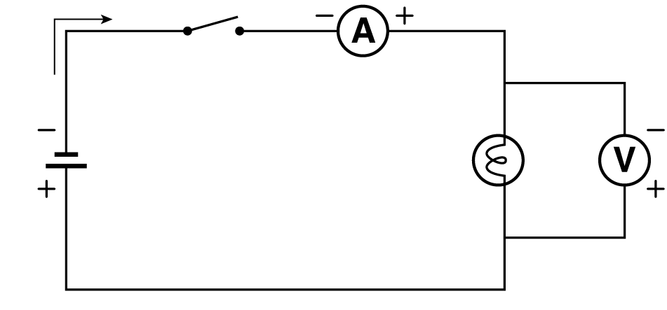

General
• Always make sure that the circuit switch is in the open position before you connect an ammeter or a voltmeter.
• Every meter has two pole connections: positive (+) and negative (–). You must be able to trace a given pole connection back to the same type of terminal at the electrical source. Thus, if you start at the positive pole of a meter and trace from one wire to the next, you should arrive at the positive terminal on the electrical source.
• If the meter has a range switch, set it to the highest range before closing the circuit switch. This protects the meter.
• Always check the meter needle after closing the switch. If the needle begins to go in the wrong direction, you probably have the pole connections reversed. Open the switch, and reverse the connections.
• If the meter has a range switch, select progressively smaller ranges until the meter needle is in the highest part of the scale. Do not allow the needle to hit the peg on the right side of the scale.
Ammeters
• Before connecting an ammeter, always disconnect the basic circuit at the point where you want to insert the ammeter.
• Always connect an ammeter in series, because it measures current. Locate the point in the basic circuit where you would like to measure the current. Then trace along the wire until you come to a connection. Disconnect the wire at this connection, and use the same wire for one of the ammeter connections.
A second wire must be connected to the other pole on the meter to complete the basic circuit.
Voltmeters
• Always connect a voltmeter in parallel with a load by connecting wires from the voltmeter across the load where you want to measure the potential difference. Connecting a voltmeter never requires disconnecting and reconnecting components in a circuit.

