Date: Name: Class:
GENERAL | Reading an Analogue Meter | BLM G-22
Science toolkit | Reading an Analogue Meter

Goal • Practise reading an analogue meter.
What to Do
• Record the value for each scale setting displayed by the following meters.
Be sure to include the correct units.
Scale Setting  1. | Meter Reading | Scale Setting | Meter Reading | 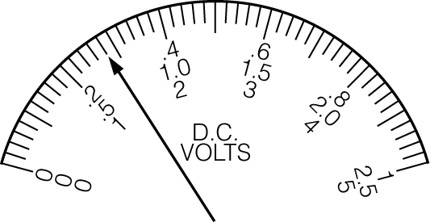
1 V |  | 50 V
2.5 V |  | 100 V
5 V |  | 250 V
10 V |  | 500 V
25 V |  | 1000 V

Scale Setting  2. | Meter Reading | Scale Setting | Meter Reading | 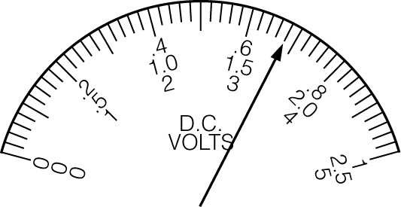
1 V |  | 50 V
2.5 V |  | 100 V
5 V |  | 250 V
10 V |  | 500 V
25 V |  | 1000 V

Scale Setting  3. | Meter Reading | Scale Setting | Meter Reading | 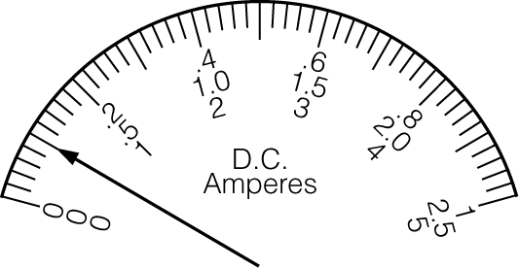
10 mA |  | 1 A
100 mA |  | 5 A
500 mA |  | 10 A

Scale Setting  4. | Meter Reading | Scale Setting | Meter Reading | 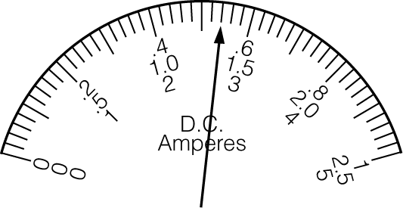
10 mA |  | 1 A
100 mA |  | 5 A
500 mA |  | 10 A

