Date: Name: Class:
GENERAL | Build an H-R Diagram | BLM G-41
Reference | Build an H-R Diagram

Goal • Create an H-R Diagram to show relationships among celestial objects.
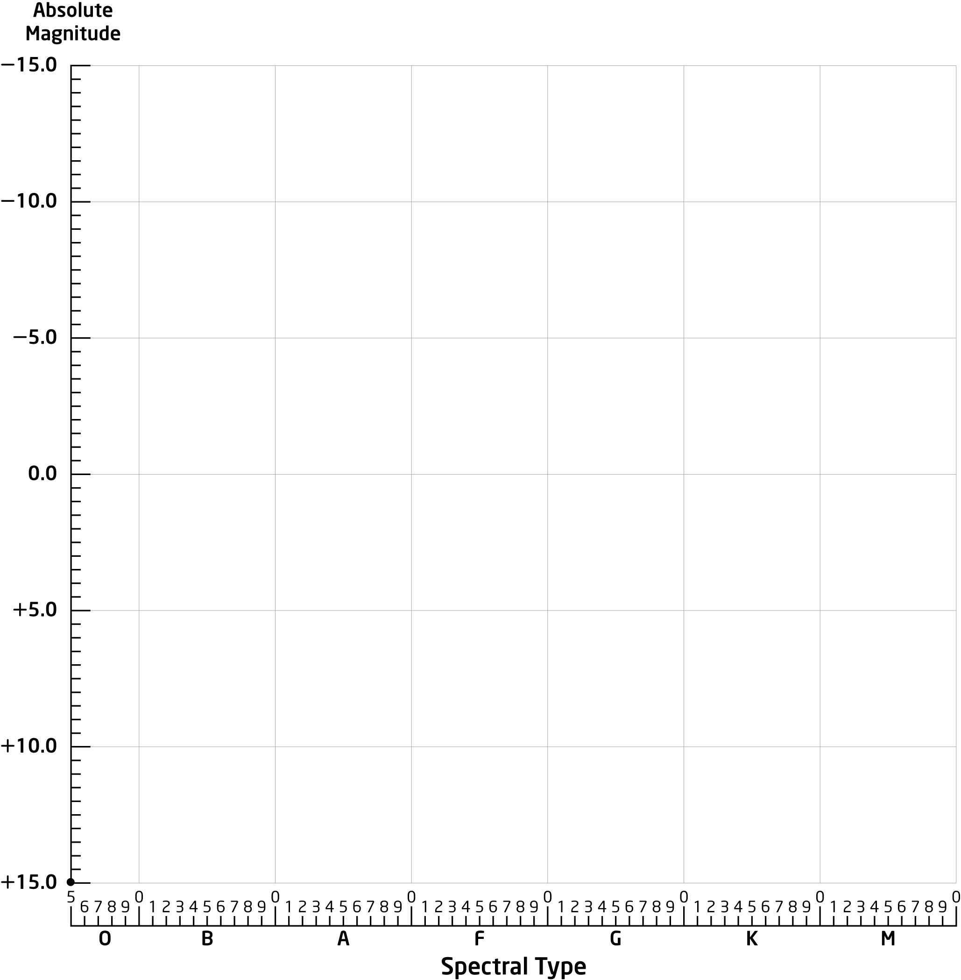
Date: Name: Class:
GENERAL | Star Maps for Fall, Winter, Spring | BLM G-41
Reference | Star Maps for Fall, Winter, Spring

Goal • Use the star maps to learn more about the celestial bodies.
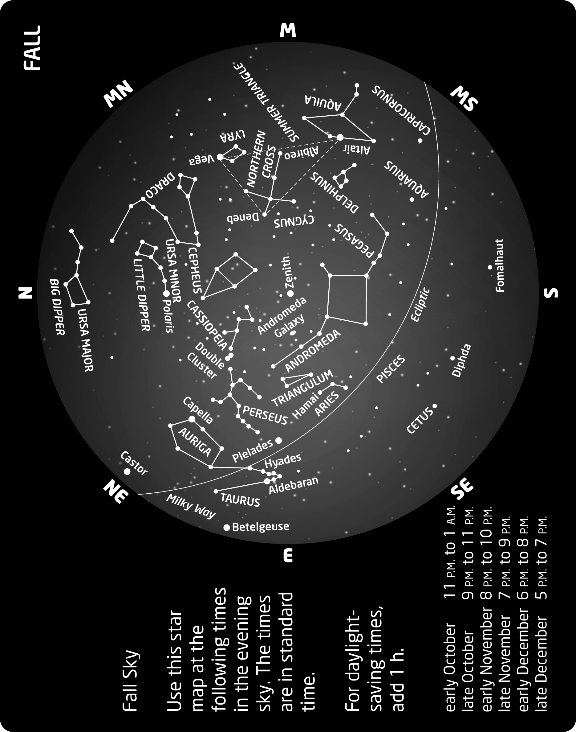
Date: Name: Class:
GENERAL | Star Maps for Fall, Winter, Spring | BLM G-41
Reference | Star Maps for Fall, Winter, Spring | (continued)
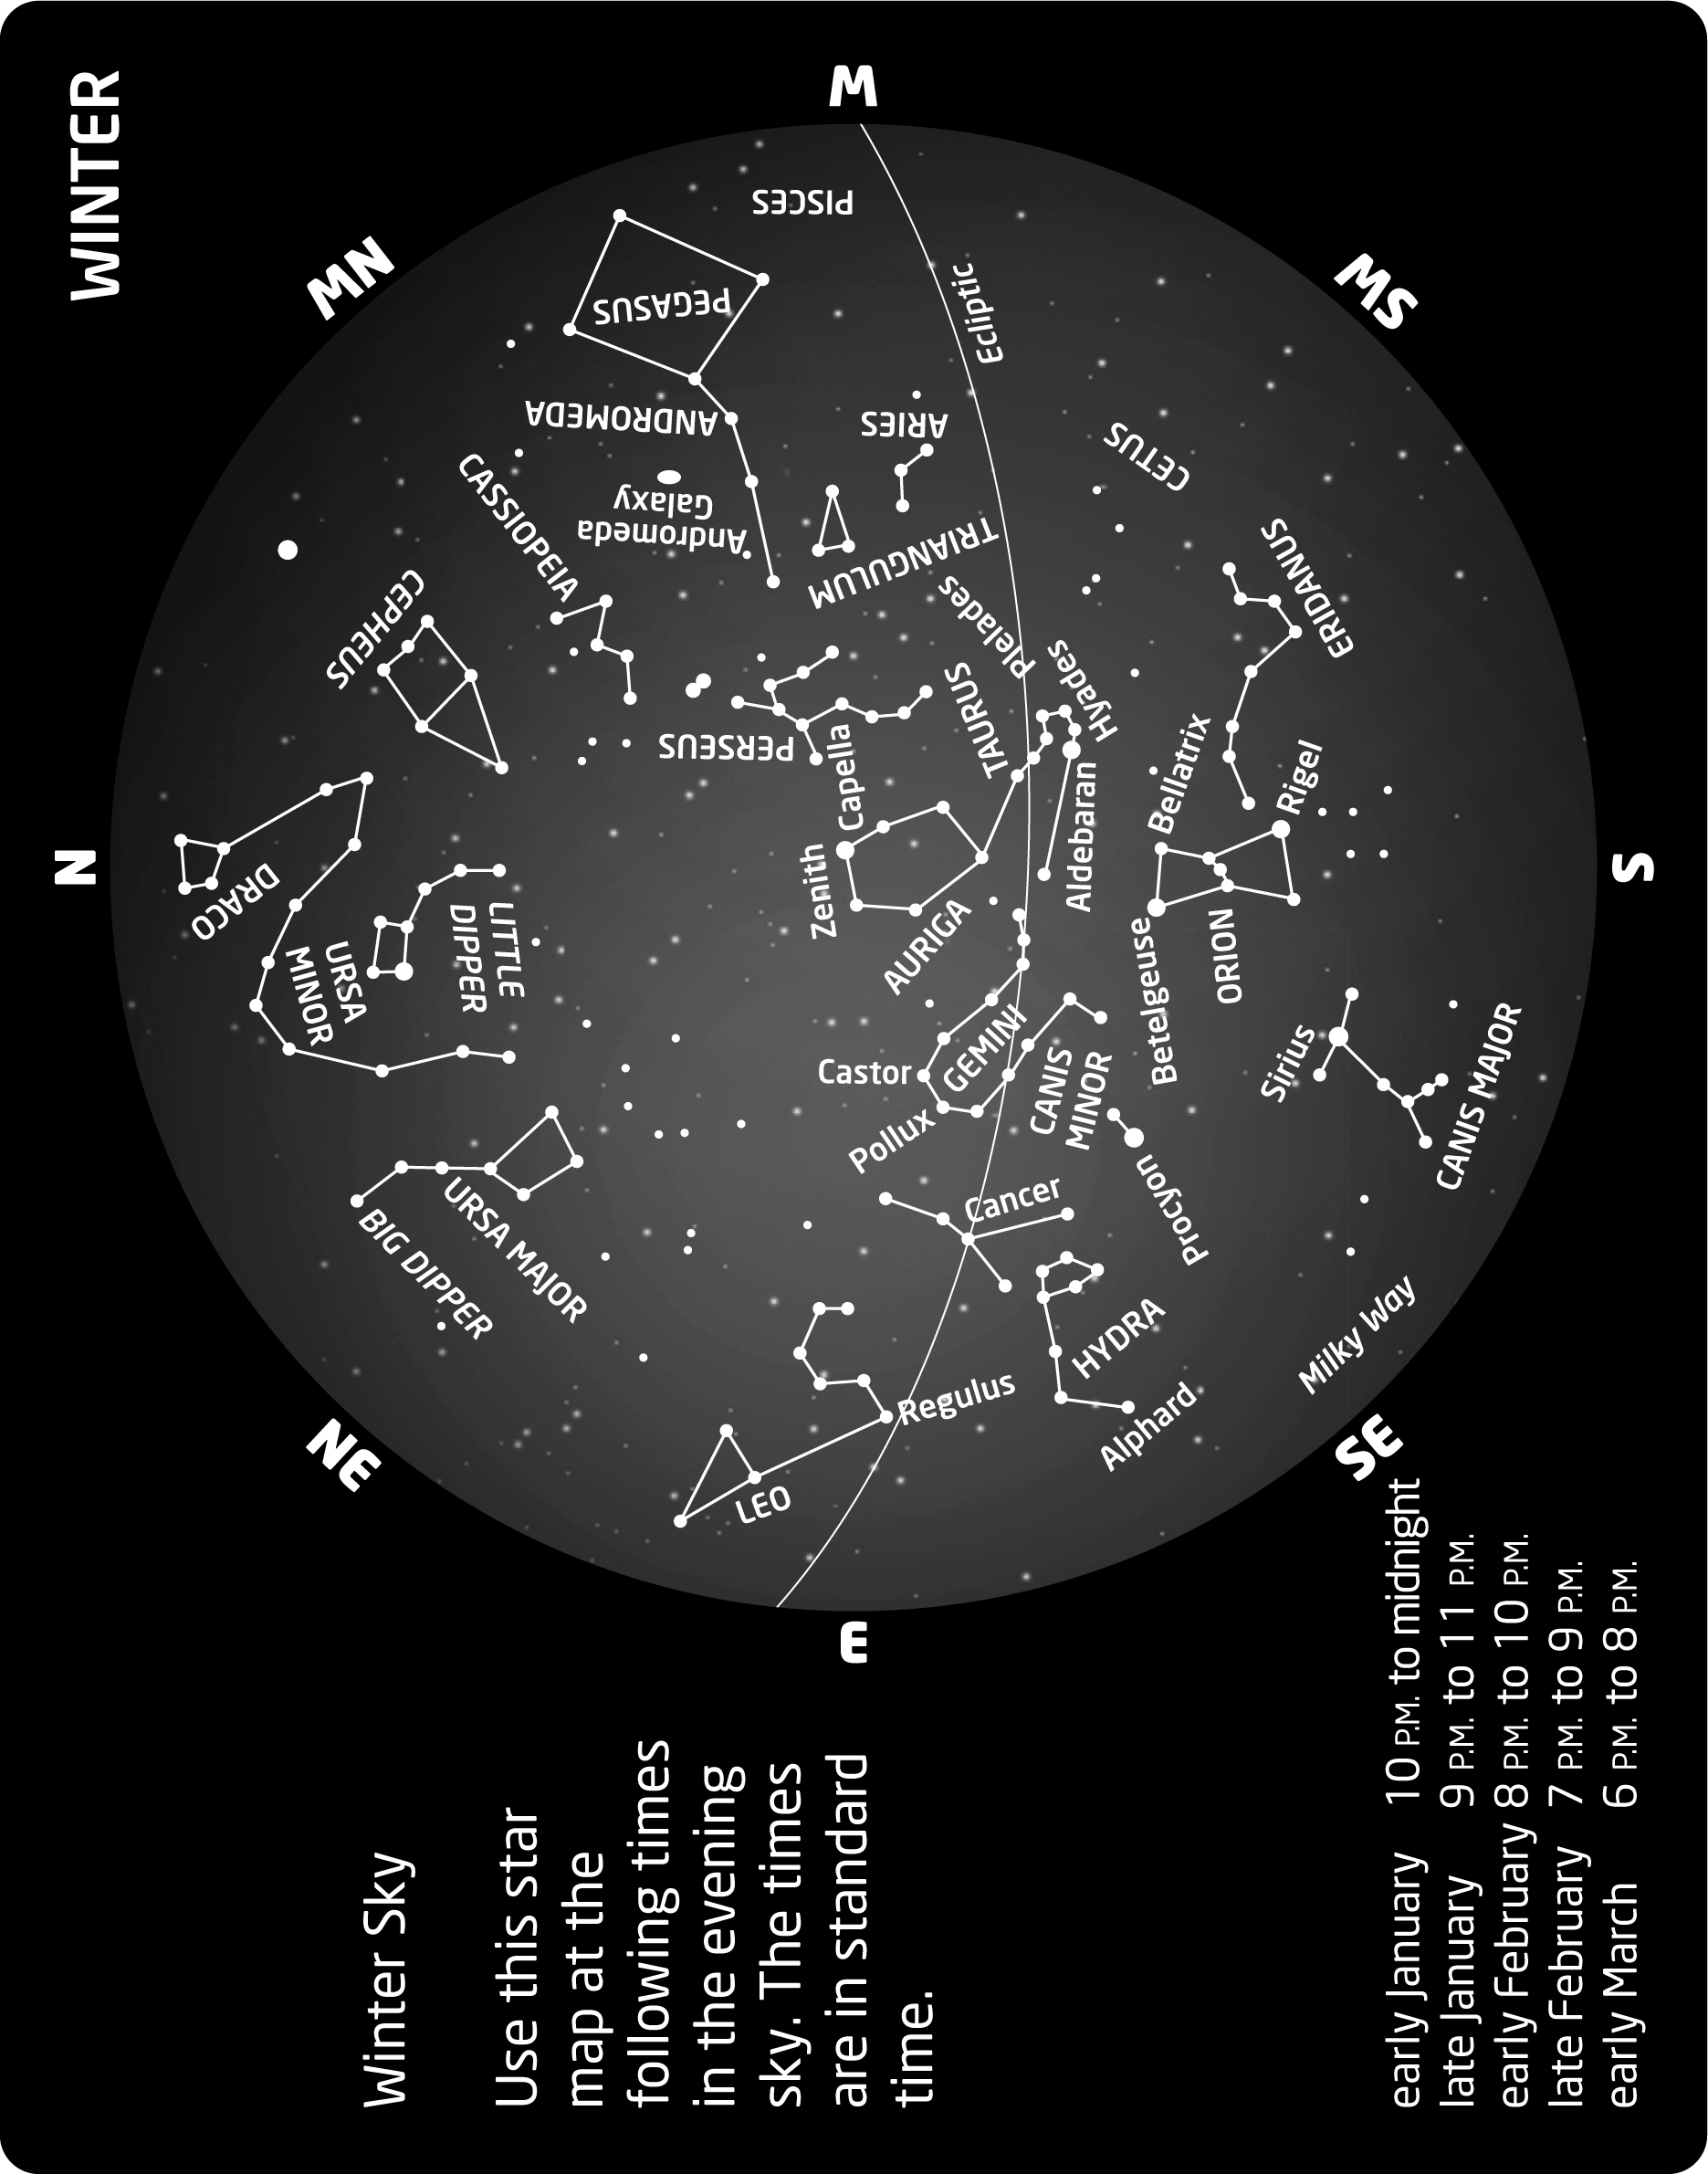
Date: Name: Class:
GENERAL | Star Maps for Fall, Winter, Spring | BLM G-41
Reference | Star Maps for Fall, Winter, Spring | (continued)
