Date: Name: Class:
GENERAL | Unit 3 Connect to the Big Ideas Answers | BLM G-45
Big Ideas | Unit 3 Connect to the Big Ideas Answers

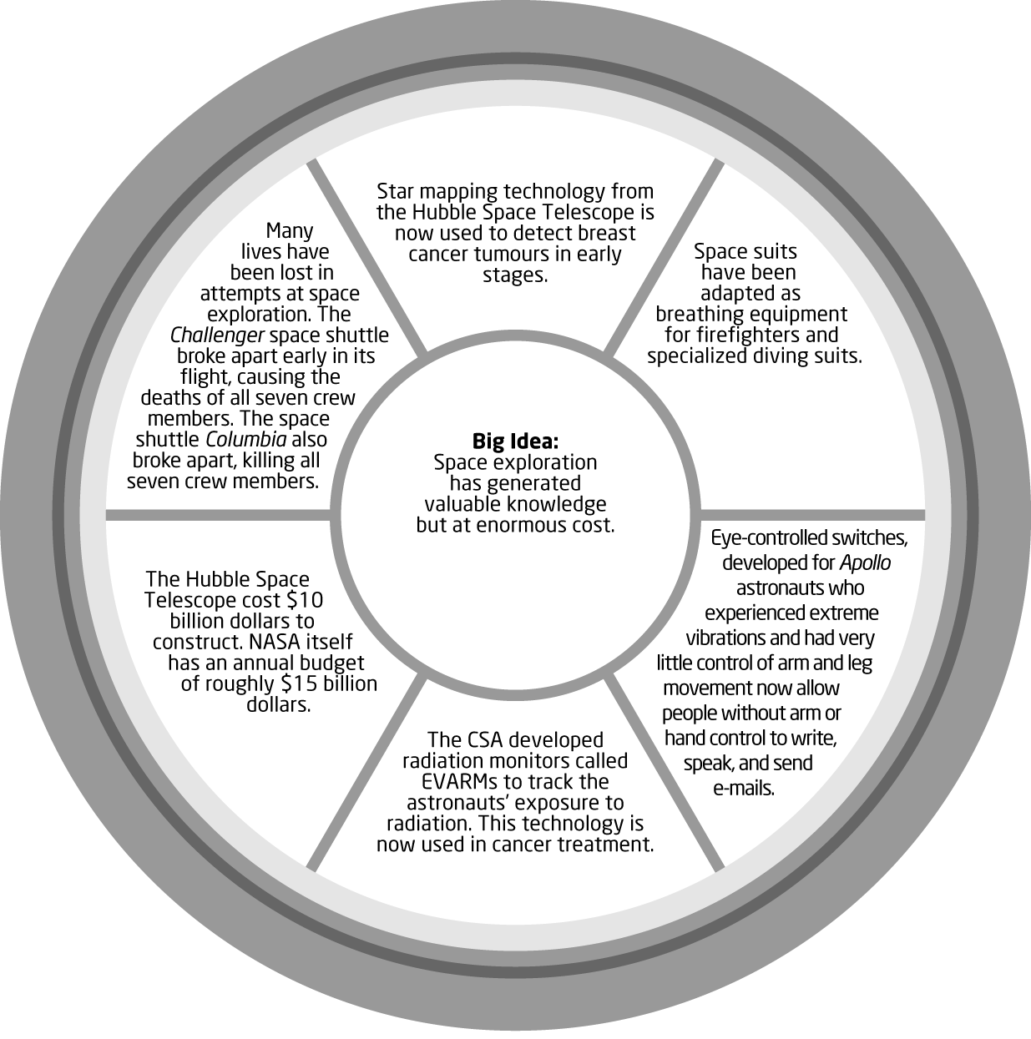
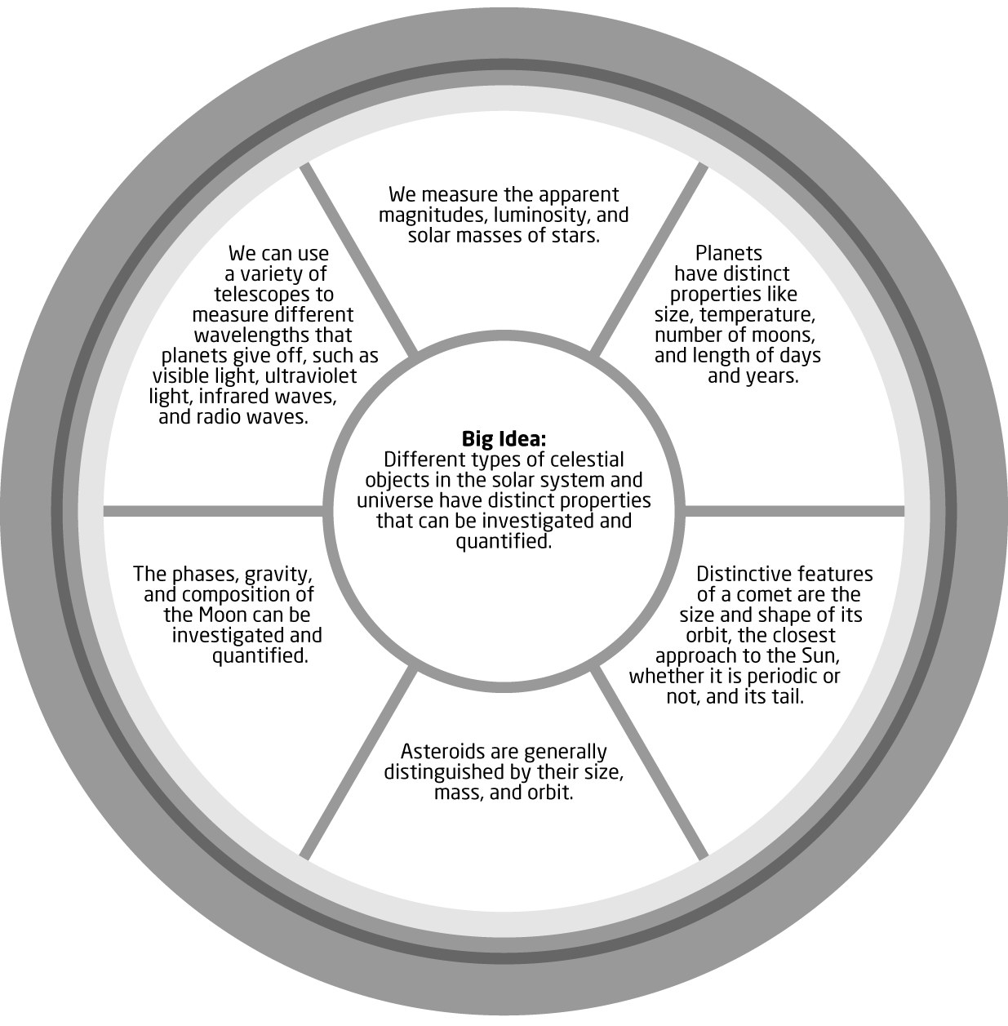
Date: Name: Class:
GENERAL | Unit 3 Connect to the Big Ideas Answers | BLM G-45
Big Ideas | Unit 3 Connect to the Big Ideas Answers | (continued)

