Date: Name: Class:
GENERAL | Unit 4 Connect to the Big Ideas Answers | BLM G-46
Big Ideas | Unit 4 Connect to the Big Ideas Answers
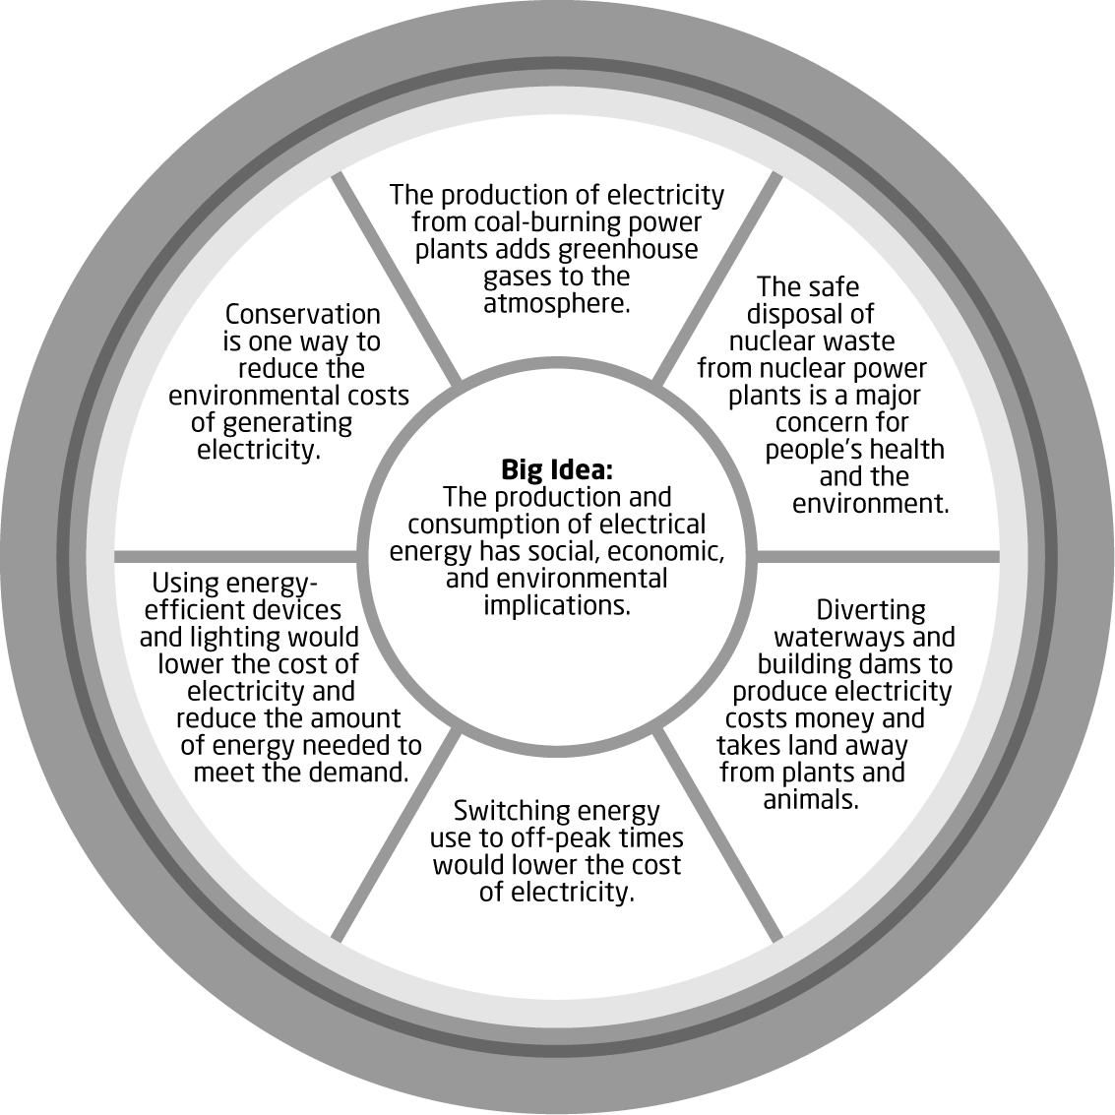
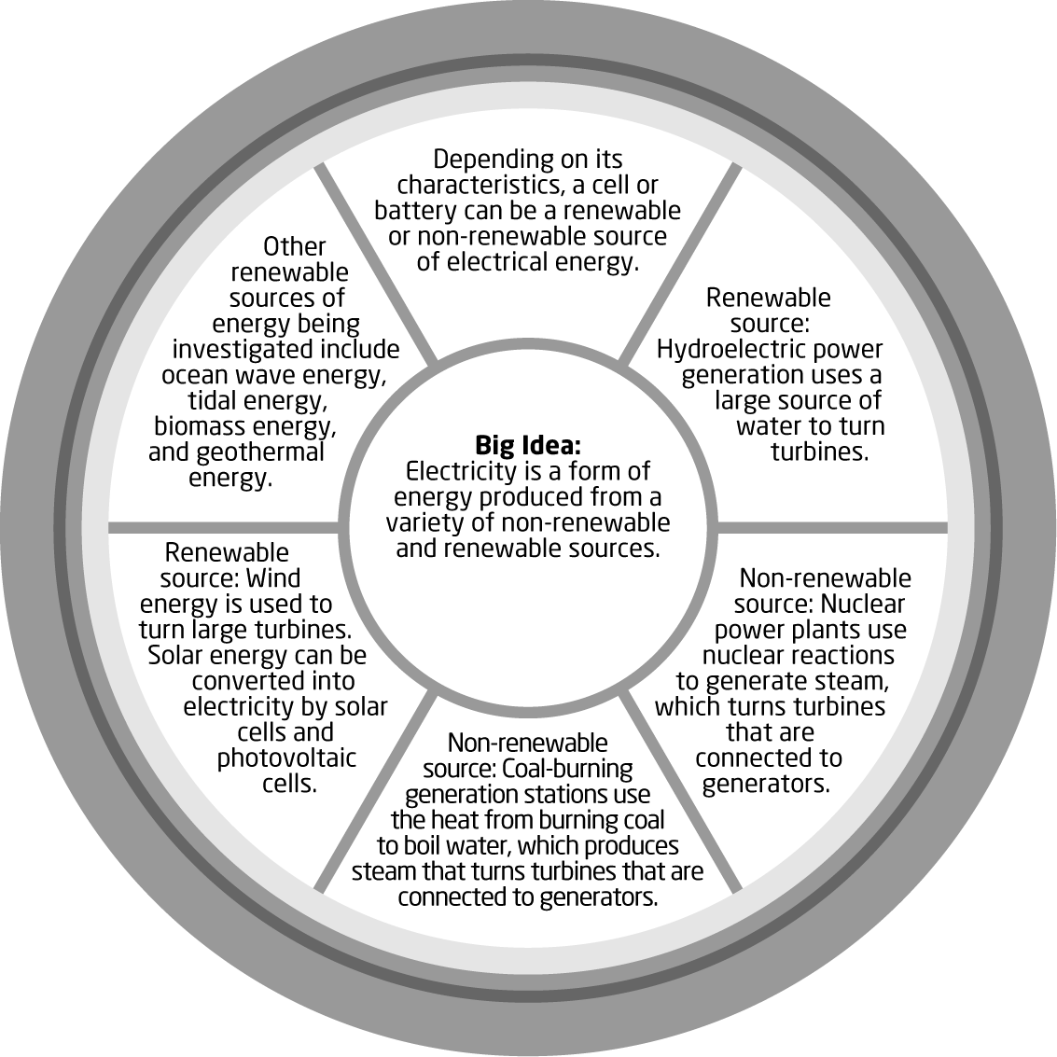
Date: Name: Class:
GENERAL | Unit 4 Connect to the Big Ideas Answers | BLM G-46
Big Ideas | Unit 4 Connect to the Big Ideas Answers | (continued)
