Date: Name: Class:
GENERAL | WHMIS Symbol Cards | BLM G-3
SAFETY | WHMIS Symbol Cards

Goal • Use these cards to play a card game to learn the meanings of the WHMIS symbols.
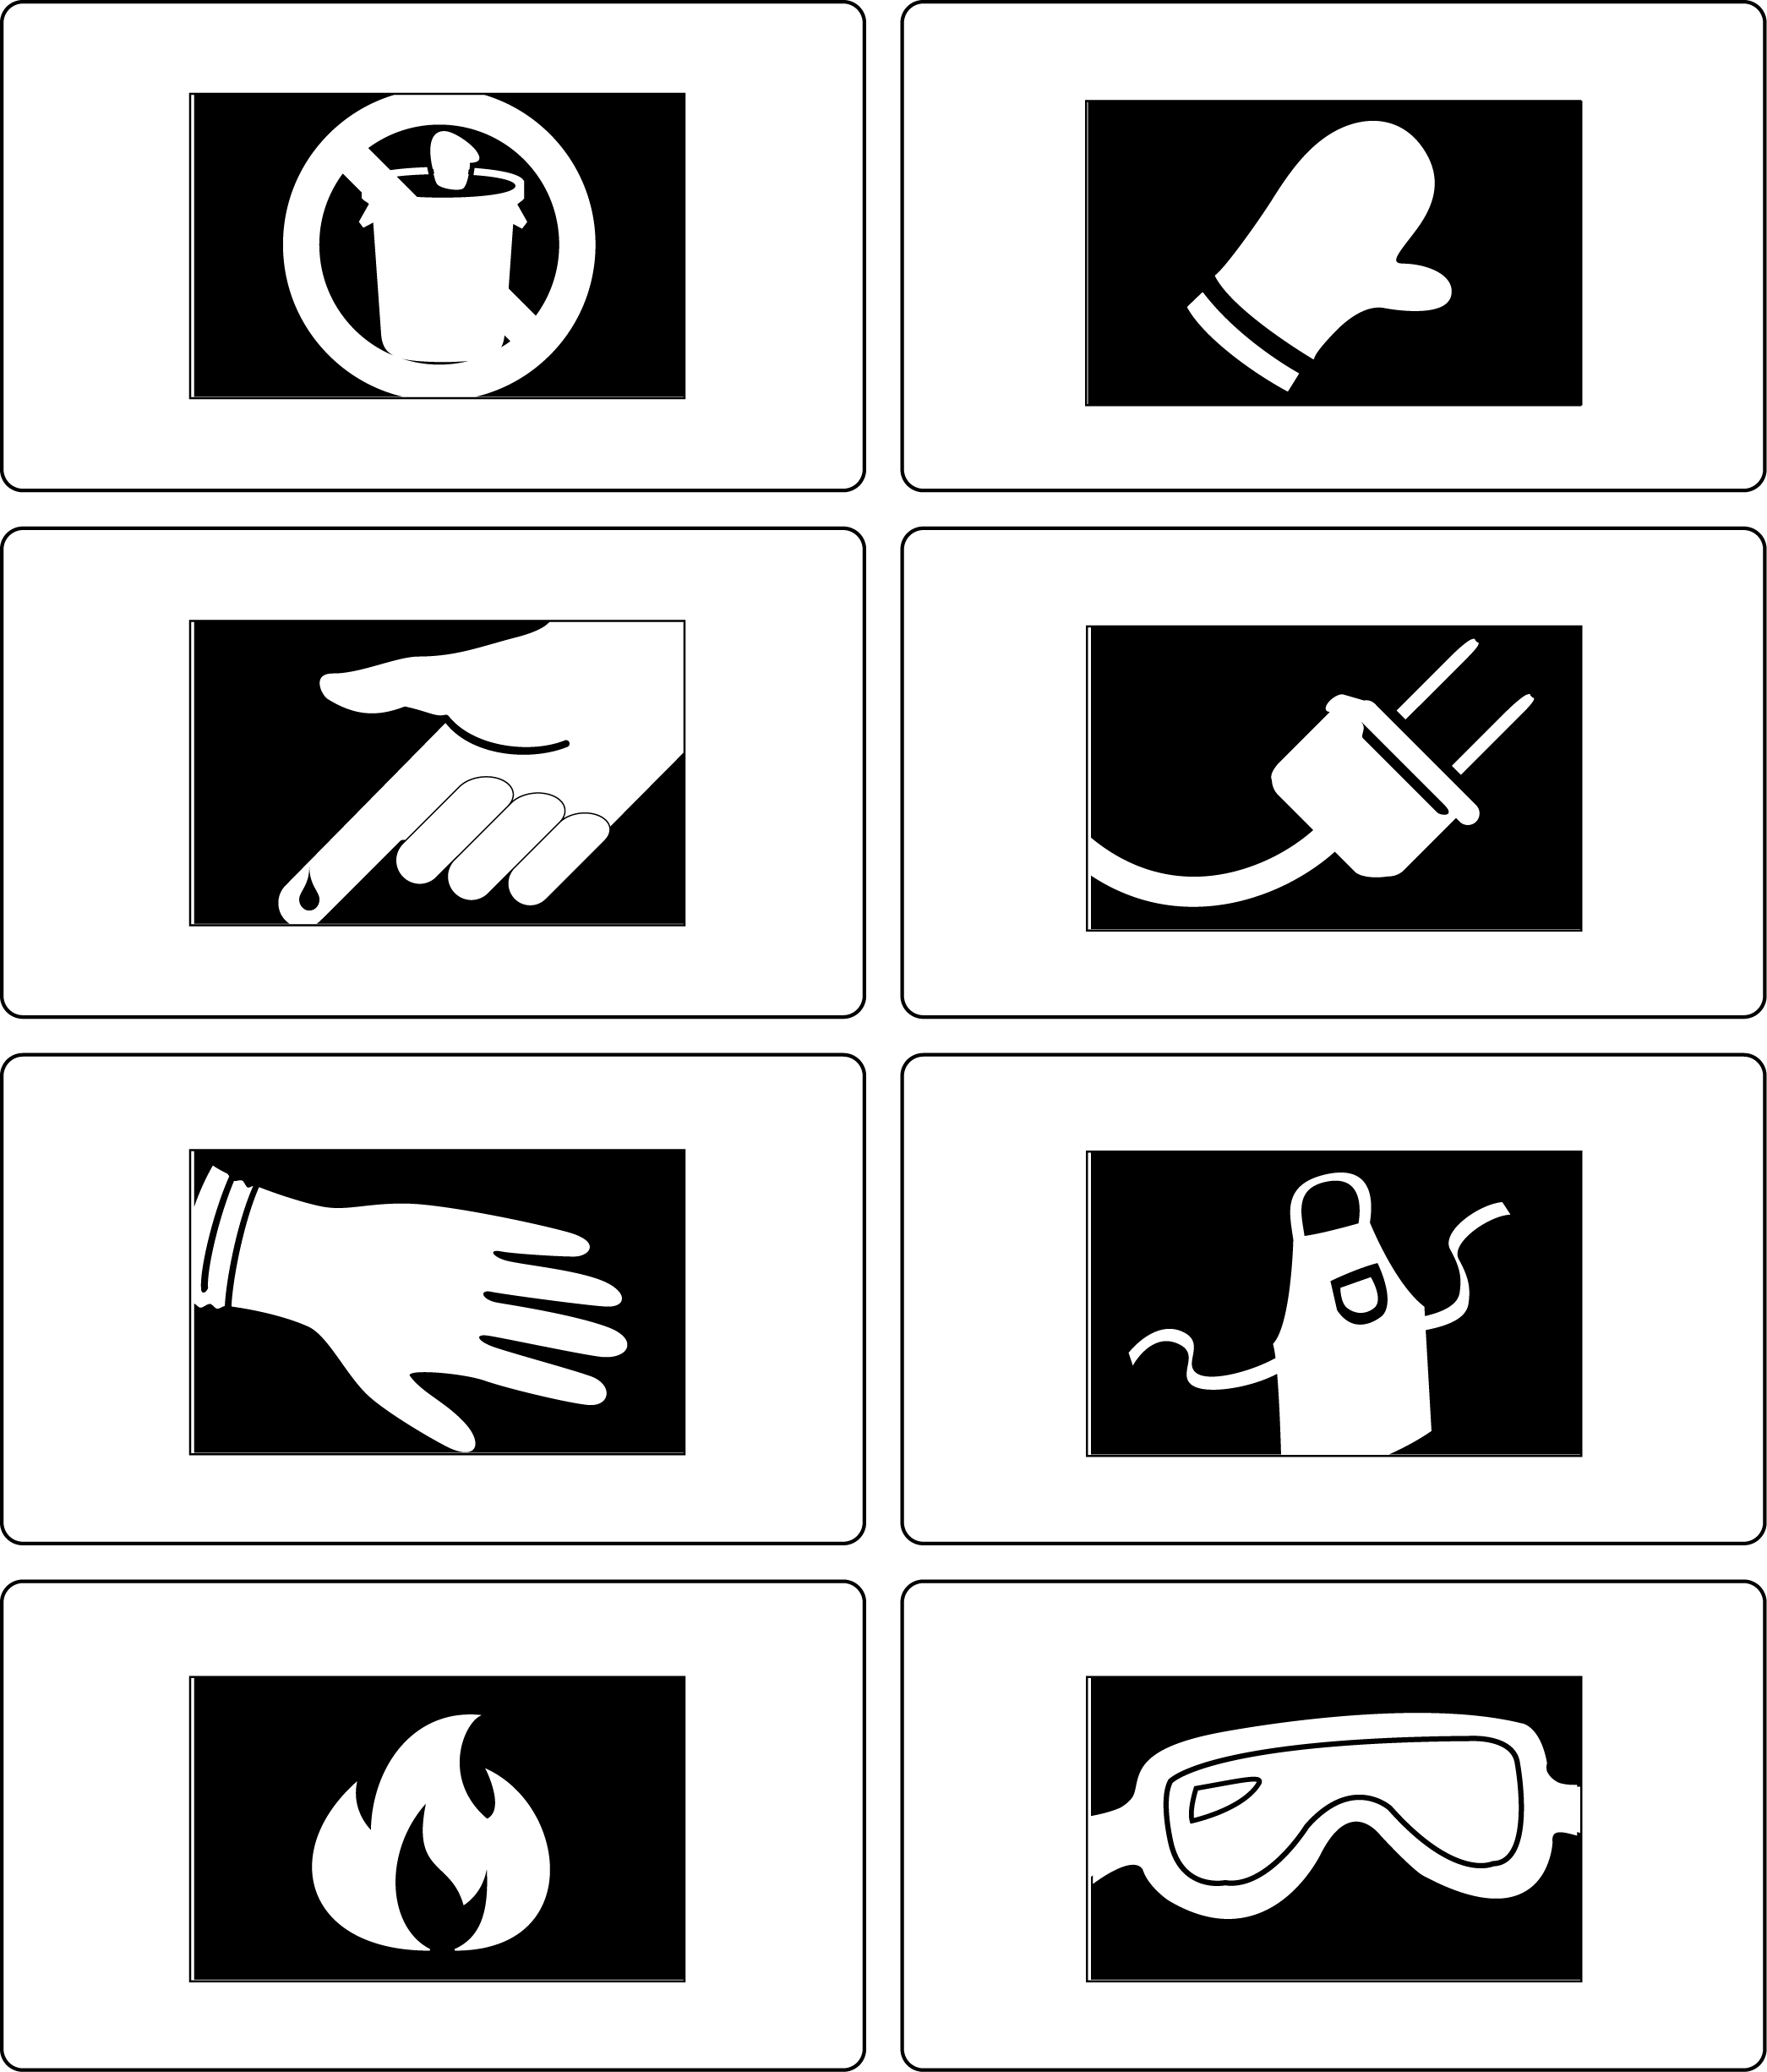
Date: Name: Class:
GENERAL | WHMIS Symbol Cards | BLM G-3
SAFETY | WHMIS Symbol Cards | (continued)
