Date: Name: Class:
GENERAL | Science Inquiry Organizer | BLM G-6
SCIENCE inquiry | Science Inquiry Organizer

Goal • Understand and follow the steps in a science inquiry.
Introduction
When investigating a science inquiry, scientists follow a systematic procedure. When you follow orderly steps, you are able to explain to people how you reached your conclusions.
What to Do
• Use this outline to help you organize your notes on a science inquiry you conduct by yourself.
Outline

Topic:
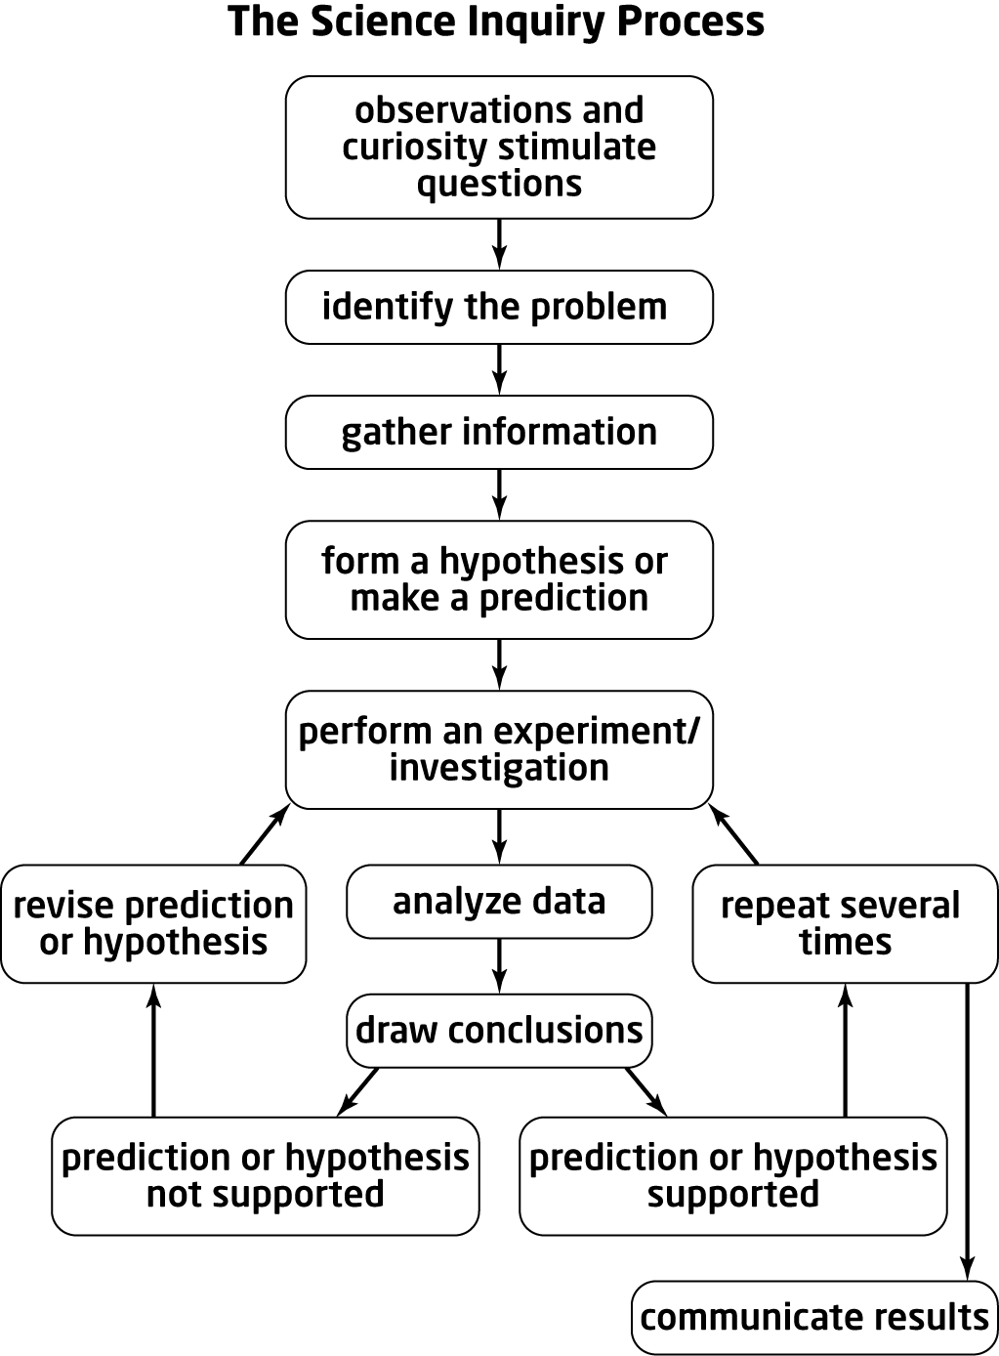 | Think about topic of interest.  • What interests me is .  • What I already know about this topic is  .  • What I want to learn about this topic is  .  • The problem I can explore is .  • Where I can look for more information is  .  • I can explore this problem further by  . (Experiment? Interviews? Research?)  • The hypothesis for this inquiry is .  • The equipment and materials I will need to include are .  • I will record my findings by .  (Notes? Graphs? Tables? Charts?)  • When I will review my inquiry design:  .  • When I might revise my hypothesis: .  • Why I might change my design: .  • How I might adjust my design: .  • How I can pace my work to meet due dates:  .  • How I will communicate my findings:  .  (Write-up? Oral presentation? Model? Display?)

