Date: Name: Class:
GENERAL | Technological Problem-Solving Organizer | BLM G-10
TEchnological  problem solving | Technological Problem-Solving Organizer

Goal • Plan and design technological solutions to problems.
Introduction
Technological problems are best solved through a step-by-step process. Consider the process in the flow chart before building a useful product or carrying out an improved technique.
What to Do
• Use the flowchart below to help you develop a design for a technological solution to a problem.
• Use the question to help you introduce your idea to an audience
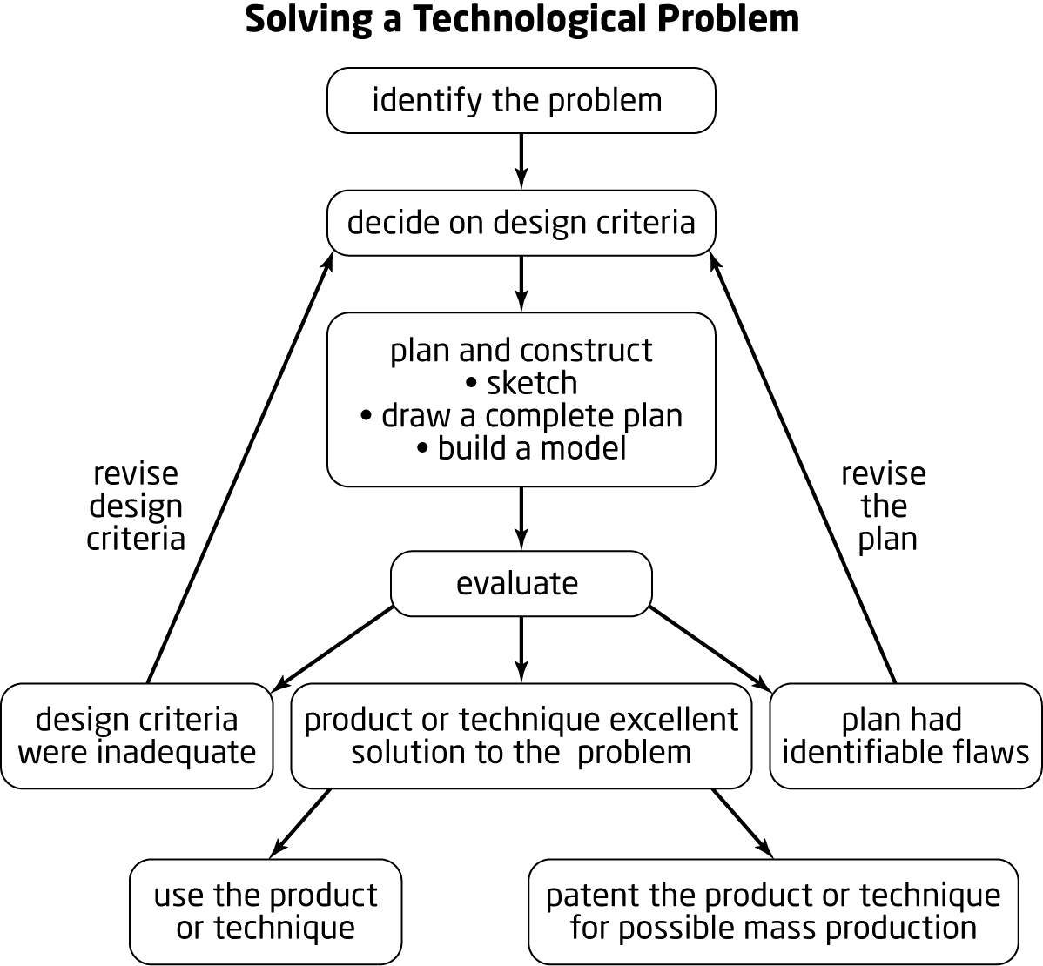 | State the problem to be solved.  • Area or topic:  • Key words for research:  Develop design criteria:  • Materials needed  • Cost of materials  • Time required (for each step)  • Account for design adjustment(s)  Plan and build working model:  • Sketch with estimates  • Blueprints with specifications  • Construction criteria (i.e., safety, space, testing)  Evaluation:  • Adjustments, if flaws found  • Repeated testing, if design works  • Suggest uses
Question
You have been asked to speak to a group of citizens concerned about the problem your proposal is designed to solve. Draft a fact sheet for them describing the uses of your design. You may include
a sketch and offer to demonstrate your model. Include any safety, ethical, and special social considerations related to the model.

