Date: Name: Class:
GENERAL | Circuit Symbols | BLM G-19

Goal • Learn to understand and draw circuit symbols.
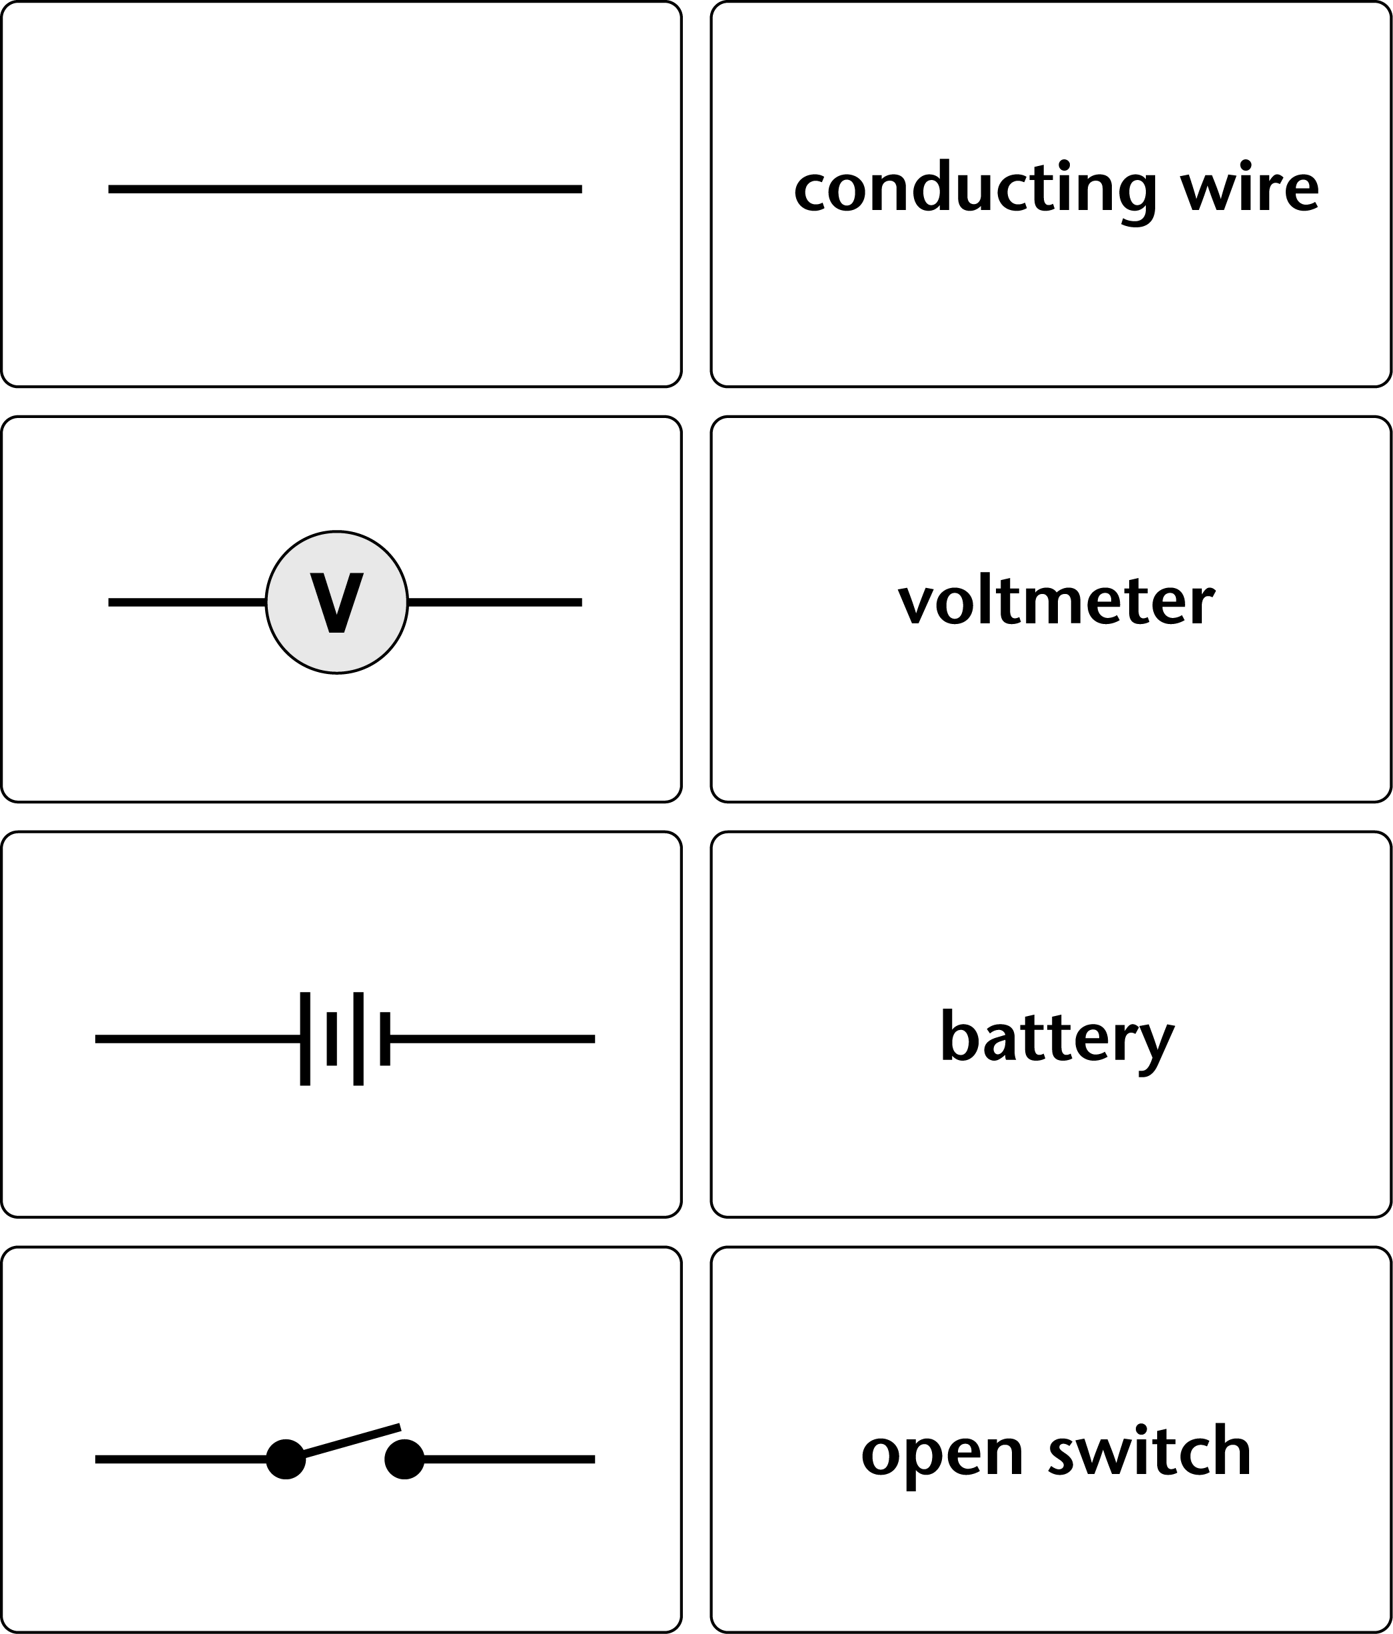
Date: Name: Class:
GENERAL | Circuit Symbols | BLM G-19
