Date: Name: Class:
GENERAL | Constructing a Line Graph | BLM G-25
science inquiry | Constructing a Line Graph

Goal • Practise developing line graphs with a step-by-step process.
Introduction
Every graph has two sides or axes. The horizontal side shows the units for the independent variable
(or cause). It is called the x-axis. The vertical side, shows the units for the dependent variable (or effect). It is called the y-axis.
Each axis of a line graph shows the units of measurement on a consistent scale. The two axes do not have to have the same scale.
The units along each axis should start with 0 and increase uniformly—for example, in multiples of 1, 2, 5, or 10. Choose a scale that will allow you to plot all your data on the graph and that produces a graph that is large enough to read easily.
What to Do
• Follow the steps provided to construct a line graph with Data Set #1.
• Draw another line on your graph using Data Set #2.
Data Set #1
A cyclist races for 20 s. The cyclist’s distance is measured at 4 s, and then after every 2 s.
Time | Distance Travelled
4 s | 10 m
6 s | 19 m
8 s | 27 m
10 s | 35 m
12 s | 42 m
14 s | 48 m
16 s | 53 m
18 s | 61 m
20 s | 70 m
Steps
1. Your graph should show the relationship between time and the total distance the cyclist has travelled. Identify which factor from Data Set #1 is the independent variable (x-axis) and which is the dependent variable (y-axis).
 | a. time in seconds |  | axis
 | b. distance travelled in metres |  | axis
Date: Name: Class:
GENERAL |  | Constructing a Line Graph |  | BLM G-25
science inquiry
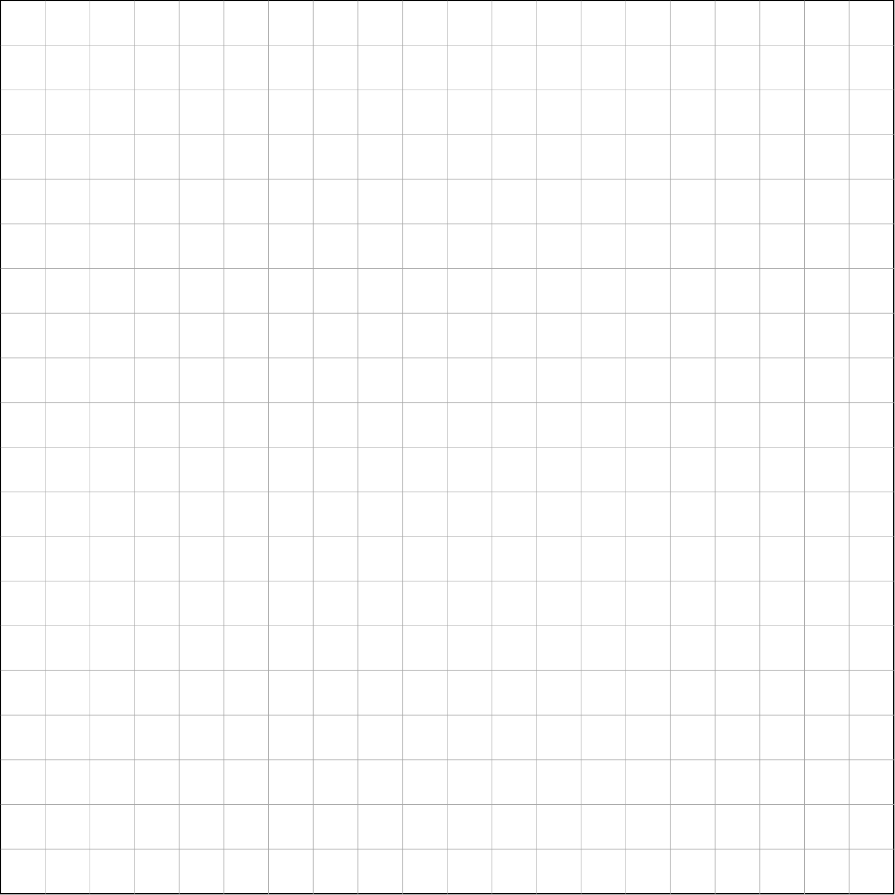
2. Draw and label the x- and y-axes. Label each axis with an accurate title, including the name of the variable and the unit of measurement.
3. Select a suitable scale and label the axes.
4. Plot the data on your line graph using a dot surrounded by a small circle for each point.
5. When all the data points have been plotted, draw a line through most of the points to show the pattern formed by the data. The line does not have to pass through every data point, but there should be the same number of data points above and below the line. This is called the “line of best fit”.
6. Repeat steps 4 and 5 for the information from Data Set #2 (below). Use a coloured pencil and coloured line for this set of data.
Data Set #2
Time | Distance Travelled
4 s | 12 m
6 s | 22 m
8 s | 30 m
10 s | 38 m
12 s | 45 m
14 s | 45 m
16 s | 59 m
18 s | 64 m
20 s | 70 m

7. Add a legend for the two lines. Give your graph a title.

