Date: Name: Class:
GENERAL | Metric Conversions | BLM G-28

Goal • Develop your understanding of the metric system.
What to Do
• Read about the metric system and how to do metric conversions.
• Answer the questions that follow.
The Metric System
• The metric system is based on multiples of 10. Each type of measurement (for example length or mass) has a base unit (for example metres or grams). Larger and smaller units are named by adding a prefix to the base unit.
• For example, the prefix is kilo- means multiplied by 1000, so one kilometre is 1000 metres. The prefix milli- means divided by 1000, so one millimetre is one thousandth of a metre.
• The table shows the most commonly used metric prefixes.
Prefix | Symbol | Relationship to the Base Unit
giga- | G | 10⁹ = 1 000 000 000
mega- | M | 10⁶ = 1 000 000
kilo- | k | 10³ = 1000
hecto- | h | 10² = 100
deca- | da | 10¹ = 10
 |  | 10⁰ = 1
deci- | d | 10⁻¹ = 0.1
centi- | c | 10⁻² = 0.01
milli- | m | 10⁻³ = 0.001
micro- | μ | 10⁻⁶ = 0.000 001
nano- | n | 10⁻⁹ = 0.000 000 001

Date: Name: Class:
GENERAL | Metric Conversions | BLM G-28
 | Metric Conversions | (continued)
Converting Metric Units Using Metric Stairs
• You can use metric stairs to covert metric units. To use the stairs, simply start at the level of the original measurement (litre, metre, gram) and move the number up or down the stairs to the unit to which you are converting. Each “jump” up the stairs is the same as dividing by 10. This means you move the decimal place in the measurement one place to the left.
• Look at the example. To convert 3.4 cm to metres, make two jumps up the stairs (you are dividing by 100 (10 × 10)). This is the same as moving the decimal two places to the left, which would make
3.4 cm = 0.034 m.
• To convert 5.2 km to metres, make three jumps down the stairs, the same as multiplying by 1000
(10 × 10 × 10). This is also the same as moving the decimal three places to the right, which would
make 5.2 km = 5200 m.
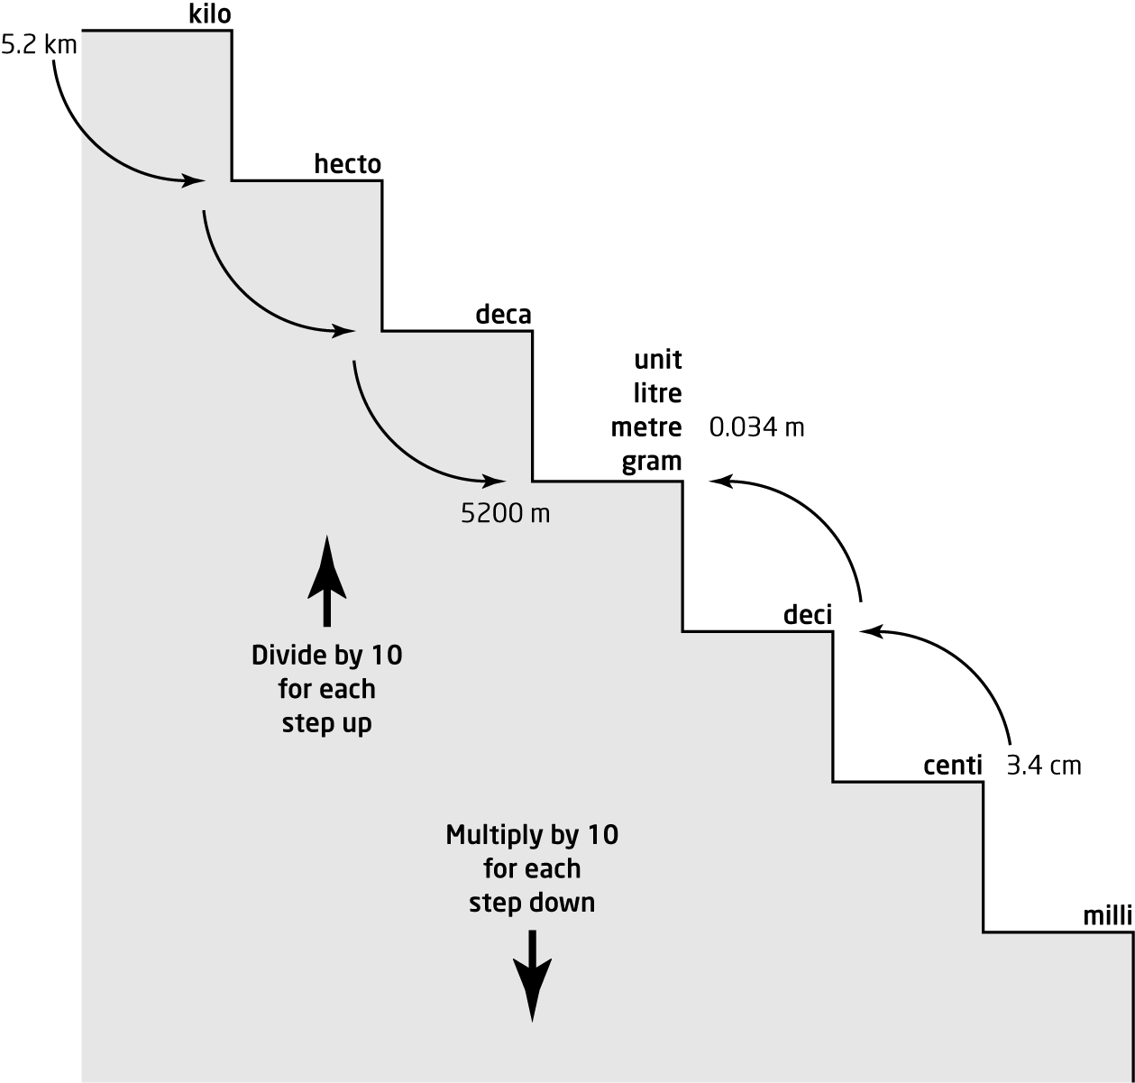
Hint: To remember in which direction to move the decimal, look at the stairs. When you come down the stairs (multiply), you are going to the right, so move the decimal to the right. When you go up the stairs (divide), you are going to the left, so move the decimal to the left.
Date: Name: Class:
GENERAL | Metric Conversions | BLM G-28
 | Metric Conversions | (continued)
Questions
Length
Example 1
Convert 37 m to centimetres.
Solution
Look at the stairs on the previous page. To convert metres to centimetres, jump down two stairs
or multiply by 10 × 10.
37 m = 37 × 10 × 10
= 3700 cm
Example 2
Convert 18 km to metres.
Solution
Look at the stairs on the previous page. To convert kilometres to metres, jump down three stairs
or multiply by 10 × 10 × 10.
18 km = 18 × 10 × 10 × 10
= 18 000 m
Convert each length to the given measurement.
1. 85 cm = _______ m  2. 0.85 km = _______ m  3. 8.5 cm = _______ mm  4. 85 000 dm = _______ m | 5. 0.85 dam = _______ m  6. 2.77 m = _______ dam  7. 0.277 cm = _______ dm  8. 27.7 dam = _______ hm

Date: Name: Class:
GENERAL | Metric Conversions | BLM G-28
 | Metric Conversions | (continued)
Mass
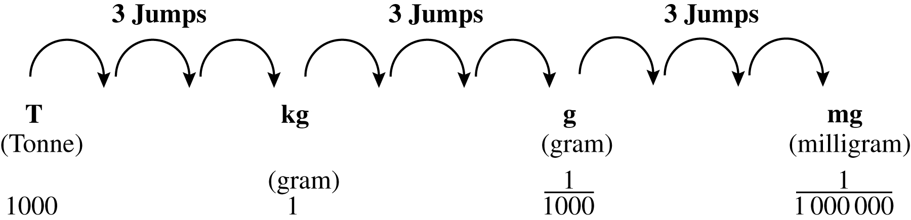
Use the table above or metric stairs to convert each mass to the given units.
9. 8.3 kg = _______ g  10. 830 mg = _______ g | 11. 2.77 hg = _______ g  12. 2700 mg = _______ dg
Capacity
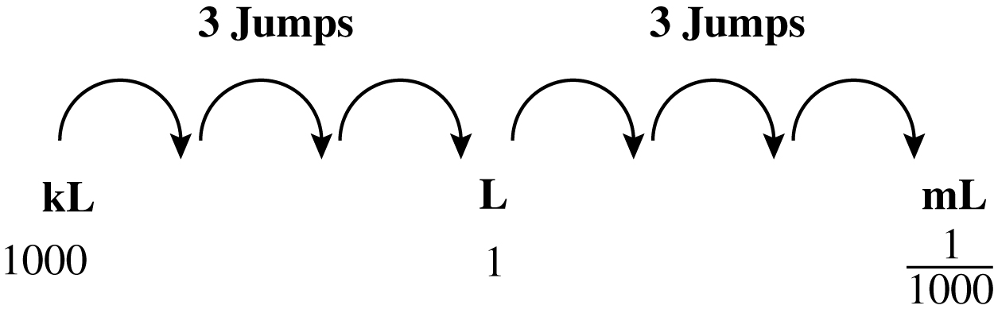
Use the table above or metric stairs to convert each volume to the given unit.
13. 830 ml = _______ L
14. 083 L = ________ mL
15. 8.3 L = ________ mL
16. 83 000 mL = _______ L

