Date: Name: Class:
GENERAL | Star-Finder Wheel Template | BLM G-42

Goal • Use a model of the night sky to find and identify constellations.
Instructions to Make Your Own Star-Finder Wheel
1. Cut along the dashed lines on the Wheel Holder on the second last page. Fold along the dotted lines.
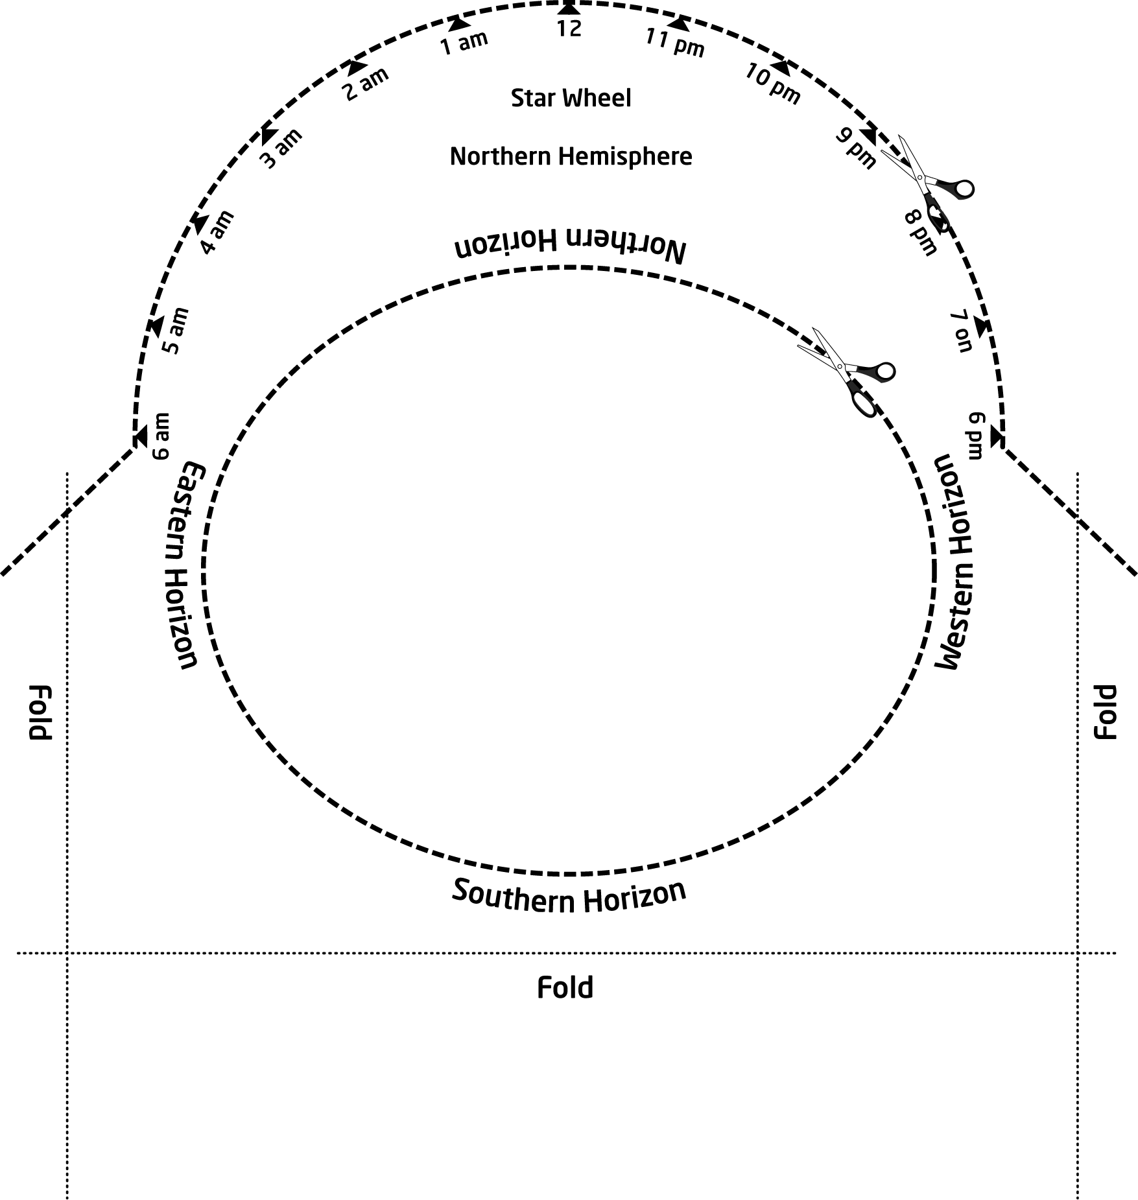
2. Fold up the smaller portion to make a pocket. Fasten the sides with glue, staples, or tape.
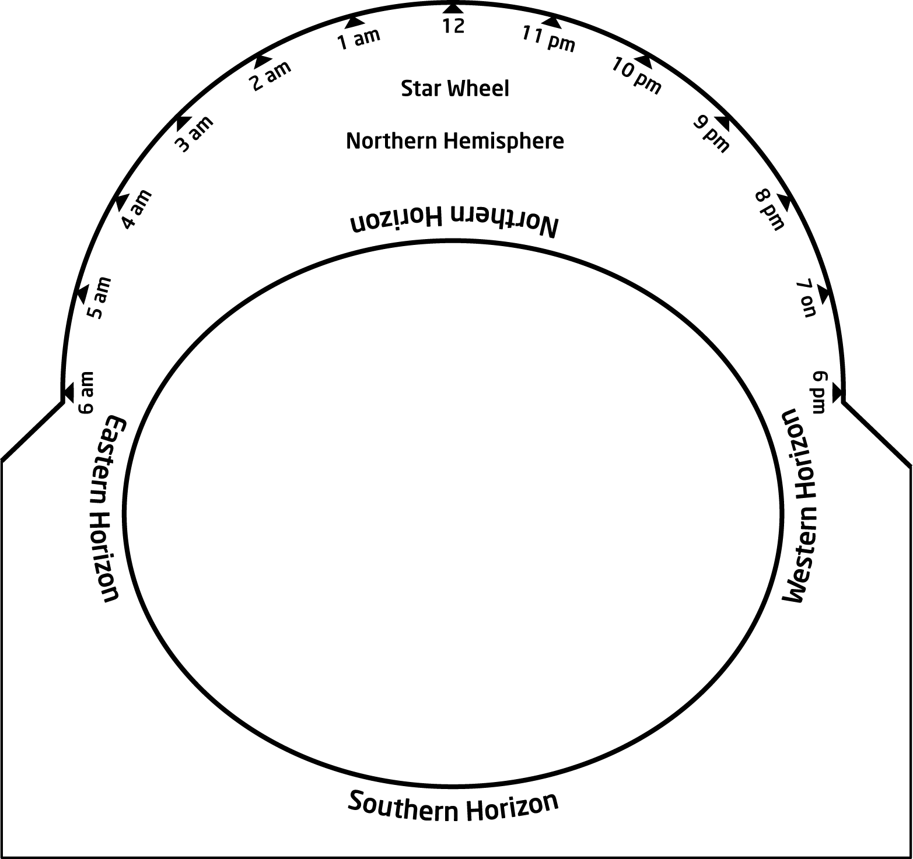

Date: Name: Class:
GENERAL | Star-Finder Wheel Template | BLM G-42
 | Star-Finder Wheel Template | (continued)
3. Cut along the outer dashed line on the Star-Finder Wheel found on the last page. Place the wheel inside the holder.
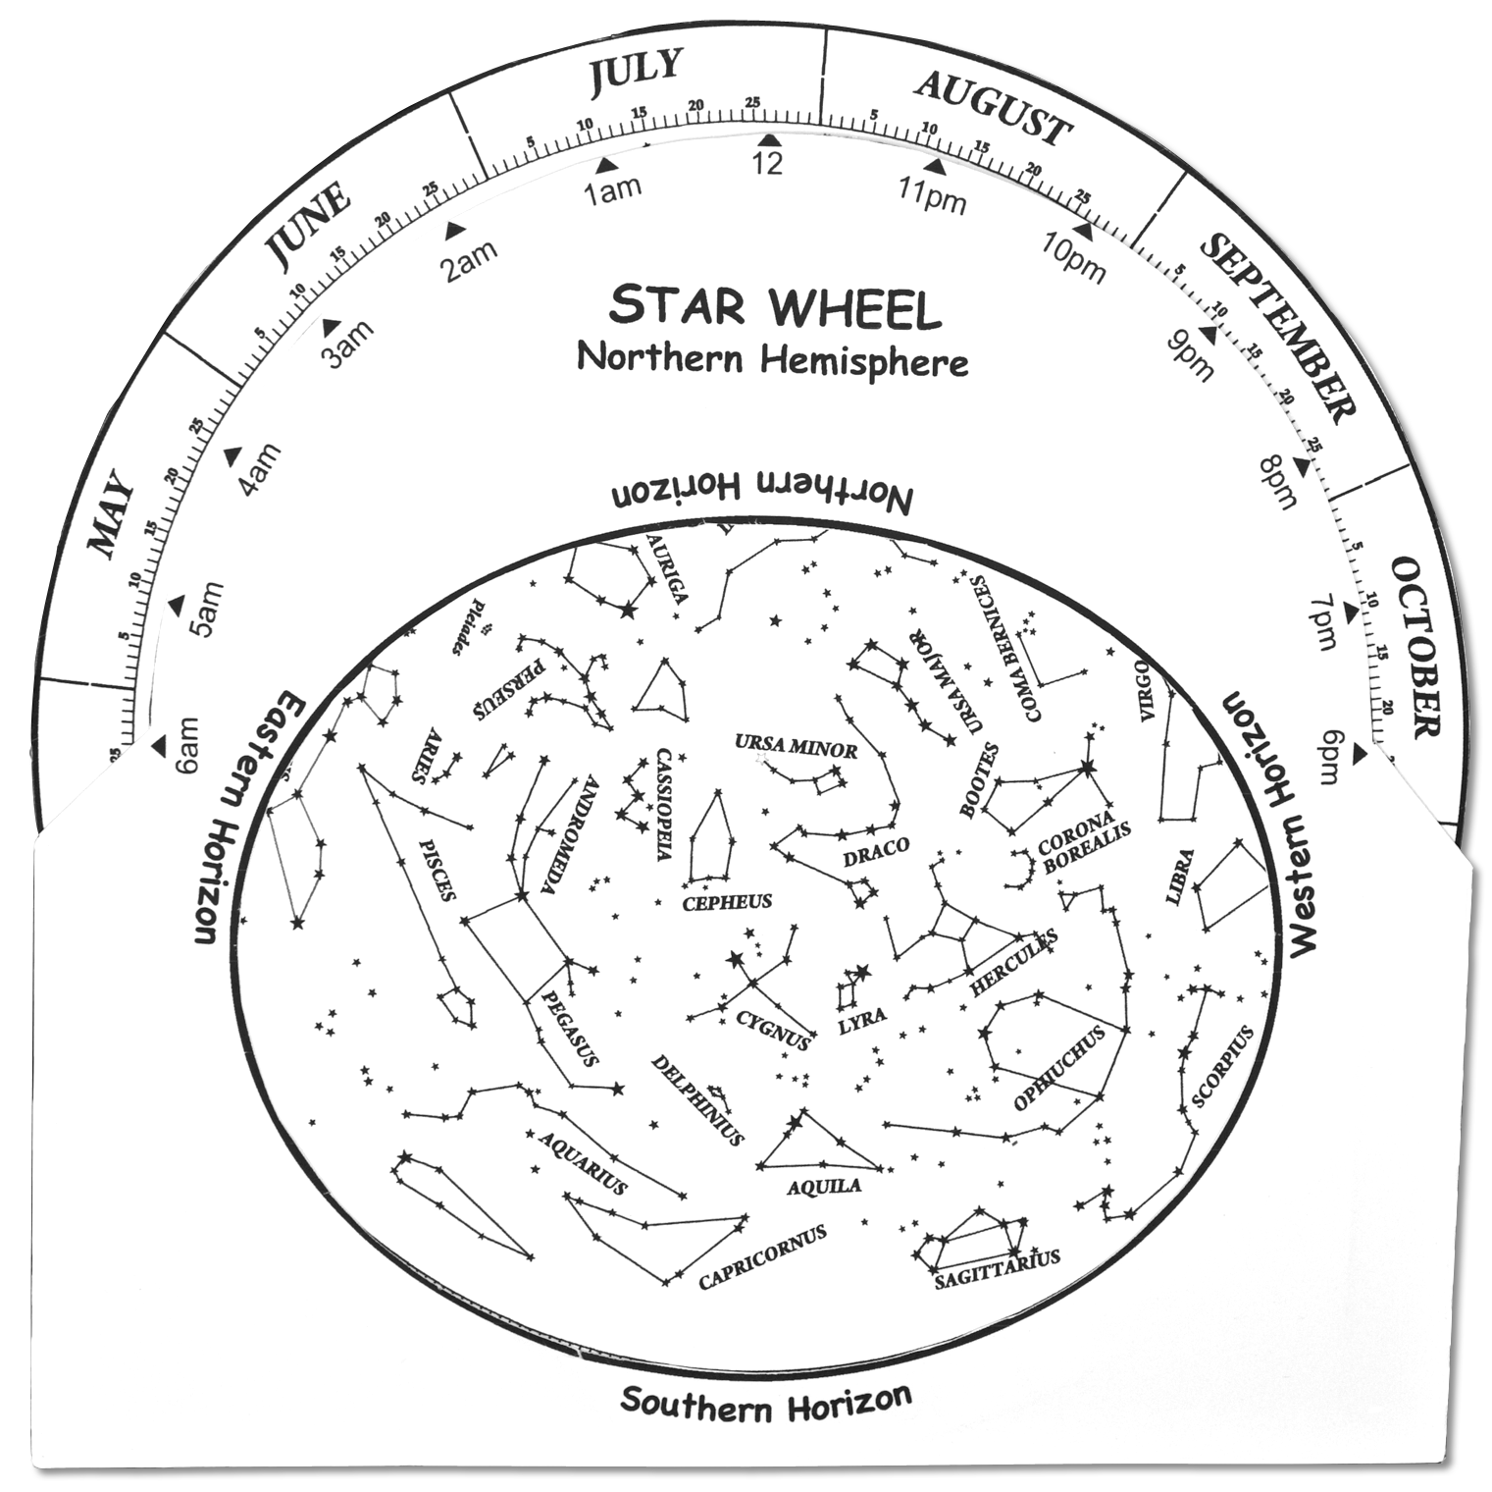
Date: Name: Class:
GENERAL | Star-Finder Wheel Template | BLM G-42
 | Star-Finder Wheel Template | (continued)
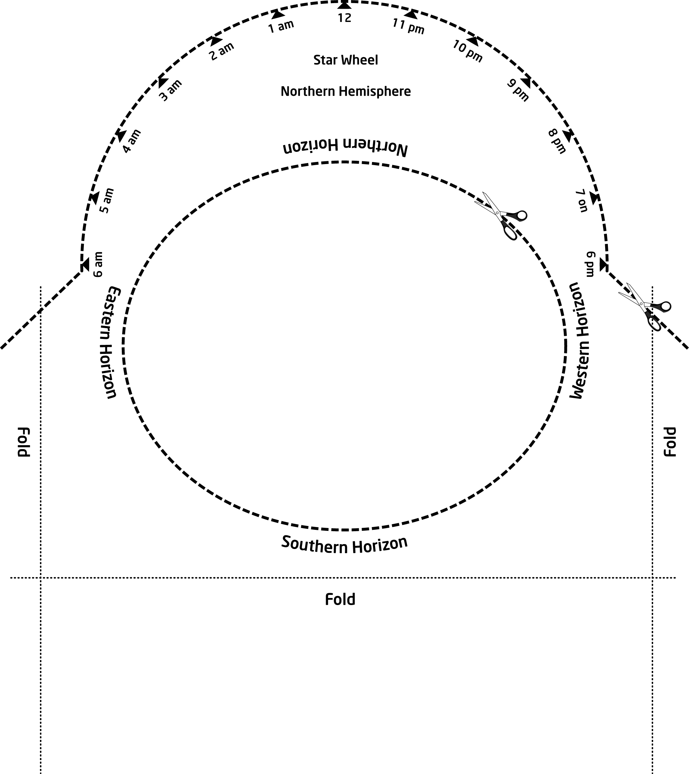
Wheel Holder
Date: Name: Class:
GENERAL
ReferenceStar Maps for Fall, Winter, SpringBLM G-41

Date: Name: Class:
GENERAL | Star-Finder Wheel Template | BLM G-42
 | Star-Finder Wheel Template | (continued)

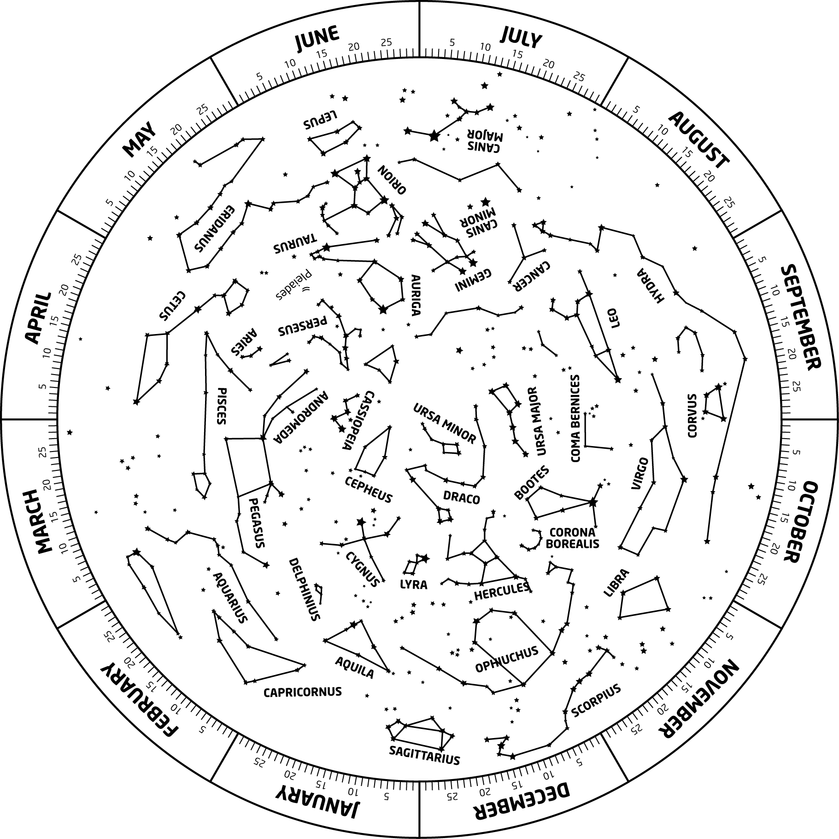
Star-Finder Wheel

