Name: ___________________________________________ Date: _____________________________
BLM 10–1
Chapter 10 Prerequisite Skills

1. Consider the functions f (x) = 2x² − 3x + 1 and g(x) = x³ − 3x² + x + 2. Determine each value.
a) f (−3)
b) g(−1)
c) g(0) + f (0)
d)
e) g(−x)
2. Add the expressions in each pair, and then simplify.
a) 3x − 5 1 − x
b) −2x −4x² + x − 1
c) 5x² − 4x + 3 1 − x − x²
d) x³ − 4x² + 2x 3x³ − 2x + x² − 8
3. Simplify.
a) 2x − (3x − 2)
b) (x − 3) − (x − 5)
c) (2x² − 8x + 7) − (x² − 3x − 1)
d) (−2x² + 3x) − (1 − 2x + 3x²)
4. Suppose you are asked to determine the difference between 2x² − 7x and x² − 4x.
How many answers are possible? Explain.
5. Simplify.
a) x(3x² − x + 1)
b) (4x)(−3x²)
c) (x − 7)(3x − 1)
d) (2x + 1)²
e) (x + 1)(x² − 2x + 3)
f) (x − 2)³
6. State any non-permissible values for x, and then simplify.
a)
b)
c) (2x² − 3x + 1) ÷ (x − 1)
7. Write an equation for each line in
slope–intercept form.
a) slope of 2 and y-intercept of −5
b) slope of −3 and through (−1, 4)
c) through (−2, 1) and (0, −5)
d) through (1, −2) and perpendicular to a line with slope
8. Determine an equation for each parabola in the form y = ax² + bx + c.
a) A parabola with x-intercepts −3 and 2.
b) A parabola that opens downward and passes through (1, 0).
9. Consider the graph of y = x³ − 3x² + 2x.
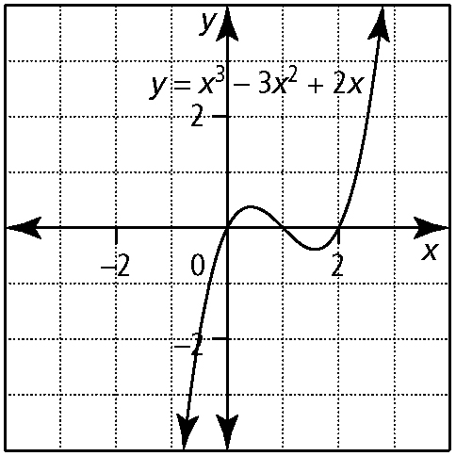
a) What are the x-intercepts?
b) What are the domain and range?
10. If x + 2 is a factor of the function
p(x) = x³ − x² − 10x − 8, then p(x) can be written in the form (x + 2)(ax² + bx + c).
a) Determine the values of a, b, and c.
b) Write p(x) as the product of 3 factors.

Name: ___________________________________________ Date: _____________________________
BLM 10–1
(continued)

11. Describe the transformation on Graph A that results in Graph B.
a) Graph A
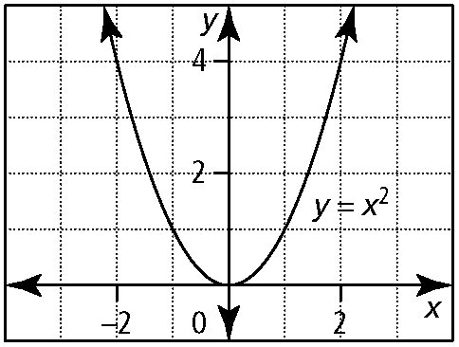
Graph B
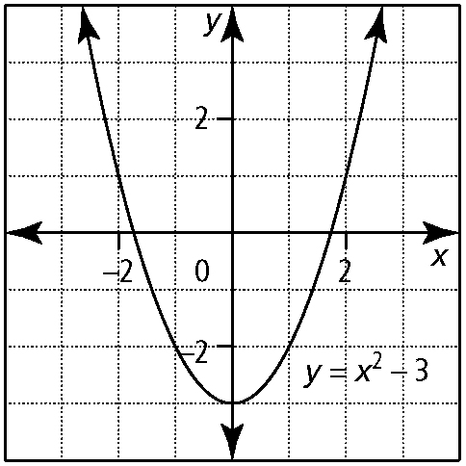
b) Graph A
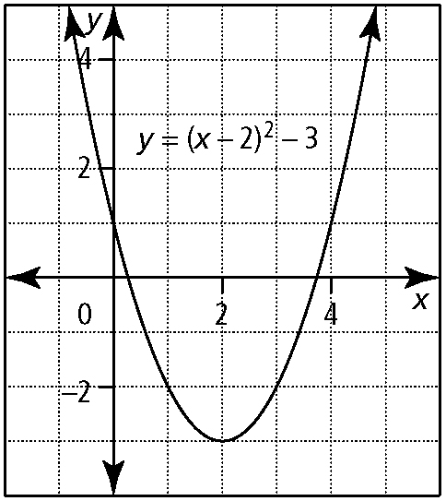
Graph B
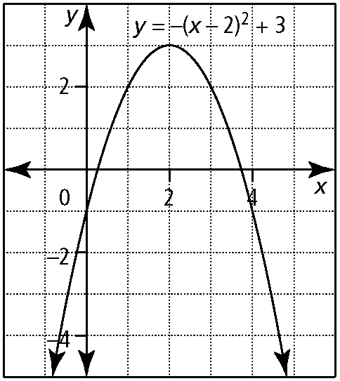
c) Graph A
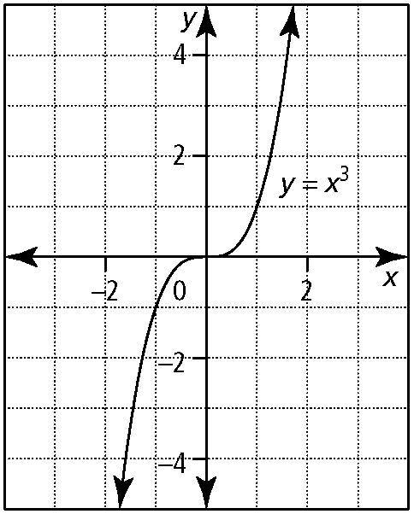
Graph B
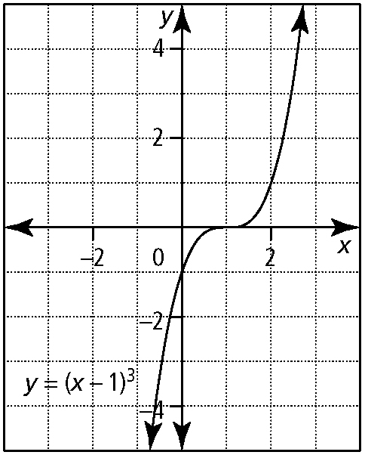
12. Refer to #11. Let y = f (x) represent
Graph A. Write an equation for Graph B.

