Name: ___________________________________________ Date: _____________________________
BLM 11–1
Chapter 11 Prerequisite Skills

1. Evaluate each expression.
a) when x = 5, y = 2, and z = −1
b) when n = 3
c) when n = 5
d)when n = 6
2. Write down six consecutive natural numbers.
a) Find the product of the first and sixth numbers.
b) Find the product of the second and fifth numbers.
c) Do this for other sets of six consecutive natural numbers. What pattern do you notice?
3. Let n be the first of six consecutive natural numbers.
a) Write expressions for the other five consecutive numbers.
b) Find the product of the first and sixth numbers, and for the second and fifth numbers.
c) Use algebra to help explain one pattern you found in part a).
4. Simplify each rational expression.
a)
b)
c)
5. Determine consecutive integers that satisfy the following:
a) two integers with a product of 30
b) two integers with a product of 72
c) two positive integers with a product of 56
d) three positive integers with a product
of 210
e) three integers with a product of 60
6. Consider a grid having the dimensions shown.
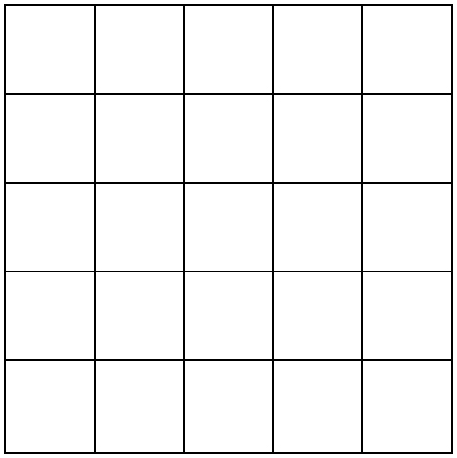

a) How many 1 by 1 squares are in the diagram?
b) How many different 2 by 2 squares are in the diagram?
c) What is the total number of squares in the diagram?
7. Use a table to identify all the possibilities for each of the following:
a) What 2-digit numbers can be made from
2, 4, and 6?
b) You have several, nickels, dimes, and quarters in a bag. How many different sets of 3 coins can be drawn from the bag? Return the selected coin after each draw.
8. Create tree diagrams to show all the possibilities for each part in #7.
9. The diagrams show magic squares in which the sum of the numbers in any row, column, or diagonal is the same. If each digit can be used once only, determine the value of x in each square.
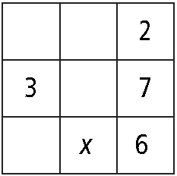
a)

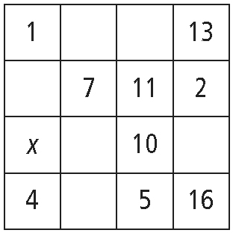
b)

Name: ___________________________________________ Date: _____________________________
BLM 11–1
(continued)

10. Other than 1 and 3, all odd numbers less than 100 can be written in the form a + 2^{n}, where a is a prime number and n ∈ N. Write each odd number in the form a + 2^{n}.
a) 23
b) 57
c) 81
d) 5
11. Solve each equation algebraically.
a) x² + 2x = 15
b) 6x² = 11x – 3
c) x³ + 4x² + x – 6 = 0
12. Solve each equation graphically.
a) x² – 3x – 4 = 0
b) (x – 3)(x – 4) = 6
c) x³ + 4x² + x – 6 = 0

13. a) Write expressions in terms of x for the angles labelled a and b.
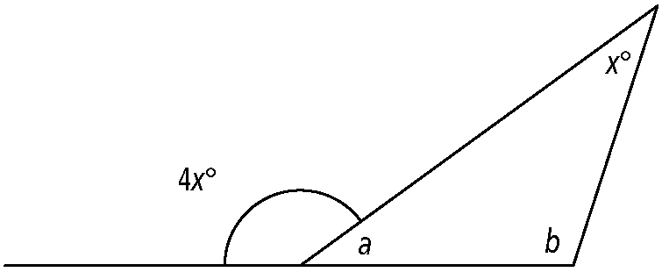

b) Is it possible to determine x as a real number using the given information and your knowledge of geometry? Explain.

