Name: ___________________________________________ Date: _____________________________
BLM 2–1
Chapter 2 Prerequisite Skills

1. Express each power as an equivalent radical.
a) b) 45^{0.5}
c) d)

2. Express each radical as a power.
a) b)
c) d)

3. Convert each mixed radical to an equivalent entire radical.
a) b)
c)

4. Convert each entire radical to a mixed radical in simplest form.
a) b)
c) d)

5. Evaluate without the aid of a calculator.
a) b)
c) d)

6. Express each product in simplest form.
a)
b)
c)
d)

7. Identify any restrictions on the variable in each expression or equation.
a)
b)
c)
d)
e)
f)

8. State whether each equation is true or false. If false, rewrite the equation so it is true.
a)
b)
c) −2² = 4

9. Solve each radical equation.
a)
b)
c)
d)

Name: ___________________________________________ Date: _____________________________
BLM 2–1
(continued)

10. Determine the domain and range of the function shown in each graph.
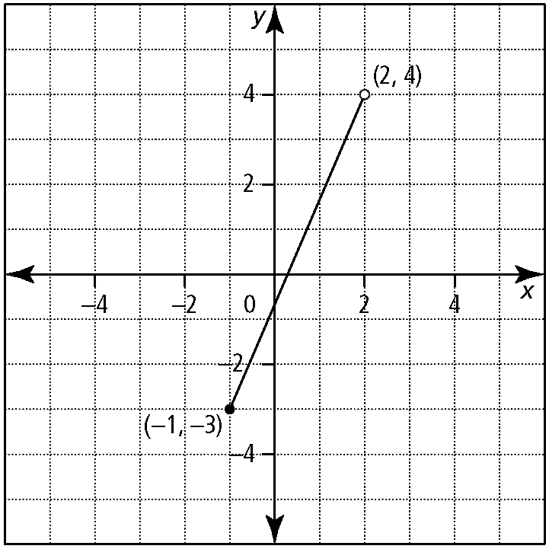
a)

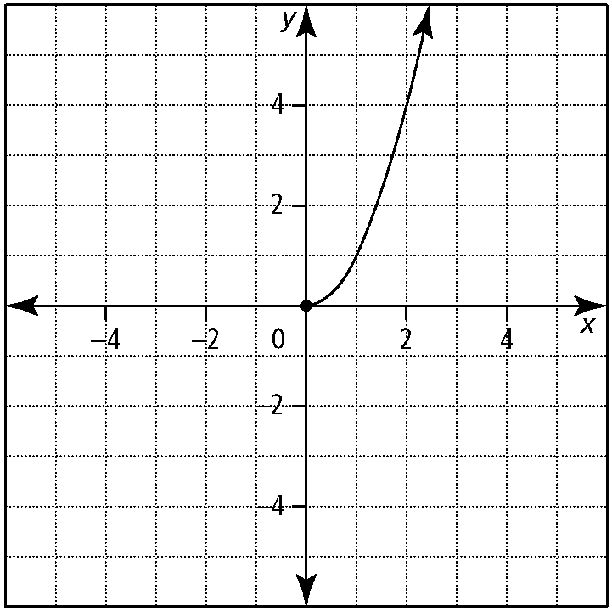
b)

11. Express each domain using another notation.
a)
b)
c) [1.4, 6]
d) (∞, 4)

12. Sketch the graph of a function having a domain of (−3, 2] and a range of (0, 5].

13. Solve each equation for n. Leave each answer in simplest radical form.
a)
b)
c)

