Name: ___________________________________________ Date: _____________________________
BLM 4–1
Chapter 4 Prerequisite Skills

1. Estimate the measure of each angle in degrees. Then, measure each angle to the nearest degree.
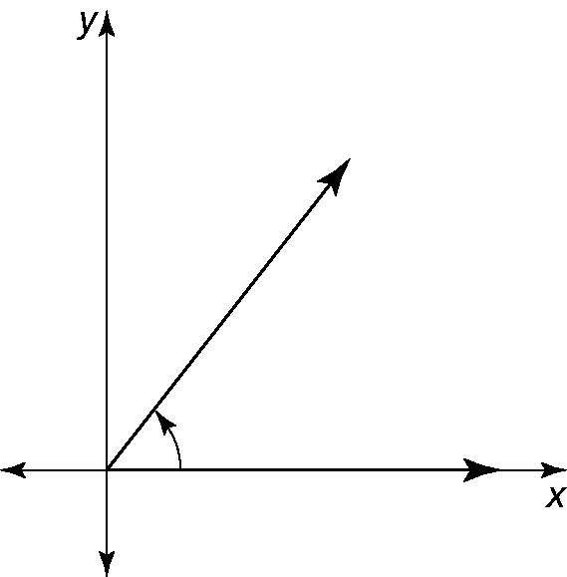
a)

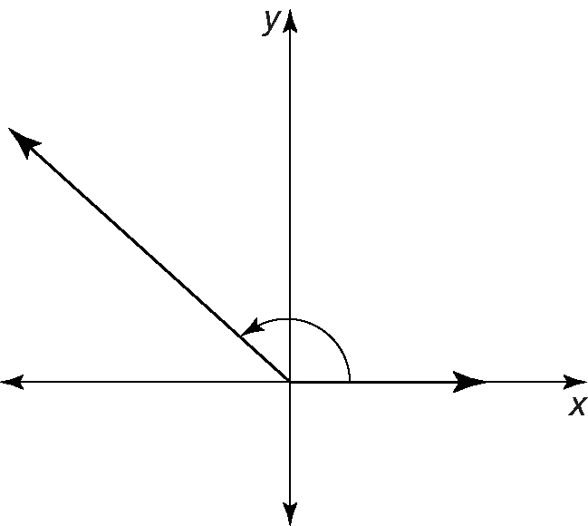
b)

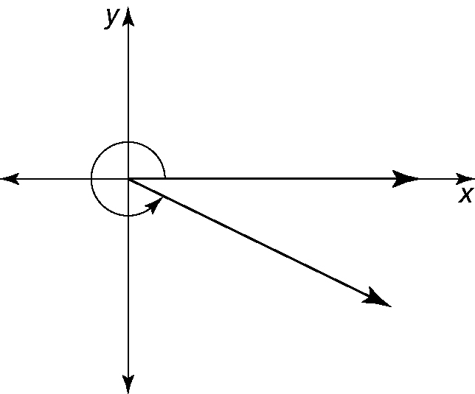
c)

2. Draw angles with each measure.
a) 110° b) 40°
c) 120° d) 315°
3. In which quadrant does the terminal arm lie if the angle is drawn in standard position?
a) 320° b) 140° c) 80°
d) 265° e) 309.4° f ) 174°
4. Determine the reference angle for each angle in #3.
5. Calculate the unknown measure. Express answers as both exact values and approximate values correct to one decimal place.
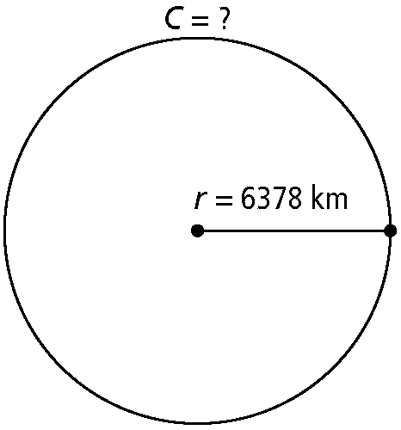
a)

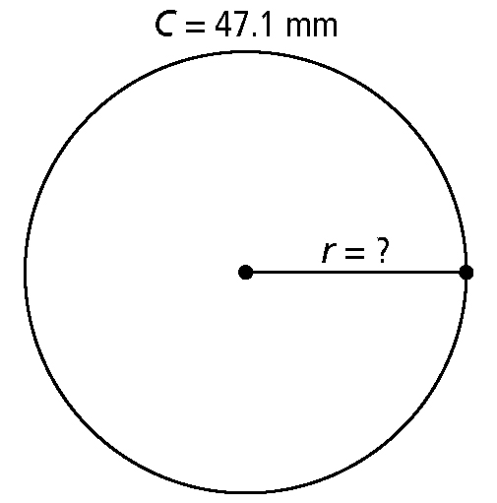
b)

c) the circumference of a circle with diameter in.
6. On a coordinate grid, draw a circle with a radius of 3 units and its centre at (1, 2). Plot and label the integral coordinates of four points on your circle.
7. A circle has its centre at the origin and a radius of 5 units. A terminal arm with angle 60° in standard position intersects the circle at B.
a) Draw the circle.
b) What is the length of the arc of the circle that extends from A(5, 0) to B as an exact value?
c) What is the length of the arc expressed as an approximate value to the nearest tenth?

Name: ___________________________________________ Date: _____________________________
BLM 4–1
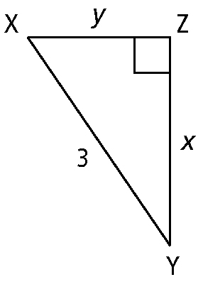
(continued)

8. Determine the length of the missing side in each right triangle. Leave your answers as exact values. Where possible, express answers in simplest radical form.
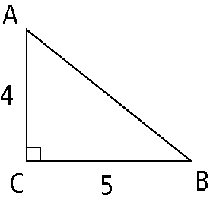
a)

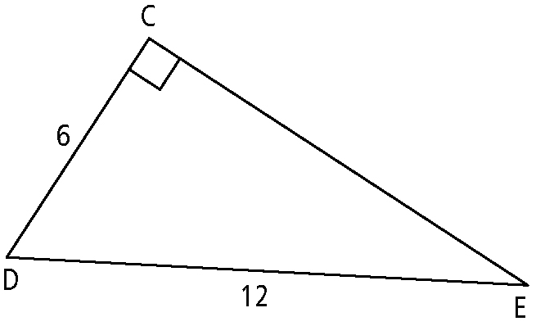
b)

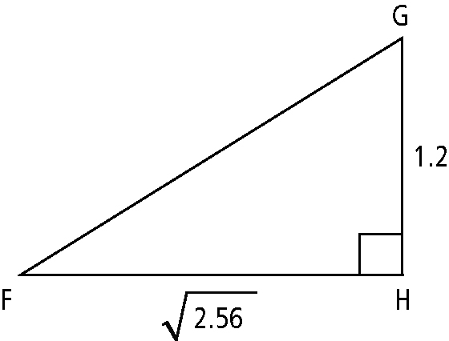
c)

9. Determine the measure of an angle θ in standard position that satisfies the given conditions.
a) reference angle = 38°; θ in quadrant IV
b) reference angle = 72.5°; θ in quadrant III
c) reference angle = 11°; θ in quadrant II
d) reference angle = 47.1°; θ in the quadrant where x < 0 and y > 0
10. Determine the trigonometric value(s) requested for each triangle. Leave answers in the form of a ratio.
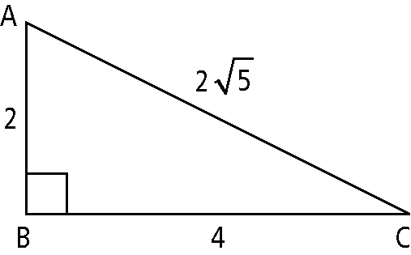
a)

cos A = ?
tan C = ?
b)

sin Y = ?
tan X = ?
11. What is the value of each trigonometric ratio? Give answers to the nearest hundredth.
a) sin 144° b) cos 87° c) tan 330°
d) cos 189° e) tan 267° f ) sin 284.6°
12. Factor each expression fully.
a) 6x²y − 24y³ b) x² − 11x + 10
c) 6x² − 21x + 9 d) 6x² − 11x − 10
13. Determine the roots of each quadratic equation. Express answers as exact values.
a) 8x² − 72 = 0 b) 4x² − 12x + 9 = 0
c) y² = 30 − 7y d) y² + 13 = 8y
14. A rectangular frame is constructed using
twelve metal rods. The rods are 18 cm,
24 cm, and 11 cm in length. To increase rigidity, a thirteenth rod is fitted as a crosspiece extending between opposite corners. Determine the length of the crosspiece to the nearest hundredth of a cm?
