Name: ___________________________________________ Date: _____________________________
BLM 8–1
Chapter 8 Prerequisite Skills

1. How are and the same? How are they different?
2. Between which two consecutive whole numbers does the value of each root fall? Which number is it closer to?
a) b)
c) d)
3. Identify two rational numbers with square roots between 8 and 9.
4. Identify the base and the exponent in each of the following powers. Evaluate each power where possible.
a) 3⁴ b) (−4)⁵
c) x⁷ d)
e) 13¹ f)
g) 1.78^{2.1}
5. Calculate.
a) b)
c) d)
e) f)
6. Write each expression as powers without parentheses. Then, evaluate each expression.
a) (−4³)² b) (7 × 3)⁴
c) d) [(−3) × 4]³
7. Determine the value of each expression.
a) 7 − 2(3²) b) (−4 − 3)² + (−3)²
c) (−2)⁶ ÷ 4³ d) 24 − 2² + (7² − 5²)
8. For each table, plot the ordered pairs (x, y) and the ordered pairs (y, x). State the domain of the function and its inverse.
a) b)
x | y |  | x | y
−2 | −4 |  | −6 | 2
−1 | −2 |  | −4 | 4
0 | 0 |  | −1 | 5
1 | 2 |  | 2 | 5
2 | 4 |  | 5 | 3
9. Sketch the inverse of each graph of a relation.
a) | 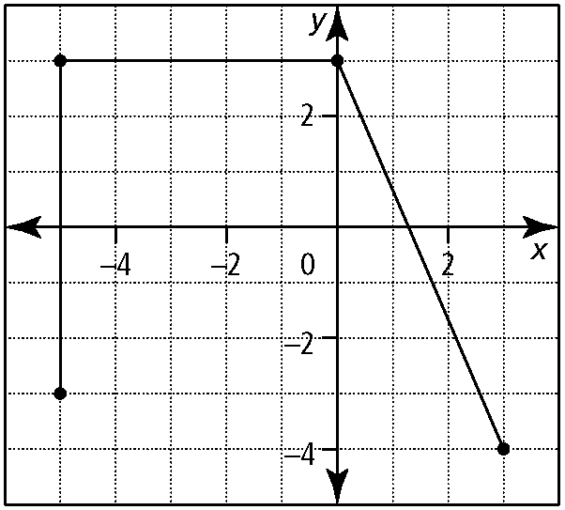
b) | 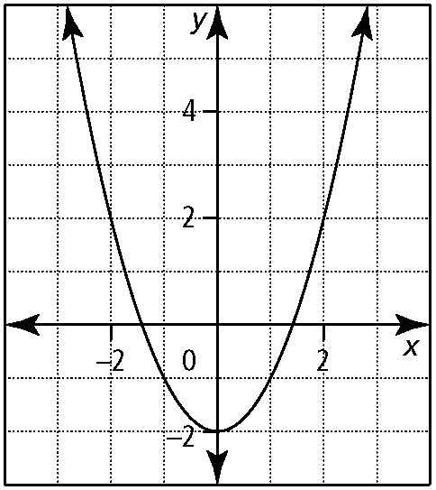
10. Determine algebraically the equation of the inverse of each function.
a) f (x) = 3x b) f (x) = −3x + 4
c) f (x) = d) f (x) = − 5
e) f (x) = 1 − 2.5x f) f (x)(x + 6)
11. For each of following functions,
• determine the equation for the inverse, f ⁻¹(x)
• sketch the graph f (x) and f ⁻¹(x)
• state the domain and range of f (x) and f ⁻¹(x)
a) f (x) = 2x + 3
b) f (x) = 5 − 3x
c) f (x) = (x − 6)
d) f (x) = x² + 3, x ≤ 0
e) f (x) = 1 − x², x ≥ 0
f) f (x) = (x + 3)², x ≥ −3

