Name: ___________________________________________ Date: _____________________________
BLM 9–1
Chapter 9 Prerequisite Skills

1. Consider the function f(x) = x³ − 2x² − 11x + 12.
a) Show that x + 3 is a factor of f(x).
b) If f(x) = (x + 3)g(x), what is g(x)?
2. Factor each expression fully.
a) 30g − 4g² b) 6fg − 8g²
c) x² − 6x + 5 d) 2x² + 11x + 5
e) 6a² − 11a + 3 f) x² − 0.01
g) 20x²y² − 45
3. Consider the sketch of the function
h(x) = x³ − 2x² − 5x + 6.
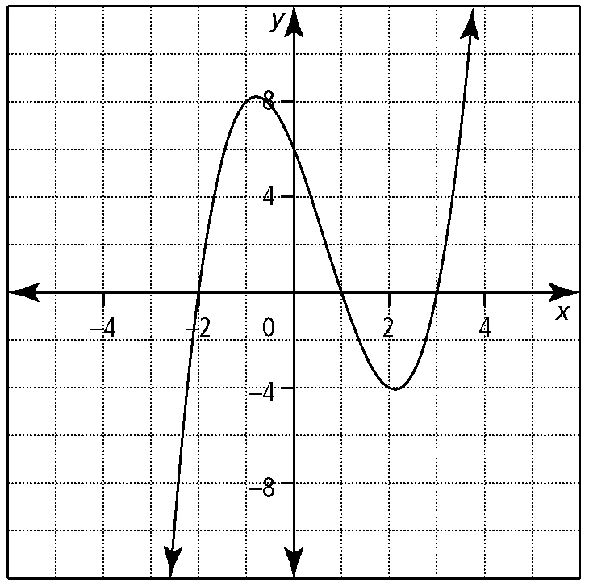
a) What are the zeros of the function?
b) Express h(x) in factored form.
c) What are the roots of the equation
x³ − 2x² − 5x + 6 = 0?
4. Identify all non-permissible values for each expression.
a) b)
c) d)
e) f)
5. Consider P(x) = x³ − 5x² + 2x + 8.
a) Use the Factor Theorem to find a factor
of P(x).
b) Completely factor P(x).
c) What is the solution of P(x) = 0?
d) Sketch the graph of P(x). Explain the significance of the x-intercepts.
6. a) Arrange the equation into the form ax² + bx + c = 0, where a, b, and c are integers. State the solution for this equation.
b) Rewrite the function you developed in part a) in the form y = (x − h)² + k, where h and k are real numbers.
c) Graph the function. Explain the relationship of the x-intercepts and coordinates of the vertex to the functions in parts a) and b).
7. Solve each equation algebraically. Express answers as exact values and identify
non-permissible values, where necessary.
a) x² − 14x + 49 = 0
b) 6x² + 17x − 3 = 0
c) x² − 6x + 7 = 0
d) 2x² − 3x − 4 = 0
e)
f)
8. Complete the square. Leave your answers in the form a(x − h)² + k = 0, where a, h, and k are real numbers.
a) x² + 10x + 4 = 0 b) x² − 8x = −13
c) 3x² + 1 = −6x d) −2x² = −4x − 3
9. Solve each equation by graphing the corresponding function.
a) −x² − 5x − 4 = 0
b) x³ + 4x² − 7x − 10 = 0
10. Simplify each rational expression. State any non-permissible values for the variables.
a) b)
11. Simplify each product or quotient. Identify all non-permissible values.
a)
b)

