Chapter 11 Prerequisite Skills Answers

BLM 11–1 Prerequisite Skills
1. a) −3 b) 504 c) 10 d) 22
2. Example: 2, 3, 4, 5, 6, 7
a) 2 × 7 = 14
b) 3 × 6 = 18
c) The product of the second and fifth numbers is always 4 greater than the product of the first and sixth numbers.
3. a) n + 1, n + 2, n + 3, n + 4, n + 5
b) 1st × 6th = n(n + 5) = n² + 5n; 2nd × 5th
= (n + 1)(n + 4) = n² + 5n + 4
c) Difference between products is
(n² + 5n + 4) − (n² + 5n) = 4. This demonstrates that the difference between products is always 4.
4. a) , x ≠ ±2
b) , a ≠ −1, 4
c) , n ≠ −5, −1, 0, 1
5. a) 5 and 6, −5 and −6
b) 8 and 9, −8 and −9
c) 7 and 8
d) 5, 6, and 7
e) 3, 4, and 5
6. a) 25 b) 16 c) 55
7. a) Assume that digits are not repeated.
Start with
2 | 4 | 6
24 | 42 | 62
26 | 46 | 64
b) Assume that the order of selection is not important.
Q | Q | Q
Q | Q | N
Q | Q | D
Q | N | N
Q | N | D
Q | D | D
N | N | D
N | N | N
D | D | N
D | D | D
Q = quarter
N = nickel
D = dime

8. a)
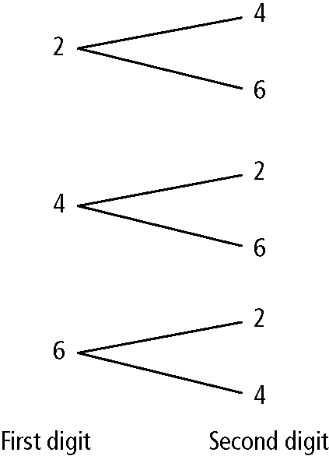

b)
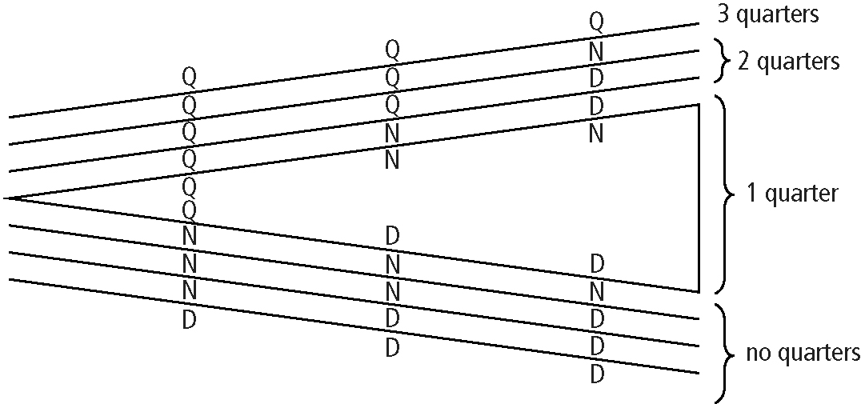

9. a) x = 1 b) x = 15
10. a) 7 + 2⁴ b) 41 + 2⁴ c) 17 + 2⁶ d) 3 +2¹
11. a) x = −5 or x = 3
b) or
c) x = 3, x = −2, or x = −3
12. a) zeros at −1 and 4
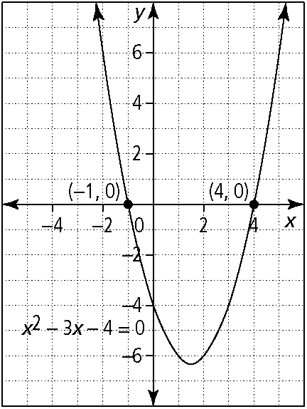

b) zeros at 1 and 6
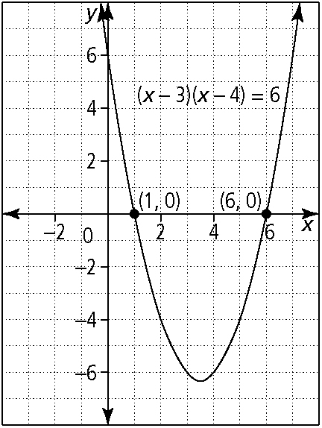

c) zeros at −3, −2 and 1
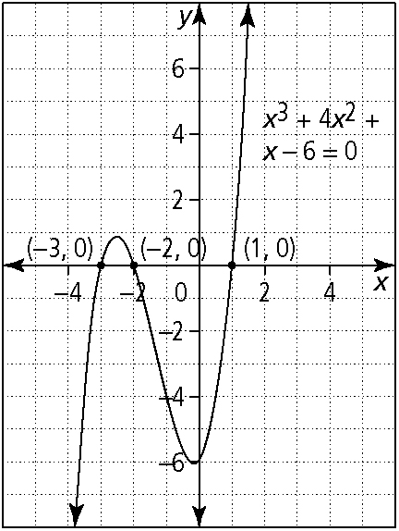

13. a) a = 180 − 4x; b = 3x
b) It is not possible to determine a unique value for x since every equation that you set up can be simplified to 0 = 0, which is indeterminate. There are many values for x that satisfy the conditions. For example, x could be 40°, 30°, or 25°.

