Chapter 1 Prerequisite Skills Answers

BLM 1–1 Chapter 1 Prerequisite Skills
1. a) vertex (3, 4), minimum; axis of symmetry x = 3; opens upward; domain {x | x ∈ R};
range { y | y ≥ 4, y ∈ R}
b) vertex (−5,−7), minimum; axis of symmetry
x = −5; opens upward; domain {x | x ∈ R};
range { y | y ≥ −7, y ∈ R}
c) vertex (0, 15), maximum; axis of symmetry x = 0; opens downward; domain {x | x ∈ R};
range { y | y ≤ 15, y ∈ R}
d) vertex , maximum; axis of symmetry
opens downward; domain {x | x ∈ R};
range
2. a) y = (x − 12)² − 134 b) y = 5(x + 4)² − 107
c) y = −2(x − 2)² + 8 d) y = −30(x + 1)² + 135
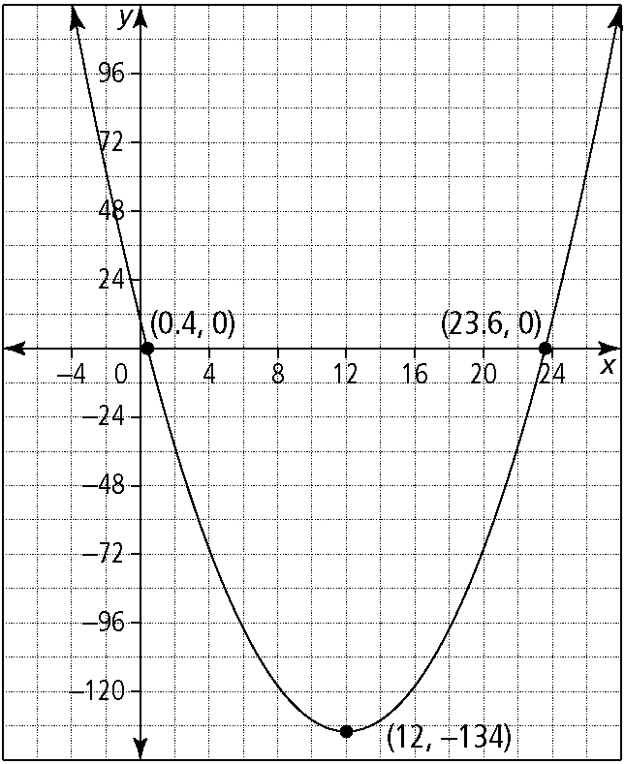
3. a)

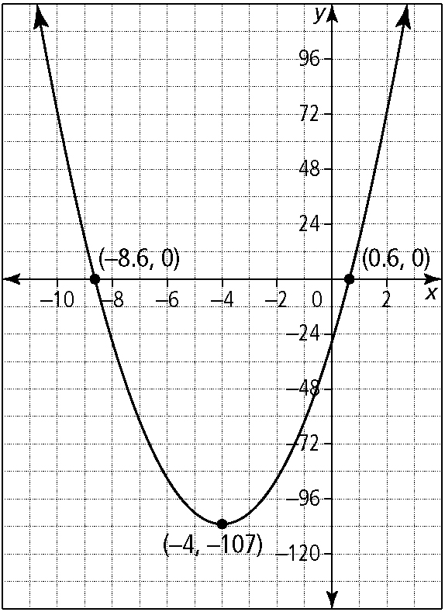
b)

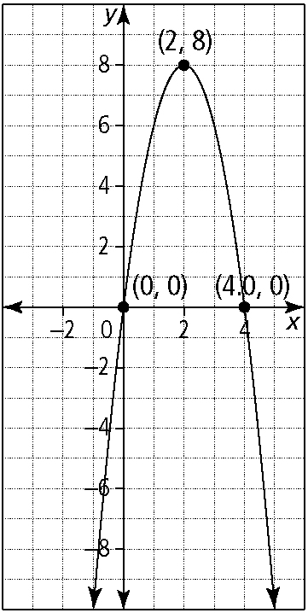
c)

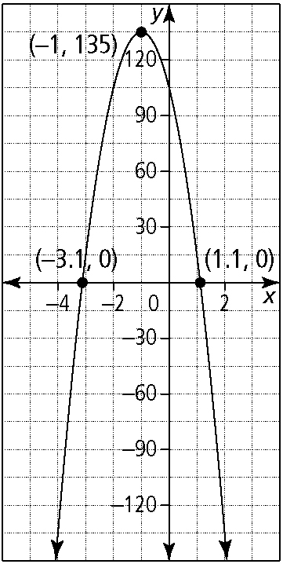
d)

4. a) 7 b) 5 c) −6 d) 9

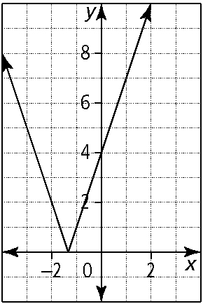
5. a)

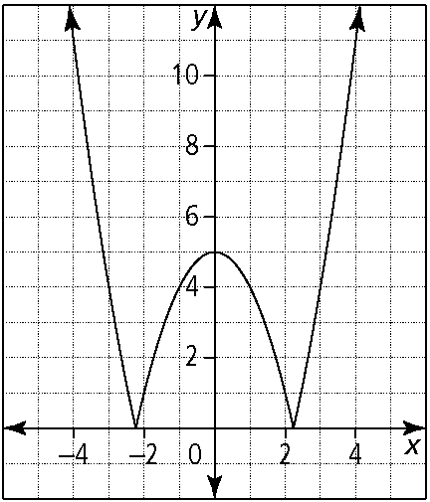
b)

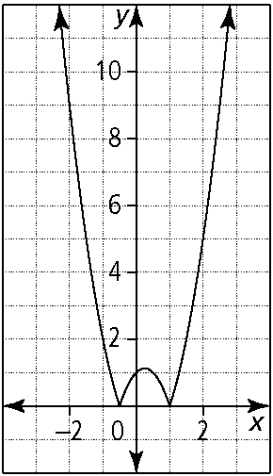
c)

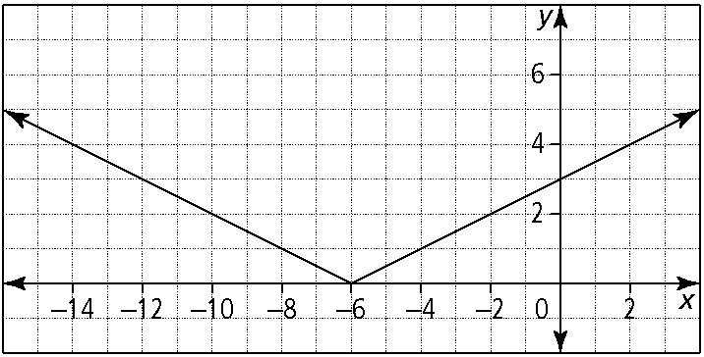
d)

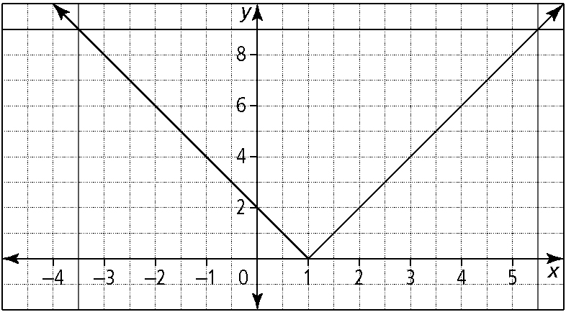
6. a)

x = −3.5, 5.5
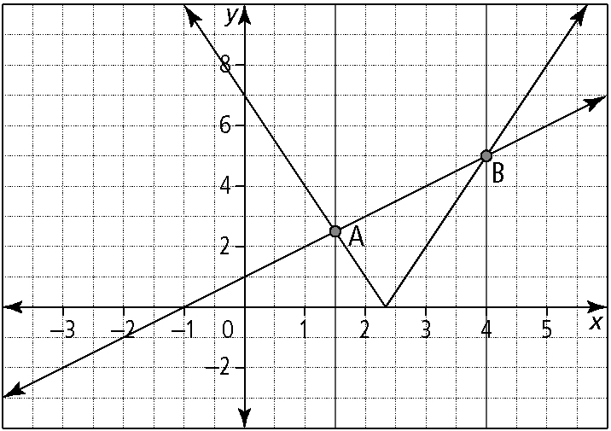
b)

,
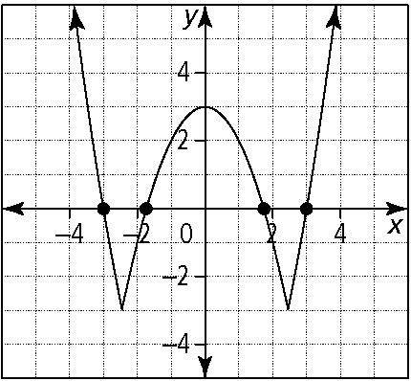
c)

x = −3, −1.73, 1.73, 3
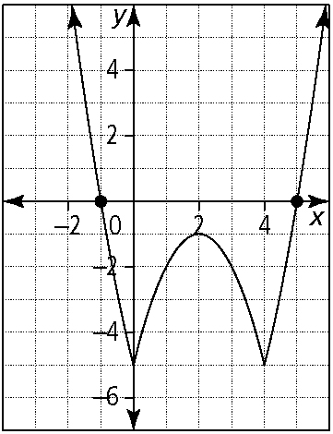
d)

x = −1, 5
7. a) b) x = 1.5, 4
c) d) x = −1, 5
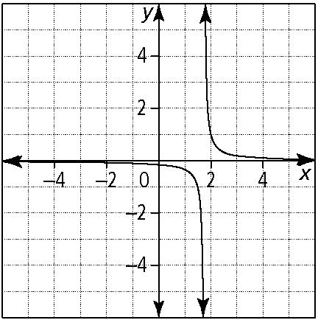
8. a)

asymptote at ;
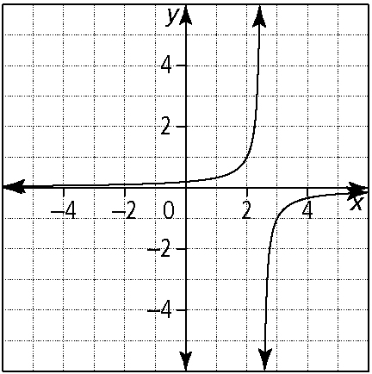
b)

asymptote at ;
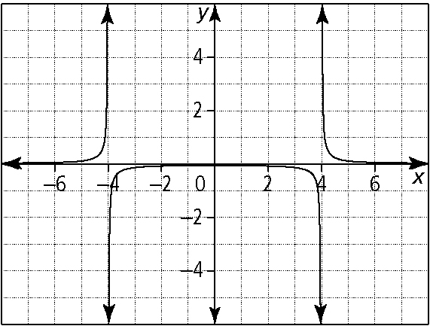
c)

asymptotes at x = 4, −4; x ≠ ±4

BLM 1–8
(continued)

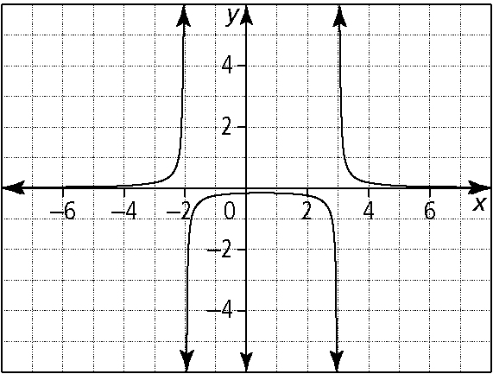
d)

asymptotes at x = 3, −2; x ≠ 3, −2

