Chapter 5 Prerequisite Skills Answers

BLM 5–1 Chapter 5 Prerequisite Skills
1. | Degrees | Radians | Revolutions
 | 270
 | 135
 | 210
 | 288
 | 105.42 | 1.84 | 0.29
 | 171 | 0.95π ≈ 2.98 | 0.475

2. a) 45° b) 80° c) 85° d) 20°
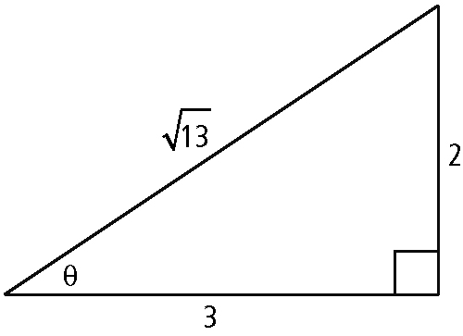
3. a)

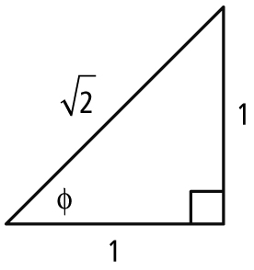
b)

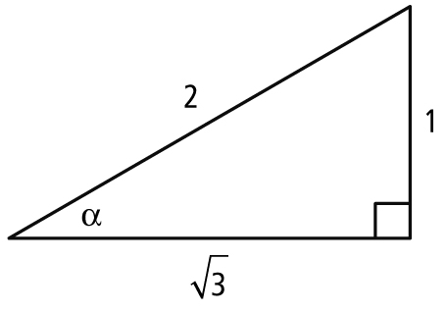
c)

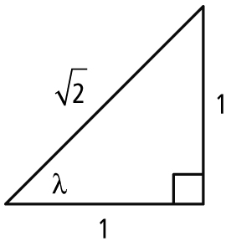
d)

4. a) b) 1 c) d)
5. a) positive b) negative
c) negative d) negative
6. a) 30°, 150° b) 135°, 225°
c) 135°, 315° d) 150°, 210°
7. a) quadrant IV b) c)
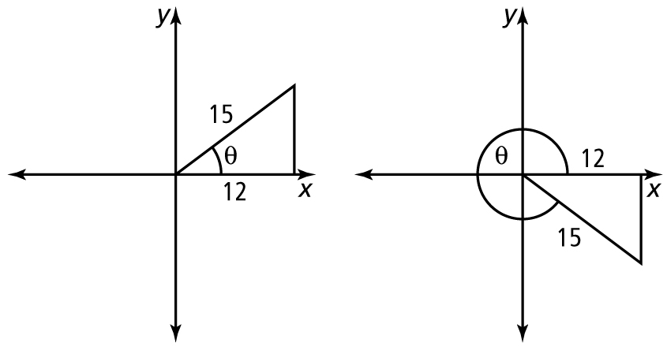
8. a)

b) 37° and 323°
9.
10. a) 60°; b) c)
d) θ terminates in quadrant III.
11. a) b) −1 c) undefined
12. a) b)

