Chapter 8 Prerequisite Skills Answers

BLM 8–1 Prerequisite Skills
1. Each is a root of a negative number. However, only can be evaluated because is not a real number.
2. a) 2 and 3; closer to 3 b) 11 and 12; closer to 11
c) 2 and 3; closer to 2 d) 4 and 5; closer to 5
3. Example: any rational number between 64 and 81
4. a) base: 3; exponent: 4; 3⁴ = 81 b) base: −4; exponent: 5; (−4)⁵ = −1024 c) base: x; exponent: 7
d) base: 3x; exponent:
e) base: 13; exponent: 1; 13¹ = 13
f) base: ; exponent: −3; = 3.375
g) base: 1.78; exponent: 2.1; 1.78^{2.1} ≈ 3.3564
5. a) 14 b) 16 c) 21 d) 15 e) 31 f) 17
6. a) (−4)⁶ = 4096 b) 21⁴ = 194 481
c) d) −12³ = −1728
7. a) −11 b) 58 c) 1 d) 44
8. a) | 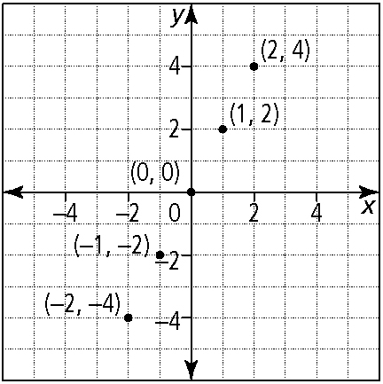
domain: { x | x = −2, −1, 0, 1, 2}
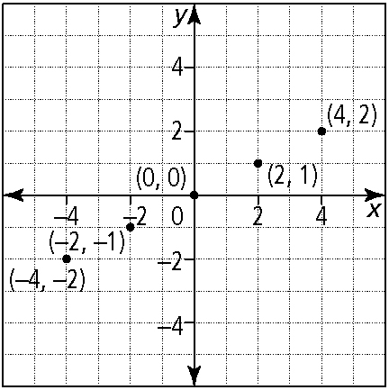
domain: { x | x = −4, −2, 0, 2, 4}

b) | 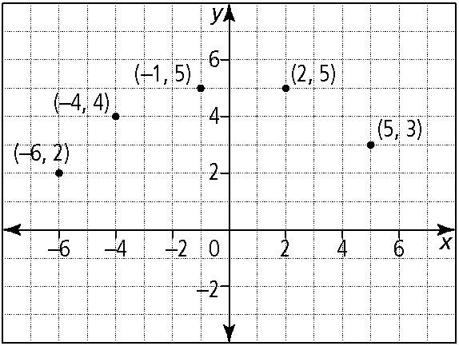
domain: { x | x = −6, −4, −1, 2, 5}
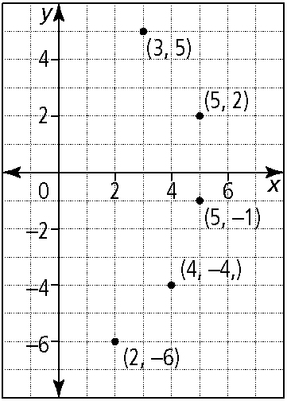
domain: {x | x = 2, 3, 4, 5}
9. a) | 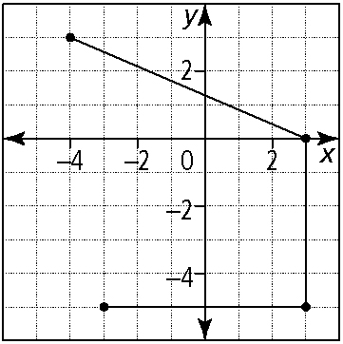

b) | 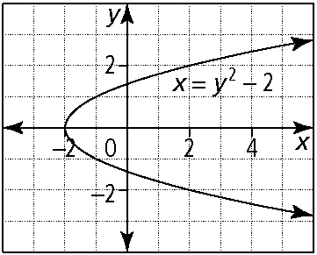
10. a) b)
c) d)
e) f)
11. a)
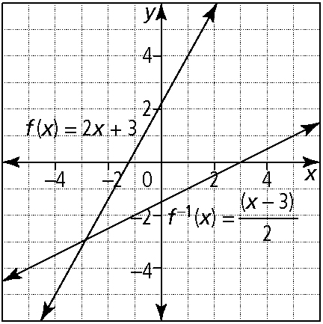
f (x)–domain: { x | x ∈ R}; range: { y | y ∈ R}
f ⁻¹(x)–domain: { x | x ∈ R}; range: { y | y ∈ R}
b)

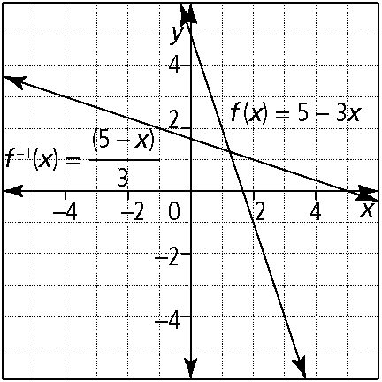

f (x)–domain: {x | x ∈ R}; range: { y | y ∈ R}
f ⁻¹(x)–domain: {x | x ∈ R}; range: { y | y ∈ R}
c) f ⁻¹(x) = 2x + 12

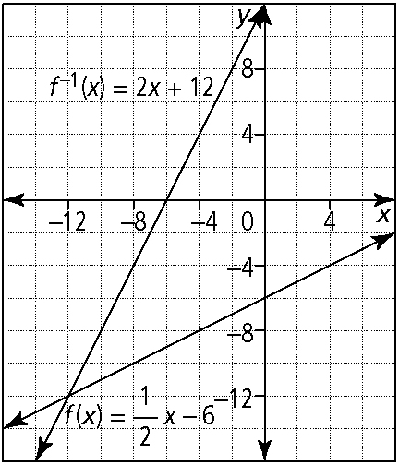

f (x)–domain: {x | x ∈ R}; range: { y | y ∈ R}
f ⁻¹(x)–domain: {x | x ∈ R}; range: { y | y ∈ R}
d)
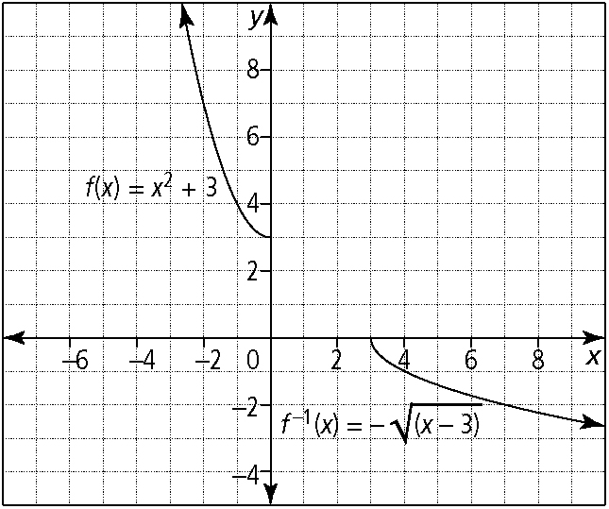
f (x)–domain: {x | x ≤ 0, x ∈ R}; range: { y | y ≥ 3, y ∈ R}
f ⁻¹(x)–domain: {x | x ≥ 3, x ∈ R}; range: { y | y ≤ 0, y∈ R}
e)
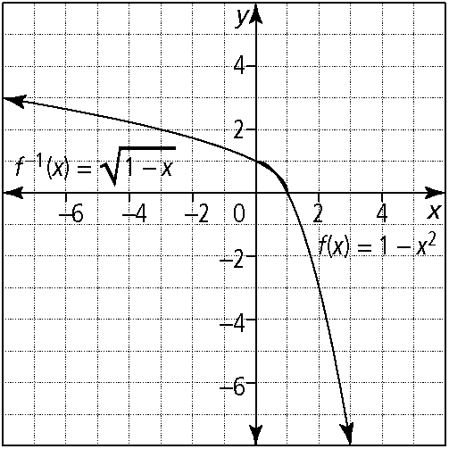
f (x)–domain: {x | x ≥ 0, x ∈ R}; range: { y | y ≤ 1, y ∈ R}
f ⁻¹(x)–domain: {x | x ≤ 1, x ∈ R}; range: { y | y ≥ 0, y∈ R}
f)
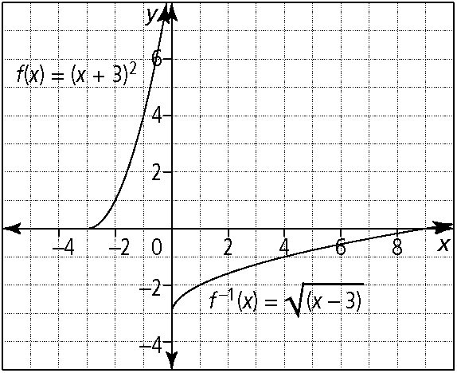
f (x)–domain: {x | x ≥ –3, x ∈ R}; range: { y | y ≥ 0, y ∈ R}
f ⁻¹(x)–domain: {x | x ≥ 0, x ∈ R}; range: { y | y ≥ −3, y  R}

