Chapter 9 Prerequisite Skills Answers

BLM 9–1 Prerequisite Skills

1. a)
b) g(x) = x² − 5x + 4

2. a) 2g(15 − 2g) b) 2g(3f − 4g) c) (x − 5)(x − 1)
d) (2x + 1)(x + 5) e) (2a − 3)(3a − 1)
f) (x − 0.1)(x + 0.1) g) 5(2xy − 3)(2xy + 3)

3. a) −2, 1, and 3 b) h(x) = (x + 2)(x − 1)(x − 3)
c) −2, 1, and 3

4. a) b ≠ 0, c ≠ 0 b) c) , x ≠ −1 d) t ≠ 3
e) f) a ≠ 1, a ≠ 2, and a ≠ −3

5. a) P(−1) = (−1)³ − 5(−1)² + 2(−1) + 8 = 0, therefore, (x + 1) is a factor.
b) P(x) = (x + 1)(x − 4)(x − 2) c) x = −1, 2, 4
d) | 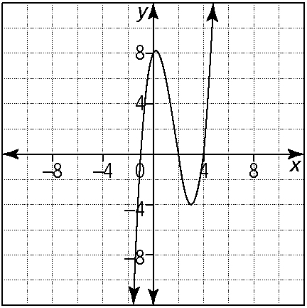
The x-intercepts are the solution to P(x) = 0.

6. a) x² − 4x − 12 = 0; 6 and −2 b) y = (x − 2)² − 16
c) | 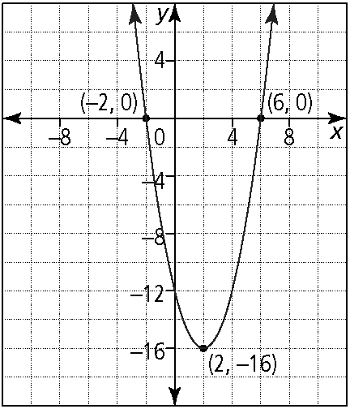
The x-intercepts are the solution to the equation. The x-coordinate of the vertex is the value that makes
(x − h) = 0 and the y-coordinate is equal to k.

7. a) x = 7 b) c)

d) e) , x ≠ 0, x ≠ −1
f) x = 6, x ≠ 2, −2

8. a) (x + 5)² − 21 = 0 b) (x − 4)² − 3 = 0
c) 3(x + 1)² − 2 = 0 d) 2(x − 1)² − 5 = 0

9. a) x = −4, −1
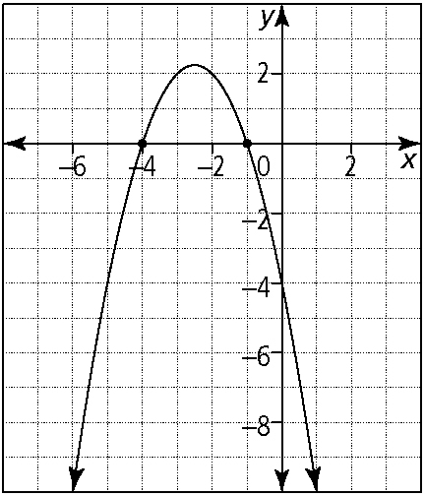
b) x = −5, −1, 2
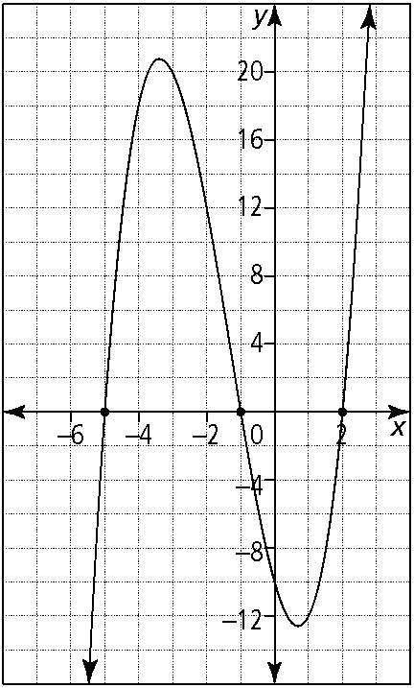

10. a) , x ≠ 1, −3 b)

11. a) b)

