BLM 7–3
Chapter 7 Warm-Up
Section 7.1 Warm-Up

1. What is the numerical value of each of the following?
a) opposite of 7
b) opposite of −3
c) difference of 6 and −3
d) number of whole numbers between
3 and −2
e) value of 4 − (−1)
f ) sum of −6 and 1
2. Sketch a number line to show the solution for each statement. Assume that all values are integers.
a) x − 4 = 1
b) −2 < x ≤ 3
c) x is a negative integer and x ≥ −4
d) {x | x < 5, x ∈ I}
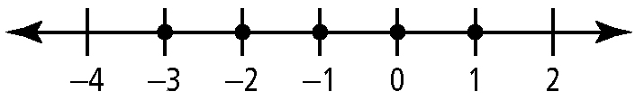
3. Determine an equation or an inequality that describes the solution shown on each number line.
a)

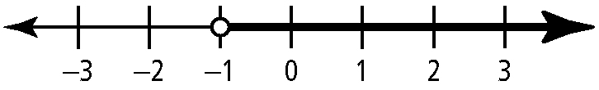
b)

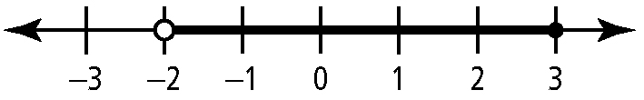
c)

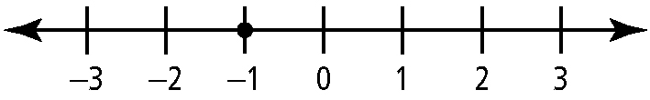
d)
4. Use the number line to help answer the questions.
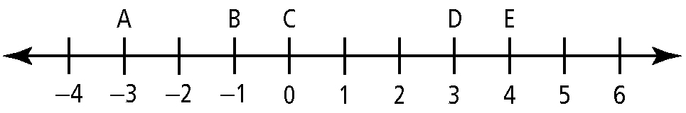
a) What number is midway between
A and D?
b) What is the distance between D and B?
c) Which two labelled points are 5 units apart?
d) What rational value is halfway between A and E?
5. Determine the total change in temperature for each day.
a) from 27 °C to 41 °C
b) from −27 °C to 18 °C
c) from −35 °C to −9 °C
d) from 14 °C to −13 °C

BLM 7–3
(continued)
Section 7.2 Warm-Up

1. What is the value of each expression?
a) −7 − (−1)
b) 4 − 9
c) | −6 | + | 3 | − 4
d) 3( | −9 | − | −3| )
e) ( | −5 | − | −8| )²
2. Draw the reflection of each line segment using the given line of reflection.
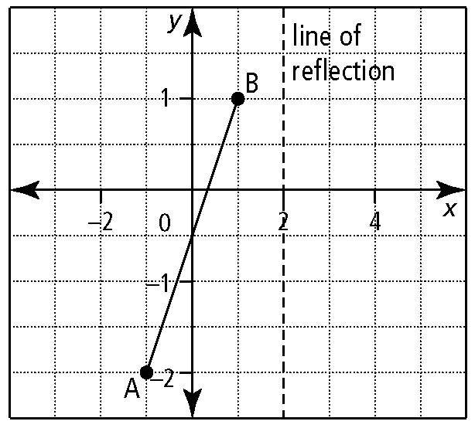
a)

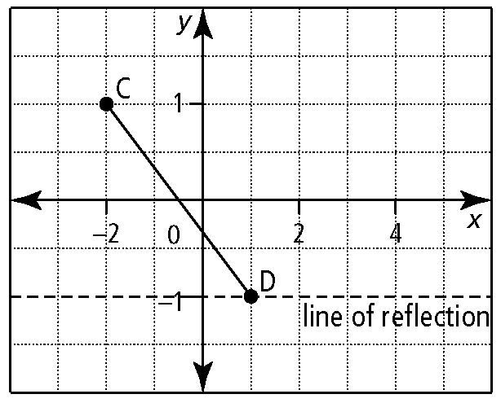
b)

3. Each graph in #2 represents a function. Use the graphs to answer the following questions.
a) What can you say with certainty about the zero(s) of the function represented by AB?
b) What is the domain and range for CD?
c) What is the equation of the reflection
for CD?
4. Draw the graph of each function.
a) y = 2x + 3
b) f (x) = x² − 4x − 5
c) y = (x − 1)² + 2
5. Determine a function for the relationship shown on each graph.
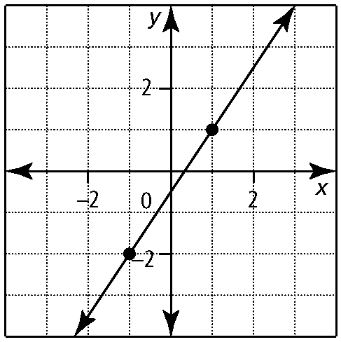
a)

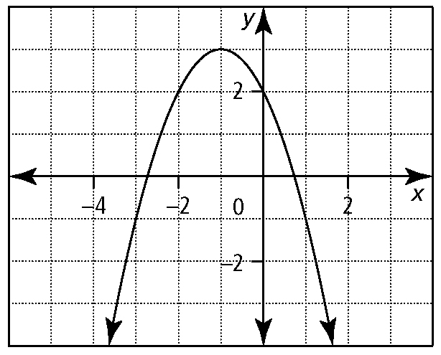
b)

BLM 7–3
(continued)
Section 7.3 Warm-Up

1. Sketch the graph of each function. State the intercepts, and the domain and range.
a) y = | −3x − 1 |
b) g(x) = | x | + 1
c) y = | x² − 5x + 6 |
2. Use the graph of y = f (x) to sketch the graph of y = | f (x)|.
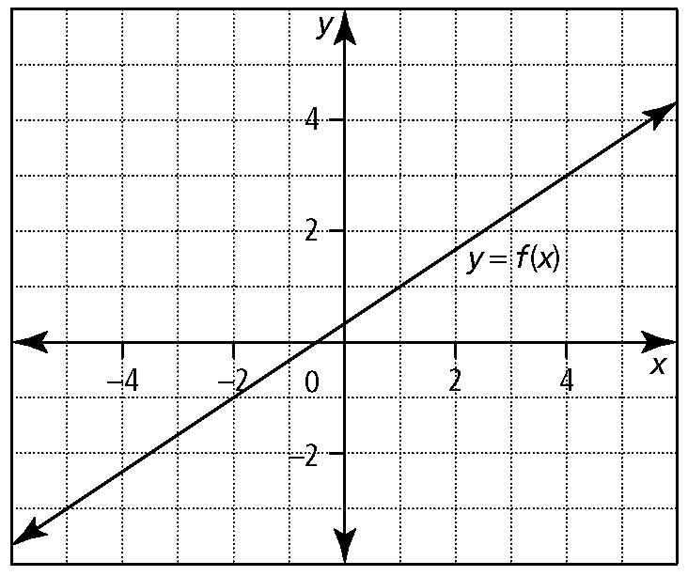
a)

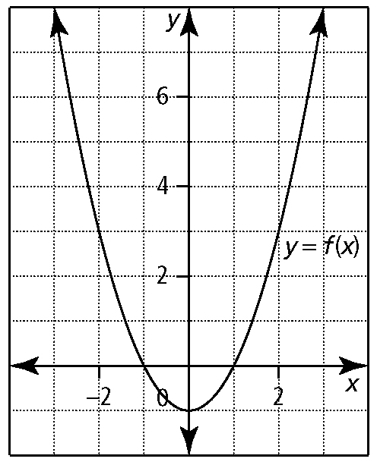
b)

3. Determine the root for each linear equation.
a) y = 2x − 5
b) 3x − y = 9
c) 4x − 3y − 12 = 0
4. What are the root(s) for each quadratic equation?
a) y = x² − 1
b) f (x) = x² + x − 6
c) y = 3x² − x − 2
5. Write the piecewise function that represents each graph.
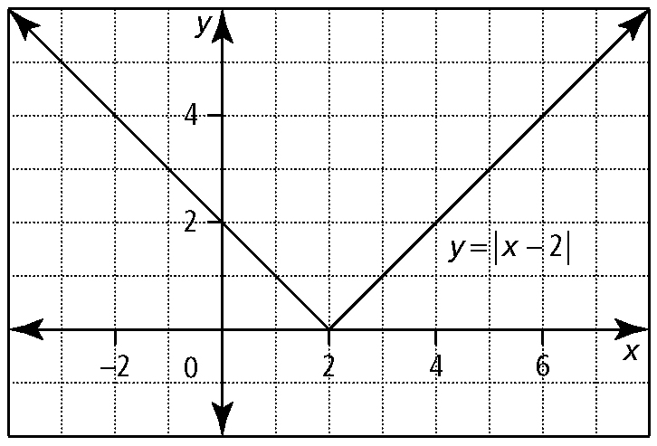
a)

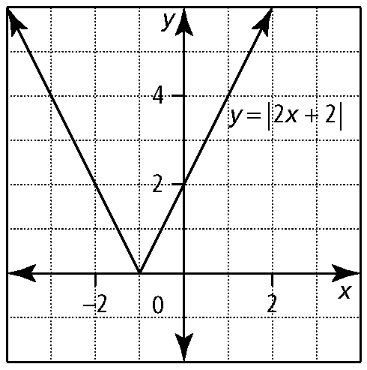
b)

Section 7.4 Warm-Up

1. What is the reciprocal of each expression?
a) −3 b)
c) 2x d)
2. What are the non-permissible values, if any, for each variable?
a) 3x² b)
c) d)
3. Solve each equation. Verify the solutions.
a) | 3x − 2 | = 7 b) | x + 1 | = 3
c) 2x + 1 = | x − 4 | d) | 7x − 3 | = 3 + x
4. Write a quadratic function that satisfies each set of conditions.
a) vertex at (−1, 2) and opens upward
b) zeros of −2 and 4 and opens downward
c) axis of symmetry at x = 2, y-intercept at (0, 4), and opens upward
5. Explain how you would determine
non-permissible values for a rational expression.

