Chapter 8 Warm Up Answers

BLM 8–3 Chapter 8 Warm-Up
Section 8.1
a) b = 2
b) b = 4
2. a) b) 0
c) Line B, since the line falls as you move to
the right
d) (2, 4)
e) Substitute the point (6, 2) into the equation
for line B:
Since both sides are equal after substituting, (6, 2)
is on the line.

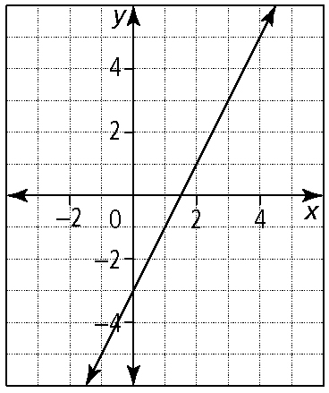
3. a)

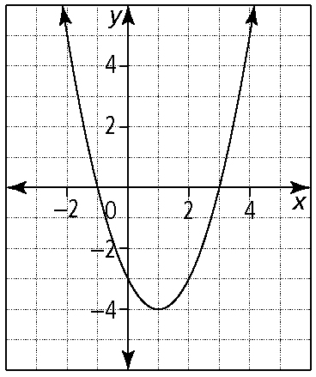
b)

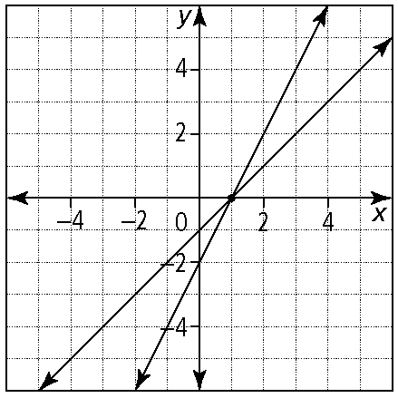
4. a)

(1, 0)
b) quadrants I, III, and IV
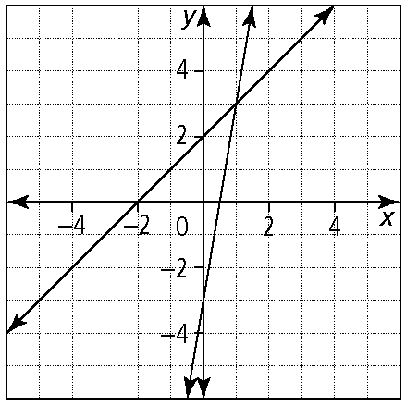
5.

lines intersect, so one solution
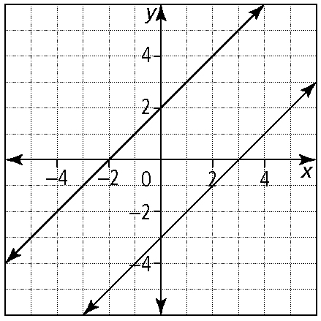
lines do not intersect, so no solution
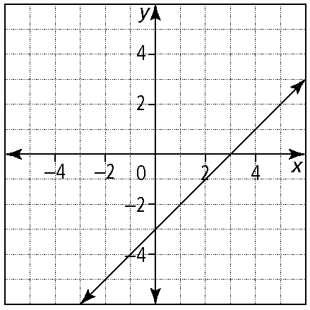
lines fall on top of each other, so infinite number of solutions.
6. a) quadratic b) parabola c) (3, 4)
d) x = 3 e) a is negative
f ) x = 1 and x = 5
Section 8.2
1. a) 4x − 7 b) −6s + 4t c) 8p² − 6pq + q²
d) −3x² − 14x + 5 e) −a − 2b f) 22m − 16p
g) 9x² − 30xy + 25y² h) 8x² + 40x + 26
2. a) (−1, 2) b) (−3, 2) c) (4, −1) d)
3. a) (2, −3) b) (3, −1) c) (3, 4) d) (1, 2)
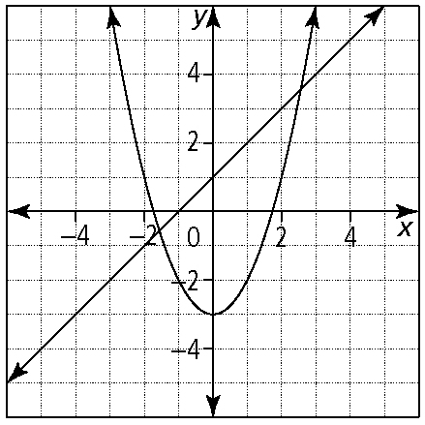
4.

The line crosses the parabola, so there are two solutions.
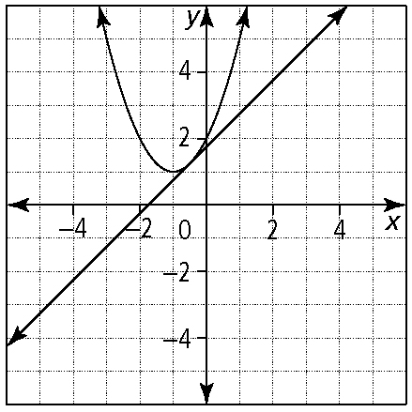
The line is tangent to the parabola, so there is one solution.
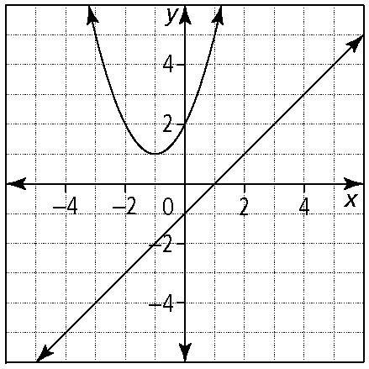
The line does not touch or cross the parabola, so there are no solutions.
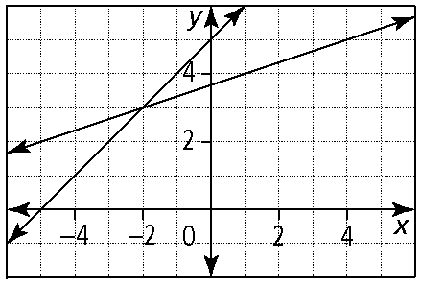
5. a)

(−2, 3)
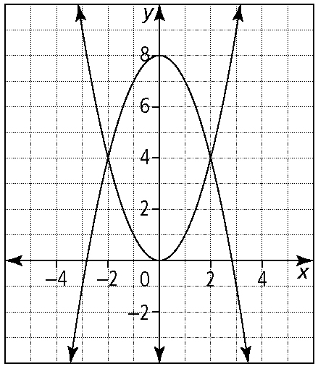
b)

(−2, 4) and (2, 4)

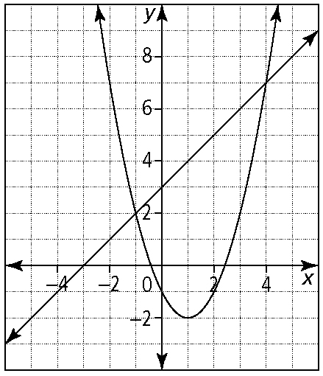
c)

(−1, 2) and (4, 7)

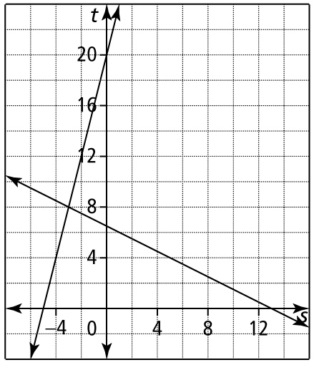
d)

(−3, 8)

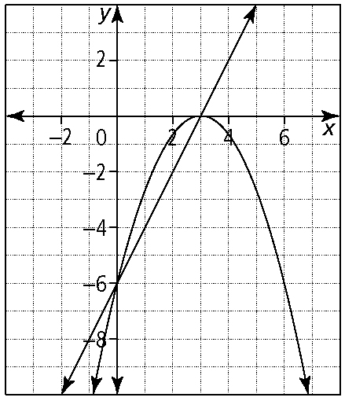
e)

(3, 0) and (0, −6)

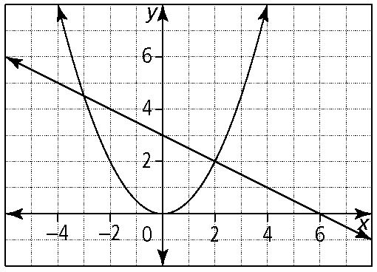
f )

(2, 2) and
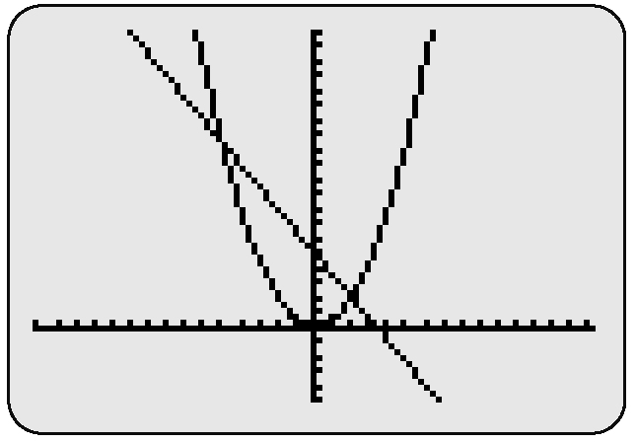
6. a)

two solutions because there are two intersection points

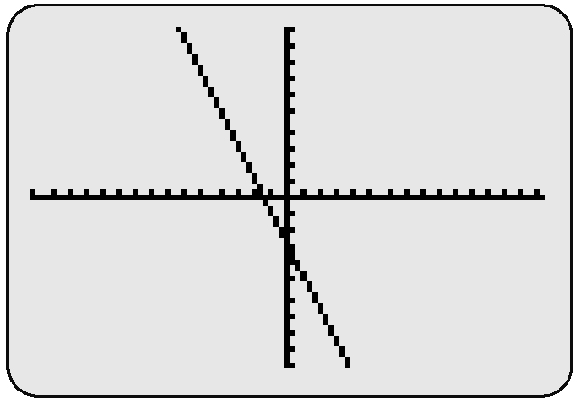
b)

infinite number of solutions because the two graphs are the same

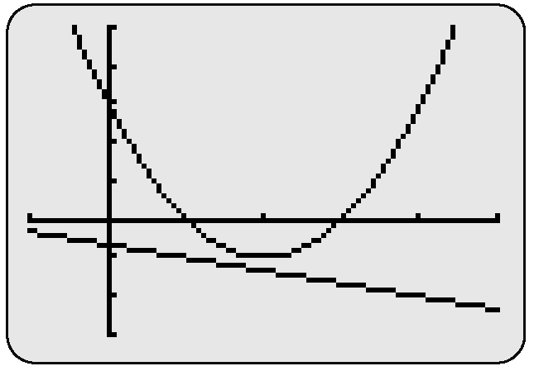
c)

no solutions, or zero solutions, because the two graphs do not intersect

