Chapter 9 BLM Answers

BLM 9–3 Chapter 9 Warm-Up

Section 9.1

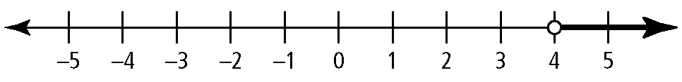**1.** **a)** *x*  2 **b)** *x*  1 **c)** *x*  3

**2.** **a)**

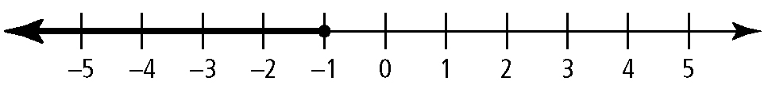

**b)**

**3.** **a**) *m*  3 **b)** *x*  3 **c)** *w*  7 **d)** *y*  3

**4.** **a)** **i)** *b*  20 **ii)** *b*  20 **iii)** *b*  20

**b)** **i)** *b*  15 **ii)** *b*  15 **iii)** *b*  15

**c)** **i)** *b*  6 **ii)** *b*  6 **iii)** *b*  6

**d)** **i)** *b*  40 **ii)** *b*  40 **iii)** *b*  40

**5.** **a)** *x*-intercept: 2; *y*-intercept: 5

**b)** *x*-intercept: *y*-intercept: 3

**c)** *x*-intercept:; *y*-intercept: 3

**6.** **a)** portrait: *h*  *w*; square: *h*  *w*; landscape: *h*  *w*

**b)** A: square; B: square; C: portrait; D: landscape;   
E: portrait; F: landscape; G: square

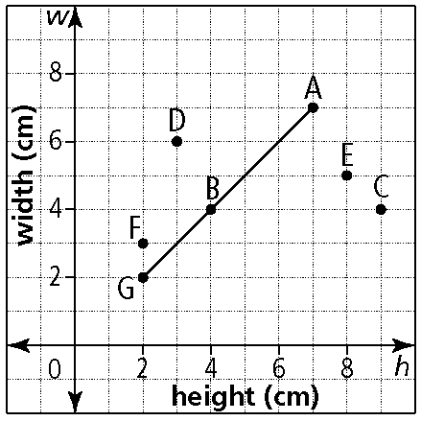**c)**

Landscape photos are above the line; portrait photos are below the line.

Section 9.2

**1.** Example: A straight line on a graph divides the Cartesian plane into the following three regions: points on the line represent the equation *y*  2*x*  3, points to the left or above the line represent the inequality *y* > 2*x* − 3, and points to the right or below the line represent the inequality *y* < 2*x* − 3.

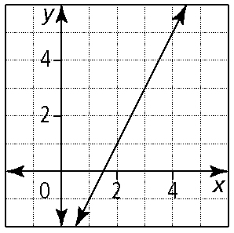

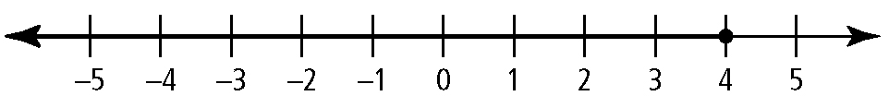**2.** **a)** Example:

**3.** **a)** no **b)** yes **c)** yes

**4.** **a)** 17 **b)** 8.29 **c)** ± 2

**d)** ± 1.2 **e)** Example: (3, 10)

**5.** **a)** (*x*  3)(*x*  10) **b)** (*x*  6)(*x*  3)

**c)** (2*x*  3)(*x*  2) **d)** (3*x*  1)(*x*  5)

**6.** **a)** 1 and 4 **b)** 5 and 2

**c)** 8 and 7 **d)** and 1

Section 9.3

**1.** **a)** *x*  ±3 **b)** *x*  7 or *x*  1

**c)** *x*  or *x*  5 **d)** *x*  or *x*  1

**2.** 

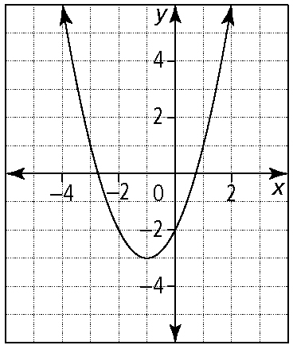**3.** **a)**

2 zeros

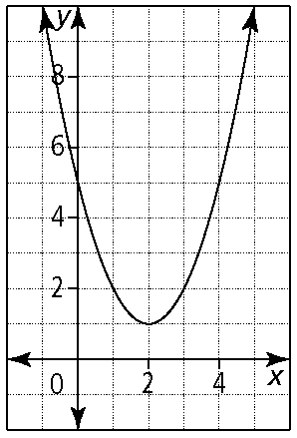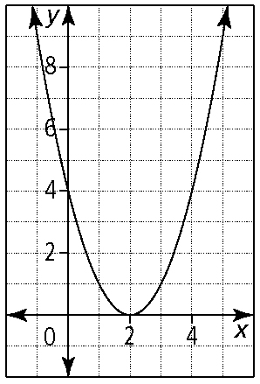**b) c)**

1 zero no zeros

**4.** Example: The solutions to a quadratic equation are the roots of the equation. You can find the roots by determining the *x*-intercepts of the graph or by determining the zeros of the quadratic function. For example, when you graph the quadratic function   
*f* (*x*)  2*x*2  2*x*  12, the *x*-intercepts are 3 and 2. The zeros of the function occur when *f* (*x*)  0, so they are 3 and 2. Therefore, the roots of the corresponding equation, *y*  2*x*2  2*x*  12,   
are 3 and 2.

**5.** **a)** 1  *x*  1 **b)** *x*  1 or *x*  1 **c)** 1  *x*  4

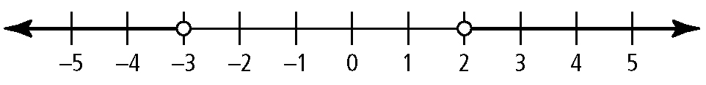**6.** **a)**

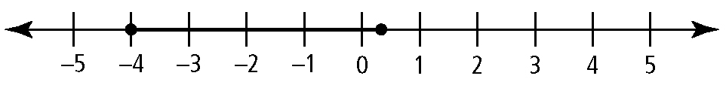

**b)**