BLM 1–3
Chapter 1 Warm-Up
Section 1.1 Warm-Up

1. Describe the pattern demonstrated by each of the following.
a) 2, 4, 6, 8, …
b) 1, 4, 7, 10, …
c) 5, 11, 17, …
2. Solve for x.
a) 35 = 3x – 4
b) 64 = –2(x – 3)
3. If g(n) = 6n – 11, determine
a) g(1)
b) g(0)
c) g(–3)
4. For each system of linear equations, use elimination or addition to solve for x.
a) 22 = 2x – y
12 + 2x = 3y
b) 7 = x + y
–10 – x = 2y
5. Consider the equation y = 4x – 1.
a) Determine the slope and y-intercept of the line.
b) Create a table of values for values of x from 0 to 5.

Section 1.2 Warm-Up

1. Identify whether each of the following is an arithmetic sequence. If so, state the values of t₁ and d.
a) 2, 4, 6, …
b) –5, 10, –20 …
c) 1, 4, 7, …
d) –6, –1, 4, …
2. For t_{n} = t₁ + (n – 1)d,
a) explain the meaning of t_{n}, t₁, n, and d
b) determine t₂₆ for 3, 6, 9, …
c) determine t₁ if t₃₀ = 82 and d = 3
d) write the general form for 2, 6, 10, …
3. Simplify each equation.
a) y = 2[3(x – 1) + 3]
b) y = [4(x + 2) – 6]
c) y = (27 + 54x)
4. Solve the following linear system for x
and y.
2y – 3x = 5 and 3y = –5x + 1
5. Copy each diagram into your notebook
and sketch the resulting rotations about the point C.
a) | 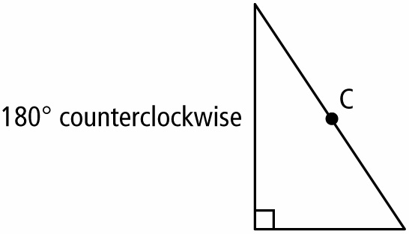
b) | 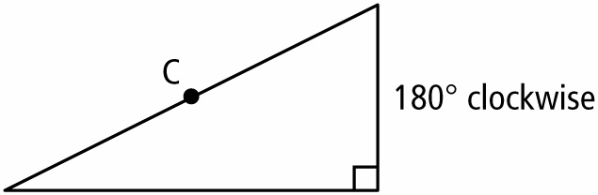

BLM 1–3
(continued)

Section 1.3 Warm-Up

1. Determine whether each pattern represents an arithmetic sequence. If it does, state the value of t₁ and d. If it does not represent an arithmetic sequence, explain why.
a) 2, 4, 6, …
b) 2, 4, 8, …
c) 5, 3, 1, …
d) –4, –2, –1, …
2. For the arithmetic sequence –6, –3, 0, …,
a) what is the general term t_{n}?
b) determine S₁₀.
3. A 20 cm × 16 cm photograph of a company logo is being used for advertisements. Determine the new dimensions if the photograph needs to be
a) enlarged 240% to create a poster.
b) reduced by 25% to fit in a book.
4. Use technology to determine each value to the nearest hundredth.
a)
b)
c)
d)
5. a) Using elimination, solve for r in the following system.
4r + s = 10
2r + s = –44
b) Using substitution, solve for r in the following system.
3s + r = 256

Section 1.4 Warm-Up

1. Determine whether each sequence is arithmetic, geometric, or neither.
a) 0.6, 0.66, 0.666, …
b) 5, 6, 7, …
c) 4, –4, 4, …
d)
e)
2. For each sequence,
• determine r.
• write the next two terms.
• determine the general term t_{n}.
a) 2, –6, 18, …
b) 5,
3. What is n in the sequence
2, 14, 98, , 4802? Justify your work.
4. What is r in each of the following?
a)
b)
5. If t₂ = 28 and t₅ = 1792, what are the values of t₁, r, and t_{n}?

BLM 1–3
(continued)

Section 1.5 Warm-Up

1. Identify whether each series is arithmetic
or geometric. Then, determine S₁₈ to the nearest tenth, if appropriate.
a)
b)
c) 10 + 13 + 16 + …
d) 12 + 24 + 48 + …
2. Consider the series .
a) Determine t₁, r, and n.
b) Write the general form for t_{n}.
c) Determine the sum of the series,
to the nearest hundredth.
3. Draw a 6 cm line and label the endpoints A and B. Locate the midpoint between
points A and B and label it C. Locate the midpoint between points A and C and label it D. Suppose this process continues with points E and F, respectively.
a) Write a sequence that represents the process.
b) If the next point is included, determine the length of segment AG.
4. Write each fraction as a repeating decimal.
a)
b)
c)
5. Simplify. Express each answer in fraction form.
a)
b)
6. Evaluate. Express each answer to the nearest hundredth.
a)
b)
c)

