BLM 2–3
Chapter 2 Warm-Up
Section 2.1 Warm-Up

1. In the diagram, ED ⊥ CD and DC ⊥ BC. Use the diagram to help answer the questions.
Hint: ED ⊥ CD means ED is perpendicular to CD.
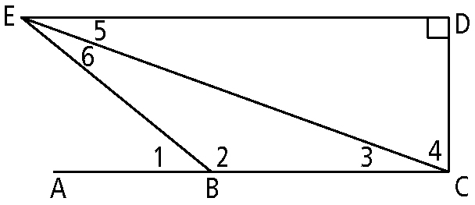
a) Define supplementary angles. Give an example of supplementary angles from the diagram.
b) Define complementary angles. Give an example of complementary angles from the diagram.
c) Show why ∠1 = ∠3 + ∠6.
d) What is another way to name ∠3?
e) In CDE, what is an expression for
cos ∠4?
2. Using a coordinate grid, create the following transformations.
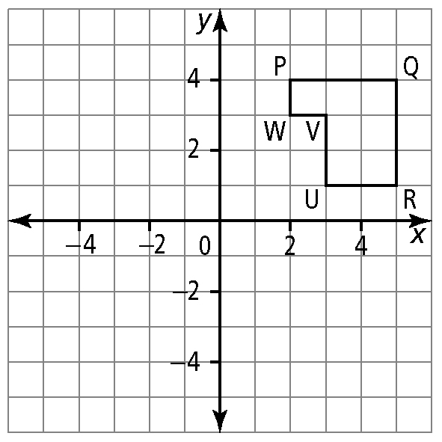
a) Reflect figure PQRUVW in the x-axis. Label the vertices P′, Q′, R′, U′, V′, and W′.
b) What are the coordinates of R′ and V′ in part a)?
c) Reflect P′Q′R′U′V′W′ in the y-axis. Label the vertices P″, Q″, R″, U″, V″, and W″.
d) What are the coordinates of Q″ and U″ in part c)?
e) If you continue reflecting in this manner, where does the fourth reflection end up?
3. Identify the adjacent and opposite sides associated with angle θ in each triangle.
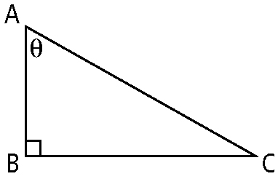
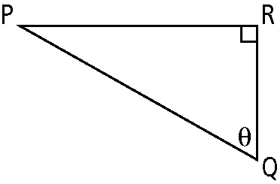
a) b)

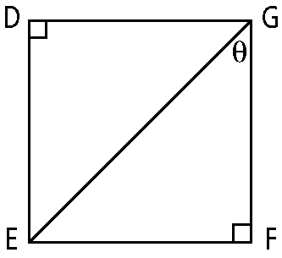
c)

4. Determine the value of each trigonometric ratio. Express the answer as a ratio.
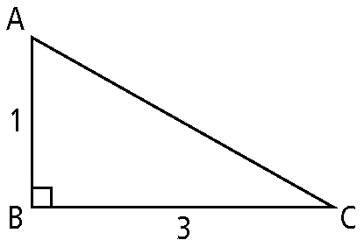
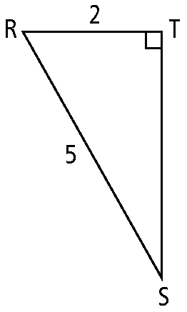
a) b)

• tan A • cos R
• cos C • sin R

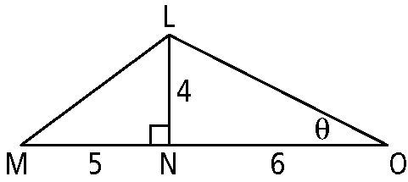
c)

• sin ∠θ
• tan ∠MLN

5. Evaluate each trigonometric ratio, to four decimal places.
a) cos 89° b) tan 42°
c) sin 45° d) sin 28°
e) tan 60° f) cos 24.7°

6. Draw a diagram for #5a). Explain what your answer represents.

BLM 2–3
(continued)

Section 2.2 Warm-Up

1. Sketch an angle in standard position that terminates in quadrant IV.
a) Label the angle along with its initial arm and terminal arm.
b) What can you say for certain about the size of any angle terminating in quadrant IV?
c) What is the direction of rotation for a positive angle in standard position?
2. If each of the following angles is drawn in standard position, in which quadrant is the terminal arm of each angle?
a) 250° b) 50° c) 134°
d) 345° e) 95° f) 199°
3. Draw a sketch for #2a) and c).
4. What is the reference angle for each angle in #2 if the angles are in standard position?
5. Use the Pythagorean relationship to determine the length of the unknown side in each triangle. Express each answer to the nearest tenth of a unit.
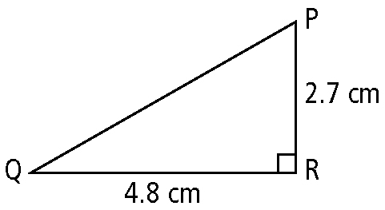
a)

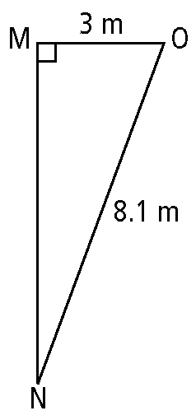
b)

6. Consider equilateral triangle ABC with side lengths of 4 cm. AD ⊥ BC.
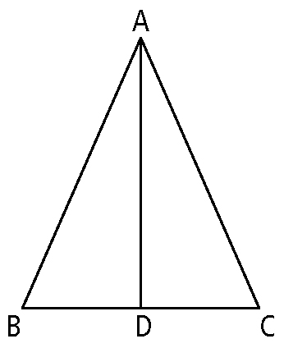
a) What is the measure of each angle in ABD?
b) What is the length of BD?
c) Calculate the length of AD.
d) Determine the value of
• tan B
• cos B
• sin B
7. a) In the isosceles triangle DEF shown, which two sides are equal in length?
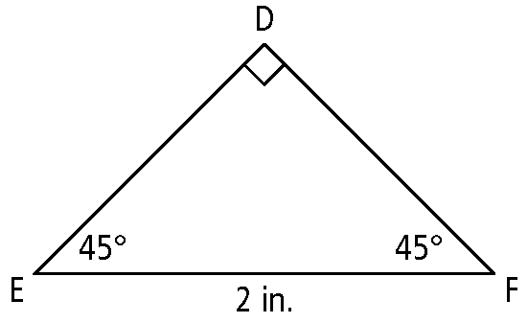
b) Draw an altitude from vertex D that meets EF at G. What is the measure of each angle in DEG?
c) Why does DG = EG?
d) What is the length of EG?
e) Determine the length of DE.
f) Determine the value of
• tan 45°
• sin 45°
• cos 45°

BLM 2–3
(continued)

Section 2.3 Warm-Up

1. Solve each equation. Express each answer as a rational number in the form , where
a and b are integers.
a) b) c)
2. Using the triangle, state each unknown value.
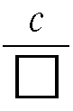
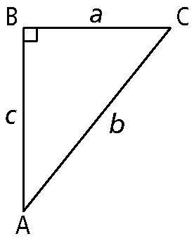

a) a² + c² = b) cos A =
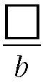
c) sin C = d) tan =
e) cos A = sin f) sin =

3. Without using a calculator, determine the exact value of each trigonometric ratio.
a) tan 45° b) cos 30° c) sin 150°
d) cos 240° e) tan 330° f) sin 300°
4. Using a calculator, determine each value, to the nearest hundredth of a degree.
a) sin 40° b) cos 110°
c) tan 200° d) sin 276.1°
5. Without using a calculator, determine the measure of θ for the given interval.
a) cos θ = , 0° ≤ θ ≤ 360°
b) sin θ = , 0° ≤ θ ≤ 180°
c) tan θ = , 90° ≤ θ ≤ 360°
d) cos θ = , 180° ≤ θ ≤ 360°

Section 2.4 Warm-Up

1. Evaluate each expression. Give the answer to the nearest tenth.
a) 6.2 cos 128°
b)
c) (2.7)² + (4.1)²
d) (4.3)² + (2.9)² – 2(4.3)(2.9)
2. The legs of a right triangle ABC measure
15 cm and 8 cm.
a) Sketch ABC.
b) What is the length of the hypotenuse, to the nearest centimetre?
c) Determine the area of ABC.
d) Determine the measure of the smallest angle in ABC.

3. Solve each equation. Express the answer to the nearest tenth.
a) b)
c)
4. Use the sine law to help solve PQR, given the angle measures shown. Determine the answer to the nearest tenth.
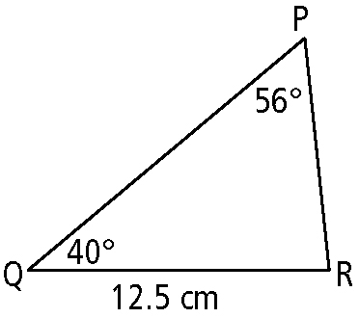
5. a) Draw and label a triangle that cannot be solved using the sine law, even though the measurements for two sides and one angle are given.
b) Explain why the sine law does not work for the triangle from part a).

