BLM 4–3
Chapter 4 Warm-Up
Section 4.1 Warm-Up

1. Quadratic functions are represented by
f (x) = 2x² – x + 3 and g(x) = 2(x –3)² + 7.
a) What is the value of f (−4)?
b) Determine g(2).
c) What is g(5) − f (0)?
2. a) Complete the table of values for the quadratic function f (x) = –3x² + 6x – 1. Then, answer the questions below.
x | −2 | −1 | 0 | 1 | 2 | 3 | 4
f (x)
b) What is the equation for the axis
of symmetry?
c) What is the maximum value of
this function?
d) How could symmetry help you complete the table of values if you knew the equation for the axis of symmetry?
3. Sketch a graph of each quadratic equation. Determine the coordinates of the vertex
and the number of real x-intercepts for
each graph.
a) y = (x – 3)² + 2 b) y = –2(x + 1)² + 5
c) y = 3(x + 2)²
4. Use the graph to help answer the following questions:
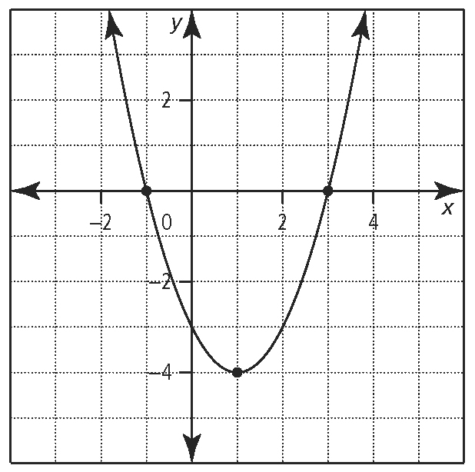
a) What is the equation for the axis
of symmetry?
b) What are the coordinates of the vertex?
c) Determine the x-intercepts for the curve.
d) If the equation for the function is written in the form y = ax² + bx + c, what can you say for certain about the coefficient a?
5. Sketch a parabola that satisfies each set
of information.
a) vertex at (−1, 2) and y-intercept of −3
b) Equation of axis of symmetry is x = 4. Vertex is below the x-axis and the parabola opens upward.
c) vertex at (0, 2) and has no x-intercepts

Section 4.2 Warm-Up

1. Multiply and combine like terms.
a) (x – 4)(x + 3)
b) 5x(2x – 5) – 3x(1 – x)
c) (3x – 7)(2x + 1)
d) (2x – 3)²
e) (2x – 7)(2x + 7)
2. The dimensions of a rectangle are given as
x + 5 and 2x − 3, in centimetres. Determine a simplified expression for
a) the perimeter of the rectangle
b) the area of the rectangle

3. Solve each equation for the variable x.
a) 5(x – 3) – 2(4x – 1) = 5
b) (2x – 5)(x + 3) = 2(x – 3)(x + 3)
4. Factor each trinomial.
a) x² + 4x – 21 b) x² + 7x + 10
c) 2x² – 7x + 6 d) 4x² + 11x – 3
5. Factor each expression fully.
a) –3x² + 9xy – 6y² b) –4x² + 49
c) 2x² – 12x + 18 d) 3x³ – 3x² + 27x
e) x⁴ – 16

BLM 4–3
(continued)

Section 4.3 Warm-Up

1. Answer the following questions using your knowledge of square roots.
a) Is a decimal value ofconsidered exact or approximate?
b) What is the value ofcorrect to three decimal places?
c) How many solutions does the equation
x² = 9 have?
d) What two whole numbers doesfall between?
e) What is the solution for the equation
2. Solve each quadratic equation.
a) x² – 36 = 0
b) 3x² – 12 = 0
c)
d) (x – 3)² = 81
e) (2p – 1)² + 4 = 53
3. Write each equation in the form
ax² + bx + c = 0, where a, b, and c are
integers and a ≠ 0.
a) (2x – 5)(x – 1) = 0
b) 3(x – 4)² = –5
c) roots are 2 and −3
d) roots are and −2
4. What number must be added to each expression to create a perfect
square trinomial?
a) x² – 8x
b) m² + 24m
c) y² – 3y
d)
5. Solve the equation (x + 2)² – (x + 2) = 42 using two different algebraic methods.

Section 4.4 Warm-Up

1. Two quadratic functions are defined by
f (x) = –2(x + 3)² + 1 and g(x) = 3x² + 6x + 1.
a) Express function g in the form
g(x) = a(x – p)² + q.
b) In a graph of the functions, which parabola’s vertex will be closest to
the x-axis?
c) Which parabola has a y-intercept of 1?
d) What is the range of function f ?
e) Express function f in the form
f (x) = ax² + bx + c.
f) What is the equation of the axis of symmetry for function g?
g) Sketch the graph of function f.
2. Solve each quadratic equation by completing the square. Express answers
to the nearest tenth.
a) x² – 8x + 13 = 0
b) –3x² + 4x = –5
3. Rewrite each quadratic equation in the form ax² + bx + c = 0. Then, identify the numerical values of a, b, and c in each case.
a)
b) – (x – 2)² = 5
4. Solve each quadratic equation using different methods.
a) x² + 6x – 4 = 0
b) 2x² + x – 6 = 0
c) x² – 8x + 15 = 0

