BLM 6–4
Chapter 6 Warm-Up
Section 6.1 Warm-Up

1. Evaluate each expression given that
x = 5, y = 2, and z = −3.
a) xy + 2z² b) x (y − z) c) z(2x − y)
d) e)
2. Write the additive inverse of each expression. Express your answers in simplest form.
a) −4 b) −4 + 3xy
c) z(2x − y) d)
3. What is the value of any rational when the following are true?
a) the numerator and denominator are equal
b) the numerator and denominator are equal in size with opposite signs
c) the numerator is greater than the denominator and they have the same sign
4. Solve each equation for the variable given. Give answers in the form of where a and b are integers.
a) 3x − 4 = 0 b) x² − 25 = 0
c) x² − 2x = 3 d)
5. Common factoring, difference of squares, and trinomial factoring are three different factoring strategies. Use two of these methods to factor each expression.
a) 9x² − 81
b) 2x² − 8x − 10
6. Factor fully.
a) 3x² − 6xy + 3xy² b) 2x² − 4xy + 2y²
c) 9x² − 16 d) 3x² − 0.03
e) 10x² − 25x − 15

Section 6.2 Warm-Up

1. What is the reciprocal of each expression?
a) b) c) 3 x
d) e)
2. What are the non-permissible values, if any, for each rational expression?
a) b) c)
d) e)
3. Write an expression that satisfies the given conditions in each case.
a) equivalent to with a denominator
of 4x
b) equivalent to with a numerator of 1
c) equivalent to with non-permissible values of ± 4
d) equivalent to with a numerator of
3c − 9f
4. Complete each number pyramid so that the number in each box is the product of the two numbers below it.
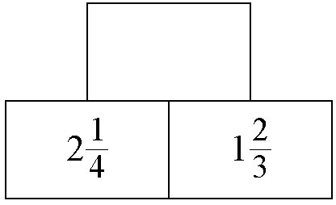
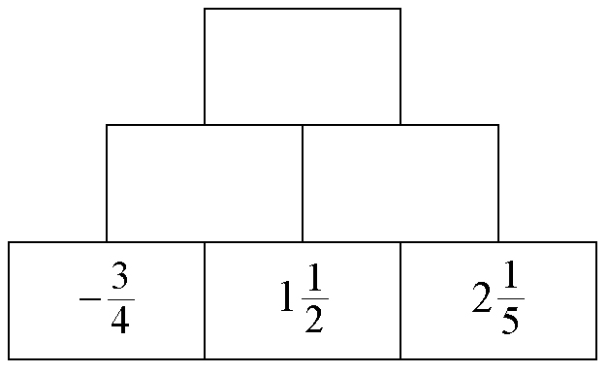
a) b)

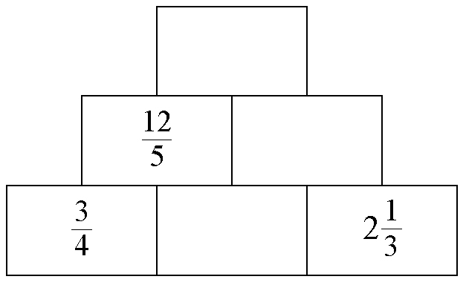
c)

5. Simplify. Determine all non-permissible values of the variables.
a) b)
c) d)

BLM 6–4
(continued)
Section 6.3 Warm-Up

1. Write an expression that satisfies the given conditions.
a) equivalent to with a denominator of 12
b) equivalent to with a denominator
of −4x
c) equivalent to with non-permissible values of ± 2
d) equivalent to and written as the product of two rational expressions
2. Complete each pyramid so that the value in each box is the product of the two values below it.
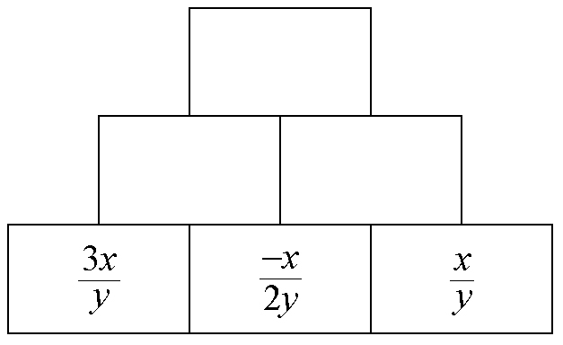
a)

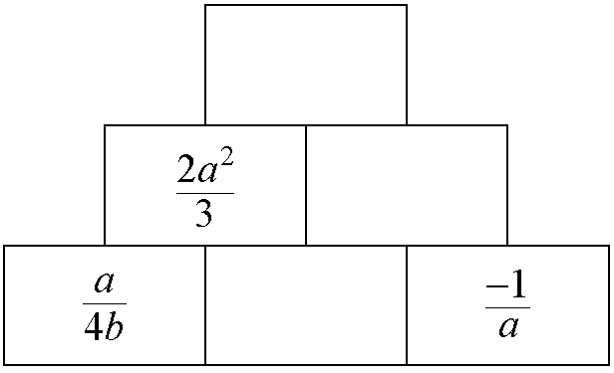
b)

3. What is the least common denominator for each set of fractions?
a) b)
c) d)
4. Simplify each product. Determine all
non-permissible values.
a)
b)
c)
d)
5. Divide, expressing answers in lowest terms. Identify any non-permissible values.
a) b)
c) d)
e)

Section 6.4 Warm-Up

1. Determine the lowest values for A and B that make each statement true.
a) b)
c) d)
2. What is the least common denominator for each sum or difference?
a) b)
c)
3. Solve for x.
a) b) 3x² − 12 = 0
c) x² − 6x + 5 = 0 d) 2x² − 7x + 3 = 0
4. Write an equation to represent each situation. Identify what your variable represents in each case.
a) The sum of a number and its reciprocal is 4.
b) The area of a rectangle is 12 cm² and the lengths of the sides differ by 3 cm.
c) The cost of a drink and a snack differ by 50¢. The total cost of one drink and
two snacks is $5.00.

