BLM 8–3
Chapter 8 Warm-Up
Section 8.1 Warm-Up

1. Arrange each linear equation in the form
y = mx + b. Then, identify the values for slope, m, and y-intercept, b, for each.
a) 3x − 4y + 8 = 0 b) x − 8 = −2y
2. Use the graph to answer the questions below.
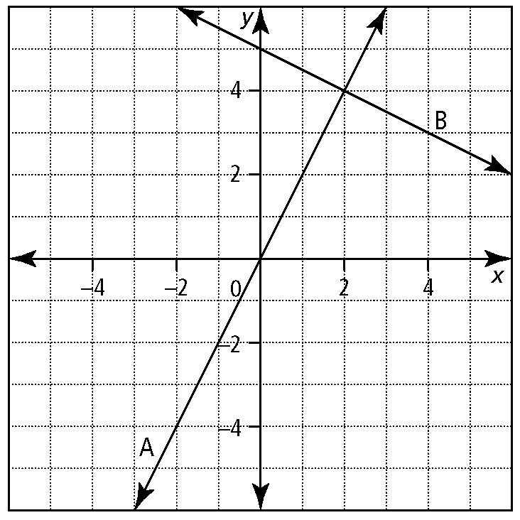
a) What is the equation for line B?
b) What is the x-intercept for line A?
c) Which line has a negative slope? How do you know?
d) What is the solution for the linear system shown on the graph?
e) Determine algebraically whether line B passes through the point (6, 2).
3. Draw a graph representing each of the following functions.
a) f (x) = 2x − 3
b) g(x) = x² − 2x − 3
4. Consider the following system of equations:
y = 2x − 2
y = x − 1
a) Solve the system graphically.
b) Through which quadrants do the graphs of the two equations pass?
5. A system of linear equations can have no solution, one solution, or an infinite number of solutions. Draw three graphs illustrating each of these possible solution sets for a linear system. For each of your graphs, describe in words how your diagram represents the solution set.
6. Use the graph to answer the questions below.
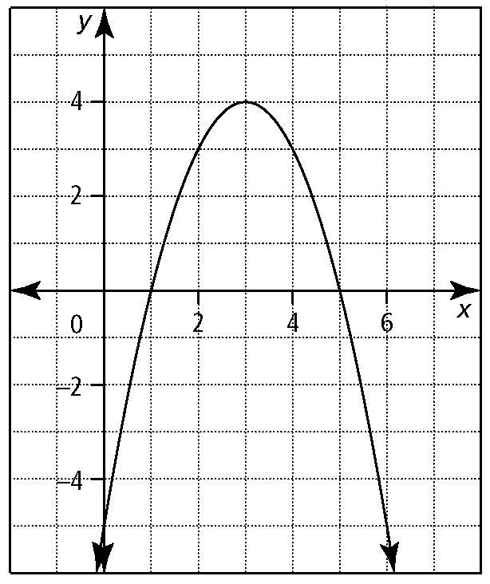
a) What type of function is represented by the graph?
b) What name is given to the curve shown on the graph?
c) What are the coordinates of the vertex?
d) What is the equation of the axis of symmetry?
e) What can you say for sure about a if the function represented by the graph is of the form f (x) = a² + bx + c?
f ) What are the roots of the equation
a² + bx + c = 0?

BLM 8–3
(continued)
Section 8.2 Warm-Up

1. Simplify each algebraic expression.
a) 6x − y − 4x + y − 7 + 2x
b) −3(s − t) − (3s − t)
c) (4p − q)(2p − q)
d) (x − 3)² − 4(x + 1)²
e) 5a − 3b − 6a + b
f ) 2(m − 3p) − 5(2p − 4m)
g) (3x − 5y)²
h) (2x − 1)² − 3(2x + 3)²
2. Use the substitution method to solve each linear system.
a) 3x − 2y = −7
x − 3y = −7
b) 2x + y = −4
x + 2y = 1
c) 2r + 3t = 5
r − 2t = 6
d)
3a + b = 1
3. Use elimination to solve each linear system.
a) 2a − 3b = 13
3a − b = 9
b) 5a + b = 14
2a + b = 5
c) 2x + 3y = 18
−7x + 9y = 15
d)
3x − y = 1
4. A linear-quadratic system of equations can have zero, one, or two solutions. Draw diagrams to illustrate each of these cases. Identify the number of solutions in each of your diagrams.
5. Solve the following systems of equations
by graphing.
a) x − 3y + 11 = 0
x − y + 5 = 0
b) y = x²
y = 8 − x²
c) y = x + 3
y = (x − 1)² − 2
d) 4s − t + 20 = 0
s + 2t − 13 = 0
e) y = 2x − 6
f ) x² − 2y = 0
x + 2y = 6
6. Graph each system of equations. How many solutions does each system have? Explain your answers.
a) x² − 2y = 0
3x + 2y = 10
b) 2x + y + 3 = 0
6x + 3y + 9 = 0
c) x + 3y = −2
x² − 4x + 3 = 0

