BLM 9–3
Chapter 9 Warm-Up
Section 9.1 Warm-Up

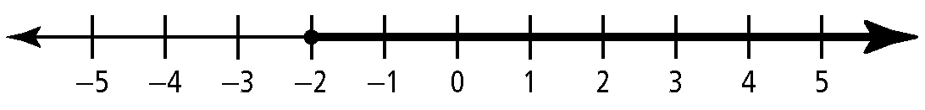
1. Express each number line in the form
of an inequality.
a)

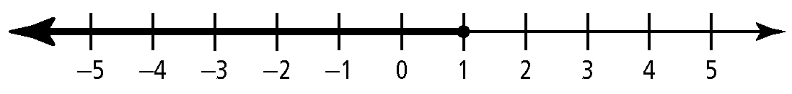
b)

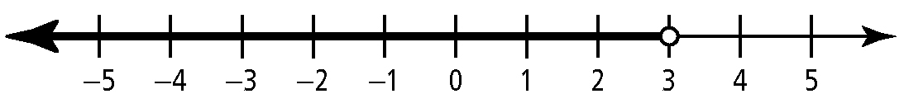
c)

2. Draw a number line showing the solution
to each linear inequality.
a) x > 4 b) x ≤ −1
3. Solve each equation.
a) 6m + 3 = 2m + 15
b) 11x − 1 = 2x − 28
c) 2 − 5w = 16 − 3w
d) 6y − 3 = 5(2y − 3)
4. For what value(s) of b is each expression
i) equal to 50?
ii) less than 50?
iii) greater than 50?
a) 5(b − 10) b) 3b + 5
c) d) −1.25b
5. What is the value of the x-intercept and
the y-intercept for each linear relation?
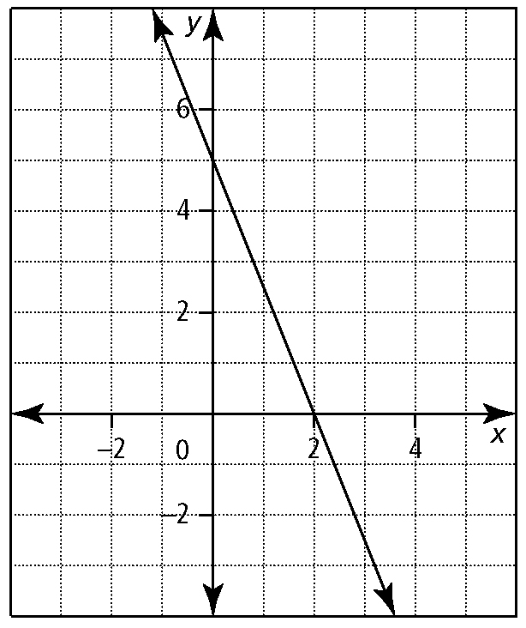
a)

b) y = 2x − 3 c) 2x + 3y = 9
6. Photographs can be classified into three shapes: portrait, square, and landscape.
Let h represent the height of a photo and
w represent the width.

Portrait  h is greater than w.  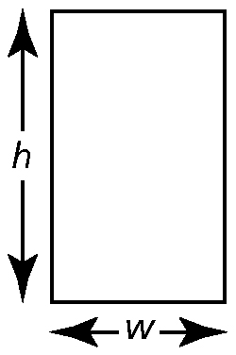 | Square  h is equal to w.  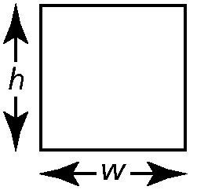

Landscape
h is less than w.
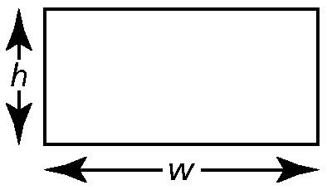

a) Express each photo classification as either an equation or an inequality.
b) Each point marked on the graph shown represents a photo. For each photo, A to G, identify whether its shape is portrait, square, or landscape.

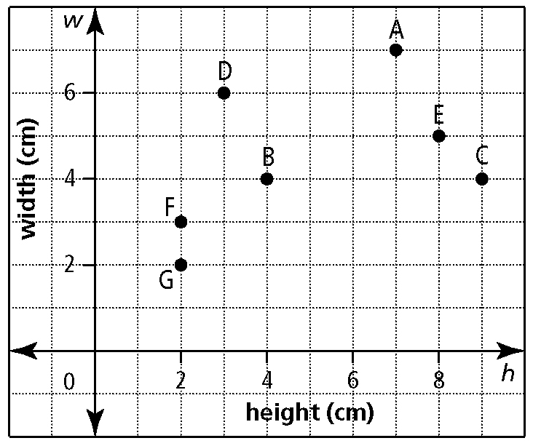
c) Draw a line on the graph through the points that represent square photos. State how the points that represent portrait and landscape photos relate to this line.

BLM 9–3
(continued)

Section 9.2 Warm-Up

1. Explain how a straight line on a graph divides the Cartesian plane into three regions. Use an example.
2. Draw a graph of your choice to show the solution set of each inequality.
a) 3(x − 5) + 2 ≤ 2x − 9
b) y < 3x − 5
c) 2x − 3y ≤ 6
3. Determine if the given value of x is a solution for the inequality.
a) x = 2
b) 3x − 1 < x − 4, x = −2
c) 4(x − 3) > −2(8 − 5x), x = −12
4. Complete each ordered pair to satisfy the equation y = x² + 1.
a) (−4, )
b) (2.7, )
c) (, 5)
d) (, 2.44)
e) (,)
5. Factor each quadratic expression.
a) x² − 7x − 30 b) x² + 9x + 18
c) 2x² − x − 6 d) 3x² + 14x − 5
6. Determine the x-intercepts of each quadratic function.
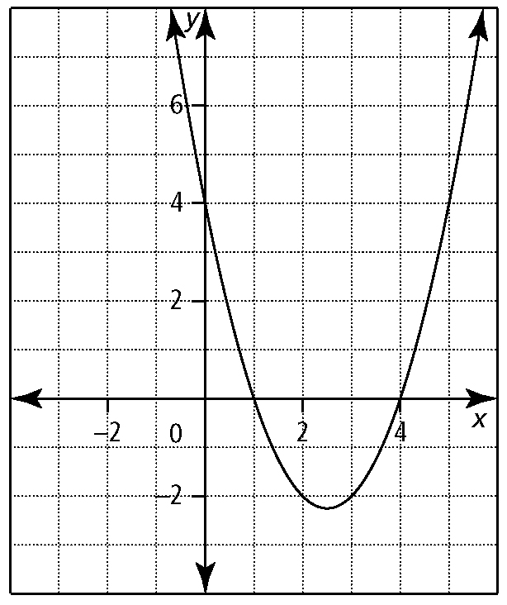
a)

b) f (x) = (x − 5)(x + 2)
c) f (x) = x² − x − 56
d) f (x) = 2x² + x − 1

Section 9.3 Warm-Up

1. Solve each quadratic equation by factoring.
a) x² − 9 = 0
b) x² − 6x − 7 = 0
c) 2x² + 13x + 15 = 0
d) 3x² − 5x = −2
2. Use the quadratic formula to determine the roots of y = 2x² + 3x − 1.
3. Draw the graph of each quadratic equation. From the graph, determine how many zeros the function has.
a) y = (x + 1)² − 3
b) y = (x − 2)²
c) y = x² − 4x + 5
4. Explain the relationship between the roots of a quadratic equation, the zeros of a quadratic function, and the x-intercepts for the graph of the function. Use examples to support your explanation.
5. Solve each quadratic inequality.
a) x² − 1 ≤ 0
b) x² − 1 > 0
c) x² − 3x ≤ 4
6. Draw a number line that shows the solution for each quadratic inequality.
a) x² + x − 6 > 0
b) 3x² + 11x − 4 ≤ 0

