Chapter 1 Warm-Up Answers

BLM 1–3 Chapter 1 Warm-Up
Section 1.1
1. a) The first term is 2. The common difference is 2.
b) The first term is 1. The common difference is 3.
c) The first term is 5. The common difference is 6.
2. a) x = 13 b) x = −29
3. a) g(1) = −5 b) g(0) = −11 c) g(−3) = −29
4. a) b) x = 38
5. a) slope = 4, y-intercept = −1
b)
x | y
0 | −1
1 | 3
2 | 7
3 | 11
4 | 15
5 | 19
Section 1.2
1. a) arithmetic sequence, t₁ = 2, d = 2
b) not arithmetic sequence
c) arithmetic, t₁ = 1, d = 3
d) arithmetic, t₁ = −6, d = 5
2. a) t_{n} is the general term, t₁ is the first term, n is the number of terms, and d is the common difference.
b) t₂₆ = 78 c) t₁ = −5 d) t_{n} = 2 + 4(n – 1)
3. a) y = 6x b) y = 2x + 1 c) y = 18 + 36x
4.
5. a) b)
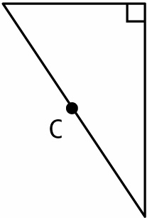 | 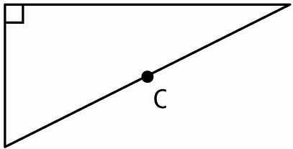
Section 1.3
1. a) arithmetic, t₁ = 2, d = 2
b) not arithmetic because you multiply by 2 to find each successive term
c) arithmetic, t₁ = 5, d = −2
d) not arithmetic because you multiply by to find each successive term
2. a) t_{n} = 3n – 9 b) S₁₀ = 75
3. a) 48 cm × 38.4 cm b) 15 cm × 12 cm
4. a) 3.56 b) 1.49 c) 1.51 d) s = 11.67
5. a) r = 27 b) r = 51.2
Section 1.4
1. a) neither b) arithmetic c) geometric
d) geometric e) arithmetic
2. a) r = –3; –54, 162; t_{n} = 2(–3)^{n – 1}
b) r = ; ;
3. Solve 2(7)^{n – 1} = 4802 to get n = 5.
4. a) r = 5 b) r =
5. t₁ = 7, r = 4, t_{n} = 7(4) ^{n – 1}
Section 1.5
1. a) arithmetic, S₁₈ = or –22.5
b) geometric, S₁₈ = 6.0 c) arithmetic, S₁₈ = 639
d) geometric, S₁₈ = 3 145 716
2. a) t₁ = 1, r = and n = 11
b) c) S₁₁ = 0.75
3. a) 6, 3,
b) The length from A to G would be cm or 0.1875 cm.
4. a) b) c)
5. a) b)
6. a) 0.06 b) 0.02 c) 0.00

