Chapter 2 Warm-Up Answers

BLM 2–3 Chapter 2 Warm-Up
Section 2.1
1. a) Example: Angles with a sum of 180° are supplementary. ∠1 and ∠2 are supplementary.
b) Example: Angles with a sum of 90° are complementary. ∠3 and ∠4 are complementary.
c) ∠1 + ∠2 = 180°; ∠2 + ∠3 + ∠6 = 180°; ∠1 + ∠2 = ∠2 + ∠3 + ∠6. Therefore, ∠1 = ∠3 + ∠6.
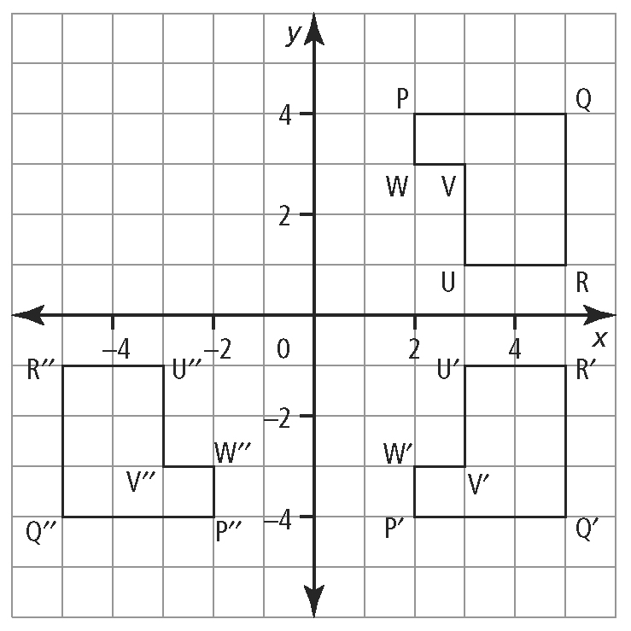
d) ∠ECB or ∠BCE e) cos ∠4 =
2. a), c)

b) R′ = (5, −1); V′ = (3, −3) d) Q′′ = (−5, −4);
U′′ = (−3, −1)
e) The fourth reflection falls on the original figure.
3. a) adjacent: AB; opposite: BC
b) adjacent: QR; opposite: PR
c) adjacent: FG; opposite: EF
4. a) tan A = 3; cos C =
b) cos R = or 0.4; sin R =
c) sin ∠θ = ; tan ∠MLN = or 1.25
5. a) 0.0175 b) 0.9004 c) 0.7071
d) 0.4695 e) 1.7321 f) 0.9085

6. Example: cos B = . The answer represents the ratio of c to a in the triangle shown.
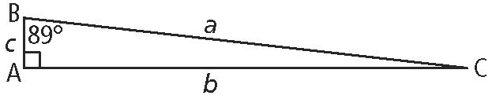
Section 2.2
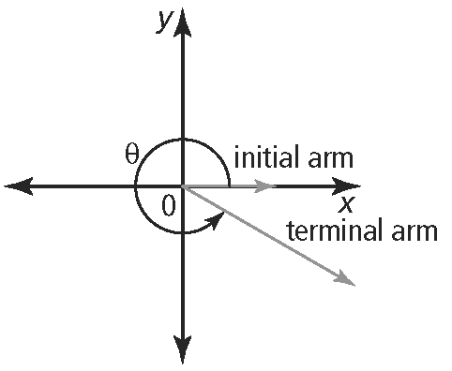
1. a) Example:

b) The angle is between 270° and 360°.
c) counterclockwise
2. a) quadrant III b) quadrant I c) quadrant II
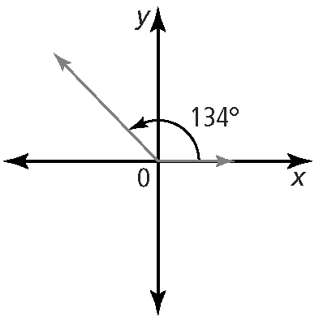
d) quadrant IV e) quadrant II f) quadrant III
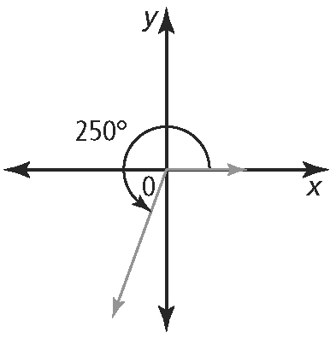
3.

4. a) 70° b) 50° c) 46° d) 15° e) 85° f) 19°
5. a) 5.5 cm b) 7.5 m
6. a) ∠B= 60°; ∠ADB = 90°; ∠BAD = 30° b) 2 cm c)
d) tan B = ; cos B =sin B =
7. a) DE = FD
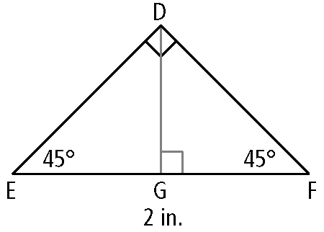
b)

∠DEG = 45°; ∠EGD = 90°; ∠EDG = 45°
c) DG and EG are equal sides of isosceles triangle EGD. d) 1 in. e)
f) tan 45° = 1; sin 45° = ; cos 45° =
Section 2.3
1. a) x = b) y = c) z =
2. a) = b² b) = b c) = c
d) = C e) = C f) = A
3. a) 1 b) c) d) e) f)
4. a) 0.64 b) – 0.34 c) 0.36 d) – 0.99
5. a) 60° or 300° b) 30° or 150° c) 240° d) 330°
Section 2.4
1. a) –3.8 b) 6.0 c) 24.1 d) 2.0
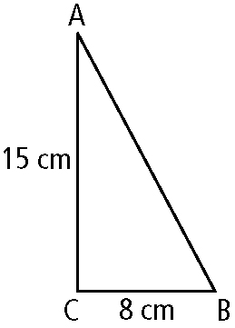
2. a)

b) 17 cm c) 60 cm² d) ∠C = 28.07°
3. a) x = 0 b) y = 13.1 c) θ = 12.0°
4. ∠R = 84°; PR = 9.7 cm; PQ = 15.0 cm

(Ch 2 Warm-Up Answers continued)

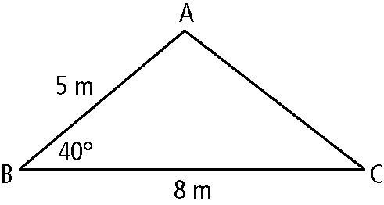
5. a) Example:

b) The sine law cannot be used to solve ΔABC since each time you set up the ratios, there are two unknowns. For example, has unknowns ∠A and side b.

