BLM 3–8
Chapter 3 BLM Answers

BLM 3–3 Chapter 3 Warm-Up
Section 3.1
1. a) b) –4 c) y = x – 2
d) { y | y R} or y is all real numbers
e) x = –6
2. a) a = 1, p = 0, q = –3 b) a = –4, p = 0, q = 9
c) a = 2, p = 18, q = –6 d) a = –7, p = – 3, q = 2
3. a)
x | −5 | –1 | 0 | 1 | 5
f (x) | 4 |  | 2 |  | 0
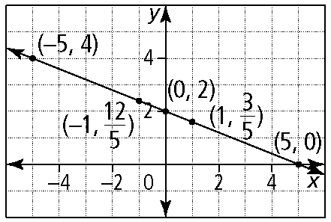
b)
x | −3 | –1 | 0 | 1 | 2
y | –5 | –2 | – | 1
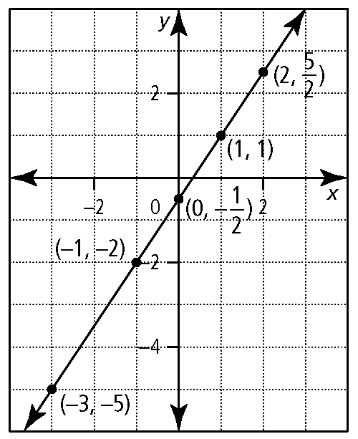
4. a) 7 b) 10 c) 6
5. 2

Section 3.2
1. p = 3; q = 2; a is negative
2. a)
x | −2 | –1 | 0 | 1 | 2 | 4
y | 0 | –5 | –8 | –9 | –8 | 0
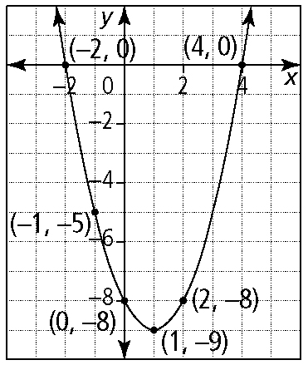
b) (1, –9) c) x = 1 d) –8 e) –2 and 4 f) y ≥ –9
3. a) 2x² + 5x + 3 b) x² – 4x + 4
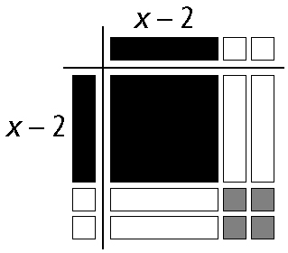
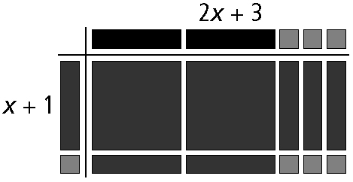
4. a) f (x) = –1(x – 3)² + 2 b) f (x) = (x + 3)² + 1
Section 3.3
1. a) y = 3x² – x – 5; a = 3, b = –1, c = –5
b) h(x) = x² – 4x – 5; a = 1, b = –4, c = –5
c) y = –3x² + 6x + 2; a = –3, b = 6, c = 2
2. a) Let x = 0 and solve for y.
b) g has a maximum at 5
c) (5, 1) d) –16 e) x = 5
3. a) y = –3x² opens downward and the parabola is narrower
b) y = x² has a wider parabola
c) y = x² – 3 is shifted 3 units downward
d) y = (x – 3)² is shifted 3 units to the right
4. a) y = (x + 2)² + 1 has its vertex at (−2, 1); opens upward, so has no x-intercept
b) y = 3x² – 3 has its vertex at (0, −3); opens upward, so has 2 x-intercepts
c) y = –2(x – 3)² has its vertex at (3, 0); opens downward, so has 1 x-intercept
5. a) 2 x-intercepts; y-intercept is likely negative, but could be positive or zero
b) 1 x-intercept; y-intercept is positive or zero
6. a) (3x – 2) (x – 2)
b) Add or combine like pieces of the rectangle.
c) 3x² – 8x + 4

