Chapter 4 Warm-Up Answers

BLM 4–3 Chapter 4 Warm-Up
Section 4.1
1. a) 39 b) 9 c) 12
2. a)
x | −2 | −1 | 0 | 1 | 2 | 3 | 4
f (x) | −25 | −10 | −1 | 2 | −1 | −10 | −25
b) x = 1 c) 2 d) Function values are the same on opposite sides of the axis of symmetry, so you really only need to find values for half the table.
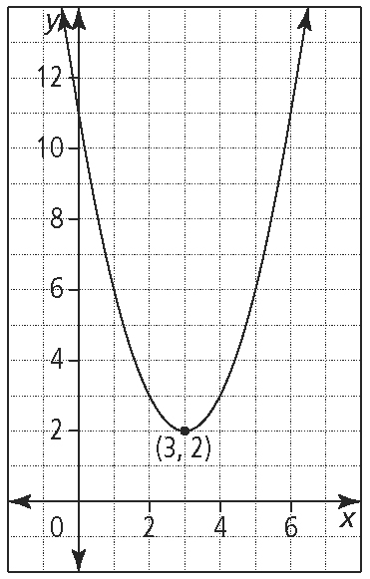
3. a)

vertex: (3, 2); no x-intercepts
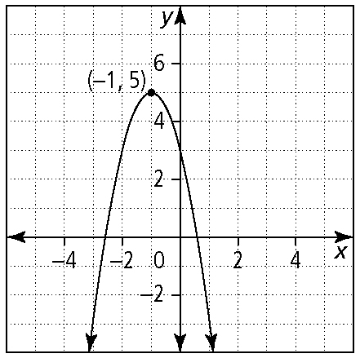
b)

vertex: (–1, 5); two x-intercepts
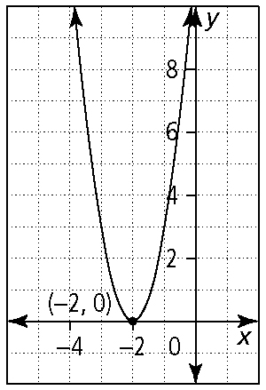
c)

vertex: (–2, 0); one x-intercept
4. a) x = 1 b) (1, −4) c) (−1, 0) and (3, 0)
d) a is positive or a > 0.
5. a) Example:
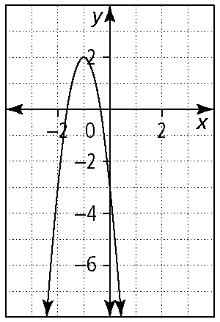
b) Example:
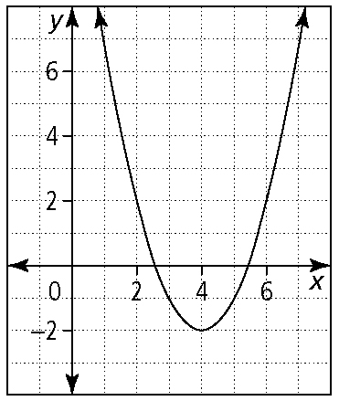
c) Example:
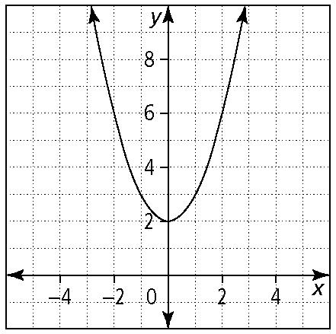
Section 4.2
1. a) x² – x – 12 b) 13x² – 28x
c) 6x² – 11x – 7 d) 4x² – 12x + 9 e) 4x² – 49
2. a) 2(x + 5) + 2(2x – 3) = (6x + 4) cm
b) (x + 5)(2x – 3) = (2x² + 7x – 15) cm²
3. a) x = −6 b) x = −3
4. a) (x + 7)(x – 3) b) (x + 5)(x + 2)
c) (2x – 3)(x – 2) d) (4x – 1)(x + 3)
5. a) –3(x² – 3xy + 2y²) = –3(x – y)(x – 2y)
b) 49 – 4x² = (7 – 2x)(7 + 2x)
c) 2(x² – 6x+ 9) = 2(x – 3)(x – 3), or 2(x – 3)²
d) 3x(x² – x + 9)
e) (x² – 4)(x² + 4) = (x – 2)(x + 2)(x² + 4)
Section 4.3
1. a) approximate b) 5.292 c) 2
d) 4 and 5 e) x = 0, x = 1
2. a) x = ±6 b) x = ±2
c) y = ±10 d) x = 12 or x = –6
e) p = 4 or p = –3
3. a) 2x² – 7x + 5 = 0
b) 3x² – 24x + 53 = 0
c) x² + x – 6 = 0

(Ch 4 Warm-Up Answers continued)

d) 3x² + 4x – 4 = 0
4. a) 16 b) 144 c) d)
5. Method 1: Multiply and solve:
x² + 4x + 4 – x – 2 = 42
x² + 3x – 40 = 0
(x – 5)(x + 8) = 0
x = 5 or x = –8
Method 2: Substitute for x + 2 and solve. Then substitute back:
Let m = x + 2.
m² – m – 42 = 0
(m + 6)(m – 7) = 0
m = –6 or m = 7
Then, –6 = x + 2, so x = –8, or 7 = x + 2, so x = 5.
Section 4.4
1. a) g(x) = 3(x + 1)² – 2
b) function f c) function g
d) {y | y ≤ 1} e) f (x) = –2x² – 12x – 17
f) x = −1
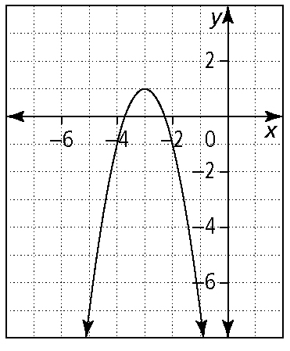
g)

2. a) x = 5.7 or x = 2.3
b) x = –0.8 or x = 2.1
3. a) , b = 6, c = –1, or
3x² + 24x – 4 = 0, a = 3, b = 24, c = –4
b) –x² + 4x – 9 = 0, a = –1, b = 4, c = –9
4. Example: a) complete the square:
b) factor:or x = –2
c) graph the quadratic function f (x) = x² – 8x + 15; roots for y = 0 are 3 and 5
