Chapter 7 Warm-Up Answers

BLM 7–3 Chapter 7 Warm-Up
Section 7.1
1. a) −7 b) 3 c) 9 d) 3 e) 5 f ) −5
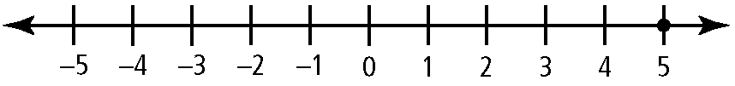
2. a)

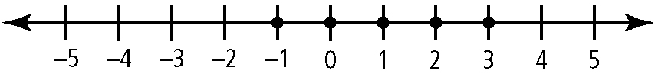
b)

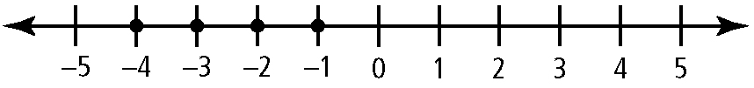
c)

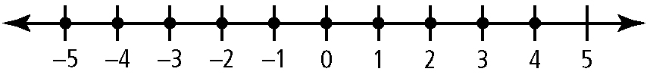
d)

3. a) −3 ≤ x ≤ 1, x ∈ I b) x > −1, x ∈ R
c) −2 < x ≤ 3, x ∈ R d) x = −1
4. a) 0 b) 4 units c) B and E d)
5. a) + 14 °C b) + 45 °C c) + 26 °C d) − 27 °C
Section 7.2
1. a) −6 b) −5 c) 5 d) 18 e) 9
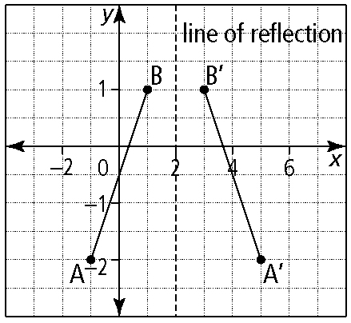
2. a)

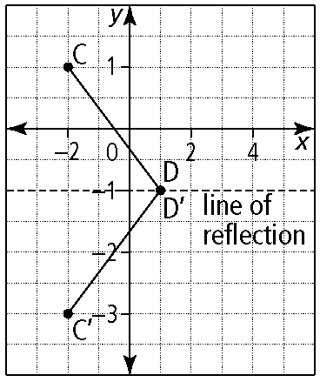
b)

3. a) There is only 1 zero and it is between 0 and 1.
b) domain: {−2 ≤ x ≤ 1, x ∈ R};
range: {−1 ≤ y ≤ 1, y ∈ R}
c) y = −1
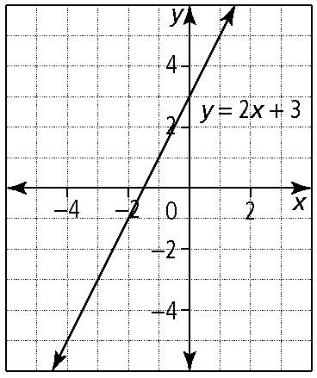
4. a)

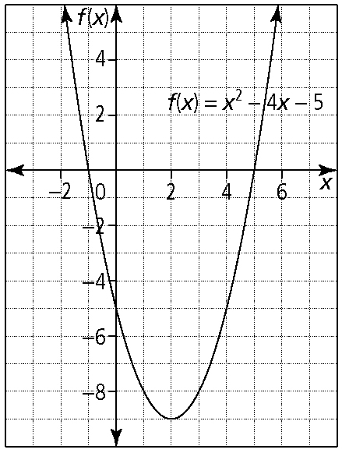
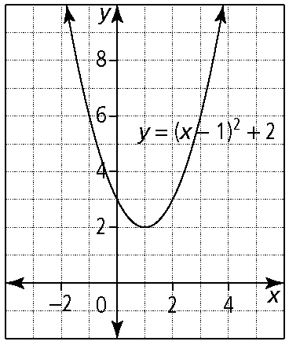
b) c)

5. a)
b) y = −(x + 1)² + 3 or y = −x² − 2x + 2
Section 7.3
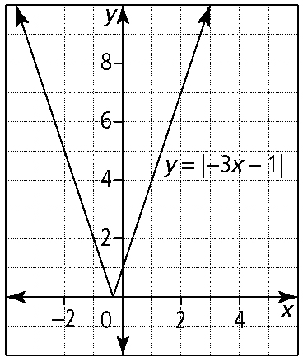
1. a)

y-intercept: (0, 1); x-intercept:
domain: x ∈ R; range: y ≥ 0
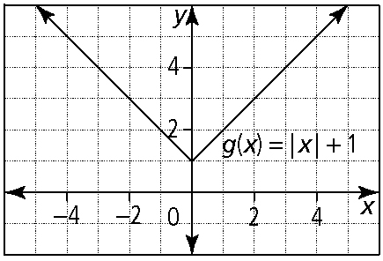
b)

y-intercept: (0, 1); x-intercept: none; domain: x ∈ R; range: y ≥ 1
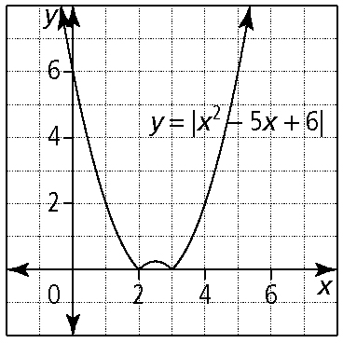
c)

y-intercept: (0, 6); x-intercepts: (2, 0) and (3, 0); domain: x ∈ R; range: y ≥ 0

(Ch 7 Warm-Up Answers continued)

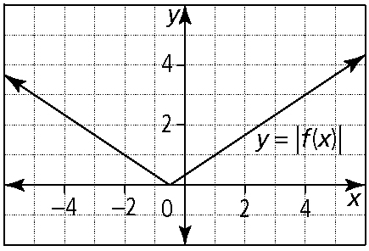
2. a)

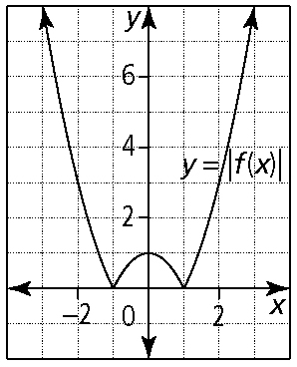
b)

3. a) b) x = 3 c) x = 3
4. a) x = ± 1 b) x = −3, x = 2 c) x = 1
5. a) b)
Section 7.4
1. a) b) 4 c) d)
2. a) none b) x ≠ 2 c) x ≠ ± 1 d) x ≠ −2 and x ≠ −1
3. a) x = 3 and x = both solutions check
b) x = 2 and x = −4; both solutions check
c) x = −5 and x = 1; solution x = − 5 is extraneous
d) x = 1 and x = 0; both solutions check
4. a) y = (x + 1)² + 2 or y = x² + 2x + 3
b) y = −x² + 2x + 8 c) y = x² − 4x + 4
5. Let each denominator equal zero and solve the resulting equation. Each solution is a non-permissible value for the rational expression.

